Angular development with typescript

source code: https://github.com/Farata/angulartypescript

Router basic

In a single-page application (SPA), the web page won’t be reloaded, but its parts may change. You’ll want to add navigation to this application so it’ll change the content area of the page (known as the router outlet) based on the user’s actions. The Angular router allows you to configure and implement such navigation without performing a full page reload.

In general, you can think of a router as an object responsible for the view state of the application.
Every application has one router object, and you need to configure the routes of your app.

You can think of an SPA as a collection of states, such as home, product detail, and shipping. Each state represents a different view of the same SPA.

Angular suports
- HashLocationStrategy (A hash sign (#) is added to the URL ) TODO
- PathLocationStrategy (default)

If you’re configuring routes for a feature module (not for the root one), use the forChild() method, which also creates a router module but doesn’t create the router service (forRoot() should have created the service by now), as you can see in the following listing.

Passing query parameters to a route
<a [routerLink]="['/products']" [queryParams]="{category:'sports'}">? Sports products </a>

showSportingProducts() { this.router.navigate(['/products'], 2 {queryParams: {category: 'sports'}});}

As the user navigates your app, Angular dispatches events, such as NavigationStart, NavigationEnd, and so on. There are about a dozen router events, and you can intercept any of them if need be

Router advanced

Angular offers several guard interfaces that give you a way to mediate navigation to and from a route. Let’s say you have a route that only authenticated users can visit. In other words, you want to guard (protect) the route.

Here are some other scenarios where guards can help:
- Open the route only if the user is authenticated and authorized to do so.
- Display a multipart form that consists of several components, and the user is allowed to navigate to the next section of the form only if the data entered in the current section is valid.
- Remind the user about unsaved changes if they try to navigate from the route.
- Allow navigation to the route only after a certain data structure is populated

These are the guard interfaces:
- CanActivate allows or disallows navigation to a route.
- CanActivateChild mediates navigation to a child route.
- CanDeactivate allows or disallows navigating away from the current route. (want to warn the user that there are some unsaved changes in the view )
- Resolve ensures that the required data is retrieved before navigating to a route.
- CanLoad allows or disallows lazy-loading modules.
If you want to make sure that by the time the user navigates to a route some data structures are populated, create a Resolve guard that allows getting the data before the route is activated.

NavigationStart is triggered, the progress bar is displayed, and on NavigationEnd it’s removed, as shown in the following listing.
To separate the rendering of components for primary and secondary outlets, you’ll need to add yet another <router-outlet> tag
<router-outlet></router-outlet>
<router-outlet name="chat"></router-outlet>

Any mid-size or large app should be split into several modules, where each module implements certain functionality (billing, shipping, and so on) and is lazy-loaded on demand

To ensure that the code supporting LuxuryModule isn’t loaded on app startup, Angular CLI places its code in a separate bundle. In your project router-samples, this app is configured under the name lazy in .angular-cli.json. You can build the bundles by running the following command

With Angular preloaders, you can do the following:
- Preload all lazy modules in the background while the user is interacting with your app
- Specify the preloading strategy in the routes configuration
- Implement a custom preloading strategy by creating a class that implements the PreloadingStrategy interface

Dependency injection in Angular

Angular documentation uses the concept of a token, which is an arbitrary key representing an object to be injected. You map tokens to values for DI by specifying providers. A provider is an instruction to Angular about how to create an instance of an object for future injection into a target component, service, or directive.

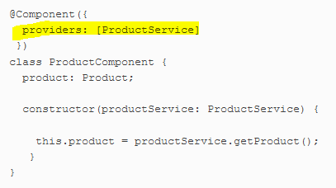
The long version would look like this: providers:[{provide: ProductService, useClass: ProductService}]

Using the provide property of @Component() or @NgModule, you can map the same token to different values or objects (such as to emulate the functionality of ProductService while someone else is developing a real service class)

The next question is, when is the instance of the service created? That depends on the decorator in which you specified the provider for this service.
- inside the @Component() decorator. This tells Angular to create an instance of ProductService when Component is created
- If you specify ProductService in the providers property inside the @NgModule() decorator, then the service instance would be created on the app level as a singleton so all components could reuse it.

Each component can have an Injector instance capable of injecting objects or primitive values into a component. Any Angular application has a root injector available to all of its modules. To let the injector know what to inject, you specify the provider. An injector will inject the object or value specified in the provider into the constructor of a component.

Although eagerly loaded modules don’t have their own injectors, a lazy-loaded module has its own subroot injector that’s a direct child of the parent’s module injector. You’ll see an example of injection in a lazy-loaded module

he @Injectable() decorator allows you to specify the provideIn property, which may spare you from explicit declaration of the provider for the service.
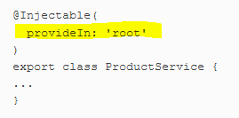
In general, factory functions are used when you need to apply some application logic prior to instantiating an object. For example, you may need to decide which object to instantiate, or your object may have a constructor with arguments that you need to initialize before creating an instance.

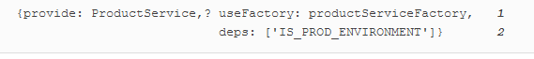

Angular offers an InjectionToken class that’s preferable to using strings
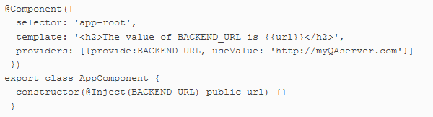
TODO: Proveders for laizy loaded module and eagar loaded module

Reactive programming in Angular

In Angular applications, you can get direct access to any DOM element using a special class, ElementRef, and we’ll use this feature to illustrate how you can subscribe to events of an arbitrary HTML element.

Flex Layout

you can use CSS media queries, represented by the @media rule. In the CSS of your app, you can include a set of media queries offering different layouts for various screen widths.

Another way to implement flexible layouts is by using CSS Flexbox with media queries (see http://mng.bz/6B42)

You can also implement RWD with the help of CSS Grid (see http://mng.bz/k29F). Both Flexbox and CSS Grid require a good understanding of @media rules.
The Angular Flex Layout library (see https://github.com/angular/flex-layout) is a UI layout engine for implementing RWD without writing media queries in your CSS files

Implementing component communications

An Angular application is a tree of views represented by components. While designing components, you need to ensure that they’re self-contained and at the same time have some means of communicating with each other

How can a component intercept the moment when the value of the input property stockSymbol changes to perform some additional processing?
Create setters and geters

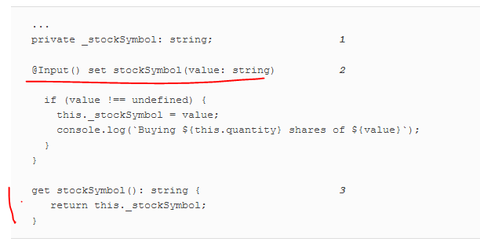

If you need to have an object that’s both an observable and an observer, use the RxJS BehaviorSubject.

Explanation of ? In the html
The safe navigation operator in priceQuote? ensures that if the priceQuote object isn’t available yet, the code in the template won’t try to access properties of an uninitialized priceQuote.

Angular doesn’t offer an API to support event bubbling. If you try to listen to the lastPrice event not on the <price-quoter> element but on its parent, the event won’t bubble up there.
If event bubbling is important to your app, don’t use EventEmitter; use native DOM events instead. The following code snippet shows how the PriceQuoterComponent uses a CustomEvent (from Web API) that supports bubbling:
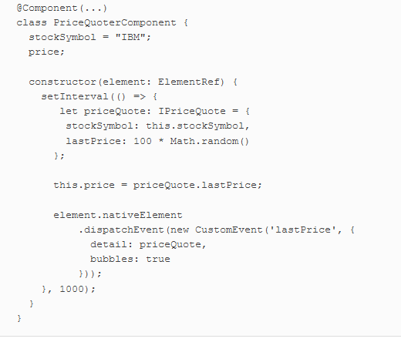

Communication between loosely coupled components can be implemented using the Mediator design pattern, which, according to Wikipedia, “defines how a set of objects interact” (https://en.wikipedia.org/wiki/Mediator_pattern).
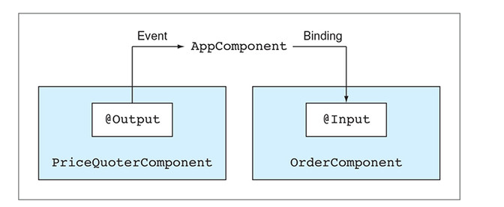

If components don’t have the same parent or aren’t displayed at the same time (the router may not display the required component at the moment), you can use an injectable service as a mediator. Use BehaviorSubject

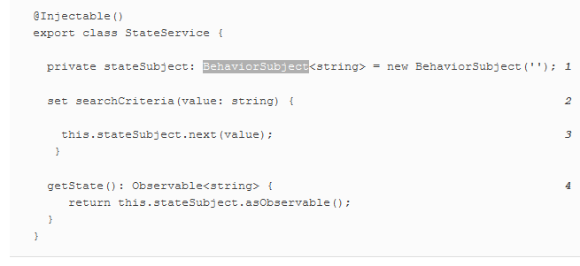
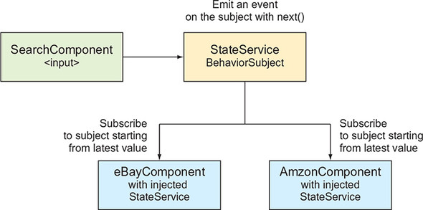

If your application is large, consider implementing app state using the NgRx library.

You’ve learned how a parent component can pass data to its child using bindings to input properties. But there are other cases when the parent just needs to use the API exposed by the child.
Then use this (for classs @ViewChild() )->
<child name= "John" #child1></child>

Projecting templates at runtime with ngContent

In some cases, a parent component needs to render arbitrary markup within a child at runtime, and you can do that in Angular using projection.
- In the child component’s template, include the tags <ng-content></ng-content> (the insertion point).
- n the parent component, include the HTML fragment that you want to project into the child’s insertion point between tags representing the child component (for example, <my-child>)

In short, Shadow DOM introduces scopes for CSS styles and encapsulation of DOM nodes in the browser. Shadow DOM allows you to hide the internals of a selected component from the global DOM tree. Shadow DOM is well explained in the article “Shadow DOM v1: Self-Contained Web Components” by Eric Bidelman, available at http://mng.bz/6VV6.

Change detection and component lifecycle

CD = change detection
For automatic change detection, Angular uses the library zone.js (the Zone)
Angular subscribes to Zone events to trigger CD, which keeps the component’s model and UI in sync. The CD cycle is initiated by any asynchronous event that happens in the browser. The change detector keeps track of all async calls made in components, services, and so forth; and when they complete, it makes a single pass from top to bottom of the component tree to see whether the UI of any component has to be updated.

An Angular application is structured as a tree of views (components), with the root component at the top of the tree. When Angular compiles component templates, each component gets its own change detector. When CD is initiated by the Zone, it makes a single pass, starting from the root down to the leaf components, checking to see whether the UI of each component needs to be updated

Change detection strategies
For UI updates, Angular offers two CD strategies: Default and OnPush.
If all components use the Default strategy, the Zone checks the entire component tree, regardless of where the change happened.
If a particular component declares the OnPush strategy, the Zone checks this component and its children only if the bindings to the component’s input properties have changed, or if the component uses AsyncPipe, and the corresponding observable started emitting values.
If a component that has the OnPush strategy changes a value of one of its properties bound to its template, the change detection cycle won’t be initiated. To declare the OnPush strategy, add the following line to the @Component() decorator:
changeDetection: ChangeDetectionStrategy.OnPush

“Everything you need to know about change detection in Angular” by Maxim Koretskyi at http://mng.bz/0YqE.

In general, it’s a good idea to make OnPush a default CD strategy for each component. If you see that the UI of a component doesn’t get updated as expected, review the code and either switch back to the Default change detection strategy or manually initiate the CD pass by injecting the ChangeDetectorRef object and using its API (see https://angular.io/api/core/ChangeDetectorRef).

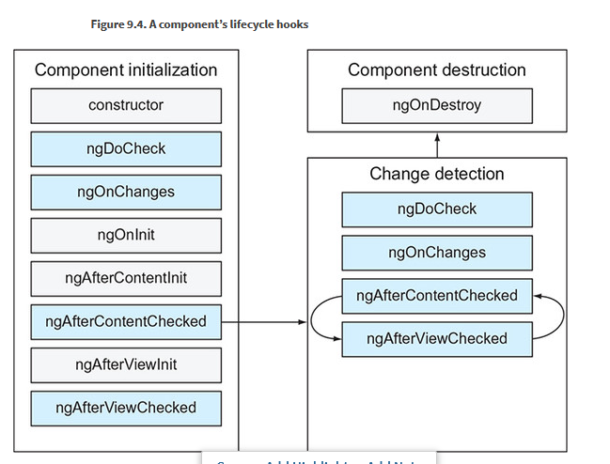
Angular components lifecycle hooks

The callbacks shown on the light-gray background will be invoked only once, and those on the darker background can be invoked multiple times during the component life span

The user sees the component after the initialization phase is complete. Then the change detection mechanism ensures that the component’s properties stay in sync with its UI. If the component is removed from the DOM tree as a result of the router’s navigation or a structural directive (such as *ngIf), Angular initiates the destroy phase.

The constructor is invoked first when the instance of the component is being created, but the component’s properties aren’t initialized yet in the constructor. After the constructor’s code is complete, Angular will invoke the following callbacks if you implemented them:
- ngOnChanges()— Called when a parent component modifies (or initializes) the values bound to the input properties of a child. If the component has no input properties, ngOnChanges() isn’t invoked.
- ngOnInit()— Invoked after the first invocation of ngOnChanges(), if any. Although you might initialize some component variables in the constructor, the properties of the component aren’t ready yet. By the time ngOnInit() is invoked, the component properties will have been initialized, which is why this method is mainly used for the initial data fetch
- ngDoCheck()— Called on each pass of the change detector. If you want to implement a custom change detection algorithm or add some debug code, write it in ngDoCheck(). But keep in mind that placing any code in the ngDoCheck() method can affect the performance of your app because this method is invoked on each and every pass of the change detection cycle.
- ngAfterContentInit()— Invoked when the child component’s state is initialized and the projection completes. This method is called only if you used <ng-content> in your component’s template.
- ngAfterViewInit()— Invoked after a component’s view has been fully initialized
- ngAfterViewChecked()— Invoked when the change detection mechanism checks whether there are any changes in the component template’s bindings. This callback may be called more than once as the result of modifications in this or other components.
- ngOnDestroy()— Invoked when the component is being destroyed. Use this callback to clean unneeded resources, for example, to unsubscribe from explicitly created subscriptions or remove timers.

When you use the router to navigate from component A to component B, component A gets destroyed, and component B is created. If you created an explicit subscription in component A, don’t forget to unsubscribe in ngOnDestroy()

JavaScript strings are primitives, which are immutable—when a string value is created at a certain location in memory, you can’t change it there.
JavaScript objects (as well as functions and arrays) are mutable and are stored in heap memory, and only references to objects are stored on the stack. After the object instance is created at a certain memory location, the reference to this object on the stack doesn’t change when the values of the object’s properties change in the heap memory.

To make an object immutable, you need to create a new instance of the object whenever any of its properties changes. Read more here

Suppose you want to catch the moment when a JavaScript object gets mutated.
Adding logging in the DoCheck() callback

Introducing the Forms API

With the template-driven API, forms are fully programmed in the component’s template using directives, and the model object is created implicitly by Angular. The template defines the structure of the form, the format of its fields, and the validation rules. Because you’re limited to HTML syntax while defining the form, the template-driven approach suits only simple forms.

With the reactive API, you explicitly create the model object in TypeScript code and then link the HTML template elements to that model’s properties using special directives. You construct the form model object explicitly using the FormControl, FormGroup, and FormArray classes. In the template-driven approach, you don’t access these classes directly, whereas in the reactive approach, you explicitly create instances of these classes. For non-trivial forms, the reactive approach is a better option.

With the template-driven API, you can use only directives in a component’s templates. These directives are included in the FormsModule: NgModel, NgModelGroup, and NgForm

NgForm is the directive that represents the entire form. It’s automatically attached to every <form> element

<form #f="ngForm"></form>
<pre>{{ f.value | json }}</pre>

NgForm intercepts the standard HTML form’s submit event and prevents automatic form submission. Instead, it emits the custom ngSubmit event:
<form #f="ngForm" (ngSubmit)="onSubmit(f.value)"></form>

NgModel in template driven form marks html elemen that should becme partof the form model (NgModel represents a single field on the form ) ( NgModel can be used to two-way data binding, (not here) )

NgForm.value property points at the JavaScript object that holds the values of all form fields. The value of the field’s name attribute becomes the property name of the corresponding property in the JavaScript objecte.
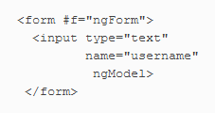
NgModelGroup represents a part of the form and allows you to group form fields together.

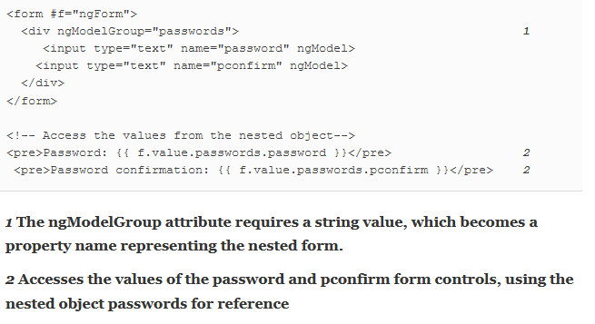
Submit template form

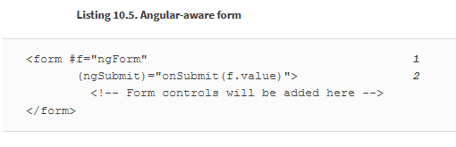
Reactive forms
steps:
- In your TypeScript code, create an instance of the model object FormGroup to store the form’s values.
- Create an HTML form template, adding reactive directives.
- Use the instance of the FormGroup to access the form’s values.

The form model is a data structure that holds the form’s data. It can be constructed from FormControl, FormGroup, and FormArray classes.

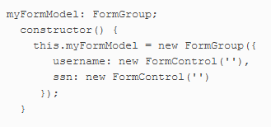
FormControl instance stores the current value of the HTML element it corresponds to, the element’s validity status, and whether it’s been modified. You can also create a FormControl attaching one or more built-in or custom validators.
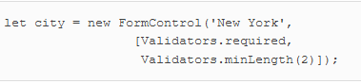
FormGroup is a collection of FormControl objects and represents either the entire form or its part. FormGroup aggregates the values and validity of each FormControl in the group

FormArray usually represents a collection of form controls that can grow or shrink. For example, you could use FormArray to allow users to enter an arbitrary number of emails.

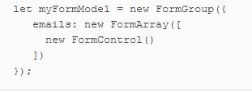
The reactive approach also requires you to use directives in component templates. The reactive directives come with ReactiveFormsModule and are prefixed with form—for example, formGroup (note the small f ).
In reactive forms, you explicitly create a model in TypeScript and don’t need to access the model in the component template.

The reactive directives formGroup and formControl bind a DOM element to the model object using property-binding syntax with square brackets. The directives that link a DOM element to a TypeScript model’s properties by name are formGroupName, formControlName, and formArrayName. They can only be used inside the HTML element marked with the formGroup directive.

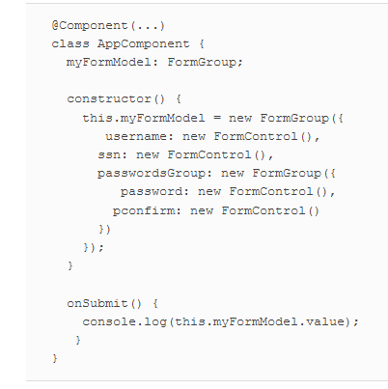
In the reactive API, the onSubmit() method doesn’t need arguments because you access the form values using your component’s myFormModel property.
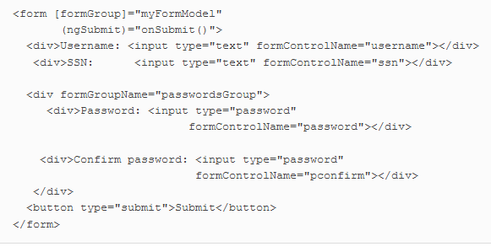

Dynamically adding controls to a form

But if you want to be able to dynamically add/remove controls, you need a different way to link the control names with the model properties. By using FormArray instead of FormGroup, you can specify an array index as a name of the corresponding template element.

Let’s look at an example that allows users to have a form with an arbitrary number of email controls. First, you’ll define the model that will include a FormArray called emails, which will initially have just one form control for entering an email.
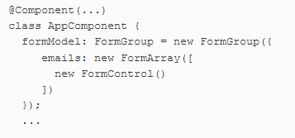
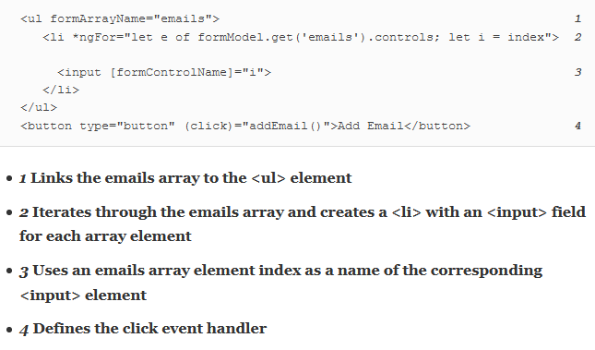
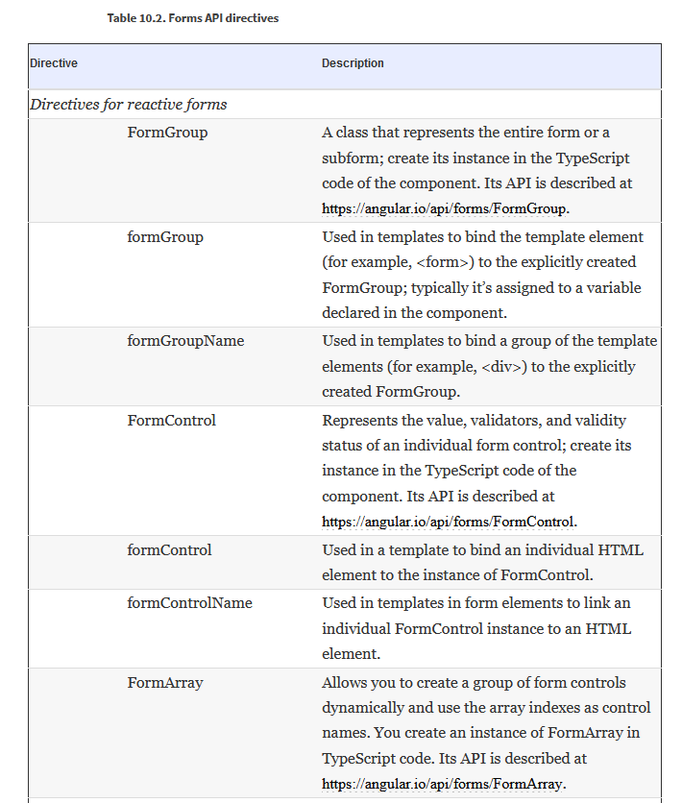
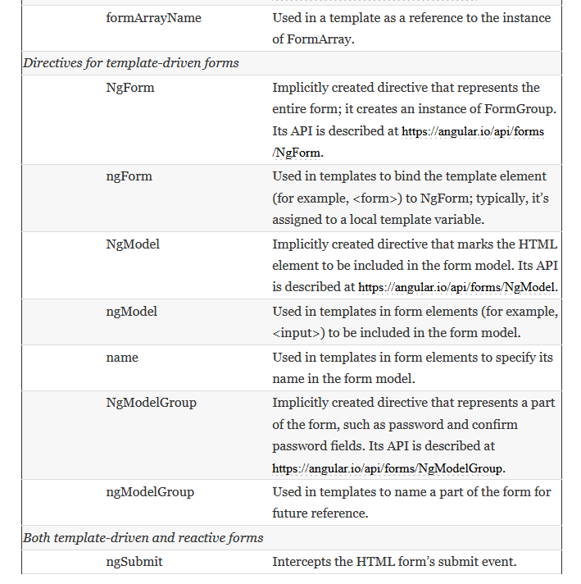

Note that the name of any directive used in the component template starts with a lowercase letter. The name of the underlying class that implements the directive starts with a capital letter. In template-driven forms, you don’t need to explicitly create instances of these classes, but in reactive forms, you instantiate them in the TypeScript code as needed.

The Angular Forms API offers several functions for updating a form model including
- reset() function reinitializes the form model and resets the flags on the model, like touched, dirty, and others
- setValue() function is used for updating all values in a form model
- patchValue() function is used when you need to update the selected properties of a form model
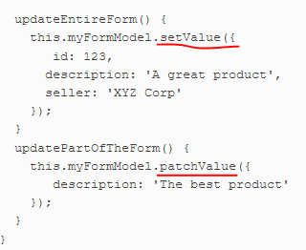

The injectable service FormBuilder simplifies the creation of form models. It doesn’t provide any unique features compared to the direct use of the FormControl, FormGroup, and FormArray classes, but its API is terser and saves you from the repetitive instantiation of objects.

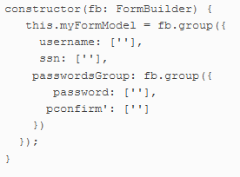
The FormBuilder.group() method accepts an object with extra configuration parameters as the last argument. You can use it to specify group-level validators there if needed.
As you can see, configuring a form model with FormBuilder is less verbose and is based on the configuration object rather than requiring explicit instantiation of the control’s classes.

Validating forms

The Angular Forms API includes the Validators class, with static functions such as required(), minLength(), maxLength(), pattern(), email(), and others. These built-in validators can be used in templates by specifying the directives required, minLength, maxLength, pattern, and email, respectively. The pattern validator enables you to specify a regular expression.

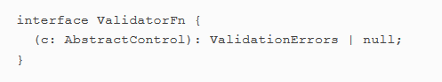

If a validator function returns null, that means no errors. Otherwise, it’ll return a ValidationErrors object of type {[key: string]: any}, where the property names (error names) are strings, and values (error descriptions) can be of any type.

AbstractControl is the superclass for FormControl, FormGroup, and FormArray; hence, validators can be created for all model classes

Controlling when validation starts (you can specify when validation should start )
- change— This is the default mode, with validators checking a value as soon as it changes.
- blur— Checks validity of a value when the control loses focus.
- submit— Checks validity when the user submits the form.
To applay add add [ngModelOptions]= "{updateOn:'blur'}

You need to declare a function that accepts an instance of one of the control types—FormControl, FormGroup, or FormArray—and returns the ValidationErrors object or null.
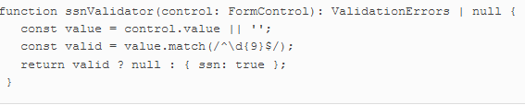
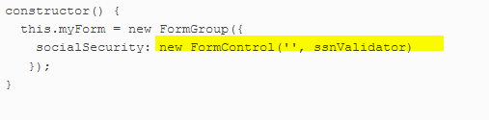
You can validate a group of form controls by attaching validator functions to a FormGroup instead of an individual FormControl.
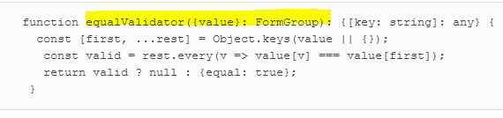
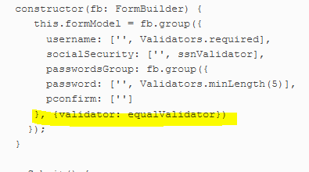
You already used such control properties as valid, invalid, and errors for checking field status.

In addition to checking a control’s validity, you can also use the touched and untouched properties to check whether a form control was visited by the user. If the user puts the focus into a form control using the keyboard or mouse and then moves the focus out, this control becomes touched; while the focus remains in the control, it’s still untouched.

Another useful pair of properties are pristine and dirty. pristine means the user never interacted with the form control. dirty indicates that the initial value of the form control was modified, regardless of where the focus is.

Using the reactive Forms API, you can change the validators attached to a form or one of its controls during runtime. You may need to implement a scenario where, depending on user input in one control, validation rules for another control should be changed. You can do that using the setValidators() and updateValueAndValidity() functions.

Asynchronous validators can be used to check form values by making requests to a remote server. Like synchronous validators, async validators are functions. The main difference is that async validators should return either an Observable or a Promise object.

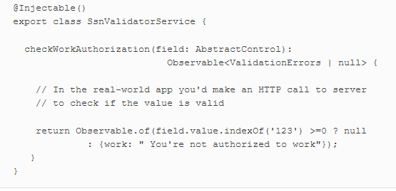

Interacting with servers using HTTP

Browser-based web apps run HTTP requests asynchronously, so the UI remains responsive, and the user can continue working with the application while HTTP requests are being processed by the server. Asynchronous HTTP requests can be implemented using callbacks, promises, or observables

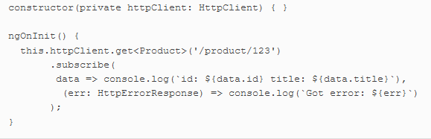
HttpClient expects the data in JSON format, and the data is automatically converted into JavaScript objects. If you expect non-JSON data, use the responseType option

You didn’t use ngOnDestroy() to explicitly unsubscribe from the observable because once HttpClient gets the response (or an error), the underlying Observable completes, so the observer is unsubscribed automatically.

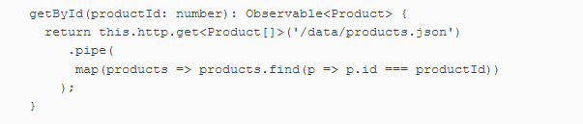

Interceptor

Angular allows you to create HTTP interceptors for pre- and post-processing of all HTTP requests and responses of your app. They can be useful for implementing such cross-cutting concerns as logging, global error handling, authentication, and others. We’d like to stress that the interceptors work before the request goes out or before a response is rendered on the UI.

To create an interceptor, you need to write a service that implements the HttpInterceptor interface, which requires you to implement one method: intercept(). Angular will provide two arguments to this callback: HttpRequest and HttpHandler.

The first one contains the request object being intercepted, which you can clone and modify. The second argument is used to forward the modified request to the backend or another interceptor in the chain (if any) by invoking the handle() method.

The HttpRequest and HttpResponse objects are immutable, and the word modify means creating and passing through the new instances of these objects. and if you want to modify their properties, you need to clone them first, as in the following listing.

Because an interceptor is an injectable service, don’t forget to declare its provider for the HTTP_INTERCEPTORS token in the @NgModule() decorator:

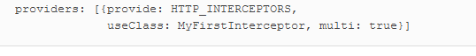
The multi: true option tells you that HTTP_INTERCEPTORS is a multiprovider token—an array of services can represent the same token

If you have more than one interceptor, they’ll be invoked in the order they’re defined.

Progress events
Sometimes uploading or downloading certain assets (like large data files or images) takes time, and you should keep the user informed about the progress. HttpClient offers progress events that contain information like total size of the asset, current number of bytes that are already uploaded or downloaded, and more.

HttpClient offers progress events that contain information like total size of the asset, current number of bytes that are already uploaded or downloaded, and more. To enable progress events tracking, make your requests using the HttpRequest object with the option {reportProgress: true}. For example, you can make an HTTP GET request that reads the my_large_file.json file.

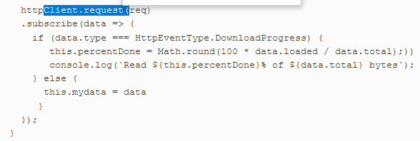
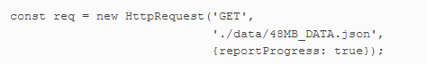

Interacting with servers using the WebSocket protocol

WebSocket is a low-overhead binary protocol supported by all modern web browsers (see https://en.wikipedia.org/wiki/WebSocket). It allows bidirectional message-oriented streaming of text and binary data between browsers and web servers. In contrast to HTTP, WebSocket is not a request/response-based protocol, and both server apps and client apps can initiate data push to the other party as soon as the data becomes available, in real time. This makes the WebSocket protocol a good fit for the following types of applications:
- Live trading/auctions/sports notifications
- Controlling medical equipment over the web
- Chat applications
- Multiplayer online games
- Real-time updates
- Live charts

The WebSocket protocol is based on events and callbacks. For example, when your browser app establishes a connection with the server, it receives the connection event, and your app invokes a callback to handle this event. To handle the data that the server may send over this connection, expect the message event providing the corresponding callback. If the connection is closed, the close event is dispatched so your app can react accordingly. In case of an error, the WebSocket object gets the error event.

In angula WebSocket is a native browser object, and you’ll create it inside a service class.
the WebSocket object offers an API that’s easy to turn into an observable stream of multiple values like changing stock prices or bids on product

Think of a WebSocket as a data producer that can emit values, and an Observable object can relay these values to subscribers (for example, Angular components). In Angular, you can either manually create a service producing an observable stream from a WebSocket connection or use the WebSocketSubject offered by RxJS

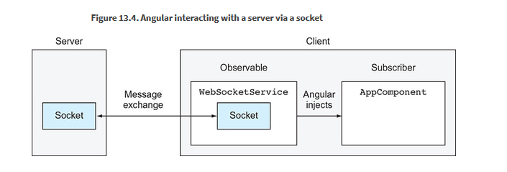
Wrap the browser’s WebSocket object into an observable stream.

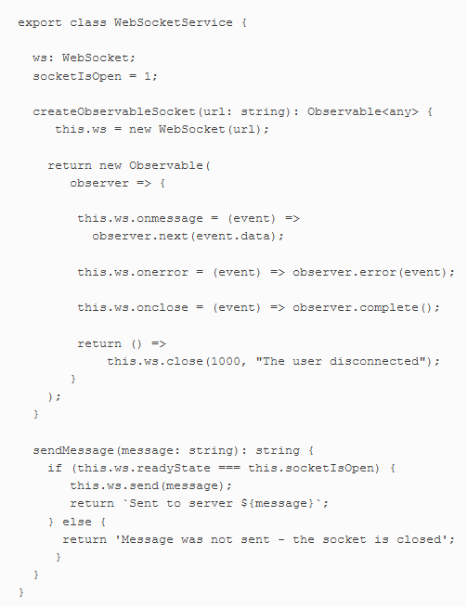

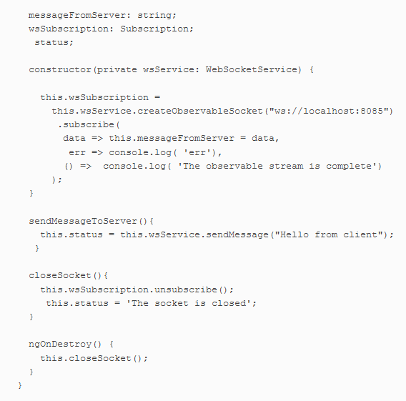

The good news is that WebSockets can use subprotocols to integrate with server-side messaging systems. For example, server-side code can map the WebSocket endpoint to an existing queue in ActiveMQ. This way, when a server’s software places a message into a queue, it’s automatically pushed to the client. Similarly, when a client sends a message to a WebSocket endpoint, it’s placed in the queue on the server. Implementing heartbeats comes down to providing a configuration option.

STOMP is one of the popular subprotocols used for sending text messages over WebSockets (see http://mng.bz/PPsy). It describes a client-side message broker that communicates with its server-side peer. For client STOMP support, we use ng2-stompjs, available at http://mng.bz/KdIM.

Testing Angular applications

Unit test – BDD with Jasmine
Jasmine (https://jasmine.github.io/) enables you to implement a behavior-driven development (BDD) process, which suggests that tests of any unit of software should be specified in terms of the desired behavior of the unit. With BDD, you use natural language constructs to describe what you think your code should be doing.
Because it’s so easy to understand the meaning of tests, they can serve as your program documentation.
Even though Jasmine comes with its own browser-based test runner, you’ll be using a command-line-based test runner called Karma that can be easily integrated into the automated build process of your apps.

In BDD frameworks, a test is called a spec, and a combination of one or more specs is called a suite. A test suite is defined with the describe() function—this is where you describe what you’re testing. Each spec in a suite is programmed as an it() function, which defines the expected behavior of the code under test and how to test it. The following listing shows an example.
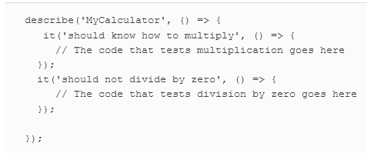
But running unit tests from the command line is a better option, because that way you can integrate tests into the project build process.

Then you need to prepare a configuration file, karma.conf.js, for your project—but you’re spoiled by Angular CLI, which installs and configures everything you need for testing Angular apps, including Jasmine and Karma

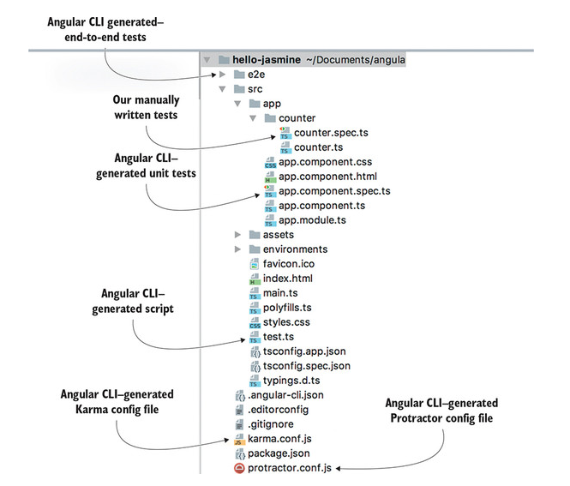
The generated file test.ts is the main testing script that loads all test scripts. The karma.conf.js file is used by the Karma runner as soon as you run the ng test command, which compiles and runs unit tests. After the tests are compiled, ng test uses the compiled script test.js to load the Angular testing library and all the .spec.ts files, and start the Karma runner

. Consider using the continuous testing tool called Wallaby (see https://wallabyjs.com/docs), which shows you a short error message in your IDE right next to the code of the spec that failed.

Karma configuration more info here http://karma-runner.github.io/1.0/config/configuration-file.html

Karma can report how well your code is covered with tests using the Istanbul reporter, and you can run the following command to generate the coverage report:
ng test –code-coverage.
you can specify ChromeHeadless to use the headless Chrome browser

Angular comes with a testing library that includes the wrappers for some Jasmine functions and adds such functions as inject(), async(), fakeAsync(), and others.
To test Angular artifacts, you need to create and configure an Angular module for the class under test using the configureTestingModule() method of the TestBed utility

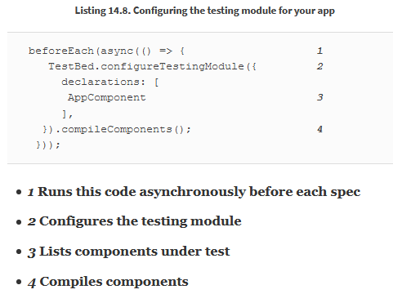

In an Angular app, the components are “magically” created and services are injected, but in test scripts, you’ll need to explicitly instantiate components and invoke the inject() function or the TestBed.get() function to inject services. If a function under test invokes asynchronous functions, you should wrap such it into async() or fakeAsync().

async() will run the function(s) under test in the Zone. If your test code uses time-outs, observables, or promises, wrap it into async() to ensure that the expect() function is invoked after all the asynchronous functions are complete.

fakeAsync() identifies the timers in the code under test and replaces the code inside setTimeout(), setInterval(), or the debounceTime() with immediately executed functions as if they’re synchronous, and executes them in order

Testing components

Under the hood, an Angular component consists of two parts: an instance of the class and the DOM element. Technically, when you write a unit test for a component, it’s more of an integration test, because it has to check that the instance of the component class and the DOM object work in sync.

The Angular testing library offers the TestBed.createComponent() method, which returns a ComponentFixture object that gives you access to both the component and the native DOM object of the rendered template.

To access the component instance, you can use the ComponentFixture.componentInstance property, and to access the DOM element, use ComponentFixture.nativeElement. If you want to get access to the fixture’s API (for example, to access the component’s injector, run CSS query selectors, find styles or child nodes, or trigger an event handler), use its DebugElement, as in ComponentFixture.debugElement.componentInstance and ComponentFixture.debugElement.nativeElement, respectively. Figure 14.6 illustrates some of the properties of the ComponentFixture object, which also exist in debugElement.

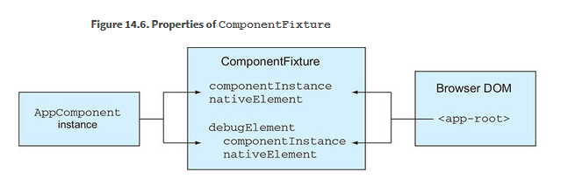
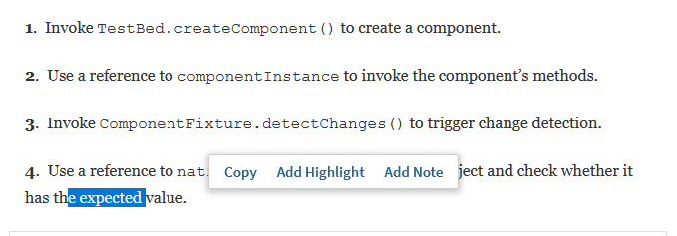
If you want change detection to be triggered automatically, you can configure the testing module with the provider for the ComponentFixtureAutoDetect service. Although this seems to be a better choice than manually invoking detectChanges(), this service only notices the asynchronous activities and won’t react to synchronous updates of component properties.

Testing services

You expect the getProducts() method to make a single request to /data/products .json and return its mock, and this is what expectOne() is for. If no such request has been made, or if more than one such request has been made, the spec will fail.

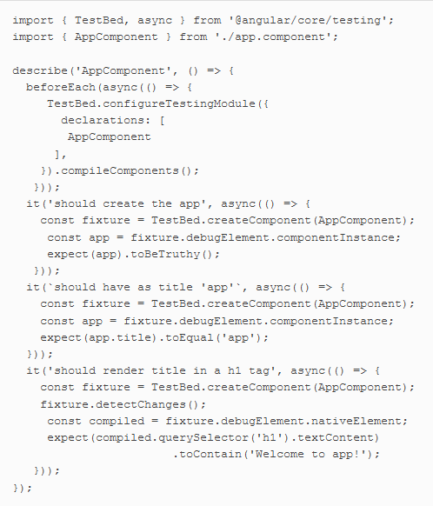

Keep in mind that if your component uses lifecycle hooks, they won’t be called automatically. You need to call them explicitly, as in app .ngOnInit().

Test routing
For example, you may want to test that the router properly navigates where it’s supposed to, that parameters are properly passed to the destination component, and that the guards don’t let unauthorized users visit certain routes.

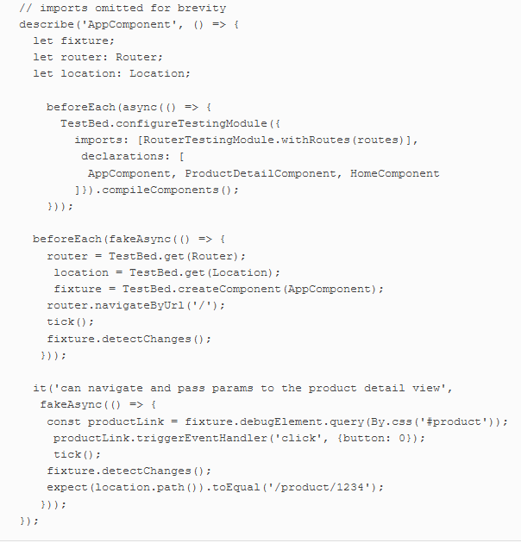

E2e with Protractor

Protractor is a testing library that allows you to test app workflows simulating user actions without the need to perform them manually. You still need to prepare test data and script the test logic, but the tests will run without human interaction.

In your setup, Protractor will run the web browser and tests on the same machine, so you need Selenium WebDriver for the browser(s) you want to run the tests in. Selenium offers implementations of WebDriver for different programming languages, and Protractor uses the one called WebDriverJS.

You run the E2E tests by entering the ng e2e command

Maintaining app state with ngrx

ngrx is a library that can be used for managing state in Angular apps (see https://github.com/ngrx). It’s built using the principles of Redux (another popular library for managing state), but the notification layer is implemented using RxJS. Although Angular has other means for managing app state, ngrx is gaining traction in mid- and large-size apps.
The complexity of your app can increase, and the code will become more difficult to understand by any new person who joins the project

Your web app maintain a store that holds the state of your app. Like a real store, at any given time your app’s store has a current state. Some data collections have specific data retrieved from the server and possibly modified by a user. Some radio buttons are checked, and a user selects some products and navigates to some routes represented by a specific URL.

If a user interacts with the UI, or the server sends new data, these actions should ask the store object to update the state. To keep track of state changes, the current state object is never updated, but a new instance of the state object is created.

Redux is an open source JavaScript library that offers a state container for JavaScript apps. It was created at Facebook as an implementation of the Flux architecture

Redux is based on the following three principles:
- There’s a single source of truth. There’s a single store where your app contains the state that can be represented by an object tree.
- State is read-only. When an action is emitted, the reducer function doesn’t update but clones the current state and updates the cloned object based on the action
- State changes are made with pure functions. You write the reducer function(s) that take an action and the current state object and return a new state.
- the data flow is unidirectional:
- The app component dispatches the action on the store.
- The reducer (a pure function) takes the current state object and then clones, updates, and returns it.
- The app component subscribes to the store, receives the new state object, and updates the UI accordingly.
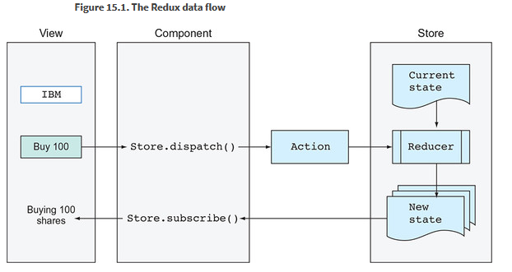
An action is a JavaScript object that has a type property describing what happens in your app
have another property with a payload of data that should change the app state
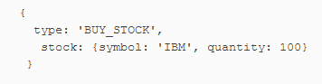
This object only describes the action and provides the payload. It doesn’t know how the state should be changed. Who does? The reducer.
A reducer is a pure function that specifies how the state should be changed. The reducer never changes the current state, but creates a new (and updated) version of it. The state object is immutable. . You can read about the rationale for creating shallow state copies at http://mng.bz/3271.

The reducer can implement minimal app logic related to state change. For example, suppose a user decides to cancel an order, which requires a reset of certain fields on the state object. The main app logic remains in your application code (for example, in services) s. Use the ngrx library, which suggests using Angular services combined with so-called effects that live outside of the store and that can aggregate Angular services working as a bridge between the store and services.

Large enterprise apps often implement messaging architecture on the server side, where one piece of software sends a message to another via some messaging server or a message bus. You can think of ngrx as a client-side messaging system. The user clicks a button, and the app sends a message (for example, dispatches an action). The app state changed because of this button click, and the ngrx Store sends a message to the subscriber(s), emitting the next value into an observable stream.

If a component dispatches an action that requires communication with external resources, the action can be picked up by the Effects object, which will handle this action and dispatch another one on the reducer. For example, an effect can receive a LOAD_PRODUCTS action from the store, invoke loadProducts(), and, when the data is loaded, dispatch either of the LOAD_PRODUCTS_SUCCESS or LOAD_PRODUCTS_FAILURE actions. The reducer will pick it up and update state accordingly. Figure 15.4 shows the ngrx flow that uses effects

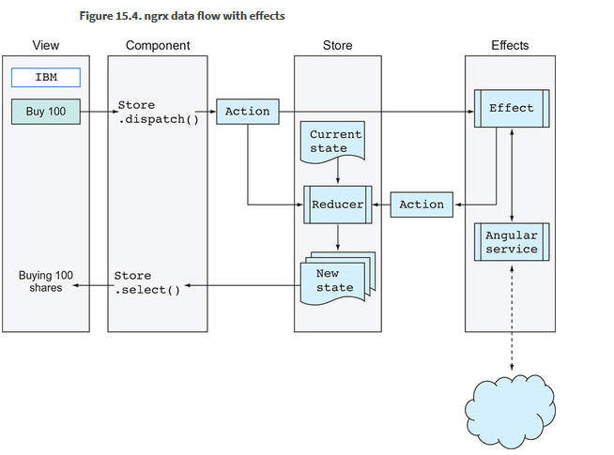
We’d like to stress that even though actions can be handled in both a reducer and an effect, only a reducer can change the state of an app.

An effect returns an observable that wraps some payload. In your effects class, you’ll declare one or more class variables annotated with the @Effect decorator. Each effect will apply the ofType operator to ensure that it reacts to only the specified action type, as shown in the following listing.

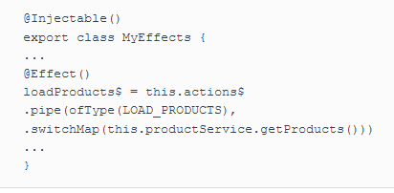

In this example, the @Effect decorator marks the observable property loadProducts$ as a handler for the actions of type LOAD_PRODUCTS and invokes getProducts(), which returns an Observable.
Then, based on the emitted value, the effect will dispatch another action (for example, success or failure)
you can think of an effect as middleware between the original action and the reducer.
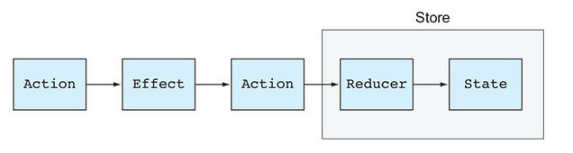
In real-world apps, the state object can be represented by a tree of nested properties, and you may want to obtain specific slices of the store state rather than obtain the entire state object and manually traverse its content.
First, get the selector of the top-level feature state using the createFeatureSelector() method. Then, use this selector as a starting point for other more specific selectors using the createSelector() method, which returns a callback function for selecting a slice of state

@ngrx/entity is an entity state adapter for managing record collections.
@ngrx/schematics is a scaffolding library that provides blueprints for generating ngrx-related code.
you’ll also use @ngrx/router-store, which offers bindings for connecting and monitoring Angular Router
The API of all ngrx packages is described at http://mng.bz/362y
Because you delegate state-management operations to ngrx, you need a tool to monitor state changes during runtime. The browser extension Redux DevTools along with the @ngrx/store-devtools package are used for the instrumentation of the app state.

Good libraries are those that allow you to write less code. Currently, ngrx requires you to write lots of additional code, but we hope that future versions of ngrx will be simpler to implement and understand. Meanwhile, keep an eye on a promising state management library called NGXS (see https://ngxs.gitbooks.io/ngxs), which doesn’t require you to write as much code as ngrx and is built on TypeScript decorators. Another new project called ngrx-data (http://mng.bz/h6Nc) promises to support ngrx/Redux workflows with less coding.

Start with managing state using a singleton injectable service with BehaviorSubject. This approach may cover all your needs. Watch the video “When ngrx is an overkill” by Yakov Fain (www.youtube.com/watch?v=xLTIDs0CDCM), where he compares two small apps that manage state with and without ngrx. It’s never too late to add ngrx to your app, so don’t try to prematurely solve a problem you’re not facing yet.

