Building Micro-Frontends
by Luca Mezzalira
Additional Resources:
https://martinfowler.com/articles/micro-frontends.html
https://microfrontends.com/
https://microfrontends.info/microfrontends/
https://micro-frontends.org/
todo https://www.manning.com/books/micro-frontends-in-action
https://itnext.io/11-micro-frontends-frameworks-you-should-know-b66913b9cd20
https://dzone.com/articles/micro-frontends-by-example-8
https://www.linkedin.com/pulse/micro-frontends-what-why-how-rany-elhousieny-phd%E1%B4%AC%E1%B4%AE%E1%B4%B0/
https://www.it-labs.com/micro-frontends/
https://dev.to/phodal/micro-frontend-architecture-in-action-4n60
https://blog.beautifulinteractions.com/posts/micro-frontend-with-angular/
https://blogs.halodoc.io/microfrontends-practical-approach/

git
https://github.com/ChristianUlbrich/awesome-microfrontends
https://github.com/lsm/micromono

Chapter 1. The Frontend Landscape

Micro-frontends are an emerging architecture inspired by microservices architecture.
The main idea behind them is to break down a monolithic codebase into smaller parts, allowing an organization to spread out the work among autonomous teams, whether collocated or distributed, without the need to slow down their delivery throughput.
As with other architectures, micro-frontends are not suitable for all projects; nevertheless, they can provide a new way to structure our frontend applications, solving some key scalability challenges we have encountered in the past not only from a technical perspective but also from an organizational one.
Too often I have seen great architectures on paper that didn’t translate well into the real world because the creator didn’t take into account the environment (company’s structure, culture, developers skills, timeline, etc.) where the project would have been built

Other options
- Single-page applications (SPAs)
- Isomorphic or universal applications are web applications where the code between server and client is shared (Because the page requested is pre-rendered on the server and is partially or fully interpreted on the backend, the time to interaction is enhanced )
- Static page websites
- JAMStack
- Progressie web application ?

Chapter 2. Micro-Frontends Principles

Another significant advantage is that we can scale part of the application and use the right approach for a microservice instead of a one-size-fits-all approach similar to a monolith.

there are also some pitfalls to working with microservices. The investment on automation, observability, and monitoring has to be completed to have a distributed system under control. Another pitfall is the wrong definition of a microservice’s boundary, for instance, having a microservice that is too small for completing an action inside a system relying on other microservices causing a strong coupling between services and forcing them to be deployed together every time

Embracing microservices also means reviewing our database strategy and, therefore, having multiple databases that are not shared across microservices; if needed, our data is partially replicated, so each microservice reduces the latency for returning the response.

Code abstraction is not a silver bullet either; prematurely abstracting code for reuse often causes more problems than benefits. I have frequently seen abstractions make code thousands of times more complicated than necessary to be reused just twice inside the same project

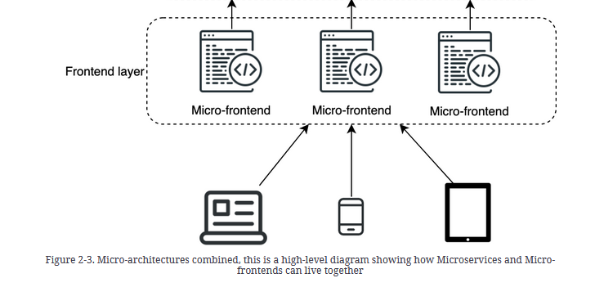

Applying Microservices Principles to Micro-frontends

-> Automation (we need a robust culture of automating the deployment of independent units in different environments )

-> Independed deployment (we can deploy autonomously without increasing the possibility of breaking our entire API layer. Furthermore, we have solid techniques, like blue-green deployment or canary releases )

-> Isolate failuer (graceful failures with microservices and the fact that they )

-> Modeling around business domains (domain-driven design (DDD) )

-> Hiding implementation details (Hiding implementation details and working with contracts are two essential practices, especially when parts of our application need to communicate with each other. )

-> Decentralize all the things (moves us away from a one-size-fits-all approach that often ends up being the lowest common denominator. Instead, the team will use the right approach or tool for the job )
-> highly obervable (chalange -> with tools like Sentry and LogRockets providing great visibility for every developer. Using these tools is essential to understanding where our application is failing and why )

Not a silver bullet.

Micro-frontends are not appropriate for every application because of their nature and the potential complexity they add at the technical and organizational levels.
TODO costs

Chapter 3. Micro-Frontend Architectures and Challenges

A micro-frontend represents a business domain that is autonomous, independently deliverable, and owned by a team.

In these architectures, we face some specific challenges to success bound by similar questions, such as how we want to communicate between micro-frontends, how we want to route the user from one view to another, and, most importantly, how we identify the size of a micro-frontend.

These types of decisions are called the micro-frontends decisions framework. It is composed of four key areas:
- defining what a micro-frontend is in your architecture
- composing micro-frontends
- routing micro-frontends
- communicating between micro-frontends

micro-frontend from a technical point of view

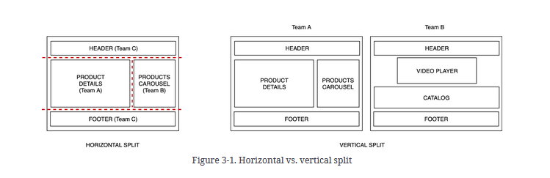

With the horizontal split, multiple micro-frontends will be on the same view. Multiple teams will be responsible for parts of the view and will need to coordinate their efforts. This approach provides a greater flexibility considering we can even reuse some micro-frontends in different views, although it also requires more discipline and governance for not ending up with hundreds of micro-frontends in the same project.
In the vertical split scenario, each team is responsible for a business domain, like the authentication or the catalog experience. In this case, domain-driven design (DDD) comes to the rescue. It’s not often that we apply DDD principles on frontend architectures, but in this case, we have a good reason to explore it.

After defining all the bounded contexts, we will have a map of our system representing the different areas that our system is composed of. In Figure 3-2 we can see a representation of bounded context. In this example the bounded context contains the catalogue micro-frontends that consumes APIs from a microservices architecture via a unique entry point, a backend for frontend, we will investigate more about the APIs integration in chapter 9.
In DDD, the frontend is not taken into consideration but when we work with micro-frontends with a vertical split we can easily map the frontend and the backend together inside the same bounded context.

Another important term in DDD is the bounded context: a logical boundary that hides the implementation details, exposing an application programming interface (API) contract to consume data from the model present in it.

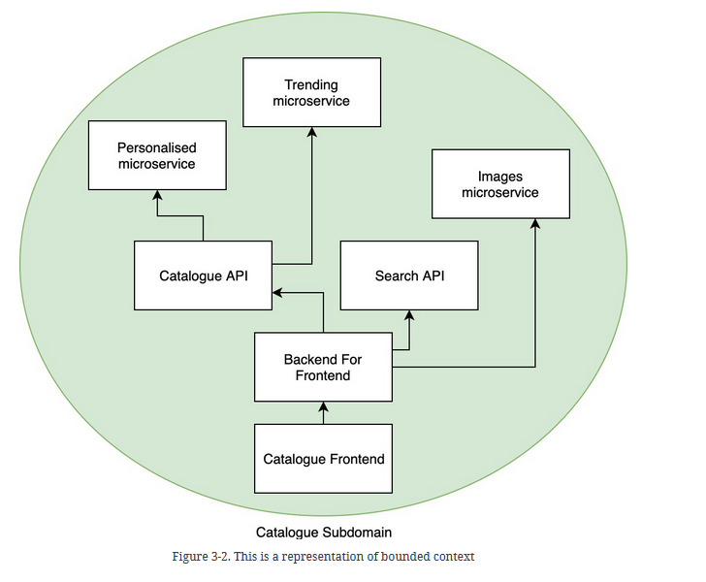

Micro-Frontend compositon

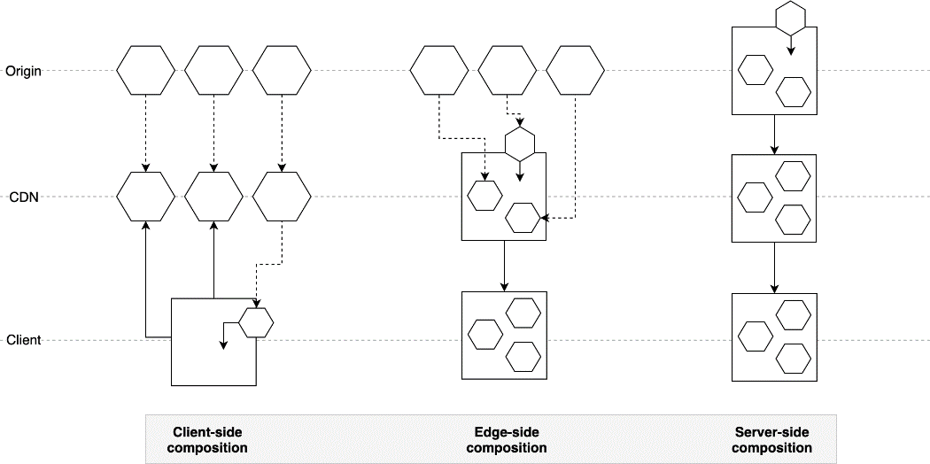

There are different approaches for composing a micro-frontends application

In this diagram we can see three different ways to compose a micro-frontends architecture:
- Client-side composition
- Edge-side composition
- Server-side composition
Starting from the left of our diagram, we have a client-side composition, where an application shell loads multiple micro-frontends directly from a content delivery network (CDN), or from the origin if the micro-frontend is not yet cached at the CDN level. In the middle of the diagram, we compose the final view at the CDN level, retrieving our micro-frontends from the origin and delivering the final result to the client. The right side of the diagram shows a micro-frontends composition at the origin level where our micro-frontends are composed inside a view, cached at the CDN level, and finally served to the client.
Here https://codeburst.io/4-practical-ways-to-build-micro-frontends-4dc4f0b8a921

Client-side composition

In the client-side composition case, where an application shell loads micro-frontends inside itself, the micro-frontends should have a JavaScript or HTML file as an entry point so the application shell can dynamically append the document object model (DOM) nodes in the case of an HTML file or initializing the JavaScript application with a JavaScript file.

We can also use a combination of iframes to load different micro-frontends, or we could use a transclusion mechanism on the client side via a technique called client-side include. Client-side include lazy-loads components, substituting empty placeholder tags with complex components. For example, a library called h-include uses placeholder tags that will create an AJAX request to a URL and replace the inner HTML of the element with the response of the request.

edge-side composition
we assemble the view at the CDN level. Many CDN providers give us the option of using an XML-based markup language called Edge Side Include (ESI).
More info here: https://blog.cloudflare.com/making-edge-side-includes-esi-automatic-and-e/

server-side composition
runtime or at compile time
In this case, the origin server is composing the view by retrieving all the different micro-frontends and assembling the final page. If the page is highly cacheable, the CDN will then serve it with a long time-to-live policy. However, if the page is personalized per user, serious consideration will be required regarding the scalability of the eventual solution, when there are many requests coming from different clients. When we decide to use server-side composition we must deeply analyze the use cases we have in our application

Routing micro-frontends
strictly linked to the micro-frontends composition mechanism
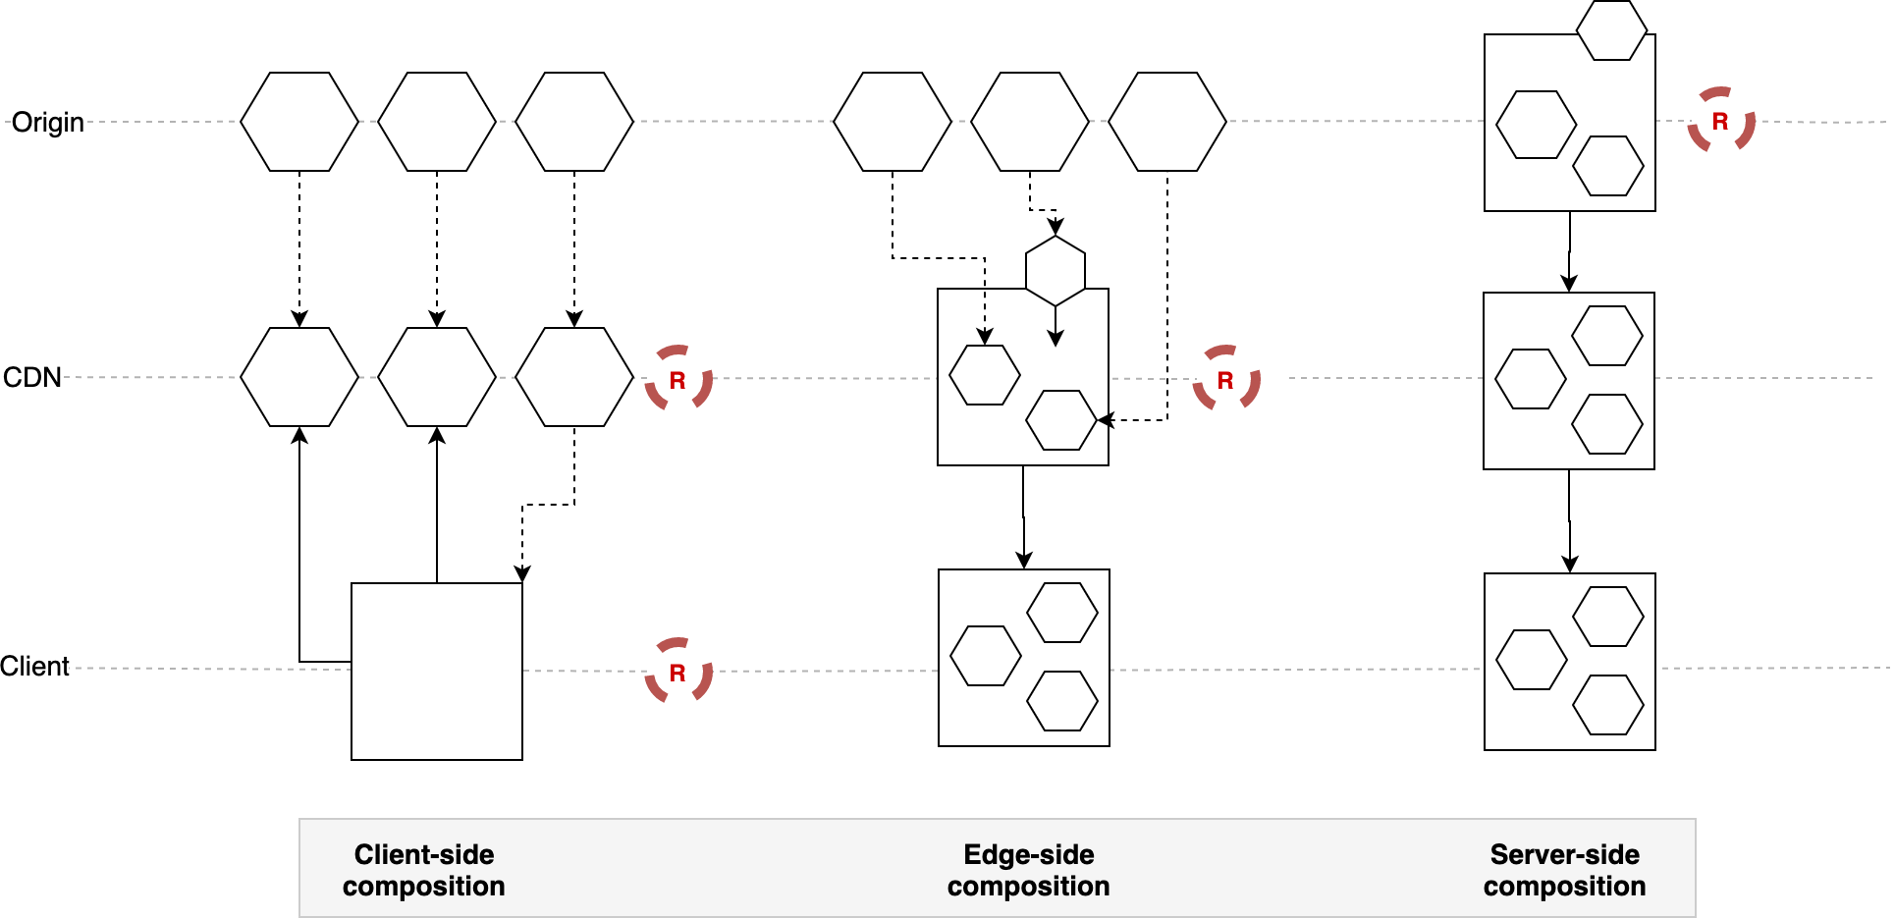
We can decide to route the page requests in the origin, on the edge, or at client-sid

When we decide to compose micro-frontends at the origin, therefore a server-side composition on the right of Figure 3-4.4, we are forced to route the requests at origin considering the entire application logic lives in the application servers.
However, we need to consider that scaling an infrastructure could be non trivial, especially when we have to manage burst traffic with many requests per second (RPS). Our servers need to be able to keep up with all the requests and scale horizontally very rapidly. Each application server then must be able to retrieve the micro-frontends for the composing page to be served.
We can mitigate this problem with the help of a CDN. The main downside is that when we have dynamic or personalized data, we won’t be able to rely extensively on the CDN serving our pages because the data would be outdated or not personalized.
When we decide to use edge-side composition in our architecture, the routing is based on the page URL and the CDN serves the page requested by assembling the micro-frontends via transclusion at edge level.
In this case, we won’t have much room for creating smart routing—something to remember when we pick this architecture.
The final option is to use client-side routing. In this instance, we will load our micro-frontends according to the user state, such as loading the authenticated area of the application when the user is already authenticated or loading just a landing page if the user is accessing our application for the first time.
If we use an application shell that loads a micro-frontend as an SPA, the application shell is responsible for owning the routing logic, which means the application shell retrieves the routing configuration first and then decides which micro-frontend to load.
This is a perfect approach when we have complex routing, such as when our micro-frontends are based on authentication, geo-localization, or any other sophisticated logic. When we are using a multipage website, micro-frontends may be loaded via client-side transclusion. There is almost no routing logic that applies to this kind of architecture because the client relies completely on the URL typed by the user in the browser or the hyperlink chosen in another page, similar to what we have when we use edge-side include approach.
We won’t have any scalability issue in either case. The client-side routing is highly recommended when your teams have stronger frontend skills so that it becomes natural having a client-side routing over a backend configuration.
Those routing approaches are not mutually exclusive, either. As we will see later in this book, we can combine those approaches using CDN and origin or client-side and CDN together.
The important thing is determining how we want to route our application. This fundamental decision will affect how we develop our micro-frontends application.

Micro.frontend communication

In an ideal world, micro-frontends wouldn’t need to communicate with each other because all of them would be self-sufficient. In reality, it’s not always possible to notify other micro-frontends about a user interaction, especially when we work with multiple micro-frontends on the same page.

We can inject an eventbus, a mechanism that allows decouple components to communicate with each other via events sent via a bus,in each micro-frontend and notify the event to every micro-frontend. If some of them are interested in the event dispatched, they can listen and react to it

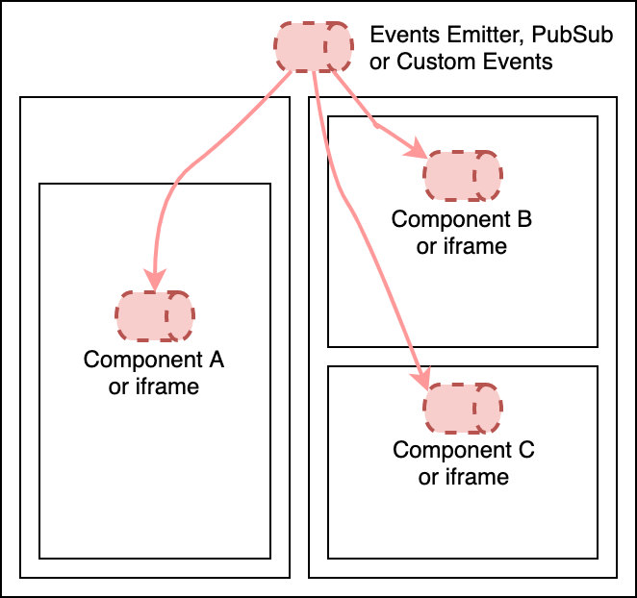
To inject the eventbus, we need the micro-frontends container to instantiate the eventbus and inject it inside all of the page’s micro-frontends.

Another solution is to use Custom Events. These are normal events but with a custom body, in this way we can define the string that identifies the event and an optional object custom for the event. Following an example
new CustomEvent('myCustomEvent', { someObj: “customData” });
The custom events should be dispatched via an object available to all the micro-frontends, such as the window object, the representation of a window in a browser. If you decide to implement your micro-frontends with iframes, using an eventbus would allow you to avoid challenges like which window object to use from inside the iframe, because each iframe has its own window object. No matter whether we have a horizontal or a vertical split of our micro-frontends, we need to decide how to pass data between views.

We can use a web-storage-like session, local storage, or cookies

Another option could be to pass some data via query strings - for example, www.acme.com/products/details?id=123 the text after the question mark represents the query string, in this case the ID 123 of a specific product selected by the user - and retrieves the full details to display via an API (Figure 3-7). Using query strings is not the most secure way to pass sensitive data, such as passwords and user IDs, however. There are better ways to retrieve that information if it’s passed via the HTTPS protocol. Embrace this solution carefully.

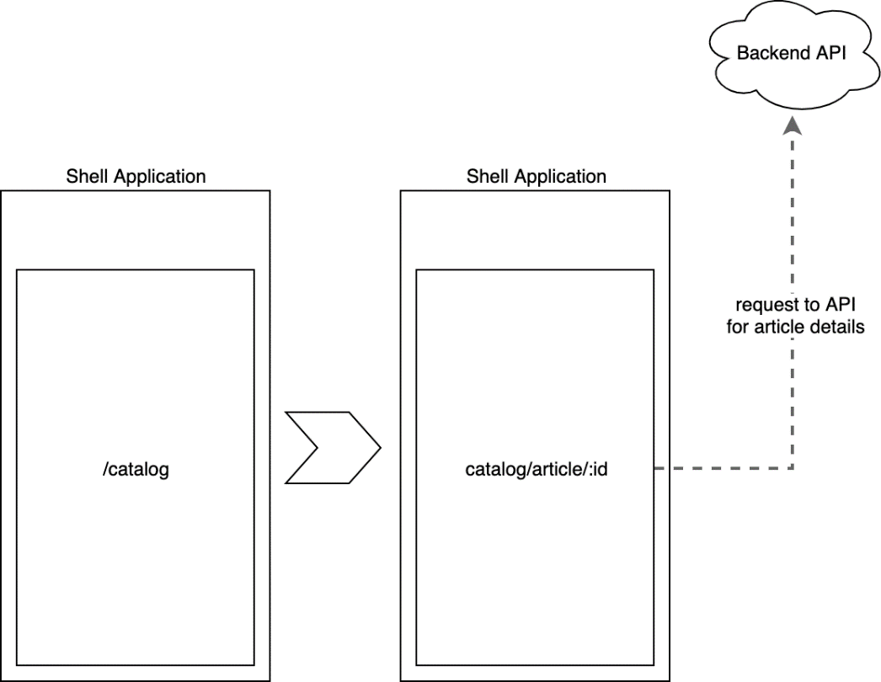

To summarize, the micro-frontends decisions framework is composed of four key decisions: identifying, composing, routing, and communicating.

More info
https://engineering.zalando.com/posts/2018/12/front-end-micro-services.html?gh_src=4n3gxh1?gh_src=4n3gxh1

Inspired by Zalando’s work, HelloFresh is now serving a multitude of SPAs orchestrated by URL.
In an interesting approach to flexibility of components, the SPAs are assembled and rendered on the servers, then cached at the CDN level, providing flexibility for generating the SPAs.
This approach also allows the development teams to be responsible for their own technology stacks; each SPA could have a different one, and each team is fully independent from the other

If we inspect the Spotify desktop application, we can easily find the multiple parts composing this application. Each single .spa file is composed by an html file, multiple css files, a manifest.json, **and a JavaScript bundle file minimized and optimized (Figure 2-8).
https://docs.google.com/drawings/u/1/d/srOqMCJWnBIaT2VKsyRwo7w/image?w=481&h=177&rev=1&ac=1&parent=1oLWU66mMvCW-van-37Sb-SEZqx9nJLgz
Figure 2-8. Spotify micro-frontend artifact

Open Components are using a really interesting approach to micro-frontends: a registry similar to the Docker registry gathers all the available components encapsulating the data and UI, exposing an HTML fragment that can then be encapsulated in any HTML template.
https://github.com/opencomponents/oc

Chapter 4. Build and Deploy Micro-Frontends

The microservices architecture adds great flexibility and scalability to our architecture, allowing our APIs to scale horizontally based on the traffic our infrastructure receives and allowing us to implement the right pattern for the right job
Having solid automation pipelines will allow our micro-frontends projects to be successful, creating a reliable solution for developers to experiment, build, and deploy.

Certainly, the deployment phase will be the same for all the micro-frontends in a project. However, the build pipeline may use different tools or different optimizations

The decision between a horizontal and vertical split with your new micro-frontends project will definitely impact the developers’ experience.
A vertical split will represent the micro-frontends as single HTML pages or SPAs owned by a single team, resulting in a developer experience very similar to the traditional development of an SPA. All the tools and workflows available for SPA will suit the developers in this case

Horizontal splits come with a different set of considerations.
When a team owns multiple micro-frontends that are part of one or more views, we need to provide tools for testing a micro-frontend inside the multiple views assembling the page at runtime. These tools need to allow developers to review the overall picture, potential dependencies clash, the communication with micro-frontends developed by other teams, and so on.
These aren’t standard tools, and many companies have had to develop custom tools to solve this challenge.

Usually, the debate is between monorepo and polyrepo, also called multi-repo. There are benefits and pitfalls in both approaches., You can emply both, though, in your micro-frontend project, so you can use the right technique for your context.

Nowadays many companies are giving developers ownership of automation pipelines.
That doesn’t mean developers should be entitled to do whatever they want in the CI, but they definitely should have some skin in the game because how fast the feedback loop is closed depends mainly on them.

More than once I would be walking the corridors and overhear conversations between engineers about how building tools like Rollup have some features or performances that the Webpack tool didn’t have in certain scenarios and vice versa. This, for me, is a sign of a great confrontation between tools tested in real scenarios rather than in a sandbox.

Blue-green deployment starts with the assumption that the last stage of our tests should be done in the production environment we are running for the rest of our platform.

In canary releases, we don’t switch all of the traffic to a new version after all tests pass. Instead, we gradually ease the traffic to a new micro-frontend version

Chapter 5. Automation Pipeline for Micro-Frontends: A Use Case

TODO Look in file example.
Performance checks have become far easier to perform within an automation pipeline, thanks to CLI tools now being available to be wrapped inside a docker container and being easy to integrate into any automation pipeline.
There are many alternatives, however. I recommend starting with Lighthouse CLI or Webhint CLI. The former is available inside any recent version of Chrome, while the latter allows us to create additional performance tests for enhancing the list of tests already available by default

Chapter 6. Backend Patterns for Micro-Frontends

In this chapter, we review some possible integrations between the frontend and backend layers, in particular, we analyze how micro-frontends can work in combination with a monolith or modular monolith backend, with microservices, and even with the backend for frontend (BFF) pattern.

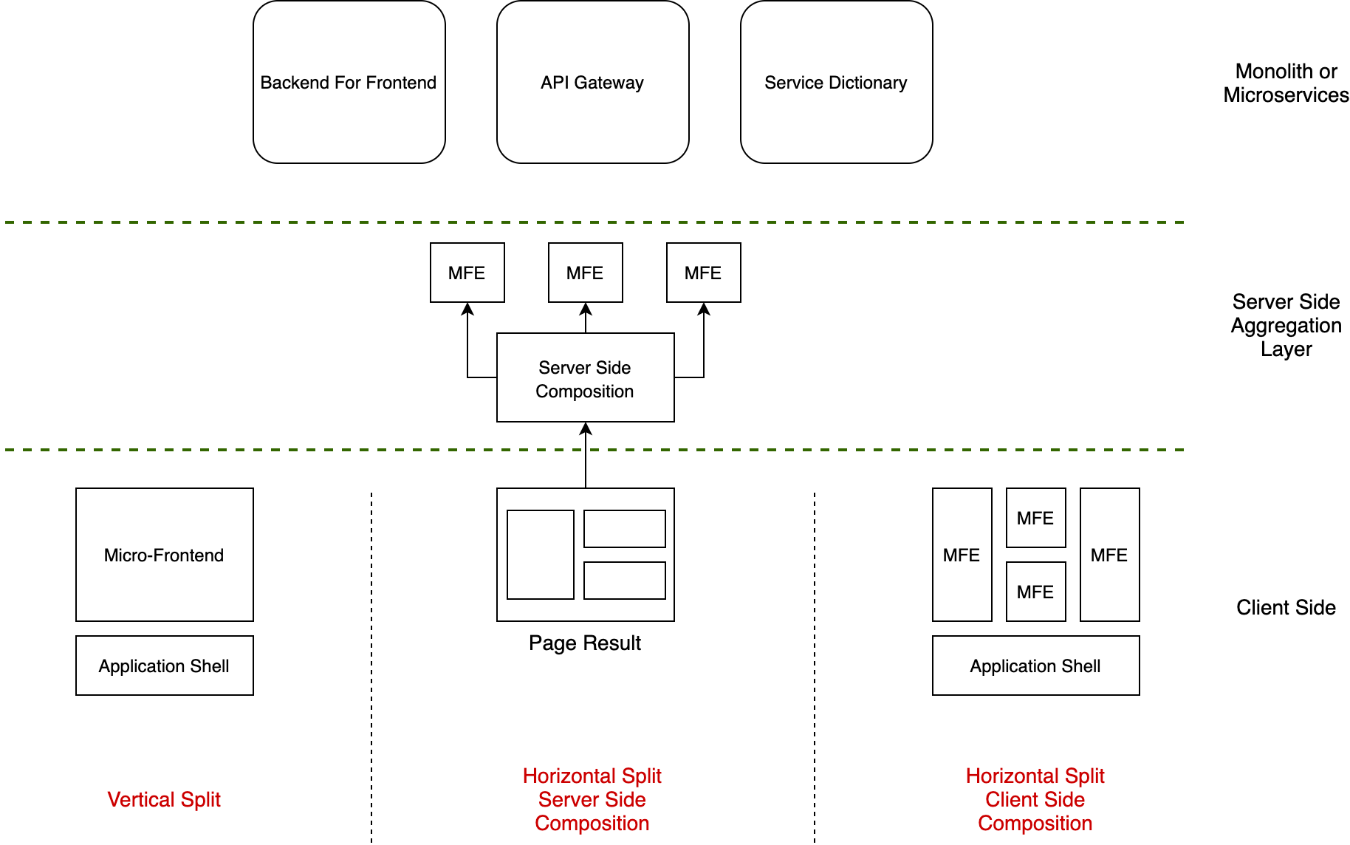

The patterns we analyze in this chapter are:
- Service dictionary. The service dictionary is just a list of services available for the client to consume. It’s used mainly when we are developing an API layer with a monolith or modular monolith architecture; however, it can also be implemented with a microservices architecture with an API gateway, among other architectures. A service dictionary avoids the need to create shared libraries, environment variables, or configurations injected during the CI process or to have all the endpoints hardcoded inside the frontend codebase.
The dictionary is loaded for the first time when the micro-frontend loads, allowing the client to retrieve the URLs to consume directly from the service dictionary.
- API gateway. Well known in the microservices community, an API gateway is a single entry point for a microservices architecture. The clients can consume the APIs developed inside microservices through one gateway.
The API gateway also allows centralizing a set of capabilities, like token validation, API throttling, or rate-limiting.
- BFF. The BFF is an extension of the API gateway pattern, creating a single entry point per client type. For instance, we may have a BFF for the web application, another for mobile, and a third for the Internet of Things (IoT) devices we are commercializing.
BFF reduces the chattiness between client and server aggregating the API responses and returning an easy data structure for the client to be parsed and render inside a user interface, allowing a great degree of freedom to shape APIs dedicated to a client and reducing the round trips between a client and the backend layer.
These patterns are not mutually exclusive, either; they can be combined to work together.

A service dictionary
A service dictionary is nothing more than a list of endpoints available in the API layer provided to a micro-frontend. This allows the API to be consumed without the need to bake the endpoints inside the client-side code to inject them during a continuous integration pipeline or in a shared library.
Usually, a service dictionary is provided via a static JSON file or an API that should be consumed as the first request for a micro-frontend (in the case of a vertical-split architecture) or an application shell (in the case of a horizontal split).

A service dictionary may also be integrated into existing configuration files or APIs to reduce the round trips to the server and optimize the client startup.
In this case, we can have a JSON object containing a list of configurations needed for our clients, where one of the elements is the service dictionary.
An example of service dictionary structure would be:
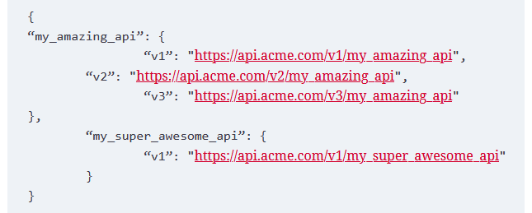

As you can see, we are listing all the APIs supported by the backend. Thanks to API versioning, we can handle cross-platforms applications without introducing breaking changes because each client can use the API version that suits it better.
One thing we can’t control in such scenarios is the penetration of a new version in every mobile device. When we release a new version of a mobile application, updating may take several days, if not weeks, and in some situations, it may take even longer.
Therefore, versioning the APIs is important to ensure we don’t harm our user experience.
Endpoint discoverability is another reason to use a service dictionary.

Last but not least, a service dictionary is also helpful for testing micro-frontends with new endpoint versions while in production.

A company that uses a testing-in-production strategy can expand that to its micro-frontends architecture, thanks to the service dictionary, all without affecting the standard user experience.
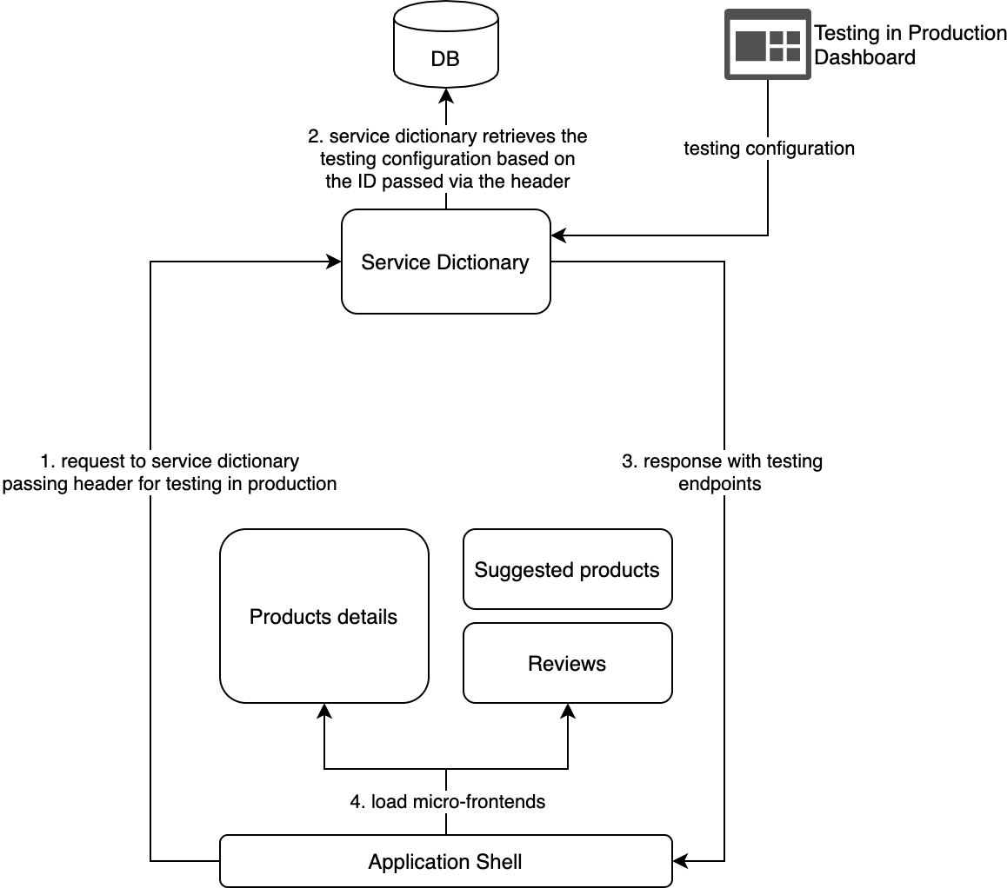
The service dictionary pattern can easily be implemented in a vertical-split micro-frontends architecture, where every micro-frontend requests the dictionary related to its business domain.

However, it’s not always possible to implement a service dictionary per domain, such as when we are transitioning from an existing SPA to micro-frontends, where the SPA requires the full list of endpoints because it won’t reload the JavaScript logic till the next user session.

In this case, we may decide to implement a tactical solution, providing the full list of endpoints to the application shell instead of a business domain endpoints list to every single micro-frontend.

To implement the service dictionary pattern with a micro-frontends architecture using a horizontal split, we have to pay attention to where the service dictionary API is consumed and how to expose it for the micro-frontends inside a single view.
When the composition is managed client side, the recommended way to consume a service dictionary API is inside the application shell or host page. Because the container has visibility into every micro-frontend to load, we can perform just one round trip to the API layer to retrieve the APIs available for a given view and expose or inject the endpoints list to every loaded micro-frontend.

Consuming the service dictionary APIs from every micro-frontend would negatively impact our applications’ performance, so it’s strongly recommended to stick the logic in the micro-frontends container as shown in figure 9.5

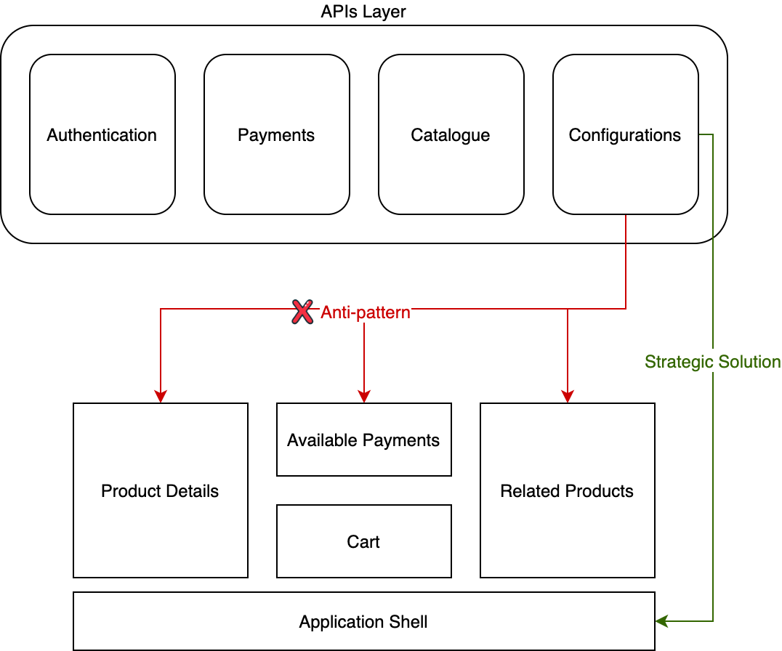
The application shell should expose the endpoints list via the window object, making it accessible to all the micro-frontends when the technical implementation allows us to do it. Another option is injecting the service dictionary, alongside other configurations, after loading every micro-frontend.

API gateway pattern

An API gateway pattern represents a unique entry point for the outside world to consume APIs in a microservices architecture.
Not only does an API gateway simplify access for any frontend to consume APIs by providing a unique entry point, but it’s also responsible for requests routing, API composition and validation, and other edge functions, like authentication and rate limiting.

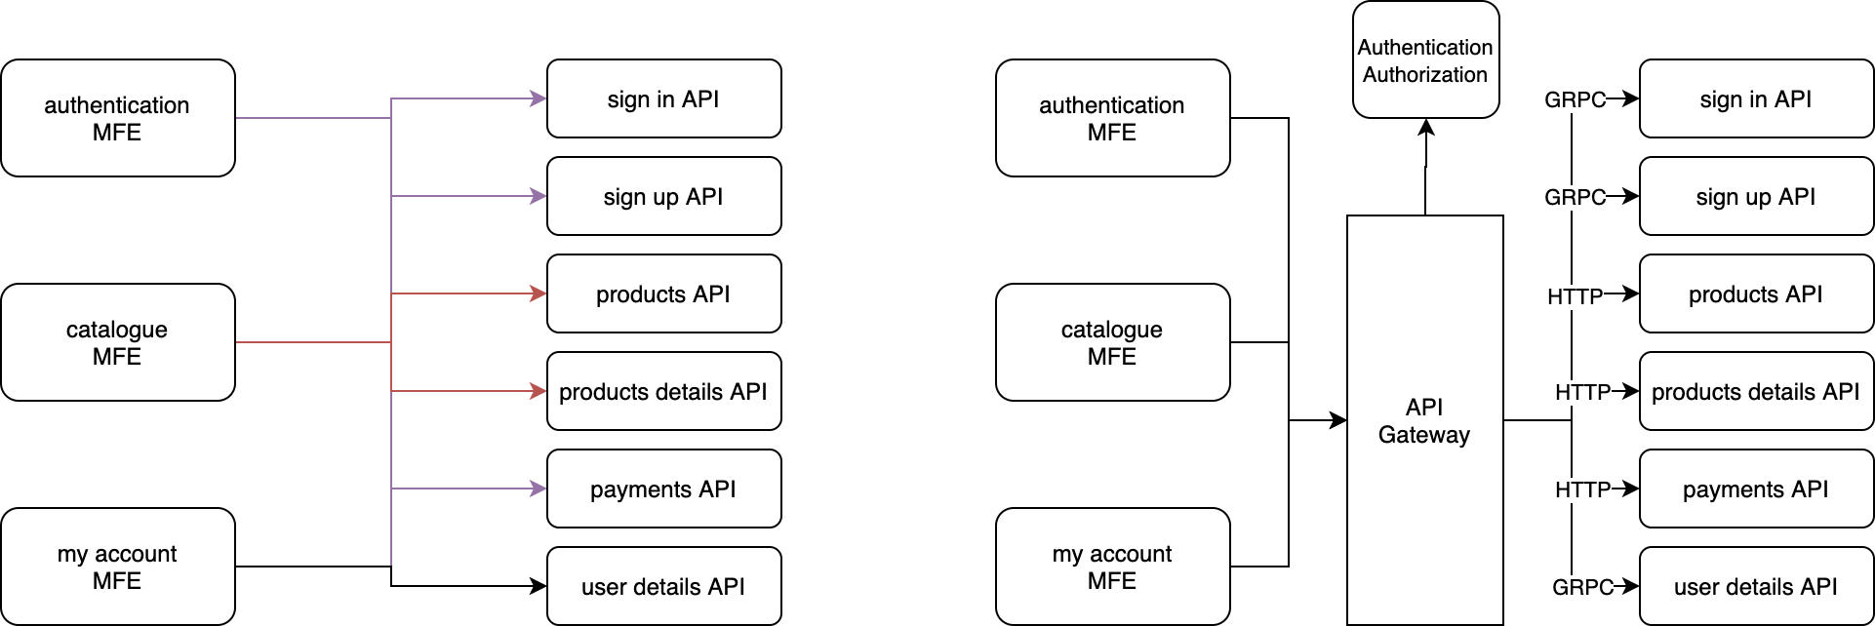
As a unique entry point, it could be a single point of failure, so we need to have a cluster of API gateways to add resilience to our application.
Another challenge is more operational. In a large organization, where we have hundreds of developers working on the same project, we may have many services behind a single API gateway. We’ll need to provide solid governance for adding or removing APIs in the API gateway to prevent .
Finally, if we implement an additional layer between the client and the microservice to consume, we’ll add some latency to the syste

Another opportunity to consider is creating one API entry point per business domain instead of having one entry point for all the APIs, as with an API gateway.

Multiple API gateways enable you to partition your APIs and policies by solution type and business domain.
In this way, we avoid having a single point of failure in our infrastructure. Part of the application can fail without impacting the rest of the infrastructure. Another important characteristic of this approach is that we can use the best entry point strategy per bounded context based on the requirements needed, as shown in figure 9.8.

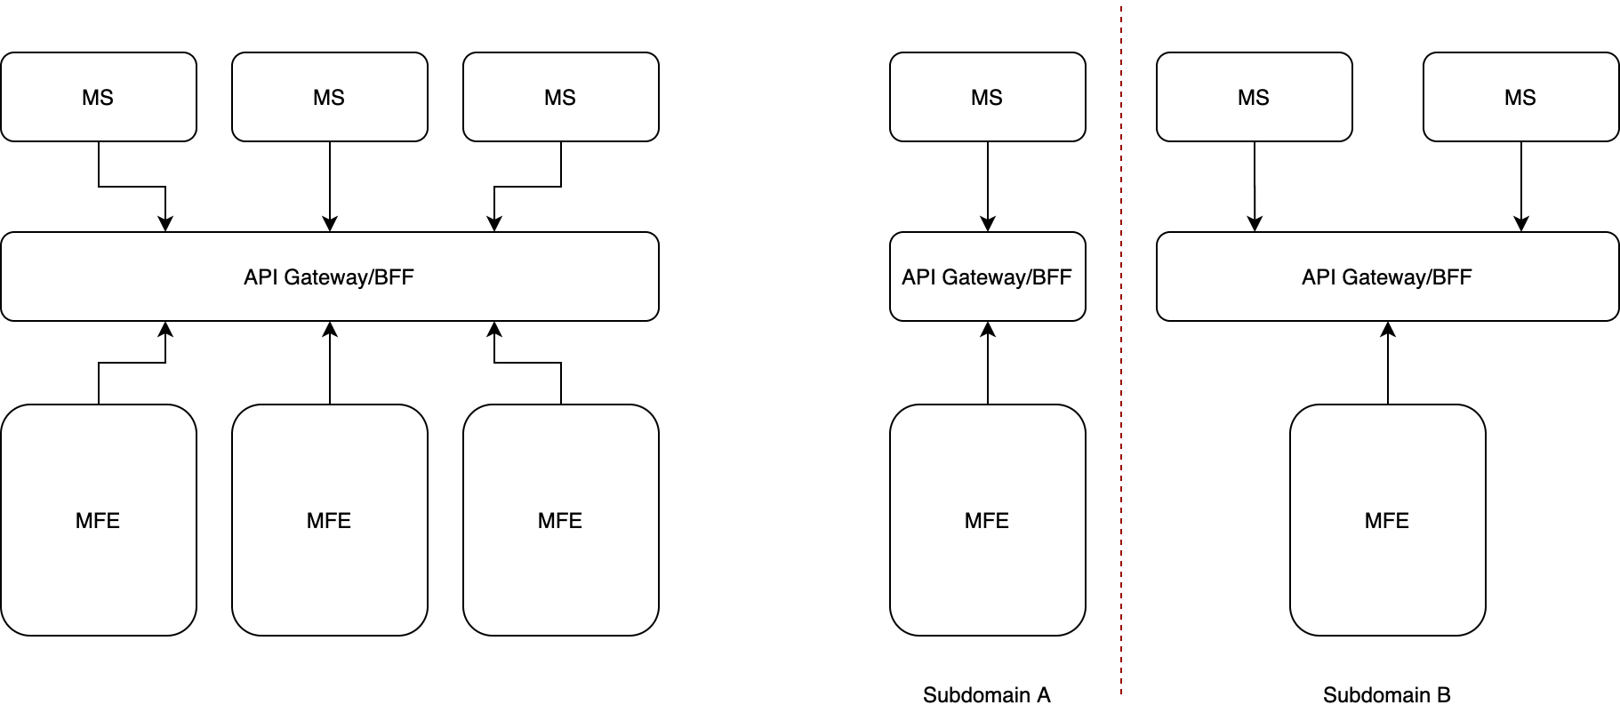

Using an API gateway with a client-side micro-frontends composition (either vertical or horizontal split) is not that different from implementing the service dictionary in a monolith backend.
In fact, we can use the service dictionary to provide our micro-frontends with the endpoints to consume, with the same suggestions we provided previously..
The main difference, in this case, will be that the endpoints list will be provided by a microservice responsible for serving the service dictionary or a more generic client-side configuration, depending on our use case.
Another interesting option is that with an API gateway, authorization may happen at the API-gateway level, removing the risk of introducing libraries at the API level, as we can see in figure 9.9.
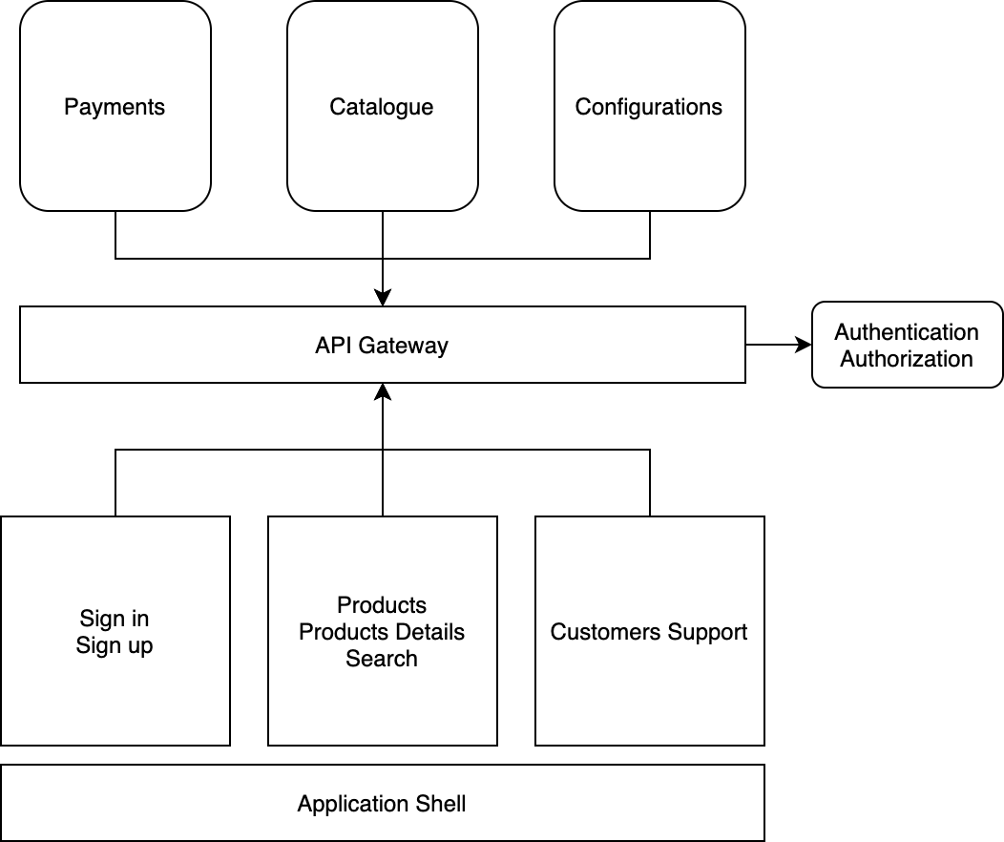

A server-side composition with an API gateway
A microservices architecture opens up the possibility of using a micro-frontends architecture with a server-side composition.

Note
Remember that with a server-side composition we identify our micro-frontends with a horizontal split, not a vertical one

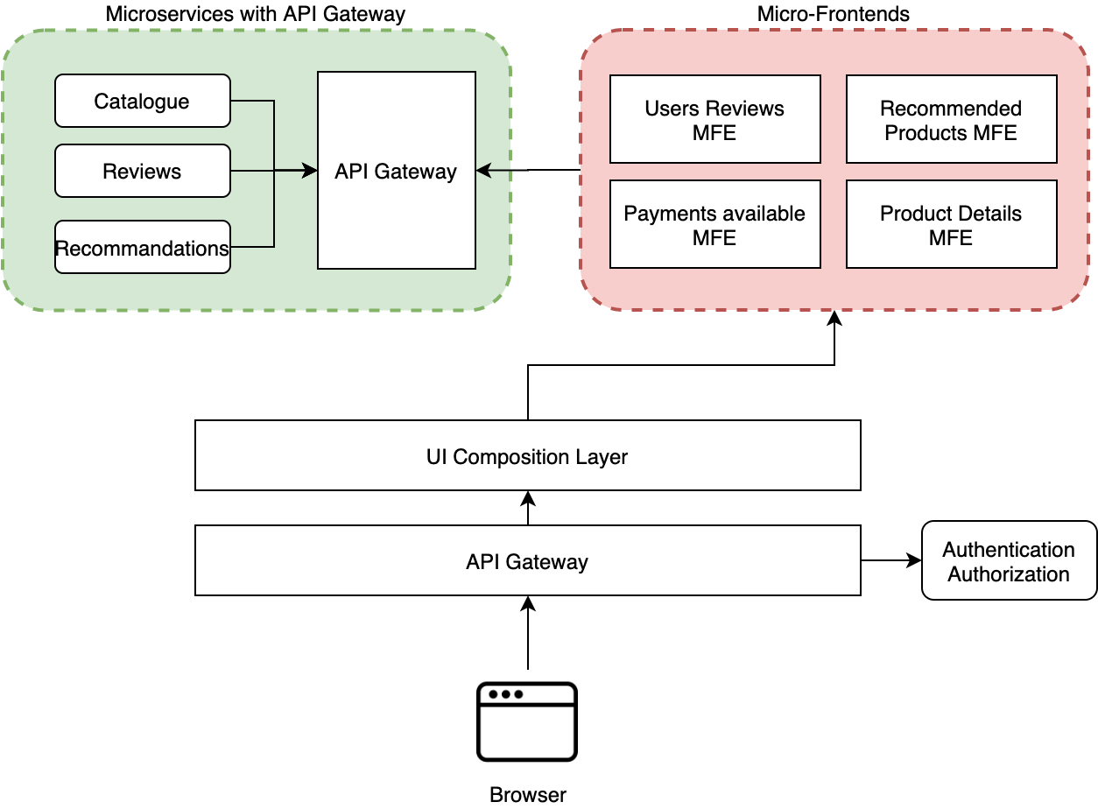

As we can see in figure 9.10, after the browser’s request to the API gateway, the gateway handles the user authentication/authorization first, then allows the client request to be processed by the UI composition service responsible for calling the microservices needed to aggregate multiple micro-frontends, with their relative content fetched from the microservices layer.
For the microservices layer, we use a second API gateway to expose the API for internal services, in this case, used by the UI composition service.

There are several micro-frontend frameworks with a similar implementation, such as the interface framework from Zalando, OpenComponents, Project Mosaic, and Ara Framework based on Airbnb Hypernova.

BFF pattern

Although the API gateway pattern is a very powerful solution for providing a unique entry point to our APIs, in some situations we have views that require aggregating several APIs to compose the user interface, such as a financial dashboard that may require several endpoints for gathering the data to display inside a unique view.

This pattern will only make sense if and when you have a significant amount of data coming from different endpoints that must be aggregated for improving the client’s performance or when you have a cross-platform application that requires different experiences for the user based on the device used.
This pattern can also help solve the challenge of introducing a layer between the API and the clients, as we can see in figure 9.12

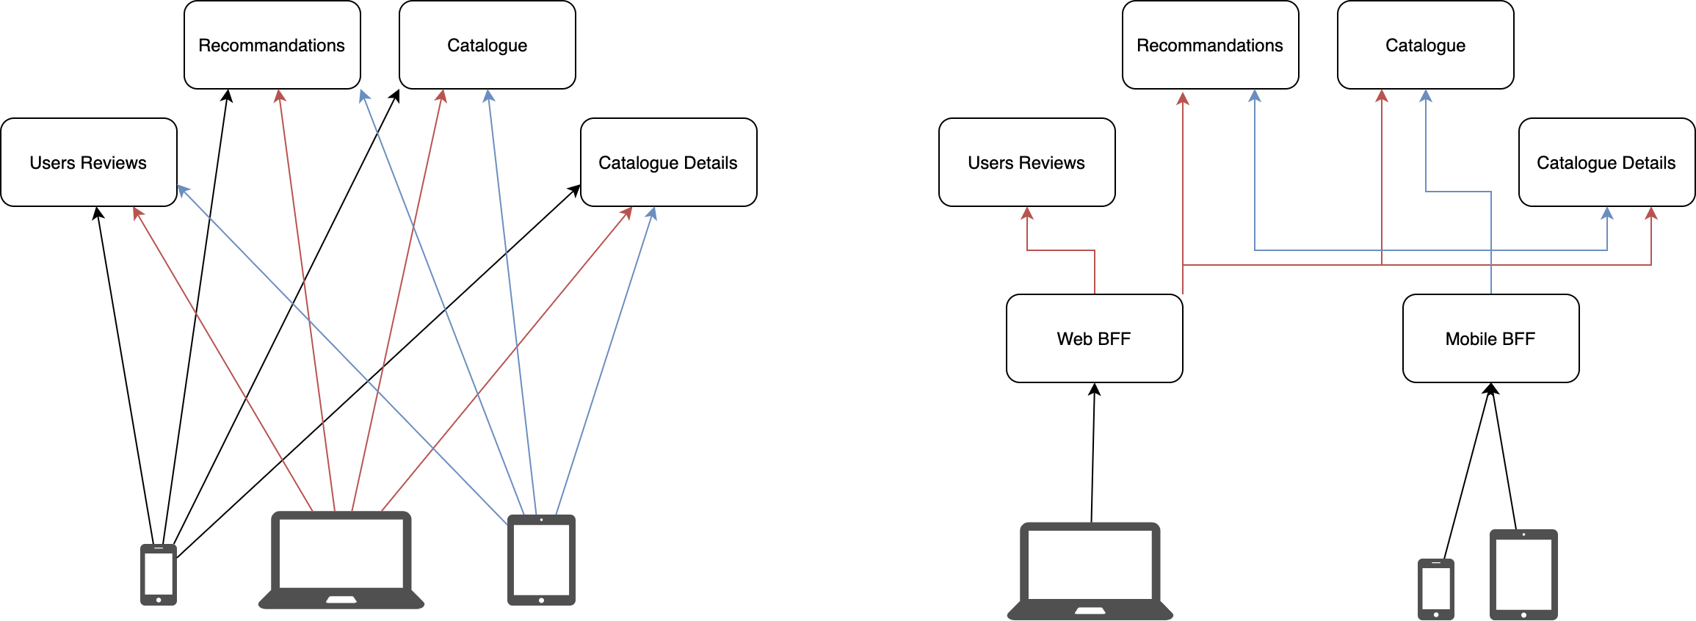
Thanks to BFF we can create a unique entry point for a given device group, such as one for mobile and another for a web application.
However, this time we also have the option of aggregating API responses before serving them to the client and, therefore, generating less chatter between clients and the backend because the BFF aggregates the data and serves only what is needed for a client with a structure reflecting the view to populate

Interestingly, the microservices architecture’s complexity sits behind the BFF, creating a unique entry point for the client to consume the APIs without needing to understand the complexity of a microservices architecture

In fact, thanks to the separation between clients and APIs, we can use the strangler pattern for killing the monolith in an iterative way, as illustrated in figure 9.13. This technique is also applicable to the API gateway pattern.

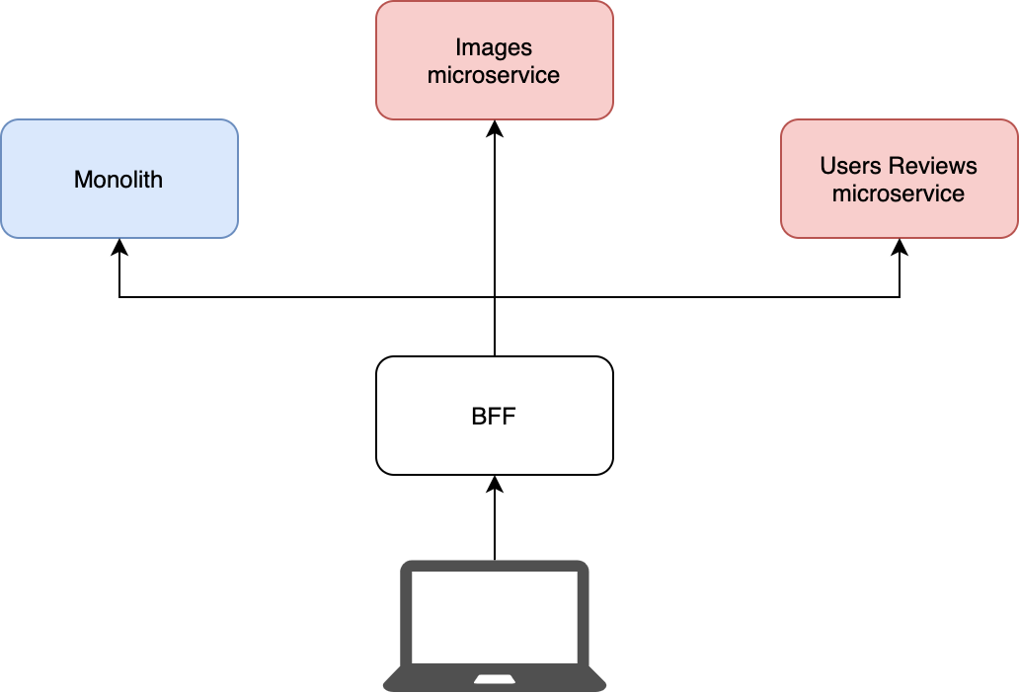

Figure 6-20.14 illustrates how we can have two BFFs, one for the catalogue and one for the Account section, for aggregating and exposing these APIs to different clients. In this way, we can scale the BFFs based on their traffic.

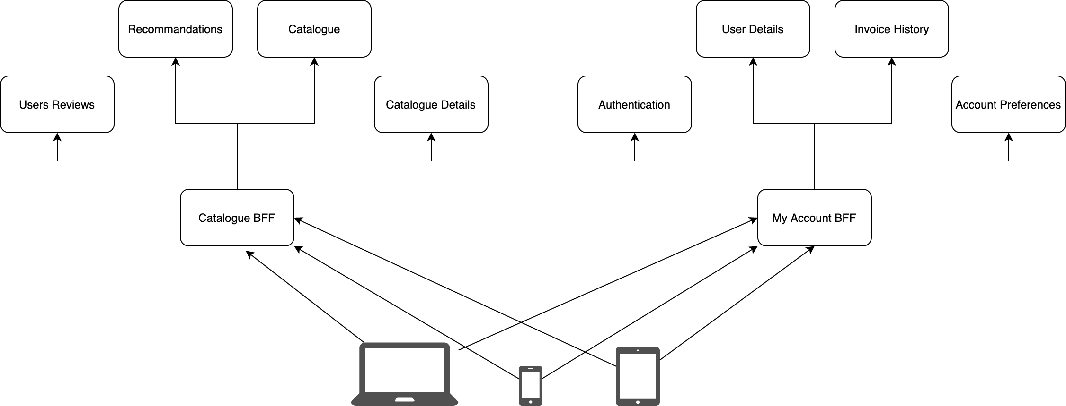

Because a BFF is an evolution of the API gateway, many of the implementation details for an API gateway are valid for a BFF layer as well, plus we can aggregate multiple endpoints, reducing client chatter with the server.
It’s important to iterate this capability because it can drastically improve application performance.
Yet there are some caveats when we implement either a vertical split or a horizontal one.

When we want to implement a vertical-split architecture, we may design the BFF to fetch all the data needed for composing this view, as we can see in figure 9.16.

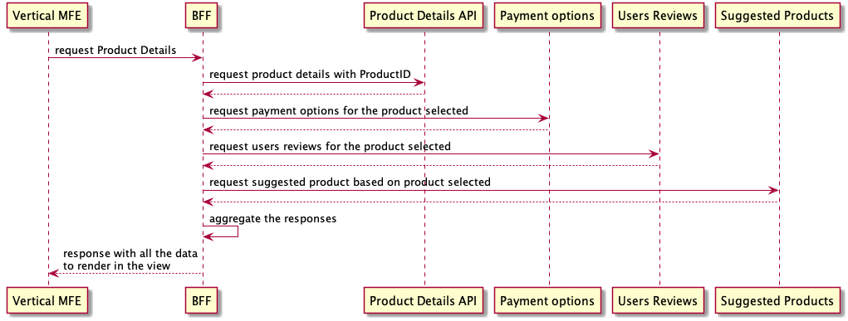
However, when we have a horizontal split composed on the client side, things become trickier because we need to maintain the micro-frontends’ independence, as well as having the host page domain as unaware as possible.
In this case, we need to combine the APIs in a different way, delegating each micro-frontend to consume the related API, otherwise, we will need to make the host page responsible for fetching the data for all the micro-frontends, which could create a coupling that would force us to deploy the host page with the micro-frontends, breaking the intrinsic characteristic of independence between micro-frontends.
Taking into consideration these micro-frontends and the host page may be developed by different teams, this setup would slow down features development rather than leveraging the benefits that this architecture provides us.
BFF with a horizontal split composed on the client side could create more challenges than benefits in this case. It’s wise to analyze whether this pattern’s benefits will outweigh the challenges.

GraphQL

GraphQL is a query language for APIs and a server-side runtime for executing queries by using a type system you define for your data.

Especially for frontend developers, GraphQL represents a great way to retrieve the data needed for rendering a view, decoupling the complexity of an API layer, rationalizing the API response in a graph, and allowing any client to reduce the number of round trips to the server for composing the UI.
Because GraphQL is a client-centric API, the paradigm for designing an API schema should be based on how the view we need to render looks instead of looking at the data exposed by the API layer.
Two projects in the GraphQL community stand out as providing great support and productivity with the open source tools available, such as Apollo and Rely.

Both projects leverage GraphQL, adding an opinionated view on how to implement this layer inside our application, increasing our productivity thanks to the features available in one or both, like authentication, rate limiting, caching, and schema federations.

GraphQL can be used as an API gateway, acting as a proxy for specific microservices, for instance, or as a BFF, orchestrating the requests to multiple endpoints and aggregating the final response for the client.

Remember that GraphQL acts as a unique entry point for your entire API layer. By design GraphQL exposes a unique endpoint where the clients can perform queries against the GraphQL server. Because of this, we tend to not version our GraphQL entry point, although if the project requires a versioning because we don’t have full control of the clients that consume our data, we can version the GraphQL endpoint. Shopify does this by adding the date in the URL and supporting all the versions up to a certain period.
GraphQL simplifies data retrieval for the clients, allows us to query only the fields needed in a view based on client type (e.g., mobile or web), and simplifies the maintenance and evolution of the GraphQL layer compared to more complicated backend ecosystems.

Schema federation is a set of tools to compose multiple GraphQL schemas declaratively into a single data graph.

When we work with GraphQL in a midsize to large organization, we risk creating a bottleneck because all the teams are contributing to the same schema.

But with a schema federation we can have individual teams working on their own schemas and exposing them to the client as unique entry points, just like a traditional data graph.

Integrating GraphQL with micro-frontends is a trivial task, especially after reviewing the implementation of the API gateway and BFF.
With schema federations, we can have the teams who are responsible for a specific domain’s APIs create and maintain the schema for their domain and then merge all the schemas into a unique data graph for our client applications.

When we integrate GraphQL with a vertical split and a client-side composition, the integration resembles the others described above: the micro-frontend is responsible for consuming the GraphQL endpoint and rendering the content inside every component present in a view.

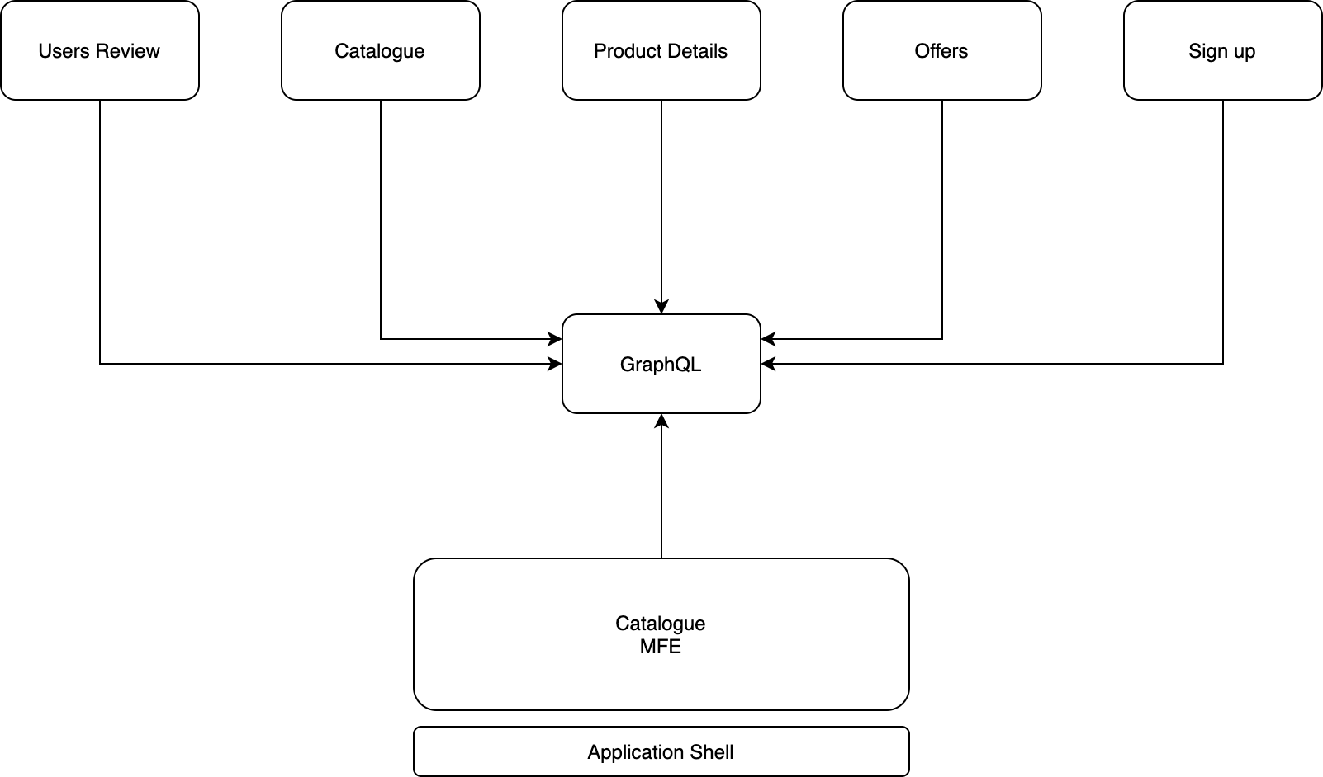

In this case, thanks to the schema federation, we can compose the graph with all the schemas needed and expose a unique data graph for a micro-frontend to consume.
Interestingly, with this approach, every micro-frontend will be responsible for consuming the same endpoint. Optionally, we may want to split the BFF into different domains, creating a one-to-one relation with the micro-frontend. This would reduce the scope of work and make our application easier to manage, considering the domain scope is smaller than having a unique data graph for all the applications.

As we see in figure 9.19, the application shell exposes or injects the GraphQL endpoint to all the micro-frontends and all the queries related to a micro-frontend will be performed by every micro-frontend.

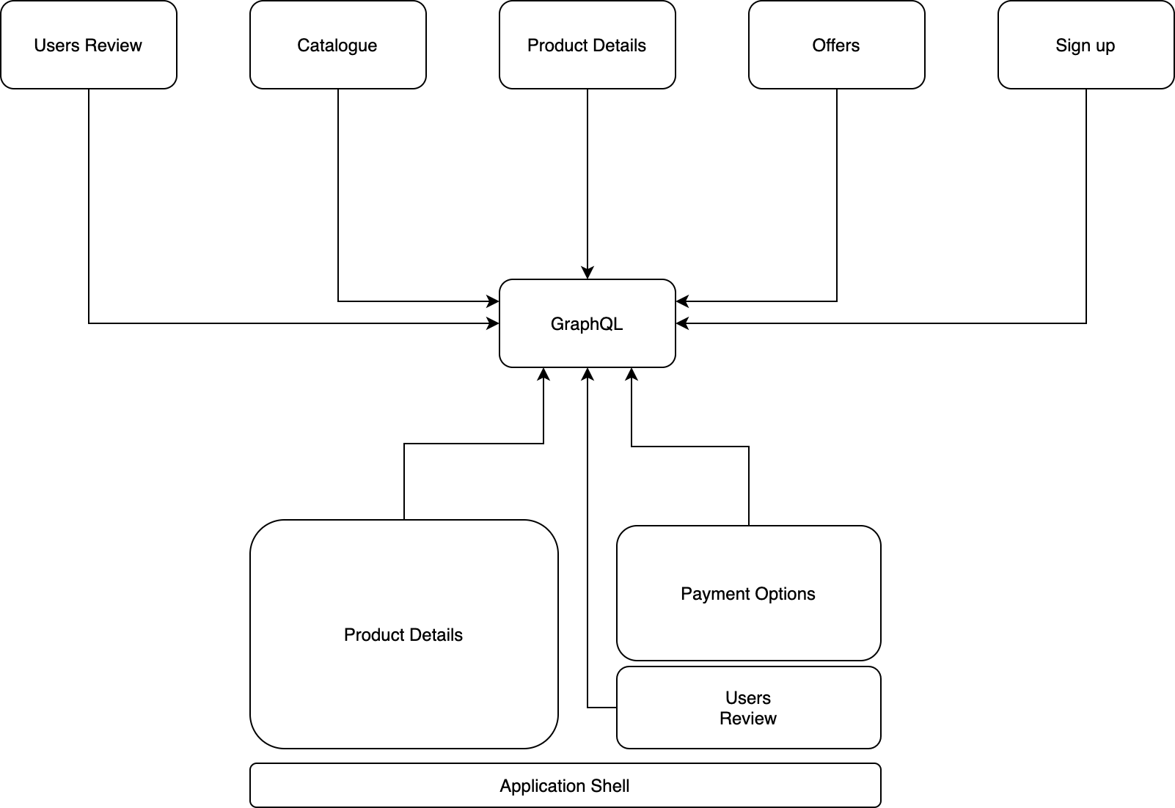

The last approach is using a GraphQL server with a micro-frontends architecture with horizontal split and a server-side composition.
When the UI composition requests multiple micro-frontends to their relative microservices, every microservice queries the graph and prepares the view for the final page composition (see figure 9.20).

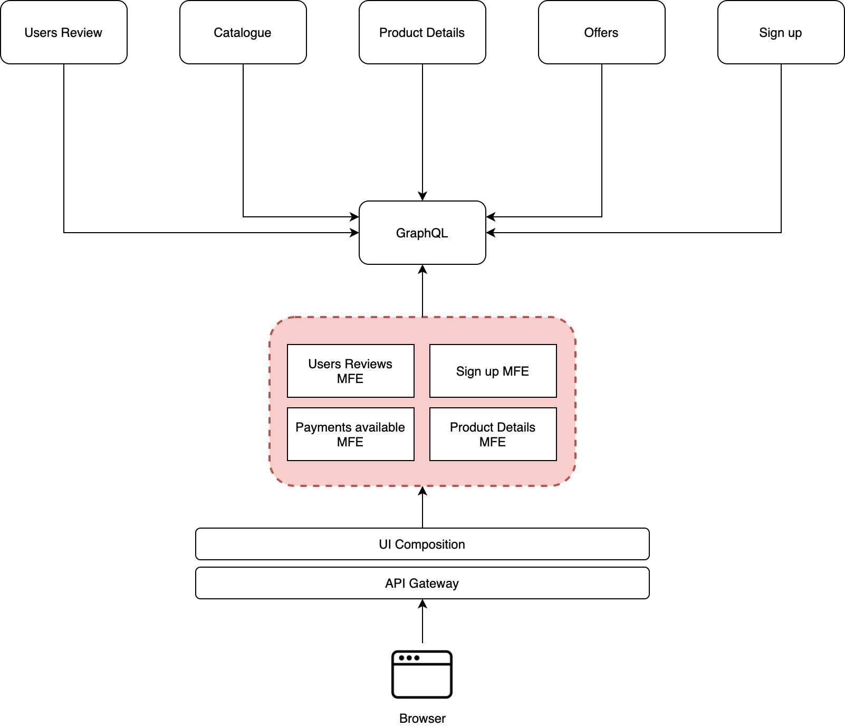

Best practices

When we work with a horizontal-split architecture, we may end up having similar micro-frontends in the same view consuming the same APIs.

In this case, we should challenge ourselves to determine whether maintaining separate micro-frontends brings any value to our system. Would grouping them in a unique micro-frontend be better?

Usually, such scenarios should indicate a potential architectural improvement. Don’t ignore that signal; instead, try to revisit the decision made at the beginning of the project with the information and the context available, making sure performing the same API request twice inside the same view is acceptable. If not, be prepared to review the micro-frontends boundaries

Independent of the architecture we will implement in our projects, we should apply API-first principles to ensure all teams are working with the same understanding of the desired result.

An API-first approach means that for any given development project, your APIs are treated as “first-class citizens.”

As discussed at the beginning of this book, we need to make sure the API identified for communicating between micro-frontends or for client-server communication are defined up front to enable our teams to work in parallel and generate more value in a shorter time.

In fact, investing time at the beginning for analyzing the API contract with different teams will reduce the risk of developing a solution not suitable for achieving the business goals or a smooth integration within the system.

Moreover, when we have to introduce a breaking change in an API, sharing a request for comments (RFC) with the teams consuming the API may help to update the contract in a collaborative way. This will provide visibility on the business requirements to everyone and allow them to share their thoughts and collaborate on the solution using a standard document for gathering comments.
RFCs are very popular in the software industry. Using them for documenting API changes will allow us to scale the knowledge and reasoning behind certain decisions, especially with distributed teams where it is not always possible to schedule a face-to-face meeting in front of a whiteboard.
RFCs are also used when we want to change part of the architecture, introduce new patterns, or change part of the infrastructure

API standardization allows developers to easily grasp the core concepts of new APIs, minimizes the learning curve, and makes the integration of APIs from other domains easier

There are very interesting insights available online for client-server communication, some of which may also be applicable to micro-frontends. Google and Microsoft API guidelines share a well-documented section on this topic, with many details on how to structure a consistent API inside their ecosystems.

In some projects, we need to implement a WebSocket connection for notifying the frontend that something is happening, like a video chat application or an online game.

Using WebSockets with micro-frontends requires a bit of attention because we may be tempted to create multiple socket connections, one per micro-frontend. Instead, we should create a unique connection for the entire application and inject or make available the WebSocket instance to all the micro-frontends loaded during a user session.

When working with horizontal-split architectures, create the socket connection in the application shell and communicate any message or status change (error, exit, and so on) to the micro-frontends in the same view via an event emitter or custom events for managing their visual update.
In this way, the socket connection is managed once instead of multiple times during a user session. There are some challenges to take into consideration, however

Nowadays we are developing cross-platform applications more often than not.
Mobile devices are part of our routine. They help us accomplish our daily tasks and a tablet may have already replaced our laptop for working.

When we approach a cross-platform application and we aren’t using a BFF layer to aggregate the data model for every device we target, we need to remember a simple rule: move the configurations as much as you can on the API layer.

With this approach, we will be able to abstract and control certain behaviors without the need to build a new release of our mobile application and wait for the penetration in the market.

Chapter 7. From Monolith to Micro-Frontends: A Case Study

Migration Strategy

Based on tech leadership’s requirements and goals, the teams started to work on a plan for migrating the entire platform to micro-frontends.

The first step was embracing the micro-frontends decisions framework, outlined in chapter 2. The first four decisions—defining what a micro-frontend is in your architecture, composing micro-frontends, routing micro-frontends, and communicating between micro-frontends—will lead the entire migration toward the right architecture for the context.

As discussed in several chapters of this book, the micro-frontends decisions framework gives us a skeleton to architect a micro-frontends project on to. All the other decisions will build on top of this frame, creating a reliable structure.
Micro-Frontends Decisions Framework Applied

The first decision of the framework is how a micro-frontend will look. The ACME teams decided on a vertical split, where micro-frontends represent a subdomain of the entire application (figure 10.5).
A vertical split micro frontend where the application shell loads only one micro frontends at a time
Figure 7-5. A vertical split micro-frontend, where the application shell loads only one micro-frontends at a time

The teams took into account the following characteristics for their context before deciding to use a vertical split:

Similar developer experience

Because the current platform is a SPA, a vertical split allows developers to work similarly to how they have worked so far but with a smaller context and less code to be responsible for.
Low component reusability

The teams have identified that not many components are similar across the different subdomains. This clearly indicates that the reusability of micro-frontends, a plus of a horizontal split approach, it’s not needed. A light design system will ensure consistency across micro-frontends, and it doesn’t create a huge overhead of dealing with it.
Better integration with current automation strategy

The vertical split fits very well with the current automation strategy, considering right now ACME is building a SPA. The teams have enhanced their automation pipelines for building multiple SPAs without the need to create custom tools for embracing this architecture style. They will need to use infrastructure as code for automating the process of building their pipelines and replicating them without human intervention.
No risk of dependency clashes

In a vertical split we always load one micro-frontend at a time, due to its nature. As a result, the teams won’t have to deal with dependency clashes, like different versions of the same library, because there will be dependencies of just one micro-frontend, reducing the possibility of runtime errors and bugs in production. There also won’t be any CSS style clash because only one stylesheet per micro-frontend will load.
A consistent user experience

Creating a consistent user experience is easier with a vertical split because the same team is working on one or multiple views inside the same SPA. Obviously, a level of coordination is required for maintaining consistency across micro-frontends, but it’s definitely less prone to errors than having multiple micro-frontends in the same view developed by multiple teams.
Reduction of cognitive load

For ACME, a vertical split will decrease its developers’ cognitive load, because they’ll only have to master and maintain a part of the platform. This choice also won’t dilute the decisions made by developers inside their business subdomain. However, every developer should have an overall understanding of the platform architecture so that when they’re on call they can understand the touching points of their business domain and recognize where a bug may appear despite not inside their domain.
Faster on boarding process

As the tech leadership requested, using this approach will lead to a faster onboarding process because the teams can use well-known, standard tools and won’t need to create their own to build, test, and deploy micro-frontends.
Also, because teams will be responsible for only a part of the platform, less coordination with other teams will be required. New joiners can hit the ground faster, with less information needed to start. Finally, every team will be encouraged to create a starter kit and induction for every new joiner to speed up the learning process and make a person capable of contributing to the base code in the fastest way possible.

The second decision of the framework is related to the composition of the micro-frontends. In this case, the best approach is composing them on the client side considering they are using a vertical split approach.

This means that the teams will have to create an application shell that is responsible for mounting and unmounting micro-frontends, exposing some APIs to allow communication between micro-frontends and ensuring it will always be available during the user session (figure 10.6).

A server-side composition was rejected immediately due to the traffic spikes, which required more effort to support and maintain than the simple infrastructure they would like to use for this project.
Client side composition where the application shell is responsible for loading and unloading one micro frontend at a time.
Figure 7-6. Client-side composition, where the application shell is responsible for loading and unloading one micro-frontend at a time.

The third decision is the routing of micro-frontends, that is, how to map the different application paths to micro-frontends. Because ACME will use a vertical split and is composing on the client side, the routing must happen on the client side, where the application shell knows which micro-frontend to load based on the path selected by the user. This mechanism also has to handle the deep-linking functionality; if a user shares a movie’s URL with someone else, the application shell should load the application in exactly that state (figure 10.7).
When the user signs in from the account path they are redirected to the authenticated area catalogue . The application shell owns the logic for unloading the current micro frontend and loading the next one based on the URL.
Figure 7-7. When the user signs in from the /account path, they are redirected to the authenticated area (/catalogue). The application shell owns the logic for unloading the current micro-frontend and loading the next one based on the URL.

When an unauthorized user tries to access an authenticated part of the system via deep linking, the application shell should validate only if the user has a valid token. If the user doesn’t have a valid token, it should load the landing page so the user can decide to sign in or subscribe to the service.

Last but not least, ACME teams have to decide how micro-frontends communicate with each other. With a vertical split, communication can happen only via query string or using web storage. ACME decided to mainly leverage the web storage and use the application shell as a proxy for storing the data. In this way the application shell can verify the space available and make sure data won’t be overridden by other micro-frontends (figure 10.8).
The application shell is responsible for storing data in the local storage and exposing several APIs to the micro frontends for storing and retrieving data.
Figure 7-8. The application shell is responsible for storing data in the local storage and exposing several APIs to the micro-frontends for storing and retrieving data.

Let’s summarize the decisions made by the teams in the following table 10.1:
Table 7-1. Summary of ACME architectural decisions Micro-Frontends Decisions Framework
Define micro-frontends -> Vertical split
Compose micro-frontends -> Client side via application shell
Routing micro-frontends -> Client side via application shell
Communication between micro-frontends -> Using web storage via application shell

After identifying the next steps for the architecture migration, ACME has to solve a few additional challenges along the migration journey. These challenges, such as authentication and dependencies management, are common in any frontend project. Implementing the following features in a micro-frontend architecture may have some caveats that are not similar in other architectures. The topics we’ll dive deeply into are:

Application shell responsibilities

Integration with the APIs that takes into account the migration to microservices that is happening in parallel

Implementation of an authentication mechanism

Dependencies management between micro-frontends

Components sharing across multiple micro-frontends

Introduction of design consistency in the user experience

Canary releases for frontend

Localization

In this way we cover the most critical aspects of a migration from a SPA to micro-frontends. This doesn’t mean there aren’t other important considerations, but these topics are usually the most common ones for a frontend application and applying them at scale is not always as easy as we think.
Application Shell Responsibilities

The application shell is a key part of this architecture. It’s responsible for mounting and unmounting micro-frontends, initializing the application. It’s also responsible for sharing an API layer for the micro-frontends to store and retrieve data from the web storage and triggering lifecycle methods. Finally, the application shell knows how to route between micro-frontends based on a given URL.
Application initialization

The first thing the application shell does is consume an API for retrieving the platform configuration stored in the cloud. It consumes an API returning features flags, a services dictionary with a few endpoints used for validating tokens before granting the access to an authenticated area and a list of micro-frontends available to mount.

After consuming the configuration from the backend, the application shell performs several actions:

Expose the relevant part of the configuration to any micro-frontends appending it to a window object so that every mounted micro-frontend will have access to it.

Check business logic: If there is a token in web storage, validate it with the API layer. Route the user to the authenticated area if they’re entitled or to the landing page if they’re not.

Mount the right micro-frontend based on the user’s state (whether they’re authenticated).

Communication bridge

The application shell offers a tiny set of APIs that every micro-frontend will find useful for storing or retrieving data or for dealing with lifecycle methods.

There are three important goals addressed by the application shell exposing these APIs:

Exposing the lifecycle methods for micro-frontends frees up memory before it is unmounted or removes listeners and starts the micro-frontend initialization when all the resources are loaded.

Being the gatekeeper for managing access for the web storage in this way, the underlying storage for a micro-frontend won’t matter. The application shell will decide the best way to store data based on the device or browser it is running on. Remember that this application runs on web, mobile, and living room devices, so there is a huge fragmentation of storage to take care of. It can also perform checks on memory availability and return consistent messages to the user in case all the permissions aren’t available in a browser.

Allow micro-frontends to share tokens or other data using in-memory or web storage APIs.

All the APIs exposed to micro-frontends will be available at the window object in conjunction with the configurations retrieved consuming the related API.
Mounting and Unmounting micro-frontends

Since ACME’s micro-frontends will have HTML files as an entry point, the application shell needs to parse the HTML file and append inside itself the related tags. For instance, any tag available in the body element of the HTML file will be appended inside the application shell body. In this way, the moment an external file tag is appended inside the application shell document object model (DOM), such as JavaScript or a CSS file, the browser fetches it in background. There is no need to create custom code for handling something that is already available at the browser level.

To facilitate this mechanism, the teams decided to add an attribute in the HTML elements of every micro-frontend for signaling which tags should be appended and which should be ignored by the application shell.
Sharing state

A key decision made by ACME was that the sharing state between micro-frontends has to be as lightweight as possible. Thus, no domain logic should be shared with the application shell that should be only used for storing and retrieving data from web storage. Because the vertical split architecture means only one micro-frontend can load at a time in the application shell, the state is very well encapsulated inside the micro-frontend. Only a few things are shared with other micro-frontends, such as access tokens and temporary settings that should expire after a user ends the session. Some components will be shared across multiple micro-frontends, but in this case there won’t be any shared states, just well-defined APIs for the integration and a strong encapsulation for hiding the implementation details behind the contract.
Global and local routing

Last but not least, the application shell knows which micro-frontend to load based on the configuration loaded at runtime, where a list of micro-frontends and their associated paths is available. In this configuration, every micro-frontend has a global path that should be linked to it. For example, the authentication micro-frontend is associated with acme.com/account, which will load when a user types the exact URL or selects a link to that URL.

When a micro-frontend is a SPA, it can manage a local route for navigating through different views. For instance, in the authentication micro-frontend the user can retrieve a password or sign up to the service. These actions have different URLs available, so that the logic will be handled at the micro-frontend level. The application shell is completely unaware, then, of how many URLs are handled inside the micro-frontend logic.

In fact, the micro-frontend appends a parameter belonging to a view to the path. The sign-up view, for instance, will have the following URL: acme.com/account/signup. The first part of the URL is owned by the bootstrap (global routing), while the sign-up part is owned by the micro-frontend. In this way the application shell will have a high-level logic for handling a global routing for the application, and the micro-frontend will be responsible for knowing how to manage the local routing and evolving, avoiding the need to change anything in the application shell codebase.
Migration strategy

During the migration period, the application shell will live alongside the SPA. In this way ACME can deliver incremental value to their user, testing that everything works as expected and redirecting traffic to the SPA if it finds some bugs or unexpected behavior in the new codebase. The trade-off will be in the platform performances because the user will download more code than formerly. However, this method will enable one of the key business requirements: reduce the risk of introducing the micro-frontends architecture. In combination with the canary release, this will make the migration bulletproof to massive issues, thanks to several levers the teams can pull if any inconveniences are found during the migration journey.
Backend Integration

Because ACME is migrating the backend layer from a monolith to microservices, the first step will be a lift and shift, in which they will migrate endpoint after endpoint from the monolith to microservices. Using a strangler fig pattern, they will redirect traffic to either the monolith or a new microservice. This means the API contract between frontend and backend will remain the same in the first release. There may be some changes, but they will be the exception rather than the rule.

This approach allows ACME to work in parallel at different speeds between the two layers. However, it may also create a suboptimal solution for data modeling. The drastic changes required to accommodate microservices’ distributed nature means some services may not be as well designed as they can be. For the ACME teams, though, this is an acceptable trade-off, considering there are a lot of moving parts to define and learn on this journey. The tech teams agreed to revisit their decisions and design after the first releases to improve the data modeling and APIs contracts.

Based on this context, the development and platform teams agreed to use load balancers to funnel the traffic to the monolithic or microservices layer, so that the client won’t need to change much. Every change will remain at the infrastructure level. Deciding the best way to roll out a new API version can be done without making the client aware of all these changes.

The client will fetch the list of endpoints at runtime via the configuration retrieved initially by the application shell, eliminating the need to hardcode the endpoints in the JavaScript codebase.
Integrating Authentication in Micro-Frontends

One of the main challenges implementing micro-frontends architecture is dealing with authentication, especially with a shared state across multiple micro-frontends. The ACME teams decided to ensure that the application shell is not involved in domain logic, keeping every micro-frontend as independent as possible. Thanks to the vertical split approach, sharing data between micro-frontends is a trivial action because they can use web storage or query string for passing persistent data (e.g., simple user preferences) or volatile data (e.g., product ID).

ACME uses the local storage in its SPA for storing basic user preferences that don’t require synchronization across devices, such as the video player’s volume level and the JSON web token (JWT) used for authenticating the user. Because the developers want to generate immediate value for their users and company, they decided to stick with this model and deliver the authenticated area of the catalogue alongside the SPA. When a user signs up or signs in within the SPA, the JWT will be placed in the local storage. When the application shell loads the catalogue micro-frontend, the micro-frontend will then request the token through the application shell and validate it against the backend (see figure 10.12).
During the migration the SPA authenticates a user and stores the token in the local storage which the authenticated micro frontend retrieves once loaded.
Figure 7-12. During the migration, the SPA authenticates a user and stores the token in the local storage, which the authenticated micro-frontend retrieves once loaded.

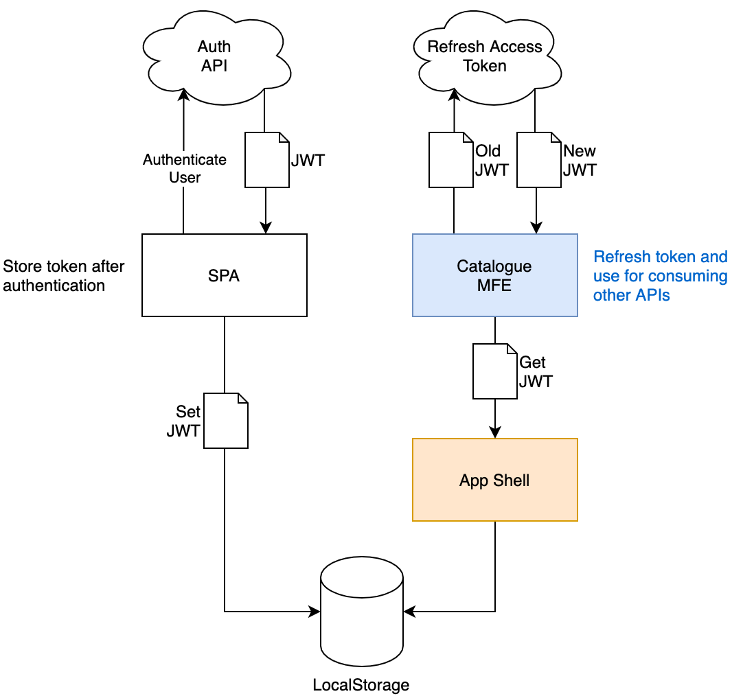

Due to the local storage security model, the SPA, the application shell, and all the micro-frontends have to live in the same subdomain because the local storage is accessible only from the same subdomain. Therefore, the SPA will have to be moved from being served by an application server to the S3 bucket, where the new architecture will be served from.

Implementing Canary Releases

Another goal of this project is being able to release often in production and gather real data directly from the users. It’s a great target to aim for, but it’s not as easy to reach as we may think.

Based on its infrastructure for serving frontend artifacts, ACME decided to implement a canary release mechanism at the edge, so that it can extend the logic of its Lambda@Edge once the migration is completed, adding logic to manage the micro-frontend releases.

ACME will also need to modify the application shell to request specific micro-frontend versions and delegate retrieving the exact artifact version to the Lambda@Edge. The tech teams decided to identify every micro-frontend release using semantic versioning (semver), This allows them to create unique artifacts, appending the semver in the filename, and easily avoid caching problems when they release new versions.

Localization
The ACME application has to render in different languages based on the user’s country. By default the application will render in English, but the product team wants the user to be able to change the language in the application and have the choice persist for authenticated users inside their profiles settings, creating a seamless experience for the user across all their devices.
In this new architecture, ACME tech teams have to consider two forces:
- Every micro-frontend has a set of labels to display in the UI, some of which may overlap with other micro-frontends, such as common error messages.
- Every micro-frontend represents a business subdomain so the service has to return just enough labels to display for that specific subdomain and not much more, otherwise resources will be wasted.

There are still some key topics related to the human aspect that we must take into consideration when we introduce this architecture, just as we do whenever we revisit our architecture or introduce a new one.
When making significant changes to architecture, we need to think about how to organize the communication flows, how to avoid siloed groups, and how to empower the developers to make the right decisions inside a business domain.
These are just some of many important considerations related to the human side of the project we need to think about at the beginning and during the entire lifecycle.
Micro-frontends may help you mitigate some of these considerations but they can make others more complex if not approached properly. Therefore, it’s crucial for you to invest the time needed to analyze your current organization structure and see how it would fit inside your new architecture.

Micro-frontends are not a silver bullet, but they definitely bring several benefits to the table, such as team independency, riskless deployment, reduction of cognitive load for developers, fast iterations, and innovation.
Despite all of that, they also bring challenges, such as a risk of creating silos inside the organization, higher investment in automation pipelines, and risk of user interface discrepancies.
When you introduce the idea of micro-frontends to your organization, focus your presentation on not only the technical benefits but also the organizational benefits.
Let me provide some food for thought to help you prepare an impactful presentation for your stakeholders:
- Point out that micro-frontends allow faster feature iterations and reduce the risk of introducing bugs into the entire application.
- Research and describe the context you operate in daily and why micro-frontends may help you to achieve business goals.
- List the problems you are trying to solve with this paradigm.
- Ponder the best way to implement micro-frontends in your context.
- Analyze the impact this architecture may have on team communication.
- Identify the ideal governance for managing such an architecture.
- Retrieve metrics from your automation pipeline, like time to deployment and testing, and think how you would be able to improve them.
These are just some topics that are relevant to your organization’s tech leaders or clients.
Remember to present not just a technical solution, which can leave many organizational challenges to overcome. Instead, think about an end-to-end transformation that brings value to the company as well as to your customers.
To discover the best technical solution for your context, I strongly encourage you to first run a proof of concept (PoC) to understand better the challenges and benefits of this approach; what works for one team or organization doesn’t always work for another. Be mindful and share the insights that will work best for your organization with your peers and tech leaders.

