Functional Programming in JavaScript

Book: https://learning.oreilly.com/library/view/functional-programming-in/9781617292828/
Code Reources: https://github.com/luijar/functional-programming-js

Chapter 1. Becoming functional

Functional programming is declarative
Functional programming falls under the umbrella of declarative programming paradigms: it’s a paradigm that expresses a set of operations without revealing how they’re implemented or how data flows through them.
functional programs aim for statelessness and immutability as much as possible.

Pure functions and the problem with side effects
Functional programming is based on the premise that you build immutable programs based on the building blocks of pure functions. A pure function has the following qualities:
- It depends only on the input provided and not on any hidden or external state that may change during its evaluation or between calls.
- It doesn’t inflict changes beyond their scope, such as modifying a global object or a parameter passed by reference
- No side effects

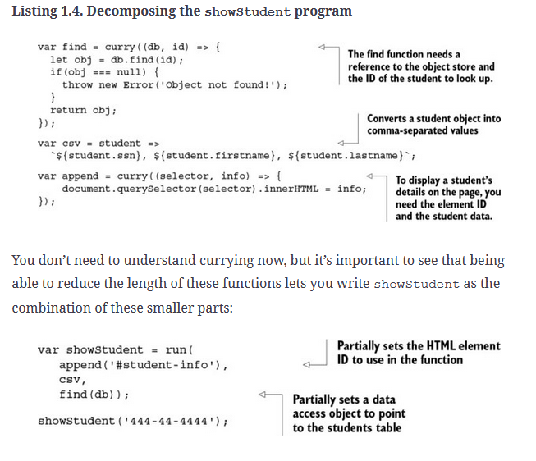
Stills improvments needs to be done : state and exceptions

Referential transparency and substitutability

if a function consistently yields the same result on the same input, it’s said to be referentially transparent.

Preserving immutable data

Immutable data is data that can’t be changed after it’s been created.
Functional programming refers to the declarative evaluation of pure functions to create immutable programs by avoiding externally observable side effects.

high level the benefits FP brings to your JavaScript applications. The following subsections explain how it can
- Encourage you to decompose tasks into simple functions
- Process data using fluent chains
- Decrease
- reactive paradigms

At a high level, functional programming is effectively the interplay between decomposition (breaking programs into small pieces) and composition (joining the pieces back together). It’s this duality that makes functional programs modular and so effective.

Modularization in FP is closely related to the singularity principle, which states that functions should have a single purpose; this was also evident in the code for average, shown earlier. Purity and referential transparency encourage you to think this way because in order to glue simple functions together, they must agree on the types of inputs and outputs. From referential transparency, you learn that a function’s complexity is sometimes directly related to the number of arguments it receives (this is merely a practical observation and not a formal concept indicating that the lower the number of function parameters, the simpler the function tends to be).
A chain is a sequential invocation of functions that share a common object return value. Like composition, this idiom allows you to write terse and concise code, and it’s typically used a lot in functional as well as reactive programming JavaScript libraries. you can use Lodash to stitch together functions representing these steps, forming a functional chain. A function chain is a lazy evaluated program, which means it defers its execution until needed.

Reactive programing is next thing after FP
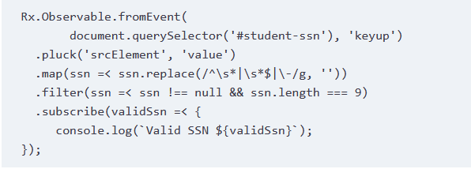
More info here: https://vincenttunru.com/Javascript-reactive-programming/

You can reduce the complexity of event-based programs by combining functional with reactive programming

Chapter 2. Higher-order JavaScript

Object-oriented applications, which are mostly imperative, rely heavily on object-based encapsulation to protect the integrity of their mutable state, both direct and inherited, in order to expose or manipulate that state via instance methods. As a result, there’s a tight coupling between an object’s data and its fine-grained behavior, forming a cohesive package; this is the goal in object-oriented programs and why the central form of abstraction is the object.

Alternatively, functional programming removes the need to hide data from the callers and typically works with a smaller set of very simple data types. Because everything is immutable, you’re free to work with objects directly, but this time through generalized functions that live outside of an object’s scope. In other words, data is loosely coupled to behavior. As you can see in figure 2.1, instead of fine-grained instance methods, functional code relies on more coarse-grained operations that can crosscut or work across many data types. In this paradigm, functions become the main form of abstraction.

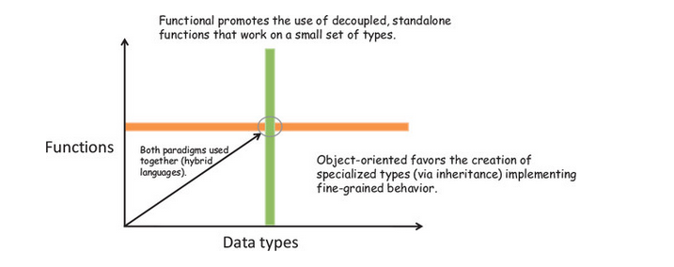
In practice, some of the best object-oriented code I’ve seen uses both paradigms together—at their intersection. To do this, you need to treat objects as immutable entities or values and separate their functionality into functions that work on these objects

The focus of OOP is to create inheritance hierarchies (such as Student from Parent) with methods and data tightly bound together. Functional programming, on the other hand, favors general polymorphic functions that crosscut different data types and avoid the use of this.

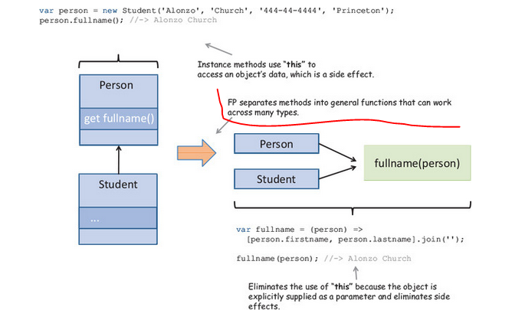

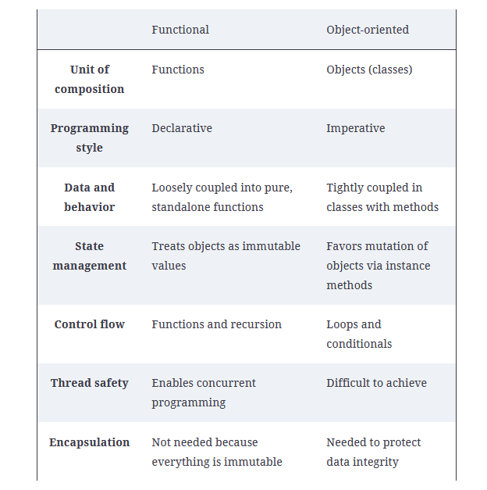

On the one hand, you get a rich domain model with natural relationships among its constituent types; and on the other, you have a set of pure functions that can work on these types.

Immutablility
strings ans numbers are primiteve dana types and uses the const keyword to create constant references
Use Value Object pattern

. A value object is one whose equality doesn’t depend on identity or reference, just on its value; once declared, its state may not change

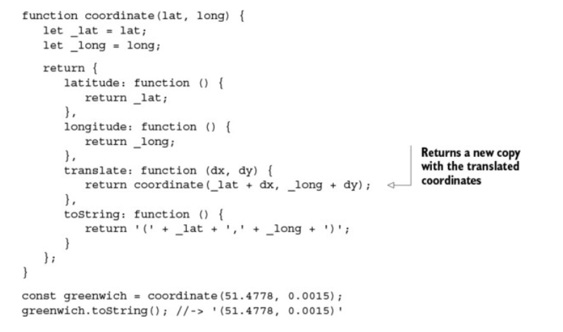
Use Object.freeze() (shallow operation. )

Best alternative is using a functional approach called lenses. . Lenses, also known as functional references, (Use Ramda.js )

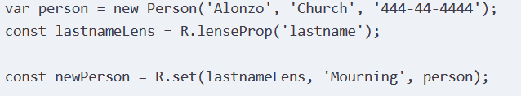

Functions
expressions (functions that produce a value) and statements (functions that don’t) FP is entirely expressional

In JavaScript, every function is an instance of the Function type. A function’s length property can be used to retrieve the number of formal parameters, and methods such as apply() and call() can be used to call functions with contexts

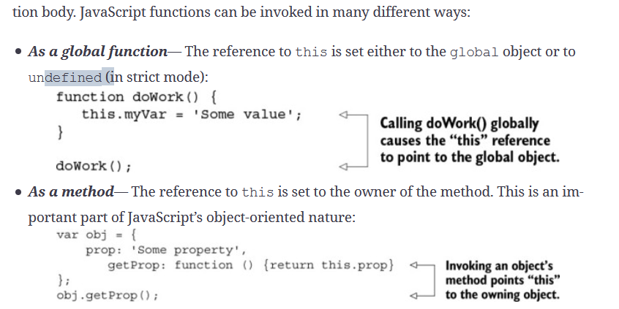
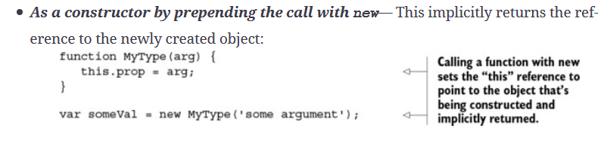
, the this reference is set based on how the function is used (globally, as an object method, as a constructor, and so on) and not by its lexical context (its location in the code). This can lead to code that’s hard to understand, because you need to pay close attention to the context in which a function is executing

Closures and scopes
A closure is a data structure that binds a function to its environment at the moment it’s declared. It’s based on the textual location of the function declaration; therefore, a closure is also called a static or lexical scope surrounding the function definition. Because it gives functions access to its surrounding state, it makes code clear and readable

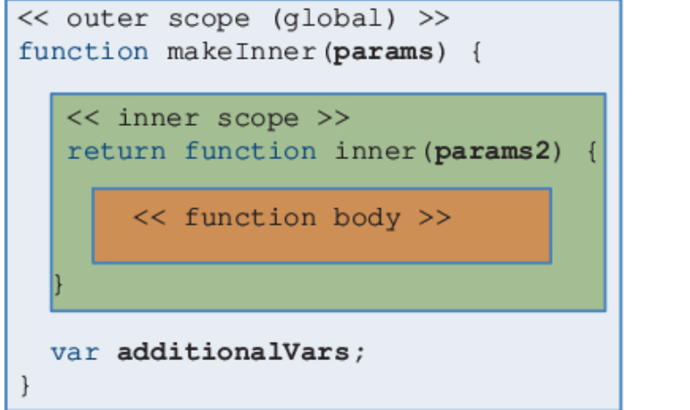
you need to understand that JavaScript has three forms of scoping: global scope, function scope, and a pseudo-block scope

Global scope is the simplest form of scoping, but also the worst. Any objects and variables declared in the outermost level of a script (not contained in any function) are part of the global scope and accessible from all JavaScript code

Any variables declared in a function are local to that function and not visible anywhere else. Also, when a function returns, any local variables declared in are deleted with it

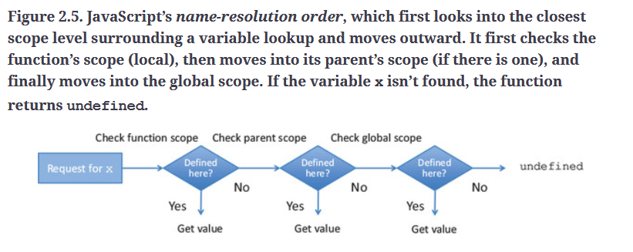

Unfortunately, standard ES5 JavaScript doesn’t support block-level scope, which is formed in brackets, {}, under control structures such as for, while, if, and switch statements. The exception is the error variable passed into a catch block. The with statement can do some level of block scope, but its use is discouraged and is removed in strict mode.

Closures have many practical applications that are important to apply when implementing large JavaScript programs. These aren’t specific to functional programming, but they do take advantage of JavaScript’s function mechanism:
- Emulating private variables (seen)
- Making asynchronous server-side calls
- Creating artificial block-scoped variables

As a general best practice, I recommend packaging all of your functional code inside well-encapsulated modules. You can transfer all the core principles of functional programming you’ve learned in this book to the level of modules. More info here http://www.adequatelygood.com/JavaScript-Module-Pattern-In-Depth.html

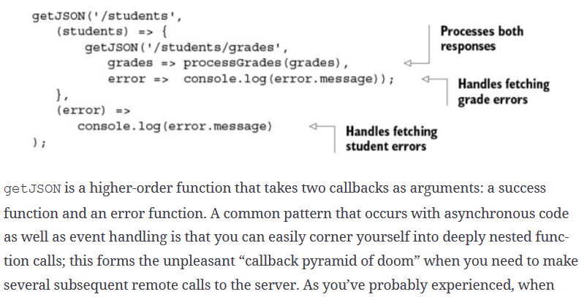

Secrets of the JavaScript Ninja, Second Edition by John Resig, Bear Bibeault, and Josip Maras (Manning, 2016, www.manning.com/books/secrets-of-the-javascript-ninja-second-edition).

Chapter 3. Few data structures, many operations

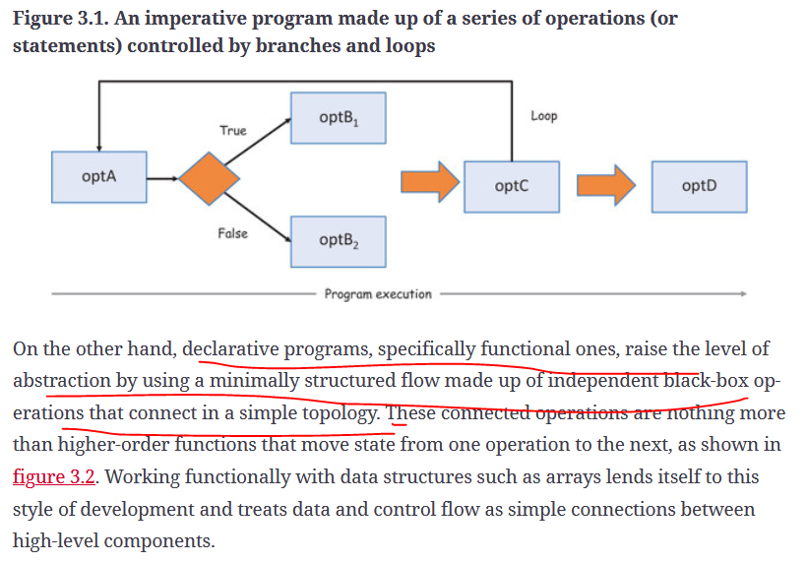

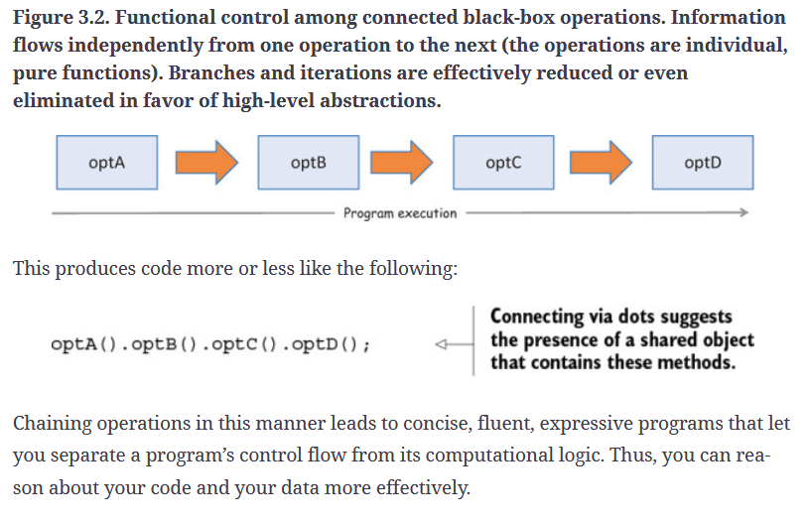
'Functional Programming'.substring(0, 10).toLowerCase() + ' is fun';

If you refactor the previous code into a more functional style, it looks like this:
concat(toLowerCase(substring('Functional Programming', 1, 10))),' is fun')

Function chaining

Functional programming takes a different approach. Instead of creating new data structure classes to meet specific needs, it uses common ones like arrays and applies a number of coarse-grained, higher-order operations that are agnostic to the underlying representation of the data. These operations are designed to do the following:

Accept function arguments in order to inject specialized behavior that solves your particular task
Replace the traditional, manual looping mechanisms that contain mutations of temporary variables and side effects, thereby creating less code to maintain and fewer places where errors can occur

A lot of functional JavaScript code is based on processing lists of data; hence, the name of the original functional language, LISP (list processing)

Functional programming’s declarative model treats programs as the evaluation of independent, pure functions, which support you in building the necessary abstractions to gain fluency and expressiveness in your code. Doing so, you can form an ontology or vocabulary that clearly expresses the intent of your application

The powerful effect of raising this level of abstraction is that you begin to think of operations as agnostic to the underlying data structures used. Theoretically speaking, whether you’re working with arrays, linked lists, binary trees, or otherwise, it shouldn’t change the semantic meaning of your program. For this reason, functional programming focuses on operations more than on the structure of the data.

On the other hand, the functional implementation merely connects black-box components together and cedes the responsibility to these well-established and tested APIs, as shown in the following listing. Notice how the cascade arrangement of function calls makes this code easier to read.

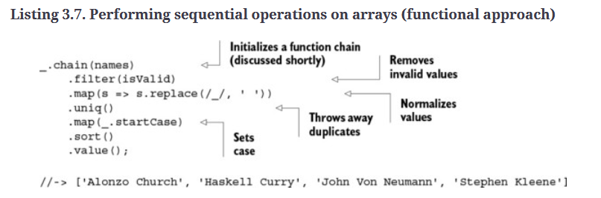
A mixin is an object that defines an abstract subset of functions relating to a particular type (in this case, a SQL command). This object isn’t concretely used in code, other than to extend the behavior of another object (it’s somewhat similar to a trait in other programming languages). The target object borrows all of functionality from the mixin I suggest reading https://javascriptweblog.wordpress.com/2011/05/31/a-fresh-look-at-javascript-mixins/.

ou should be convinced by now that functional programming can behave as a powerful abstraction over imperative code. What better way of processing and parsing your data than to use query language semantics? Like SQL, this JavaScript code models the data in the form of functions, also known as functions as data. Because it’s declarative, it describes what the data output is and not how it came to be. So far, I haven’t needed any conventional looping statements in this chapter—and I don’t intend to use them for the rest of the book. Instead, high-level abstractions replace looping.

Another technique commonly used to replace loops is recursion, which you can use to abstract iteration when tackling problems that are “self-similar” in nature. For these types of problems, sequential function chains are inefficient and inadequate. Recursion, on the other hand, implements its own ways of processing data by yielding the heavy lifting of standard looping to the language runtime. In JavaScript, recursion has many applications, such as parsing XML or HTML documents, graphs, and so on.

Back in the 1900s, the mathematics community behind functional programming (lambda calculus, category theory, and so on) was vibrant. Much of the work published was based on joint ideas and theorems by leading universities under the tutelage of professors like Alonzo Church. In fact, many mathematicians like Barkley Rosser, Alan Turing, and Stephen Kleene, among others, were doctoral students of Church’s.

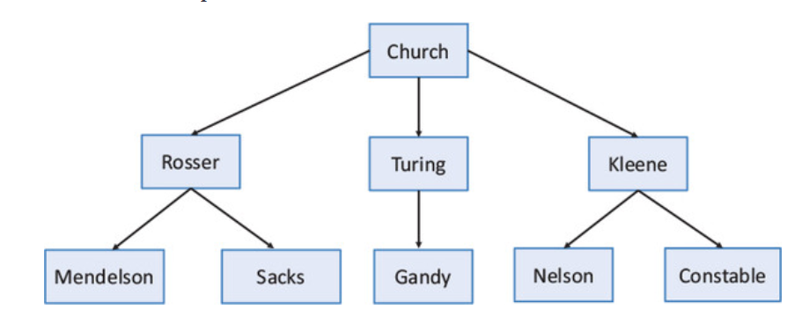

Back in the 1900s, the mathematics community behind functional programming (lambda calculus, category theory, and so on) was vibrant. Much of the work published was based on joint ideas and theorems by leading universities under the tutelage of professors like Alonzo Church. In fact, many mathematicians like Barkley Rosser, Alan Turing, and Stephen Kleene, among others, were doctoral students of Church’s.

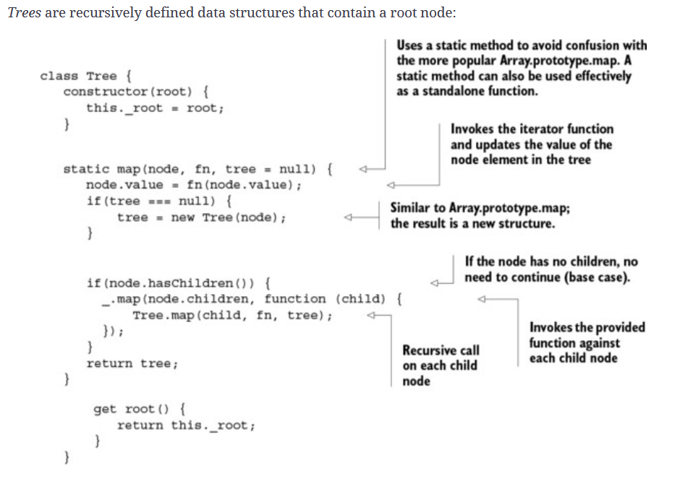

church.append(rosser).append(turing).append(kleene);
kleene.append(nelson).append(constable);
rosser.append(mendelson).append(sacks);
turing.append(gandy);
A preorder traversal of this tree has the following steps, starting with root:

1. Display the data part of the root element
2. Traverse the left subtree by recursively calling the preorder function
3. Traverse the right subtree the same way

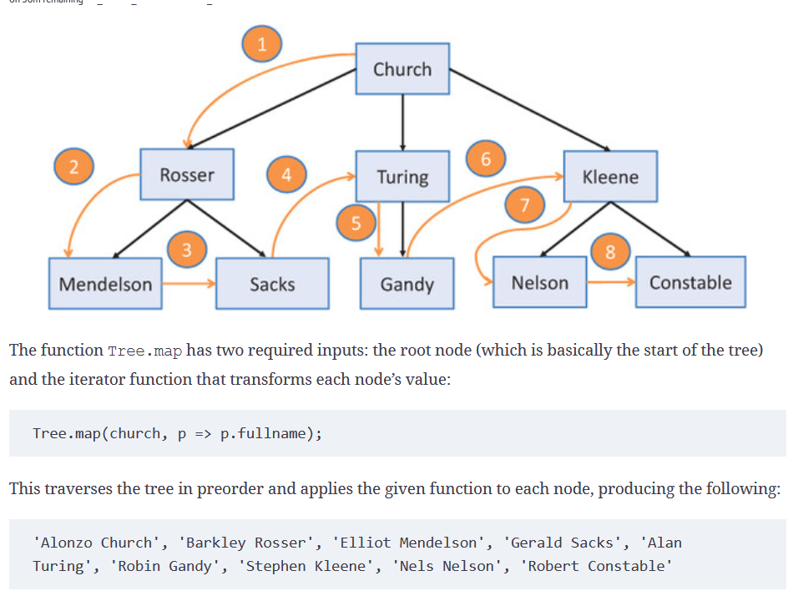

Lodash is a vehicle for data processing, creating programs via control chains where data flows and transformations are clearly
Functional programming’s declarative style creates code that’s easier to reason about.
Apping high-level abstractions to a SQL vocabulary reveals a deeper understanding of your data.
Recursion solves self-similar problems and is required to parse through recursively defined data structures.

Chapter 4. Modular and reusable code

Haskell notation for definig a function
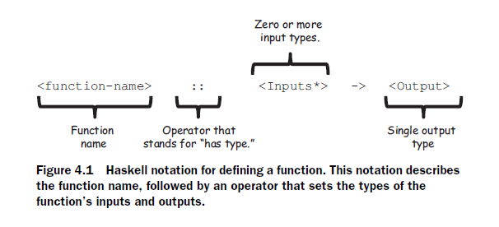
isEmpty :: String -> Boolean
Method chains vs functional pipline.
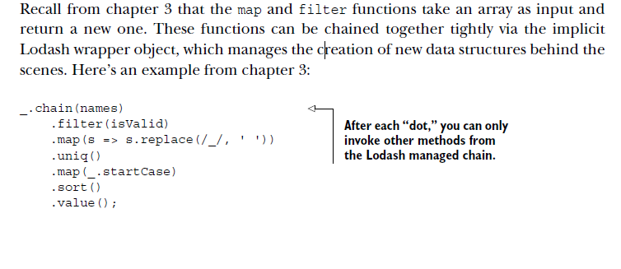
Functional programming removes the limitations present in method chaining and provides the flexibility to combine any set of functions, no matter where they come from. A pipeline is a directional sequence of functions loosely arranged so that the output of one is input into the next.

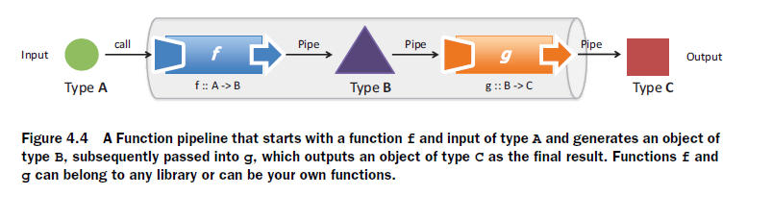
When designing function pipelines, it’s important that there exists a level of compatibility between what functions return and what they accept
The number of arguments a function declares is often directly proportional to its complexity.Our goal is to work with functions with as few arguments as possible.

Tuples are immutable structures that pack together items of different types so that they can be passed into other functions.

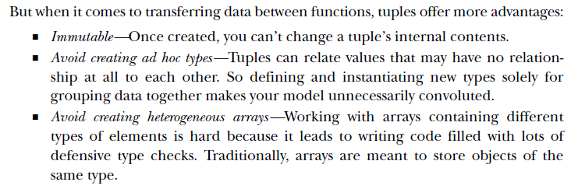
Crried function is one where all arguments have been explicitly defined so that, when called with a subset of the arguments, it returns a new function that waits for the rest of the parameters to be supplied before running

Currying is a technique that converts a multivariable function into a stepwise sequence of unary functions by suspending or “procrastinating” its execution until all arguments have been provided, which could happen later. Here’s the formal definition of a curry of three parameters:
curry(f) :: (a,b,c) -> f(a) -> f(b)-> f(c)
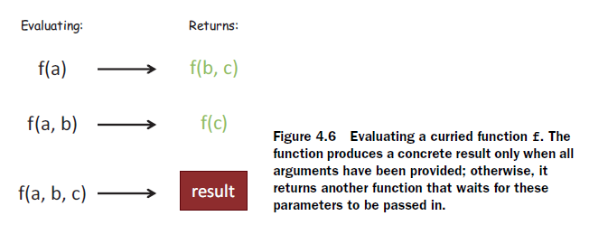
This formal notation suggests that curry is a mapping from functions to functions that deconstructs the input (a,b,c) into separate single-argument invocations.
Practical applications of currying. In particular, it can be used to implement popular design patterns:
■ Emulating function interfaces (constrct)
■ Implementing reusable, modular function templates

Emulating finction interface
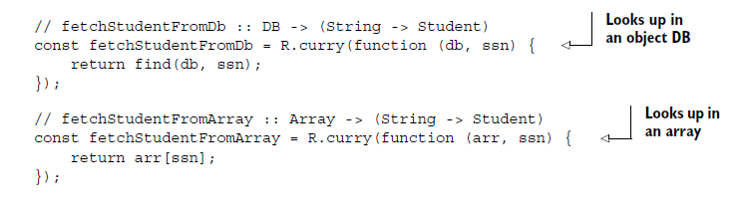
Because the functions are curried, you can separate the function definition from evaluation with a generic factory method findStudent, whose implementation details could have originated from either implementation:
const findStudent = useDb ? fetchStudentFromDb(db) : fetchStudentFromArray(arr);
findStudent('444-44-4444');

Reusable function templates
Function templates define a family of related functions based on the number of arguments that are
curried at the moment of creation.

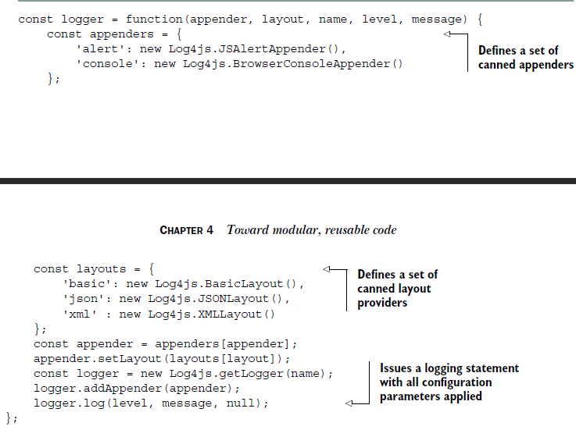

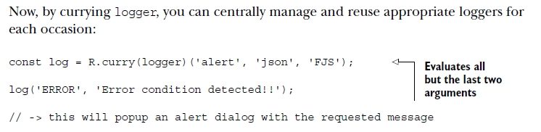
Behind the scenes, subsequent calls to curry are called on this function, finally yielding a unary function. The fact that you’re able to create new functions from existing ones and pass any number of parameters to them leads to easily building functions in steps as arguments are defined.

Partial application
Partial application is an operation that initializes a subset of a nonvariadic function’s parameters to fixed values, creating a function of smaller arity. In simpler terms, if you have a function with five parameters, and you supply three of the arguments, you end up with a function that expects the last two
Currying generates nested unary functions at each partial invocation. Internally, the final result is generated from the step-wise composition of these unary functions. Also, variations of curry allow you to partially evaluate a number of arguments; therefore, it gives you complete control over when and how evaluation takes place.
Partial application binds (assigns) a function’s arguments to predefined values and generates a new function of fewer arguments. The resulting function contains the fixed parameters in its closure and is completely evaluated on the subsequent call.

Currying is an automated way of using partial applications—this is its main difference from partial.

Composition
if a program is built from pure functions, the resulting program is itself pure, allowing it to be composed further as a part of even more-complex solutions without antagonizing other parts of the system
Beauty of function composition: separating a function’s description from its evaluation.

Because composition loosely binds type-compatible functions at their boundaries (inputs and outputs), it fairly satisfies the principle of programming to interfaces. In the previous example, you have a function explode ::
String -> [String] composed with the function count :: [String] -> Number; in other words, each function only knows or cares about the next function’s interface

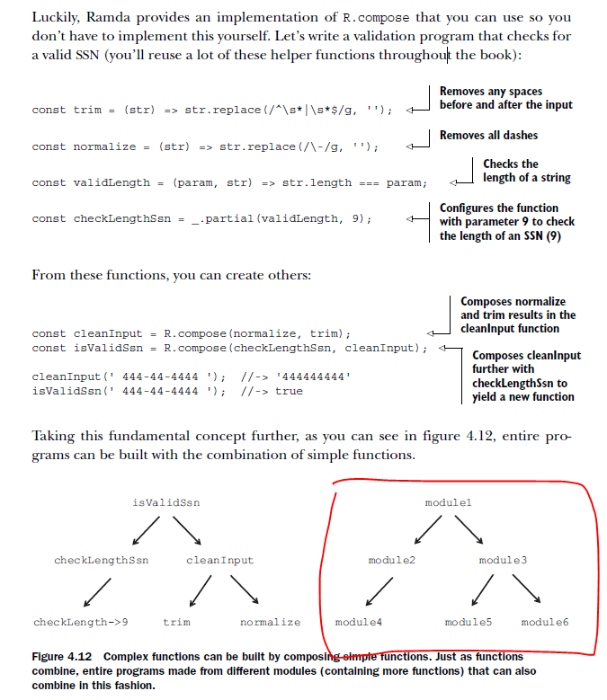

Entire programs can be built from the combination of other side effect–free, pure programs or modules.

Impure code problem (IO operations)
You must tolerate pure and impure behavior by creating a clear separation between the two and isolating the impurity as much as possible—ideally, in single functions. Then composition can be used to glue the pure and impure pieces back together

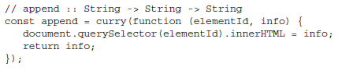
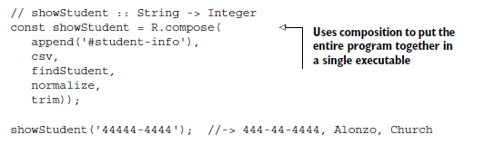
Using compose (or pipe) means never having to declare arguments (known as the points of a function), making your code declarative and more succinct or point-free.
It can be used to increase the level of abstraction by forcing you to think of composing high-level components instead of worrying about the lowlevel details of function evaluation. Currying plays an important role because it gives you the flexibility to partially define all but the last argument of an inlined function reference. This style of coding is also known as tacit programming
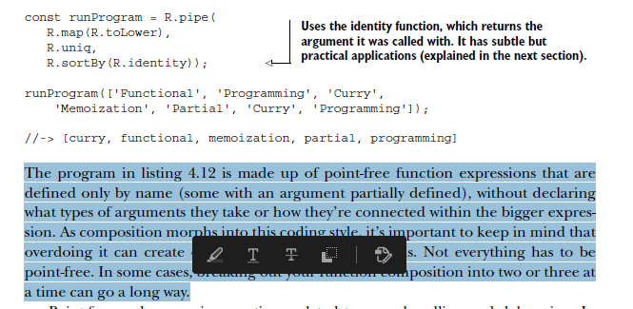
Control flow in functional way
Combinators are higher-order functions that can combine primitive artifacts like other functions (or other combinators) and behave as control logic. Combinators typically don’t declare any variables of their own or contain any business logic; they’re meant to orchestrate the flow of a functional program
there’s an infinite number of combinators, but we’ll look at some of the most
common ones:
■ identity
■ tap
■ alternation
■ sequence
■ fork (join)

The identity (I-combinator) combinator is a function that returns the same value it was provided as an argument:
identity :: (a) -> a

Tap (K-combinator)
tap is extremely useful to bridge void functions (such as logging or writing a file or an HTML page) into your composition without having to any create additional code. It does this by passing itself into a function and returning itself. Here’s the function signature:
tap :: (a -> *) -> a -> a

Alternation (OR-combinator)
The alt combinator allows you to perform simple conditional logic when providing default behavior in response to a function call. This combinator takes two functions and returns the result of the first one if the value is defined (not false, null, or undefined); otherwise, it returns the result of the second function. Let’s implement it here:
const alt = function (func1, func2) {
return function (val) {
return func1(val) || func2(val);
}
};
Alternatively, you could also write this function succinctly using curry and lambdas:
const alt = R.curry((func1, func2, val) => func1(val) || func2(val));

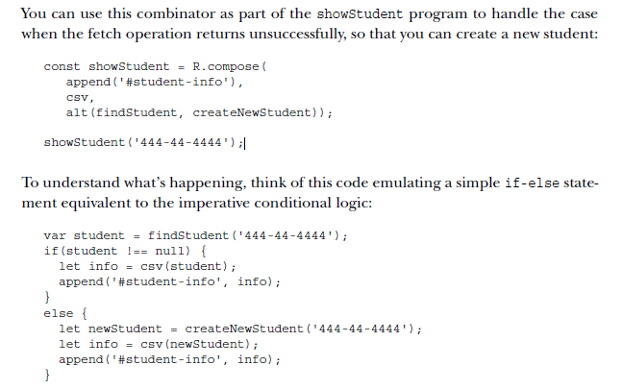
Sequence (S-combinator)
The seq combinator is used to loop over a sequence of functions. It takes two or more functions as parameters and returns a new function, which runs all of them in
sequence against the same value.

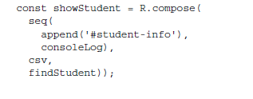
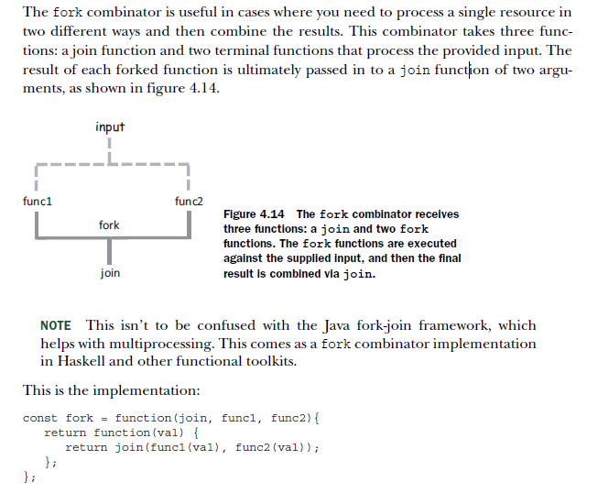
Fork (join)combinator

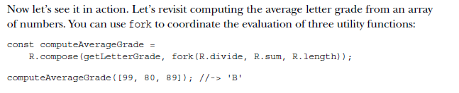
CH05 Design patterns against complexity

We need to work smarter, not harder.
functors as a means to create simple data types on which functions can be mapped
A functor is applied to data types called monads that contain specific behavior

Functional error handling is a radically different approach to properly cope with the adversities found in software systems. The idea, however, is somewhat similar: create a safety box (a container, if you will) around potentially hazardous code
Funtors
Containerizing (or wrapping) values is a fundamental design pattern in functional programming because it guards direct access to the values so they can be manipulated safely and immutably in your programs. It’s like wearing armor before going to battle

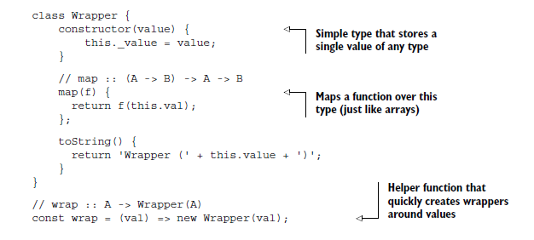

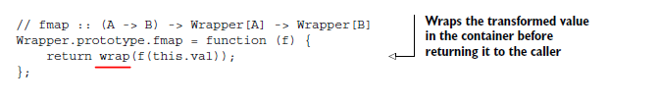
Consider this slightly different variation of map, called fmap: (This type of function is known as a functor)
In essence, a functor is nothing more than a data structure that you can map functions over with the purpose of lifting values into a wrapper, modifying them, and then putting them back into a wrapper. It’s a design pattern that defines semantics for how fmap should work. Here’s the general definition of fmap:
fmap :: (A -> B) -> Wrapper(A) -> Wrapper(B)

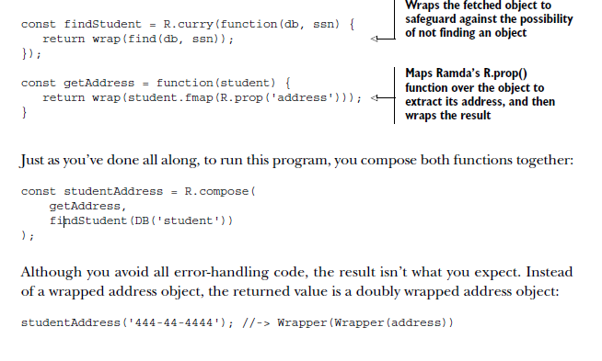
In order to extract this value, you have to apply R.identity twice:
studentAddress('444-44-4444').map(R.identity).map(R.identity);

Monads
Monads are similar to functors, except that they can delegate to special logic when handling certain cases (Special case: Either, Empty, Maybe, IO..)
A monad exists when you create a whole data type around this idea of lifting values inside containers and defining the rules of containment. Like functors, it’s a design pattern used to describe computations as a sequence of steps without having any knowledge of the value they’re operating on. Functors allow you to protect values, but when used with composition, monads are what let you manage data flow in a safe and side effect–free manner.
You need to understand these two important concepts:
- Monad—Provides the abstract interface for monadic operations
- Monadic type—A particular concrete implementation of this interface
Monadic types share a lot of the same principles as the Wrapper object you learned about at the beginning of the chapter. But every monad is different and, depending on its purpose, can define different semantics driving its behavior (that is, for how mapor fmap should work).

These types define what it means to chain operations or nest functions of that type together, yet all must abide by the following interface:
- Type constructor—Creates monadic types (similar to the Wrapper constructor).
- Unit function—Inserts a value of a certain type into a monadic structure (similar
to the wrap and empty functions you saw earlier). When implemented in the
monad, though, this function is called of.
- Bind function—Chains operations together (this is a functor’s fmap, also known as
flatMap). From here on, I’ll use the name map, for short. By the way, this bind
function has nothing to do with the function-binding concept of chapter 4.
- Join operation—Flattens layers of monadic structures into one. This is especially
important when you’re composing multiple monad-returning functions.

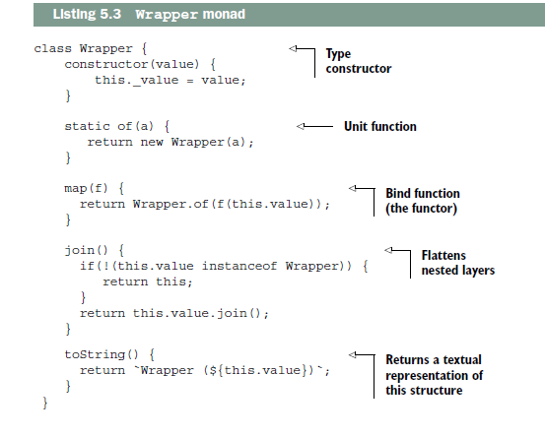

Because the composition in listing 5.4 returns a set of nested wrappers, the join operation
is used to flatten out the structure into a single layer

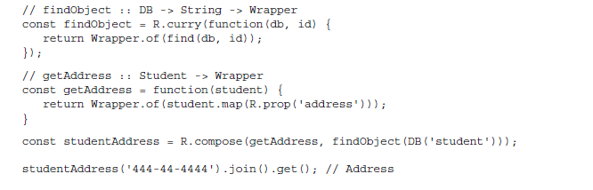
Monads typically have many more operations that support their specific behavior, and this minimal interface is merely a subset of its entire API. A monad itself, though, is abstract and lacks any real meaning. Only when implemented as a concrete type does its power begins to shine.

Maybe monad.
The Maybe monad focuses on effectively consolidating null-check logic. Maybe is an empty type (a marker type) with two concrete subtypes:
- Just(value)—Represents a container that wraps a defined value.
- Nothing()—Represents either a container that has no value or a failure that
needs no additional information. In the case of a Nothing, you can still apply
functions over its (in this case, nonexistent) value.
These subtypes implement all the monadic properties you saw earlier, as well as some additional behavior unique to their purpose. Here’s an implementation of Maybe.
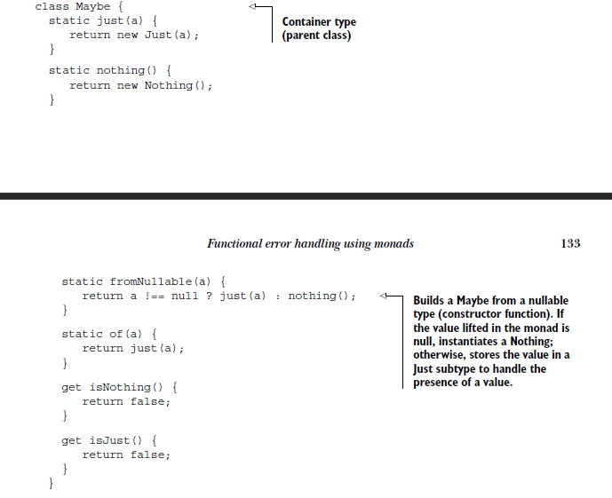
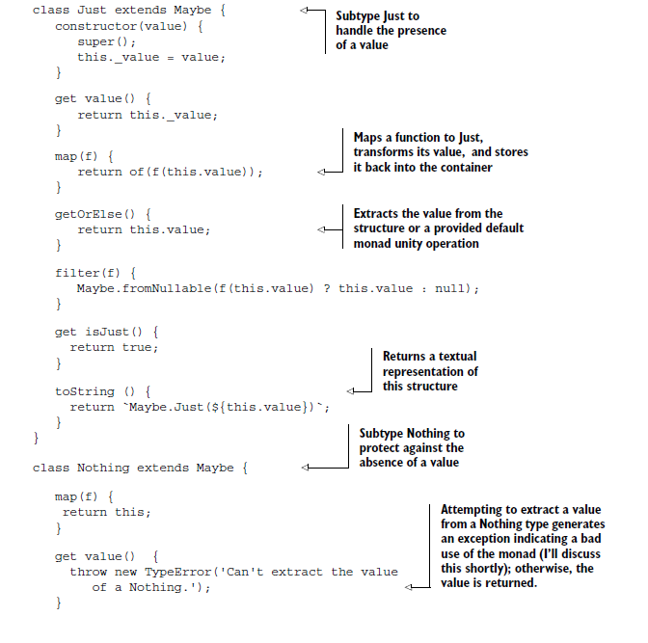
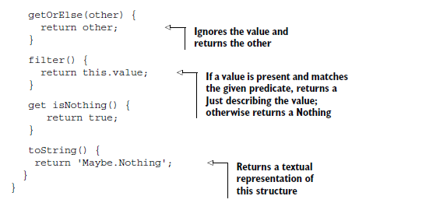
Maybe explicitly abstracts working with “nullable” values (null and undefined) so you’re free to worry about more important things. As you can see, Maybe is basically an abstract umbrella object for the concrete monadic structures Just and Nothing, each containing its own implementations of the monadic properties

// safeFindObject :: DB -> String -> Maybe
const safeFindObject = R.curry(function(db, id) {
return Maybe.fromNullable(find(db, id));
});

// safeFindStudent :: String -> Maybe(Student)
const safeFindStudent = safeFindObject(DB('student'));
const address = safeFindStudent('444-44-4444').map(R.prop('address'));
address; //-> Just(Address(...)) or Nothing

Another useful operation of Maybe is getOrElse as an alternative to returning default values.
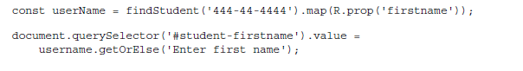
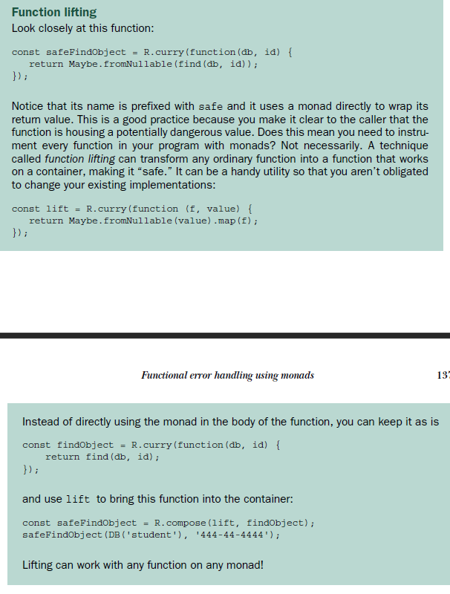

Either
Either is a structure that represents a logical separation between two values a and b that would never occur at the same time. This type models two cases:
- Left(a)—Contains a possible error message or throwable exception object
- Right(b)—Contains a successful value
Either is typically implemented with a bias on the right operand, which means mapping a function over a container is always performed on the Right(b) subtype

A common use of Either is to hold the results of a computation that may fail to provide additional information as to what the failure is. In unrecoverable cases, the left can contain the proper exception object to throw. The following listing shows the implementation of the Either monad.

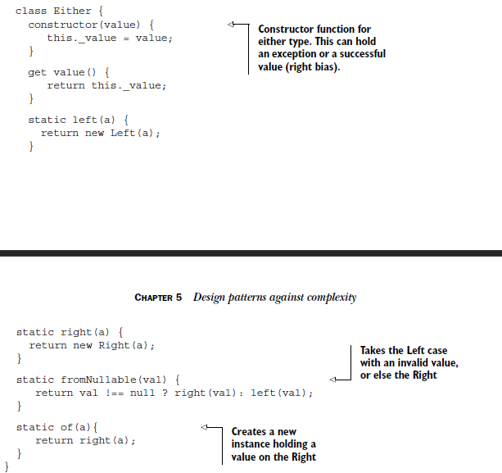

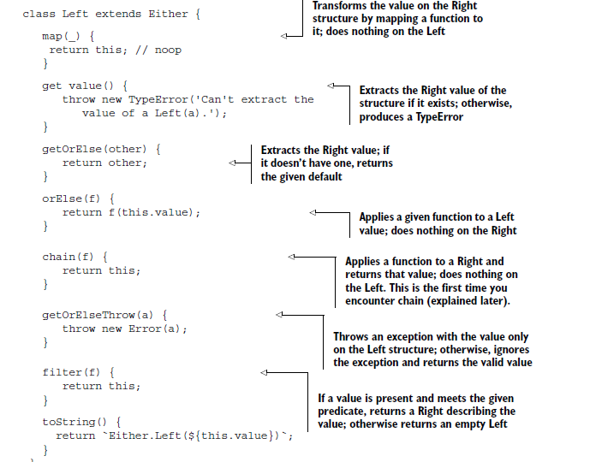
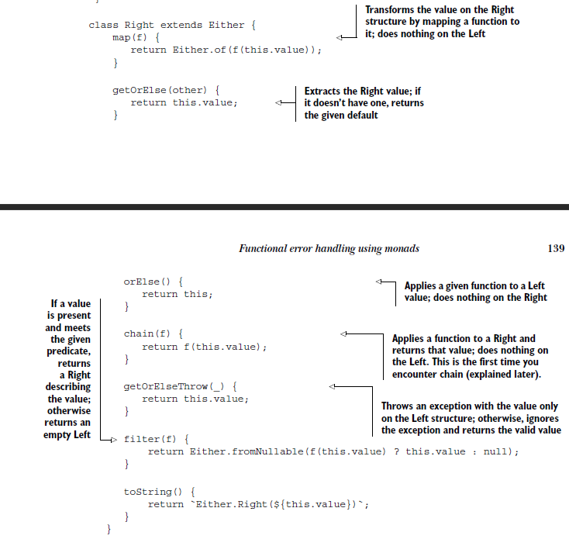
Notice in both the Maybe and Either types that some operations are empty (no-op). These are deliberate and are meant to act as placeholders that allow functions to safely skip execution when the specific monad deems appropriate

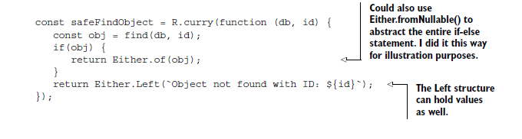
Tuples represent what’s known as a product type, which implies a logical AND relationship among its operands. In the case of error handling, it’s more appropriate to use mutually exclusive types to model the case of a value either existing OR not

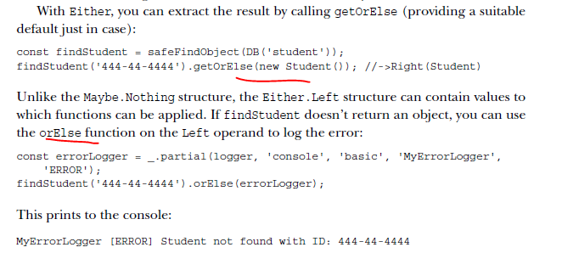
IO monad (external resources)
You can’t avoid mutations or fix the problem with side effects, but you can at least work with IO operations as if they were immutable from the application point of view.

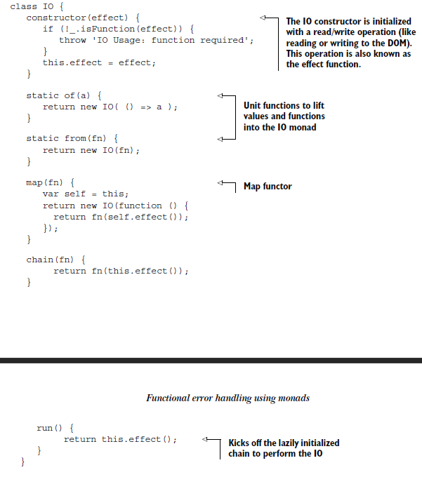
because it wraps an effect function instead of a value; remember, a function can be thought of as a lazy value, if you will, waiting to be computed. With this monad, you can chain together any DOM operations to be executed in a single “pseudo” referentially transparent operation and ensure that side effect–causing functions don’t run out of order or between calls.
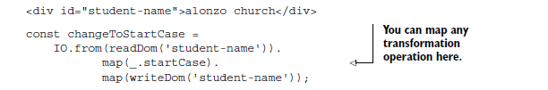
Finally, let’s run this code: changeToStartCase.run();
The most important benefit of the IO monad is that it clearly separates the pure and impure parts.
the transformation functions that map over the IO container are completely isolated from the logic of reading and writing to the DOM. You can transform the contents of the HTML element as needed. Also, because it all executes in one shot, you guarantee that nothing else will happen between the read and write operations, which can lead to unpredictable results.

Monad chaning
As you can see, monads bring the world of side effects under control, so you can use them in composable structures
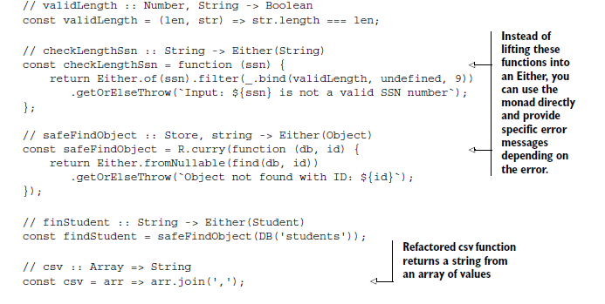
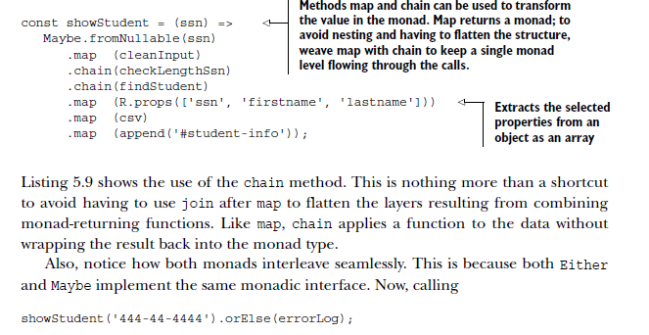
Monad compose
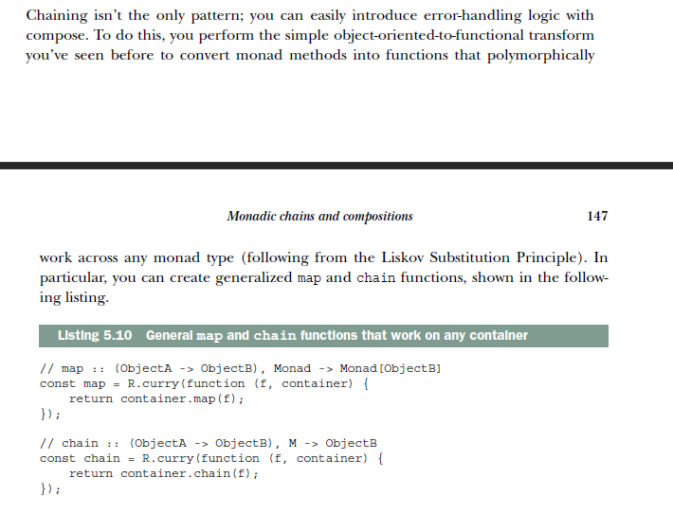
You can use these functions to inject monads into a compose expression.
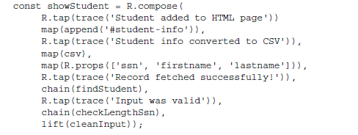
From the discussion of the IO monad, now you know you can improve the code that deals with DOM reads and writes:
map(append('#student-info')),
Because append has automatic currying, it’ll work well with IO. All you need to do at this point is lift the value from csv, extract its content by mapping the R.identity function into IO using IO.of, and then proceed with chaining both operations:
const liftIO = function (val) { return IO.of(val); };

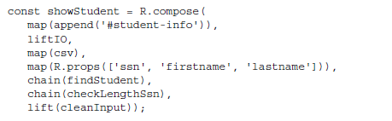
Because you’ve lifted the data into an IO monad, you need to call its run function for the data that’s lazily contained within it (in its closure) to be flushed out to the screen:
showStudent(studentId).run();
A common pattern that occurs with IO is to tuck the impure operation toward the end of the composition. This lets you build programs one step at a time, perform all the necessary business logic, and finally deliver the data on a silver platter for the IO monad to finish the job, declaratively and side effect–free.

More on monad: https://en.wikipedia.org/wiki/Monad_(functional_programming)

CH 06 Bulletproofing your code
stao

CH08 Managing asynchronus events and dana

The goal is to use functional programming in conjunction with ES6 promises, as well as introduce reactive programming, both of which are used to turn messy callback code into elegant, fluent expressions.

Temporal coupling or temporal cohesion occurs when the execution of certain functions is logically grouped together. This is done when functions need to wait for data to be available or need to wait for other functions to run

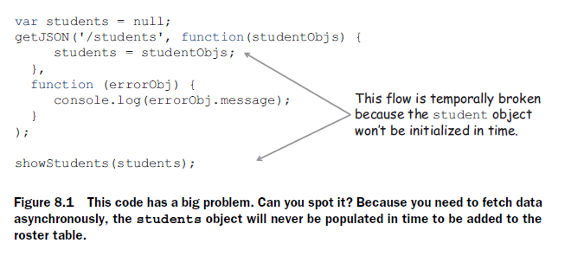
The main use of callbacks is to avoid blocking the UI to wait for long-running processes to complete. Functions that accept a callback instead of returning values implement a form of inversion of control: “Don’t call me, I’ll call you.”

As you can see, nesting a sequence of callbacks quickly makes the code resemble a horizontal pyramid like the one shown in figure 8.2. This is known casually as “callback hell” or the “Christmas tree of doom,” characteristic of programs dealing with lots of asynchronous code and user/DOM behavior

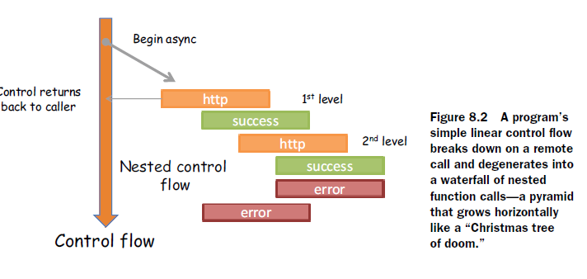

As with any functional program, you also seek other qualities like these
- Using composition and point-free programming
- Flattening the nested structure into a more linear flow
- Abstracting the notion of temporal coupling so that you don’t need to be concerned
with it
- Consolidating error handling to a single function rather than multiple error
callbacks so that it’s not in the way of the code

Soltion is Promise monad
Promise.of(<long computation>).map(fun1).map(fun2);//-> Promise(result)

Unlike the other monads you learned about in this book, promises know to “wait” for the long-running computation to complete before the mapped functions are run. Promise can be used to convert a series of nested callback functions into a sequence of actions, similar to a monad’s map functor.

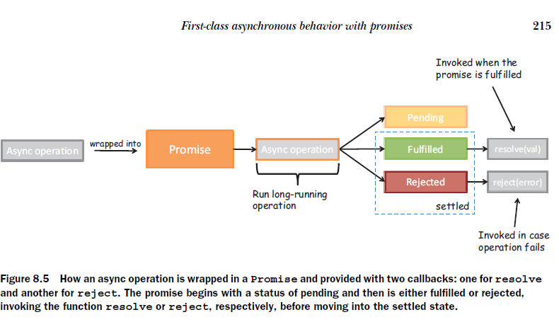

The Promise object defines a then method (analogous to a functor’s fmap), which applies an operation on a value returned in a promise and closes it back into a Promise. Similar to Maybe.map(f), Promise.then(f) can be used for chaining data transformations as well as joining functions in time, abstracting the use of temporal coupling among your functions. With this, you can chain multiple levels of dependent asynchronous behavior linearly without creating new nested levels, as seen in figure 8.6.

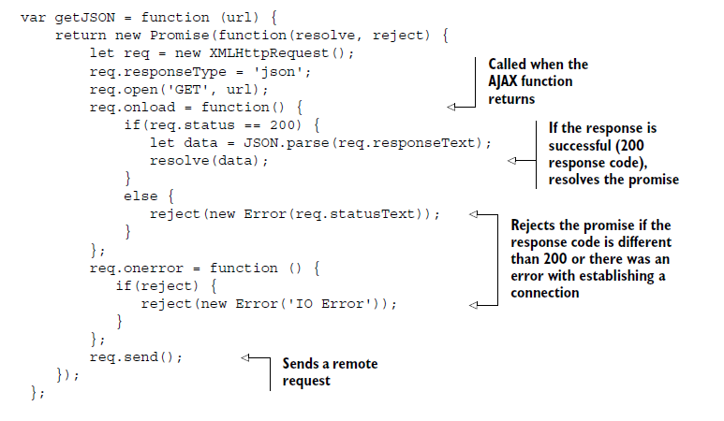

The functional on image bellow makes the following changes:
- Instead of nesting asynchronous calls, chain them together using then and use
the Promise monad to abstract out asynchronous parts of the code.
- Remove all variable declarations and mutations in favor of lambda functions.
- Take advantage of Ramda’s curried functions to create succinct data-transformation
steps like sorting, filtering, and mapping.
- Consolidate error-handling logic into a final catchall function.
- Lift the data into an IO monad to write data to the DOM in a side effect–free manner.

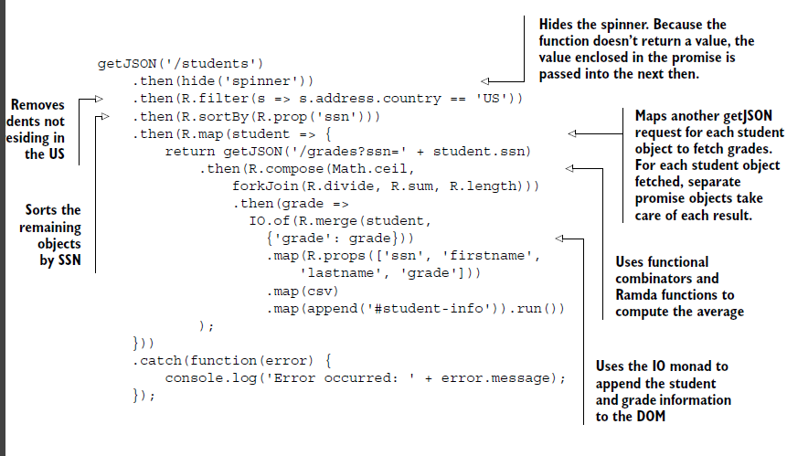

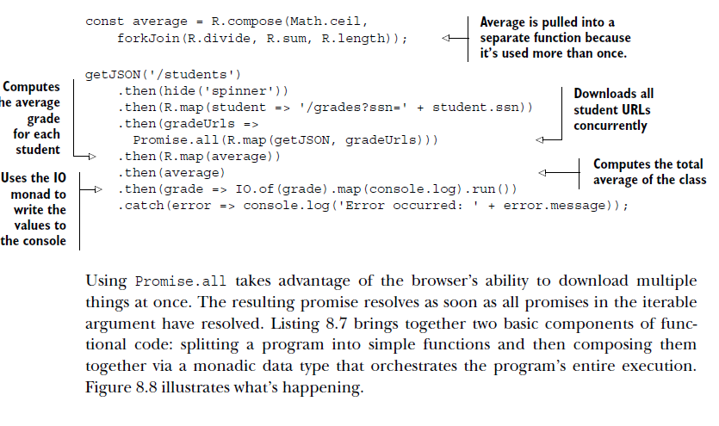
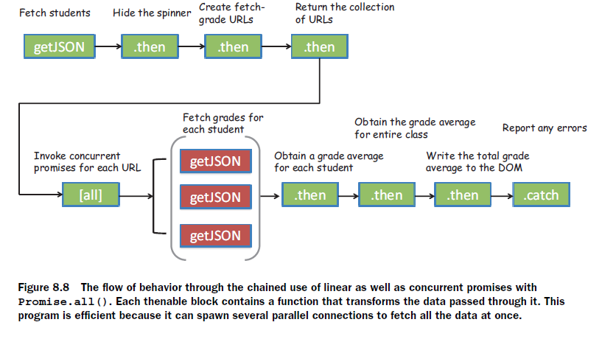

Composing asy and syc code

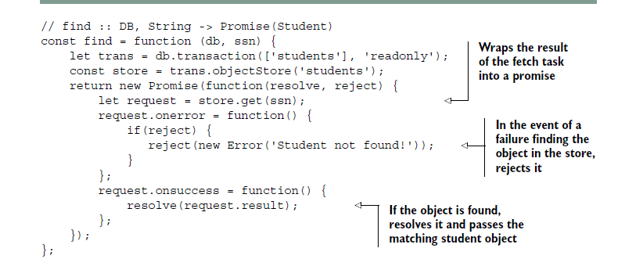

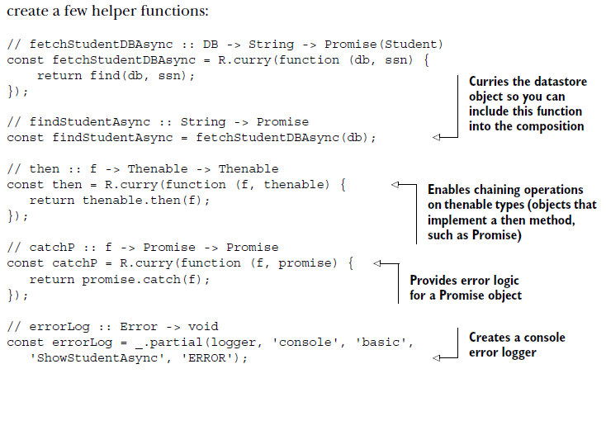

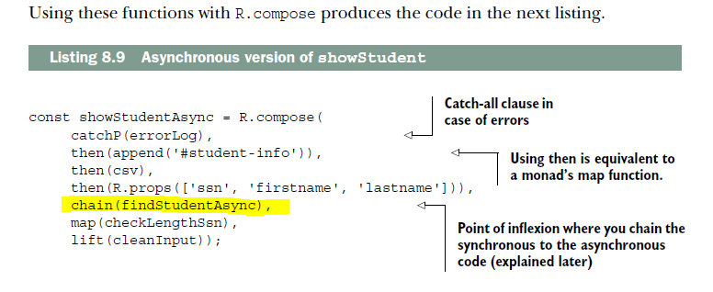

Here you can really see the power of composition with promises. As figure 8.9 shows, when findStudentAsync runs, the entire program waits for the asynchronous function to return to the caller with data, in order to proceed to execute the rest of the functions. The promise in this case acts as a gateway into the asynchronous part. It’s also declarative in that nothing in this program reveals the internal behavior of the
asynchronous nature of the function or that callbacks are being used. Thus, compose can still be used to orchestrate point-free programs that glue together functions that won’t execute at the same time, but rather in the future, showing its true color as a functional combinator.

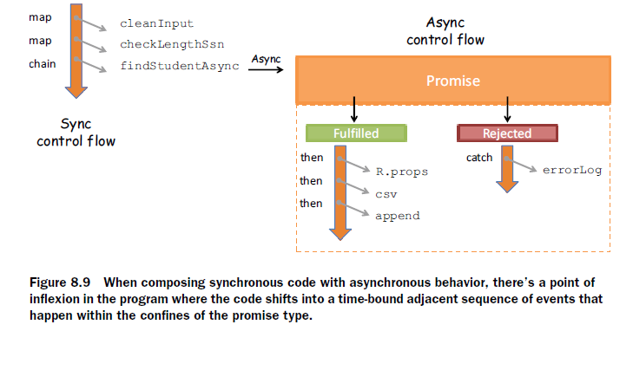
Reactive Extensions for JavaScript (RxJs)

An observable is any data object that you can subscribe to. Applications can subscribe to asynchronous events emitted from reading a file, a web service call, querying a database, pushing system notifications, handling user input, traversing a collection of elements, or even parsing a simple string. Reactive programming unifies all of these dana providers into a single concept called an observable stream, using the Rx.Observable. object. A stream is a sequence of ordered events happening over time. To extract its value, you must subscribe to it.

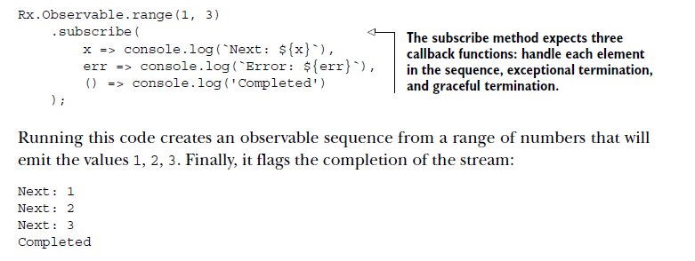

The Rx.Observable object unites the world of functional and reactive programming. It implements the equivalent of the minimal monadic interface you learned about in chapter 5 (map, of, and join) as well as many methods specific to stream manipulation. Here’s a quick example:

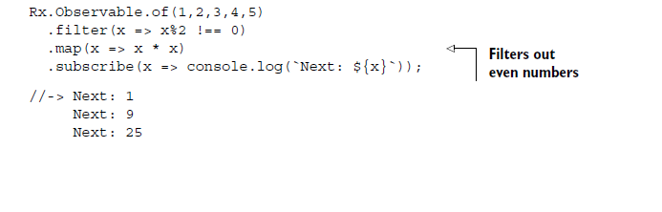

Streams bring declarativeness and chained computations into your code. Hence, reactive programming tends to resemble functional programming, giving rise to the term functional reactive programming (FRP).
Reactive programming is really functional programming applied to asynchronous and event-based problems

The same way promises solved the impedance mismatch between functional and asynchronous functions, you need the layer of abstraction provided by Rx.Observable to bridge the world of events to the functional world. This example code that listens for change events fired over time as the user updates a student SSN input field can be modeled as a stream (see figure 8.13)

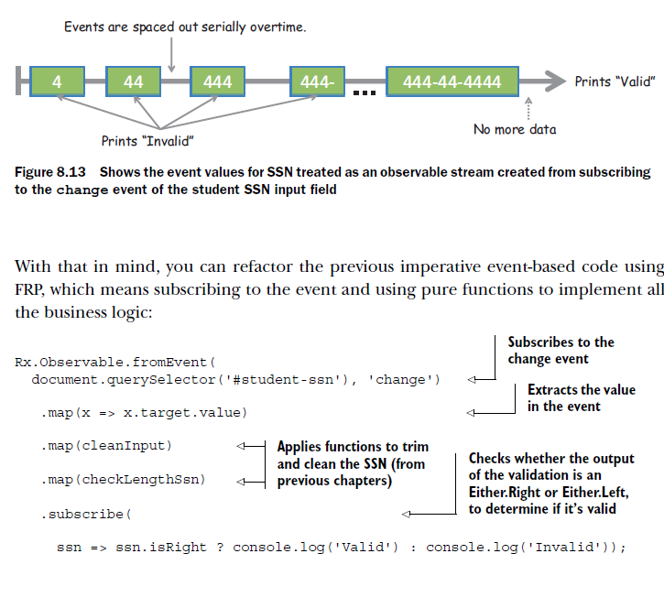

RxJS and promises

RxJS can convert any Promises/A+–compliant object into an observable sequence. This means you can wrap the long-running getJSON function so that, on resolution, its value will be converted into a stream. Consider the example of showing a sorted list of students who reside in the United States:



