Induction and Recursion as proof of algorithm corectens

In a proof by mathematical induction, we “start with a first step” and then prove that we can always go from one step to the next step. We can use this same idea to define a sequence as well. We can think of a sequence as an infinite list of numbers that are indexed by the natural numbers (or some infinite subset of N∪{0})
. We often write a sequence in the following form:
a1,a2,...,an,...
The number an
is called the nth term of the sequence. One way to define a sequence is to give a specific formula for the nth term of the sequence such as an=1n
.
Another way to define a sequence is to give a specific definition of the first term (or the first few terms) and then state, in general terms, how to determine an+1
in terms of n and the first n terms a1,a2,...,an. This process is known as definition by recursion and is also called a recursive definition. The specific definition of the first term is called the initial condition, and the general definition of an+1 in terms of n and the first n terms a1,a2,...,an is called the recurrence relation. (When more than one term is defined explicitly, we say that these are the initial conditions.)

from: https://math.libretexts.org/Bookshelves/Mathematical_Logic_and_Proof/Book%3A_Mathematical_Reasoning__Writing_and_Proof_(Sundstrom)/4%3A_Mathematical_Induction/4.3%3A_Induction_and_Recursion

The Fibonacci Numbers Example
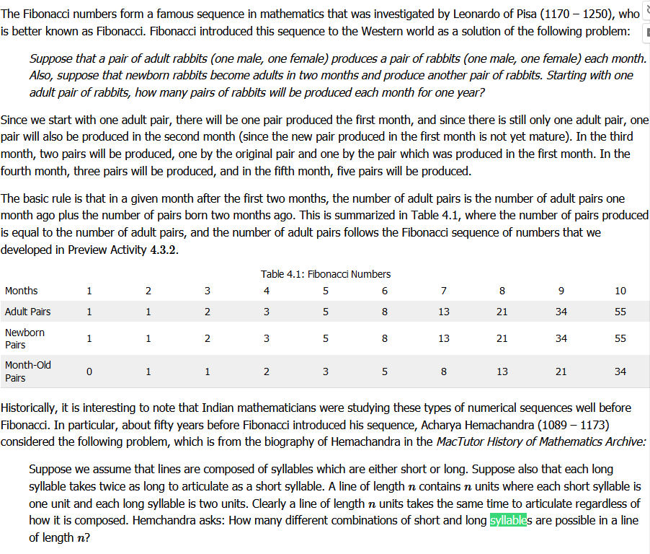

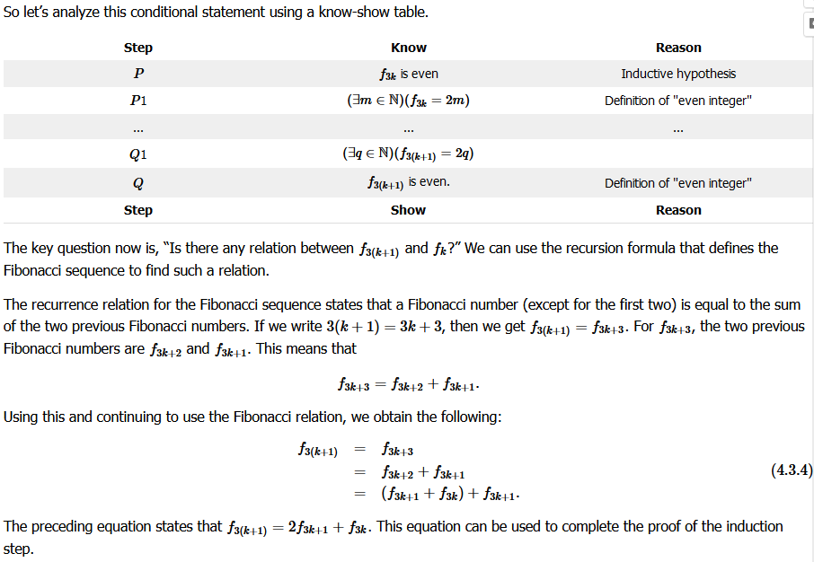

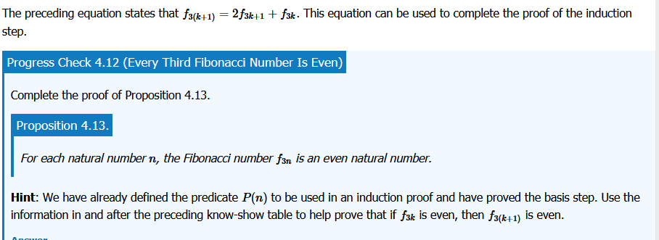

Geometric Sequences and Geometric Series

