Knapsack problem

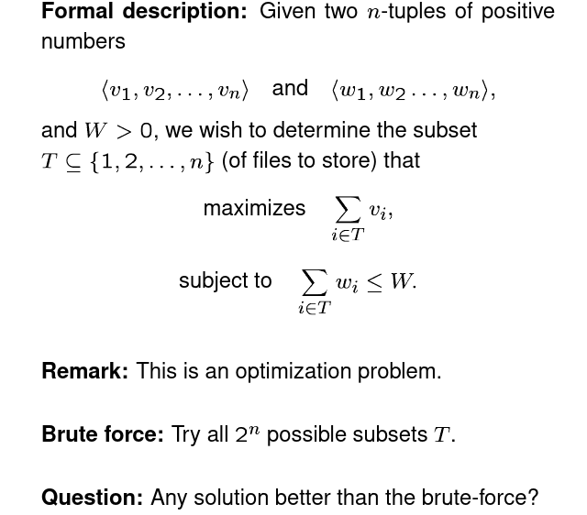

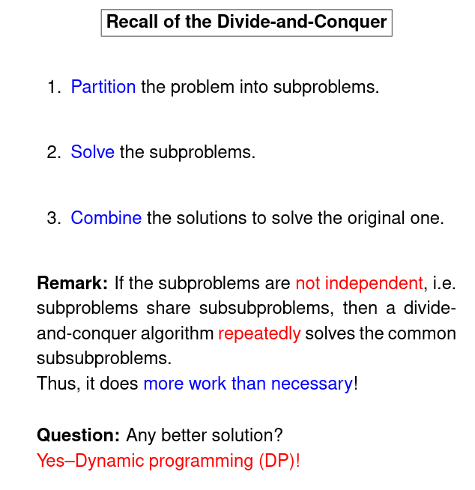

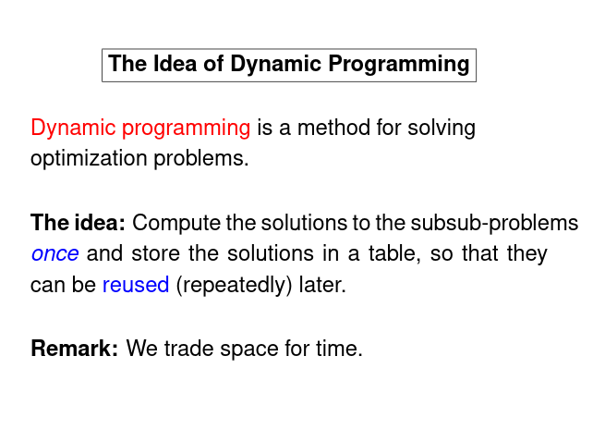

Step1:Structure:Characterize the structure of an optimal solution

Decompose the problem into smaller problems, and find a relation between the structure of the optimal solution of the original problem and the solutions of the smaller problems

Step2: Optimality: Recursively define the value of an optimal solution.

Express the solution of the original problem in terms of solutions for smaller problems.

Step 3: Bottom-up computation: Compute the value of an optimal solution in a bottom up fashion by using a table structure.

Step 4: Construction of optimal solution: Construct an optimal solution form computed information.

(Steps 3 and 4 may be combined)

