Competitive-programming-for-beginners

From: https://www.coursera.org/learn/competitive-programming-for-beginners/

Measure of run time
- a number of basic actions done by the program. Not good because of: Strong dependency on the input data, dependency on the compiler and the hardware
- use an upper bound of the number of actions (efficiency function) → unit is step in the program compare function by they ratio if change

Asymptotical complexity

Linear Algorithms
- works in all of n

Problem of maximum.
Find max number in the list

One for loop (it is n) O(n)

Problem of maximum
Find second max number in the list
Solution: find max number save it, go again if number is smaller than max number do check for max second number
One program two for loops that are not nested → O(n)
Be careful if program have to max number you need to check an the index of first max number

Sums on sub-segment

Partial sum technique. Solution can be found → O(1) Calculation O(n)
Save sum in list (first index sum of first number, second index sum from prevous + this)
the sub segment sum is = partialSum[endIndex] – partialSum[startIndex]

Binary Search – Logaritmic Algorithm
- works faster than linear → O (log n)
- assomption list is orderd asc

- go to middle of array then decide to go on lef or right side and go to midle of that side and so on.

There are specialized data structures designed for fast searching, such as hash tables, that can be searched more efficiently than binary search. However, binary search can be used to solve a wider range of problems, such as finding the next-smallest or next-largest element in the array relative to the target even if it is absent from the array.

More info here: https://en.wikipedia.org/wiki/Binary_search_algorithm

Task also: find an index of the first element which is not less then x (lower bound) Second: Find an index of the first element which is more than x (Upper bound)

Root search in the equation (apply Binary Search)

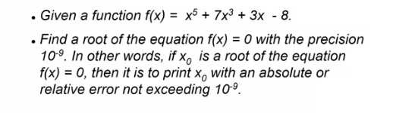

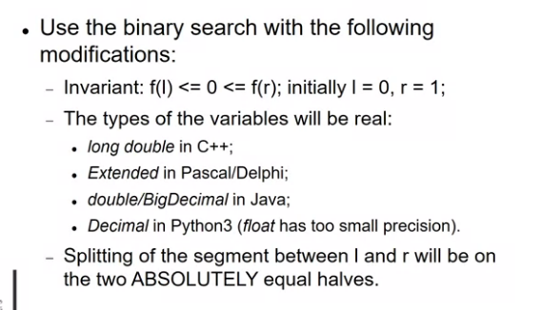

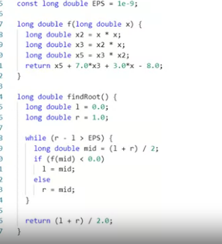

Binary search over answer
n diplomas exist, each has a width w and height h. Have board len x len need to hang all n diplomas on the board in way that: The board is hung “straight” all diplomas are hung vertically and inside board and no two diplomas overlap
maxnuber = (len/w) * (len/h)

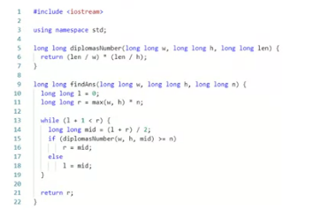

stao: https://www.coursera.org/learn/competitive-programming-for-beginners/lecture/M1SLi/integer-data-types-structure-sieve-of-eratosthenes

