Continoues Delivery in Java

CH01 Introduction

Continuous delivery (CD) is fundamentally a set of practices and disciplines in which software delivery teams produce valuable and robust software in short cycles.
New deployment fabrics and platforms have been created and have co-evolved alongside new methodologies like DevOps, Release Engineering, and Site Reliability Engineering (SRE)
The build pipline must provide:
-> Software compilation and code-quality static analysis
-> Functional testing, including unit, component, integration, and end-to-end
-> Provisioning of all environments, including the integration of logging, monitoring, and alerting hooks
-> Deployment of software artifacts to all environments, including production
-> Data store migrations
-> System testing, including nonfunctional requirements like fault tolerance, performance, and security
-> Tracking and auditing of change history
What shoud be done, domain analiza tehnike
-> The Lean Startup (Currency) by Eric Reis
-> Lean Enterprise (O’Reilly) by Jez Humble
-> User Story Mapping (O’Reilly) by Jeff Patton with Peter Economy
-> Context mapping, as detailed in Eric Evan’s Domain-Driven Design
-> Event Storming (Leanpub) by Alberto Brandolini
-> The Art of Business Value Mark Schwartz
Typical continuous delivery build pipeline for a Java-based application
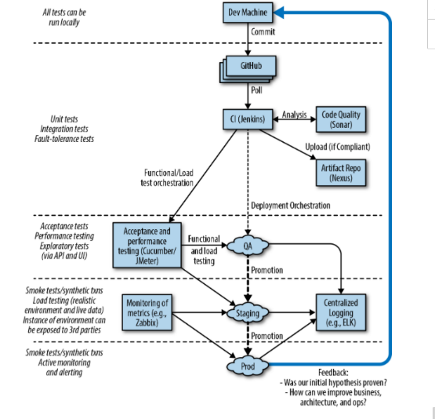
Initially, a developer or engineer makes a change on their local copy of the code. They may develop new functionality using practices such as behavior-driven development (BDD), test-driven development (TDD), and other extreme programming (XP) practices like pair programming.
Developers working locally typically commit their proposed code and configuration changes to a remotely hosted distributed version control system (DVCS) like Git or Mercurial.
and some form of code quality analysis should be applied, perhaps using tools like PMD, FindBugs, or SonarQube. A successful CI run results in the new artifact being stored within a centralized repository, such as Sonatype Nexus or JFrog Artifactory
A small number of automated end-to-end tests can be used to verify the core happy paths or user journeys within the application that are essential for the provision of business value. This is also the stage in which the system quality attributes (also referred to as nonfunctional requirements) are validated
testers or actual users start preforming exploratory testing. This manual testing should focus on the value of human cognition, and not simply consist of testers following large test scripts.
code that has been fully validated emerges from the pipeline and is marked as ready for deployment into production
Once code has been deployed to production, you should take care not to forget about observability—monitoring, logging, and alerting
Container Technology
-> Local development now typically requires the ability to provision a containerized environment
-> Packaging of the deployment artifact now focuses on the creation of a container image
-> The deployment environments now typically use another layer of abstraction for the dynamic orchestration and scheduling of containers
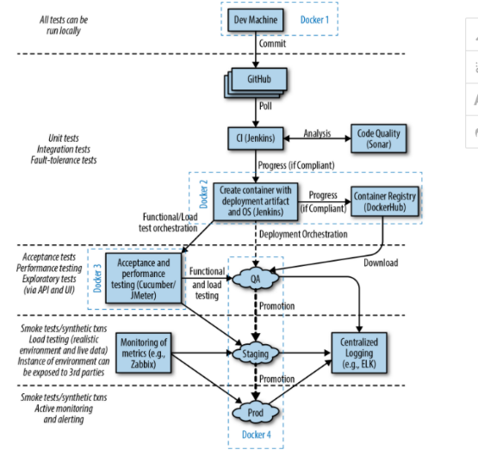

CH02 Evolution of Java Development

see: Innovative books including Java Power Tools (O’Reilly) by John Smart
emergence of popular movements such as Agile, Lean, DevOps, cloud computing, programmable infrastructure, microservices, and serverless or FaaS.
Developer role:
-> The Software Craftsman: Professionalism, Pragmatism, Pride (Prentice Hall) by Sandro Mancuso
->The Clean Coder: A Code of Conduct for Professional Programmers (Prentice Hall) by Robert C. Martin
-> The Passionate Programmer: Creating a Remarkable Career in Software Development (Pragmatic Bookshelf) by Chad Fowler
-> cloud architect at Netflix, Adrian Cockcroft
APIs are at the core of the internet and a modern developer’s daily life. APIs will continue to play a central role in trends like chatbots and virtual assistants, the Internet of Things (IoT), mobile services, and so much more.
That concepts such as the API marketplace and the API economy are becoming increasingly important within the global economy
Microservices:
-> Microservices for Java Developers (O’Reilly)
-> Sam Newman’s Building Microservices (O’Reilly)
-> Irakli Nadareishvili et al.’s Microservice Architecture (O’Reilly).
Building of Java-based microservices impacts the implementation of CD in several ways
-> Multiple build pipelines (or branches within a single pipeline) must be created and managed
-> Deployment of multiple services to an environment have to be orchestrated, managed, and tracked.
-> Component testing may have to mock, stub, or virtualize dependent services.
-> End-to-end testing must orchestrate multiple services (and associated state) before and after executing tests.
-> Process must be implemented to manage service version control (e.g., the enforcement of allowing the deployment of only compatible, interdependent services).
-> Monitoring, metrics, and application performance management (APM) tooling must be adapted to handle multiple services.
Java packaging
1. Jar: The native packaging format for Java is the Java Application Archive (JAR) file, which can contain library code or a runnable artifact.
2. WAR/EAR. initial best-practice approach to deploying Java Enterprise Edition (J2EE) applications was to package code into a series of JARs, often consisting of modules that contain Enterprise JavaBeans (EJB) class files and EJB deployment descriptors. These were further bundled up into another specific type of JAR with a defined directory and structure and required metadata file -> we then have WAR (servlet) or EAR (jar+ WAR). Then this is deployed to app server (WebLogic, WebSphere, or JBoss EAP) they had logging, persistence, transaction management, security.. also we have (Apache Tomcat, TomEE, and Red Hat’s Wildfly)
3. Fat jars
-> using lightweight and embedded application servers (n-memory Jetty web server and later editions of Tomcat)
-> Application frameworks such as DropWizard and Spring Boot soon began providing mechanisms through Maven and Gradle to package and embed these application servers into a single deployable unit that can run as a standalone process
-> The best practices for developing, deploying, and operating d by the team at Heroku as the Twelve-Factor App
4. Container Images
-> At the core of containers is Linux technologies like cgroups, namespaces, and a (pivot) root filesystem
-> n addition to packaging your Java application as a fat JAR, you must include an operating system (OS) within your container image
-> typically run on a container orchestration and scheduling platform like Kubernetes, Docker Swarm, or Amazon ECS
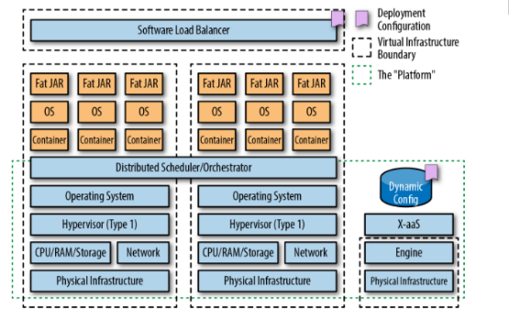
5. Function as a Service (serverless)
-> AWS Lambda, Azure Functions, Google Cloud Functions
-> platforms lets developers run code without provisioning or managing servers
-> FaaS, BaaS
DevOps, automating and monitoring the process of software integration, testing, deployment, and infrastructure changes, releasing software can happen rapidly, frequently, and more reliably.
-> The DevOps Handbook (IT Revolution Press) by Gene Kim
-> Lean Enterprise and Agile IT Organization Design
Site Reliability Engineering (SRE)
- responsible for availability, latency, performance, efficiency, change management, monitoring, emergency response, and capacity planning
- a key characteristic of SRE teams at Google is that each engineer should be doing only a maximum of 50% operations work, or “toil” as they refer to it, and the rest of their time should be spent designing and building systems and the supporting tooling
-> Site Reliability Engineering (O’Reilly) by Betsy Beyer, The Site Reliability Workbook: Practical Ways to Implement SRE (O’Reilly), Seeking SRE: Conversations About Running Production Systems at Scale (O’Reilly)
Release engineering is a relatively new and fast-growing discipline of software engineering that can be described as building and delivering software. Release engineers focus on building a continuous delivery pipeline and have expert understanding of source code management, compilers, automated build tools, package managers, installation, and configuration management.
Netflix, a rapidly growing, global video-streaming company, has presented at many conferences about the way it builds and operates software based on the concepts of freedom and responsibility.
Several luminaries within the Java space have been discussing the need for Java developers to broaden their skillset, and Ben Evan’s and Martijn Verburg’s The Well-Grounded Java Developer (Manning) is a good place to start.
Chapter 3. Designing Architecture for Continuous Delivery

see: The Software Engineering Institute (SEI) (https://www.sei.cmu.edu/research-capabilities/all-work/display.cfm?customel_datapageid_4050=21328)
read:
-> Building Evolutionary Architectures (O’Reilly) by Neal Ford
-> 97 Things Every Software Architect Should Know (O’Reilly)
-> Software Architecture for Developers (Leanpub) by Simon Brown
-> Just Enough Software Architecture (Marshall & Brainerd) by George Fairbanks
-> book
, Jez Humble, and Gene Kim
A loosely coupled system is one in which each of its components has, or makes use of, little or no knowledge of the definitions of other separate components.
Cohesion refers to the degree to which the elements within a component belong together, and can be thought of within programming as the measure of strength of the relationship between pieces of functionality within a given module or class.ž
see :
-> Building Maintainable Software, Java Edition (O’Reilly)
Test
-> unit, and integration test
-> Component test
-> End-to-end test
Api-driven applications
A good API is typically designed outside-in, as this is the best way to meet user requirements without overly exposing internal implementation details
DD technique named The Three Amigos
SEE s Cucumber Gherkin syntax acceptance test scripts; and an API specification, such as a Swagger or RAML file, which the test scripts will operate against
We also recommend that each service has basic (happy path) performance test scripts created (for example, using Gatling or JMeter) and security tests (for example, using bdd-security)
API contracts can be validated automatically, potentially using techniques like consumer contracts and consumer-driven contracts (e.g., Pact-JVM)
Dependent services that expose functionality through an API can be efficiently mocked (e.g., WireMock), stubbed (e.g., stubby4j), or virtualized (e.g., Hoverfly)
Easier access to metrics and monitoring data via internal resource endpoints (e.g., Codahale Metrics or Spring Boot Actuator)
SEE: Independent Systems Architecture Principles (https://isa-principles.org/). These are a collection of best practices based on experience with microservices and self-contained systems (SCS) some of the principles:
-> one codebase tracked in revision control, many deploys
-> explicitly declare and isolate dependencies (maven, gradle)
-> store config in the environment
-> treat backing services as attached resources
-> separate build and run stages
-> execute the app as one or more stateless processes
-> export services via port binding
-> keep development, staging, and production as similar as possible
-> treat logs as event streams
-> run admin/management tasks as one-off processes
see: Beyond the Twelve-Factor App (O’Reilly) and Michael Nygard’s Release It! (Pragmatic Bookshelf) and Eric Evans in this space was published in 2003 in Domain-Driven Design: Tackling Complexity in the Heart of Software and Microservices for Java Developers (O’Reilly) and in Microservice Architecture (O’Reilly) and Sam Newman’s Building Microservices (O’Reilly) and C4 model by Simon Brown, which he covers extensively in Software Architecture for Developers (Leanpub)

Chapter 4. Deployment Platforms, Infrastructure, and Continuous Delivery of Java Apps
Platform
-> physical or virtual location to host your application
-> java runtime
-> persistent storage
-> acess to muddleware (ejb, messaeg queues)
-> automated restar
-> service discovery
-> fundamental security
see: “Creating an Effective Developer Experience on Kubernetes”( https://www.slideshare.net/dbryant_uk/cncf-webinar-series-creating-an-effective-developer-experience-on-kubernetes)
Container Platform
container is an abstract concept of OS-level virtualization or process isolation, and Docker is an implementation of this technology by the company Docker, Inc
see: Docker Deep Dive by Nigel Poulton.
container provides OS-level virtualization, and although all of the running containers on a single machine share an OS kernel
Container scheduler/orchestrator - esponsible for starting, stopping, and managing the container processes, CIaaS
Storage -Storage for your application data , CIaaS component
Network - Connections, routers, firewalls..., CIaaS component
Services- like db, but these are typically fully managed services offered by the container platform
Continuous delivery services - Many container platform vendors provide a complete solution for taking code from a local development environment all the way through to production (Docker Enterprise -> Docker Hub)
“Debugging Java Apps In Containers: No Heavy Welding Gear Required” (https://www.slideshare.net/dbryant_uk/j1-2015-debugging-java-apps-in-containers-no-heavy-welding-gear-required)Ž
The core benefits of container technology are the standardization of deployment packaging—the container image—and the flexibility of execution
Kubernetes is an open source orchestrator for deploying containerized applications that was originally developed by Google. Based on mmutable infrastructure and declarative configuration
Pods
->group of containers
-> A pod allows a microservice application container to be grouped with other “sidecar” containers that may provide system services like logging, monitoring, or communication management. Containers within a pod share a filesystem and network namespace. Note that a single container can be deployed, but it is always deployed within a pod
Services
-> provide load balancing, naming, and discovery to isolate one microservice from another.
-> backed by Deployments,
also see Infrastructure as Code by Kief Morris (O’Reilly)
You can augment your skills as a Java developer by learning more about infrastructure as code (IaC) and using tools like Terraform and Ansible. This will allow you to create test environments and to cultivate a better understanding of the underlying platform you are using

Chapter 5. and 6 Building Java Applications

Learn: Maven, Gradel
Linux, Bash, and Basic CLI Commands
For more information, we refer to Bash Pocket Reference by Arnold Robbins (O’Reilly), Classic Shell Scripting by Arnold Robbins and Nelson Beebe (O’Reilly), and Infrastructure as Code by Kief Morris (O’Reilly)
HTTP Calls and JSON Manipulation
-> curl
-> HTTPie tool
-> jq
Learning the basics of Bash scripting can be a useful skill for a Java developer
see: The Classic Shell Scripting
Chapter 7. Packaging Applications for Deployment

Building a JAR
- learn basic of JAR pacaking
- see: Maven Shade Plugin and also : SlimFast (separate app code from depdendecies)
Building WAR
However, in addition to class files, a WAR file contains files needed to serve a web application, such as JSP, HTML, and image files, and a WEB-INF folder is required that requires web application metadata
- see: Apache Maven WAR Plugin
Application as machine
Creating and deploying an application as a machine or VM image is often referred to as baking an image. Deploying a Java application by using an RPM or DEB (or even a basic JAR or WAR file) is part of a frying deployment, whereas deploying an application using a machine VM image is baking. tools (Chef, Ansible, Puppet, SaltStack, etc.)
In general, it is recommended that you build and deploy your Java application locally as you always have done (e.g., as a fat JAR or WAR). However, all build servers and remote environments (QA, staging, and production) build and deploy using the OS package.
As an alternative to RPMs and DEBs, there exist other mechanisms for creating OS artifacts in order to deploy Java applications. The first is IzPack, which allows you to create installers that can deploy applications to Linux and Solaris, as well as to Microsoft Windows and macO
Packer is an open source tool from HashiCorp for creating identical machine images for multiple platforms from a single source configuration. Packer can be used to help keep development, staging, and production environments as similar as possible
You can also use open source multicloud Java toolkits like jclouds to create machine images, but the scope of doing this is outside this book. If you are interested in this, you can explore the jclouds ImageApi JavaDoc.
If you want to package and deploy applications as machine images, we recommend using HashiCorp Packer
Building Containers
Deploying Java applications to containers like Docker requires that not only the Java application artifact be created, but also a container image be built.
creation of a Dockerfile, which is essentially an image manifest that specifies the base operating system, the application artifacts to be added, and associated runtime configuration
fabric8 is an open source project stewarded by Red Hat that aims to provide an end-to-end development platform from development to production for the creation of cloud-native applications and microservices. You can build, test, and deploy your applications via continuous delivery pipelines and then run and manage them with ChatOps tooling. (Have Maven plugin)
Other tools: Spotify docker-maven-plugin, Google’s Jib
Packaginig FaaS
A FaaS Java application code can typically be uploaded to the service by using either a fat JAR (which shouldn’t be executable) or a ZIP file.

Chapter 8. Working Locally (Like It Was Production)

Attempt to overcome the local initialization problem by creating simple scripts (bash, Groovy, etc.) that wire everything together and initialize data for tests. In our experience, these scripts quickly become a nightmare to maintain, and therefore this isn’t a recommended approach.
Pattern #1Profiles, Mocks and Stubs
- profiles concept from Spring (each env each profile)
- then develop mock or stub implementations of externa services (problem of complexity)
Pattern #2 Service Virtualizatrion and API Simulation
- Service virtualization is a technique that allows you to create an application that will emulate the behavior of an external service without actually running or connecting to the service.
- tools Mountebank (java script), WireMock (virtualized responses), Stubby4j (SOAP, WSDL),
VCR/Betamax ( recod and replay network traffic) , Hoverfly (lastes in the market, recomend)
- If you find yourself modifying virtual services with lots of conditional logic for determining what state should be returned from interactions, or your virtual service logic begins to look similar to the real service workflow, this is an antipattern, and the user of another technique
Pattern #3 Production in a Box
HashiCorp Vagrant tool for building and initalizing VMs on your local development machine.
download precanned images of services to a local machine that can be easily executed when developing an application or running automated tests. This technology also allows you to build a production-in-a-box—a replicated (smaller version) of your production environment that can be shared around a team for a consistent development experience.
- The production-in-a-box is most useful for teams with a small number of services
Patter #4 Containers (Kubernetes, minikube, Telepresence)
the arrival of Docker (explored next) pushed this style of application packaging and sharing into the mainstream, and the Fig composition tool was the icing on the cake
- use of container-focused tooling like minikube and Telepresence for creating consistent and easily debuggable environments for local and remote development
Pattern #4: Environment Leasing
After an environment is specified and initialized, it is then “leased” by an individual developer. Each developer’s local machine is then configured to communicate with services and dependencies installed into the remote environment as if all the services were running locally.

Chapter 9. Continuous Integration: The First Steps in Creating a Build Pipeline
Continuous integration (CI) is the practice of frequently integrating your new or changed code with the existing code repository, regularly.
see: Humble and Farley’s Continuous Delivery book
Prerequisites:
-> version control
-> automated build (cmd or server)
Git
-> Version Control with Git, 2nd Edition (O’Reilly) book also Pro Git (Apress) by Scott Chacon and Ben Straub
-> It is vitally important that you do not commit secrets, such as database access passwords or cloud vendor credentials (.gitignore)
-> not to include local configuration files that are unique to you, and this includes your IDE config files (.gitignore)
-> see https://www.atlassian.com/git/tutorials/syncing and other tutoiral on them for git
-> The core idea behind the feature-branch workflow is that all feature development should take place in a dedicated branch instead of the master branch
->Gitflow is a Git workflow that was first published and made popular by Vincent Driessen at nvie. The Gitflow workflow defines a strict branching model designed around the project release
Gitflow uses two branches to record the history of the project. The master branch stores the official release history (ideally, each commit contains a release version number), and the develop branch serves as an integration branch for features and will contain the complete history of the project.
Features should never interact directly with master. When you’re finished with the development work on the feature, you merge the feature branch into the remote copy of develop.
Once the develop branch has acquired enough features for a release (or an iteration release date is approaching), you fork a release branch off the develop branch. Creating this branch starts the next release cycle, which means that no new features can be added after this point—only bug fixes, documentation generation, and other release-oriented tasks should go in this branch.
Once the release is ready to be deployed, the release branch gets merged into master and tagged with a version number.
git-flow toolset is available that integrates with Git to provide specialized Gitflow Git command-line tool extensions (https://github.com/nvie/gitflow)
-> see: https://medium.com/@jezhalford/choosing-a-git-branching-strategy-cd7a774a68a1
Code reviews
To do code revie read:
-> Robert Martin’s Clean Code (Prentice-Hall) and The Clean Coder (Prentice-Hall)
-> Best Kept Secrets of Peer Code Review (Smart Bear) by Jason Cohen
-> Josh Bloch’s Effective Java (Addison-Wesley Professional)
-> useful reference Java Code Review Checklist by Mahesh Chopker
static code analysisi tooling: PMD (https://pmd.github.io/ ), Checkstyle, and FindBugs ( SpotBugs newer replacemenrt)
also see: Although not a static code scanner, the Maven Enforcer plugin provides useful goals to control certain environmental constraints such as Maven version, JDK version, and OS family along with many more built-in rules
Gerrit provides an opinionated web-based code review and repository management for Git. As discussed on the Gerrit website, when a developer makes a change, it is sent to this store of pending changes, where other developers can review, discuss, and approve the change.
Automating Builds
-> first step use Maven or Gradle and then introduce Jenkins or TeamCity or CircleCi or Travis CI
Don't Ignore Tests, Keep the Build Fast.
When the build is broken, the highest priority of the team should be to fix the current issue
CI of the Platform (Infrastructure as Code)
see: Infrastructure as Code.

Chapter 10. Deploying and Releasing from the Pipeline

Separate processes of deployment (technical activity) and release (business activity). Deploying application but releasing a feature.
Problem is configuration. The need to track different configuration values depending on the environment that are you using (dev, test, pre.production, producition)
Deployment is technical term that refers to the act of making a new binary package of a service available in production.
Release is business term that refers to the act of making a functionality available to users.
Deploying app
→ crating the releasable artifact (JAR, WAR, EAR, docker image…)
→ automating deployments
→ set up health checks
→ working with DB and other dependent systems
Creating a container Image
Have the option to wrap the command-line orders into a plugin.
You need to provide Jenkins with some kind of authentication mechanism when pushing each new container image
It must stat and end with health checks. From local machine to end when everything is finished
Deployment Strategies TODO STAO o svakoj napiši recenicu
Single target deployment
All-at-once deployment
Minimum in-service deployment
Rolling deployment
Blue/green deployment sta

