Database design for any IT professional Oreilly online course

Puno information must become "Usuable Data". Users
-> managers
-> technical users
-> administartors
-> functional and end users
-> customers

Put users on the first when you design tables
RDBMS
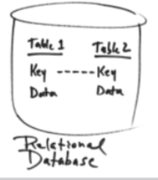
entity (group of dana, attributes, relatons) -> table (colums, rows, relations)

Referential Integrity is done by using primary and foreign keys

Schema is a group of related objects in a database. Multiple schemas may exist in a database.
