Java Concurrency Oreilly online course

Bean Evans -> read all him books

Why concurrncy in java ?
-> to increase performance

Princip of Mechanical Sympathy – Martin Thompson
-> deep undersdoing what is goin on (hardver, underline) better performace and better job are you do

see: Free luch is over performace paper
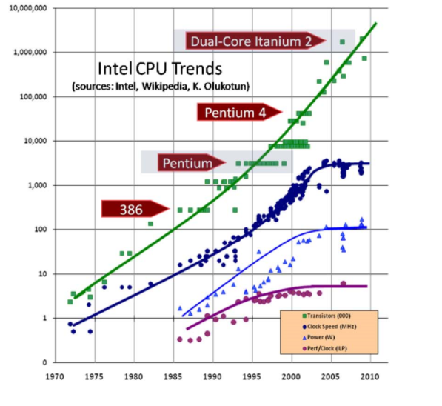
read Computer Architecture: A Quantitative Approach by Hennessy

1980 – spped to execute opertion is same as spped to acces the memory
2005 – memory is spped to 5 boot processor 1000 times
- fetch dana from memory, you need to whait (solution is caching: L1, L2, L3)

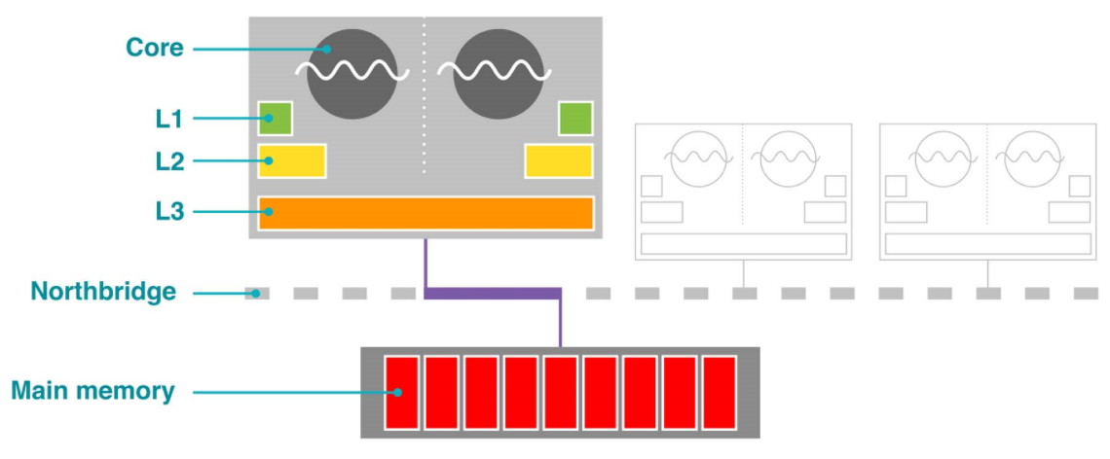
two cores – single clok is sporo, so you have two cores (two cores) -> Morre lays (puno transitora, clock brzina ne može ici brze) 6 transitrosr 1 bit ( for 1MB you need 14 milion)
so caš se povecava ali nemamo puno transiztoa za core zato je caš mali
L2, L3 cash neeed more time to acces.

