Kubernetes in 4 Hours Oreilly online coures

Kubernetes
Automating deployment, scaling and management (orchestation) of containerized app (containers)
See kubernetes.io
Docker container do not have good storage, if is down you can not restrated
Run multiple connected containers across different hosts where continuity of srvice is guaranteed
Based on Google Borg solution

Orchestration tasks
It do not manage conteiners it manage pods
Schedule containers to run on specific hosts using pod-s
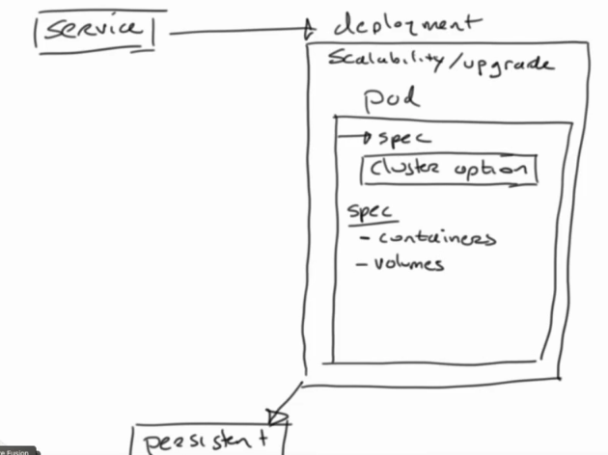
Manage containers as pod (not direktno) također ima i voluemns

Deployment inclueds pods
- responsible for scalability /upradge

Also have service (how to acces deployment)
Also have persistne storage

Schedule containers to run os specific host usiing pods
also join hosts that are running container in an etcg cluster
Take care of scalabiliy (app run on more pods, because we have big trafics)
Make storage availabe
Expose container using service
Containers
- way to package, shop and run applications
- fany way to run application like on smarfton
- application have every that need to run (all depedencies)

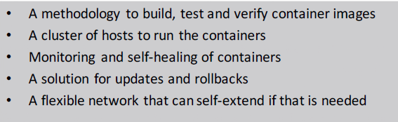
What container need

Kubernetes is implemented as conteiners (it is set of conteners) that host containers

CNCF
– Cloud Natice Computing Foundation
- ensures that Kubernetes solutions are standardized

Installing a Kubernetes

You can install it on google clode free for one yera
You can user minikube on linxu (ubuntu), run it on virtual machine, do not use host machine (run virtual machine on virtual machine)
Minikube Overview
- for runing kubernates
-Minikube offers a complete test environment that runs on Linux,
OS-X or Windows

TODO what is cluster (kubernetes)

Kubernetes
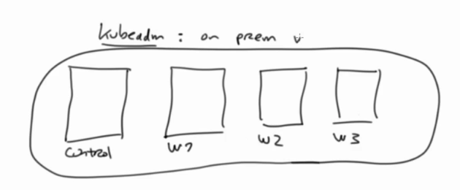
Foundation of kubernetes is kubernetes cluster, (.4 nodes)
one is controle node (master node) other thre are workers (w1, w2, w3)

starting 4 nodes is complicated -> easer solution is to use Minikube
Minikub runs virtual machine (can ran on linuc or windows, mac) Insdide this virtual machine you are going to run other virtual machine In this we have AIO (all in one)

Hosted in clud
- GCE, AKS, EKS
- you are runing you 4 nodes (contror, node, w1,.w2 , w3)

Open shift, rancher -> kubernetes distriibuton
user kubectl to manage kubernetes resources

miniube status
type -> Contro Plane (contro node)
kubelet -> take care of runing containers
apiserver -> exposes

docker ps -> see kuberneteis core services
-> docker run as processes

kubectl cluster-info

in oder to run application you need accest to container images. (from registry (docker registry), gci registry, read hot registry, you own registry)
You build image put in on private registry and pull it in kuberneties

minikube dashboar -> acces kubernes GUI

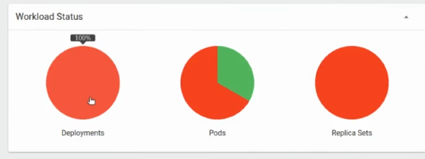
Deployments – your application
Pods – how application is implemented
Replica Set – manage rreplications

Deployment manage replica set then replica set manage and monitors pods

kubectl get all
-> give all info (deploymen, replica test, pods)

kubctl -h -> help
kubctl completion -h -> help

Resource Types
Pod
One or more container
Volume -> storage

Deployment = app, taking care of replication set

decoupling
- separate static code from configuration
Use yaml file

Services expose ip of app so that user can acces. They have Ingress (todo)
For Storage user persistent volume -> this is external storage (pvc perrisent volume clam I need 2GB of storage)

ETCD -> hart of kubernetsi -> configuration database
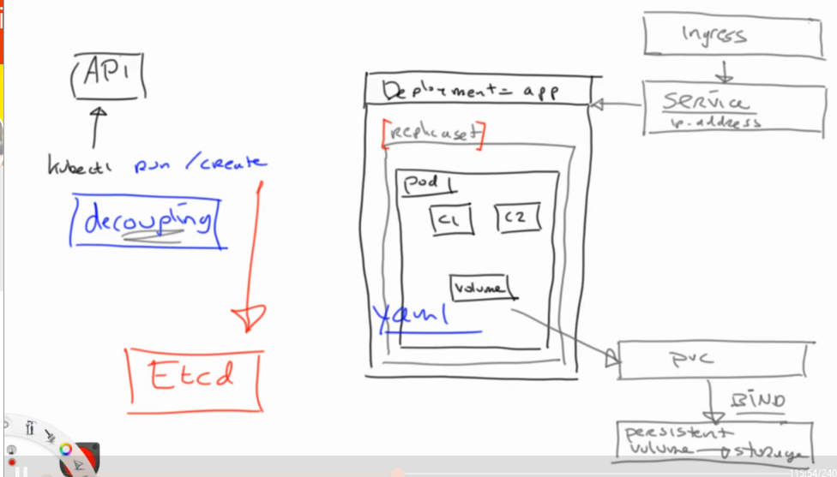
Kubernates manages Pods, not containers
Pod is using namespaces to ensure that resources in the Pod
Namesapces in kubenetes TODO access (strickly isolated)
default -> namespace pods thay you developed
kube-system -> namespaces pods thay kuberenetes deployes

Always run application as deploment not as pod. Pod wil not be managed but deployment will.

Kubernates in declarative way (yaml file)
configuraion as code on git hub
easy way to generete yaml file

Deployments

Pods hava ip adresses in cluster net internal network.

