Confirming Correctness of ER model

Entity Sets
Sometimes it is useful to try out various examples of entities from an ER model. One reason for this is to confirm the correct cardinality and optionality of a relationship. We use an `entity set diagram' to show entity examples graphically. Consider the example of `course is_studied_by student'.
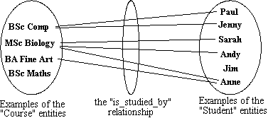
Figure : Entity set example

Confirming Correctness
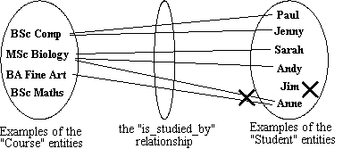
Figure : Entity set confirming errors
- Use the diagram to show all possible relationship scenarios.
- Go back to the requirements specification and check to see if they are allowed.
- If not, then put a cross through the forbidden relationships
- This allows you to show the cardinality and optionality of the relationship

Deriving the relationship parameters
To check we have the correct parameters (sometimes also known as the degree) of a relationship, ask two questions:
- One course is studied by how many students? Answer = `zero or more'.
  - This gives us the degree at the `student' end.
  - The answer `zero or more' needs to be split into two parts.
  - The `more' part means that the cardinality is `many'.
  - The `zero' part means that the relationship is `optional'.
  - If the answer was `one or more', then the relationship would be `mandatory'.
- One student studies how many courses? Answer = `One'
  - This gives us the degree at the `course' end of the relationship.
  - The answer `one' means that the cardinality of this relationship is 1, and is `mandatory'
  - If the answer had been `zero or one', then the cardinality of the relationship would have been 1, and be `optional'.

Redundant relationships
Some ER diagrams end up with a relationship loop.
- check to see if it is possible to break the loop without losing info
- Given three entities A, B, C, where there are relations A-B, B-C, and C-A, check if it is possible to navigate between A and C via B. If it is possible, then A-C was a redundant relationship.
- Always check carefully for ways to simplify your ER diagram. It makes it easier to read the remaining information.

Redundant relationships example
- Consider entities `customer' (customer details), `address' (the address of a customer) and `distance' (distance from the company to the customer address).
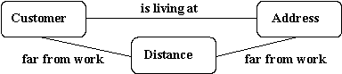
Figure : Redundant relationship

Splitting n:m Relationships
A many to many relationship in an ER model is not necessarily incorrect. They can be replaced using an intermediate entity. This should only be done where:
- the m:n relationship hides an entity
- the resulting ER diagram is easier to understand.

Splitting n:m Relationships - Example
Consider the case of a car hire company. Customers hire cars, one customer hires many card and a car is hired by many customers.
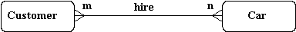
Figure : Many to Many example
The many to many relationship can be broken down to reveal a `hire' entity, which contains an attribute `date of hire'.
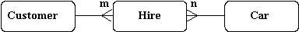
Figure : Splitting the Many to Many example

Constructing an ER model
Before beginning to draw the ER model, read the requirements specification carefully. Document any assumptions you need to make.
- Identify entities - list all potential entity types. These are the object of interest in the system. It is better to put too many entities in at this stage and them discard them later if necessary.
- Remove duplicate entities - Ensure that they really separate entity types or just two names for the same thing.
  - Also do not include the system as an entity type
  - e.g. if modelling a library, the entity types might be books, borrowers, etc.
  - The library is the system, thus should not be an entity type.
- List the attributes of each entity (all properties to describe the entity which are relevant to the application).
  - Ensure that the entity types are really needed.
  - are any of them just attributes of another entity type?
  - if so keep them as attributes and cross them off the entity list.
  - Do not have attributes of one entity as attributes of another entity!
- Mark the primary keys.
  - Which attributes uniquely identify instances of that entity type?
  - This may not be possible for some weak entities.
- Define the relationships
  - Examine each entity type to see its relationship to the others.
- Describe the cardinality and optionality of the relationships
  - Examine the constraints between participating entities.
- Remove redundant relationships
  - Examine the ER model for redundant relationships.
ER modelling is an iterative process, so draw several versions, refining each one until you are happy with it. Note that there is no one right answer to the problem, but some solutions are better than others!

