Programming Kotlin
By Venkat Subramaniam

Part 3.
Elegant Kotlin
Asynchronous programming

The famous words of Blaise Pascal, “If I had more time I would have written a shorter letter,” apply as much to programming as writing

Overloading Operators

Given a reference today of a Date class, today + 2 may mean that’s two days from now.
Don’t use operator overloading unless it’ll be obvious to the reader.

Since the JVM doesn’t support operator overloading (and Kotlin compiles down to Java bytecode), Kotlin makes operator overloading possible by mapping operators to specially named methods. For example, + will result in a call to a plus() method.

To overload an operator, define a function and mark it with the operator keyword.

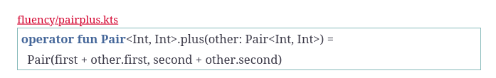
The function is named plus() which is the specialized method name for +. It operates on an implicit object, the left operand, referenced using this and on the right operand other. Instead of writing this.first + other.first, we used a short form first + other.first

The functions for the composite operators +=, -=, *=, /=, and %= take on the word Assign after the special name for the first operator, for example, plusAssign() for +=. You shouldn’t implement both plus() and plusAssign() for the same class. Likewise, for other composite operators. If you implement plus(), for example, then += will use that method appropriately. If not, to resolve +=, the compiler will look for plusAssign(). If neither plus() nor plusAssign() are found, then the compilation of += for instances of your class will fail. While plus() is a pure function and returns a new instance, plusAssign() will change the state of the instance on which it operates and thus expects the object to be mutable.

Within the inc() method we’re not mutating anything. Instead, we return a new object with new state. When used as pre-increment, Kotlin will save the returned value into the variable on which the operator is applied.

Operator overloading is a powerful feature, but follow a few recommendations when using it:
- Use sparingly.
- Overload only when the use will be obvious to the readers.
- Abide by the commonly understood behavior of the operators.
- Use meaningful names for variables so it’s easier to follow the context of overloading.

Injecting Using Extension Functions and Properties

Unlike other languages that offer metaprogramming, Kotlin performs injection without patching the runtime or class loading. In Kotlin, classes are open for extension, even though they may not be available for inheritance. Extension functions and extension properties are techniques to add methods and properties, but without altering the bytecode of the targeted classes. When you create an extension function for a class, it gives an illusion that you’ve implemented an instance method for that class. Don’t create an extension function for a method if that method already exists in the class. Members of a class always win over extension functions if there’s a conflict. When the Kotlin compiler sees a method call, it checks to see if an instance method is available and uses it if found. If an instance method isn’t found, Kotlin looks for an extension function for the targeted class.
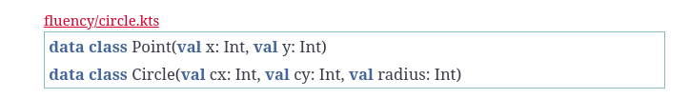

Extension function:

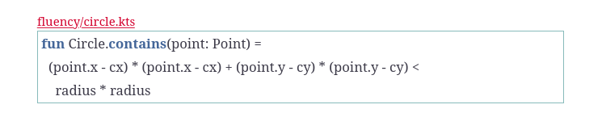

If we’d written this method within the Circle class, the only difference is that we would have written fun contains(point: Point) instead of fun Circle.contains(point: Point).
As long as this method is visible—that is, it’s either in the same file or we’ve imported it from the package where it resides—we can use it, like so:

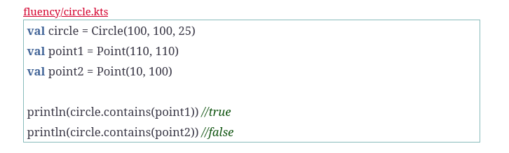
When Kotlin sees the extension function, it creates a static method in the package where the extension function exists and passes the context object—Circle in the example—as the first argument to the function, and the actual parameters as the remaining parameters. When the compiler sees the call to a method, it figures we’re calling the extension function and routes the context object circle as the first argument to the method. In short, what appears to be a method call is really a call to a static method when extension functions are involved.

Extension functions have a few limitations. When there’s a conflict between an extension function and an instance method of the same name, the instance method always wins. And unlike instance methods, which can reach into the encapsulation boundaries of an instance, extension functions can access only the parts of an object visible from within the package they are defined in.

Extension Function as operator

The extension function may be an operator as well.

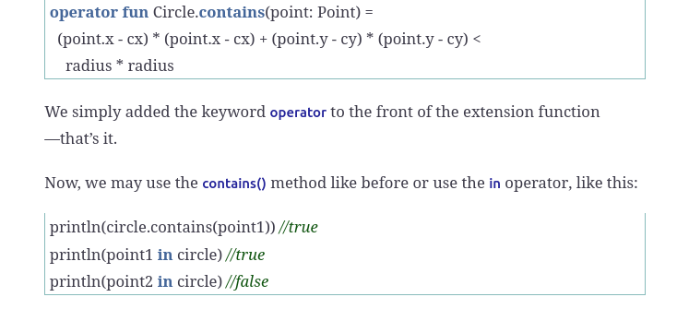

TODO naming convension extension function to operator

Injecting properties using extension properties

we may add extension properties as well. Since these are also not part of the internals of the class, extension properties can’t use backing fields—that is, they can’t access field like actual properties can. They may use other properties or methods on the class to get their work done.
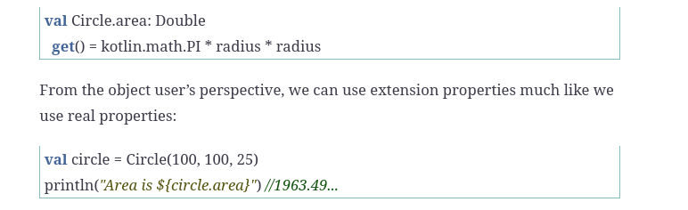

Injecting into Third-Pary Classes

You may add extension functions to third-party classes and also route the extension functions to existing methods
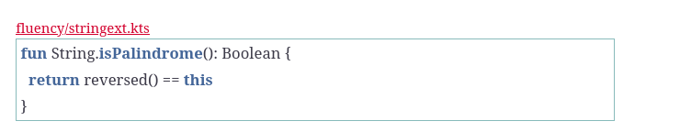

​fun​ String.​shout​() = toUpperCase()

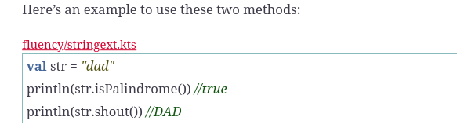

“Just because we can doesn’t mean we should.” Changing behavior of well-known methods will cause hard-to-maintain code, loss of hair for your friends, and loss of their friendship when they find out who caused it.

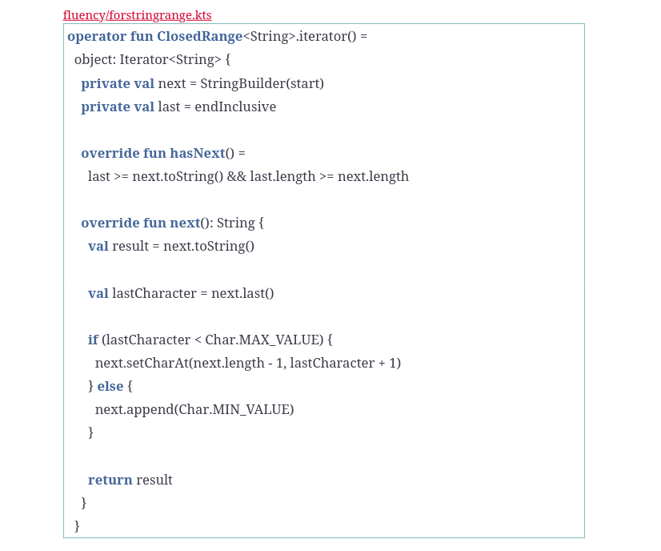

​for​ (word ​in​ ​"hell"​..​"help"​) { print(​"$word, "​) }
→
hell, helm, heln, helo, help,

Injecting static methods

You can inject static methods into classes by extending their companion object—that is, injecting method into the companion instead of the class. As a result, you may inject static methods only if the class has a companion object.

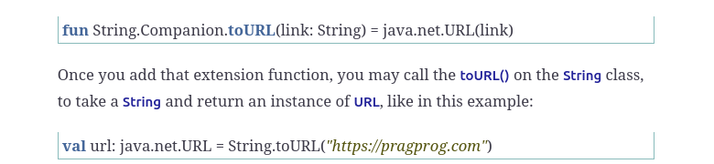

Injecting inside class

The extension function is injected into the Pair<Int, Int> from within the Point class. So any effort to use that extension function on an instance of Pair<Int, Int> from outside the class will result in compilation error. Let’s take a closer look at the extension function alone.

Since the extension function is created within a class, it has two receivers: this and this@Point. These two receivers have distinct names in Kotlin, extension receiver and dispatch receiver, respectively. An extension receiver is the object that the extension function is executing on—that is, the object that received the extension function. A dispatch receiver is the instance of the class from within which we added the extension function—that is, the class from within which we did the injection of the method.

Extending Functions

Functions are objects in Kotlin, and you can inject methods into functions, like you can inject methods into classes.
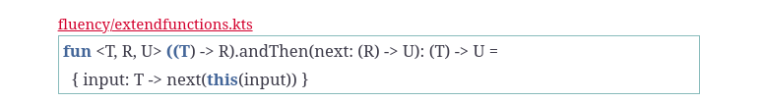

The extension function signature says that andThen() is added to a function that takes a parametrized type T and returns a result of type R. The parameter passed to andThen() has to be a function that takes as a parameter a variable of type R—the return type of the function on which andThen() is called—and it returns a result of parameterized type U.

The resulting composed function created by andThen() takes a parameter of type T and returns a result of type U. In the body of andThen() we return a lambda expression. This lambda passes its parameter to the function on which andThen() is called and passes the result to the next function—that is, the parameter to andThen(). Thus, andThen() passes the result of one function as input to the next.

Use case:

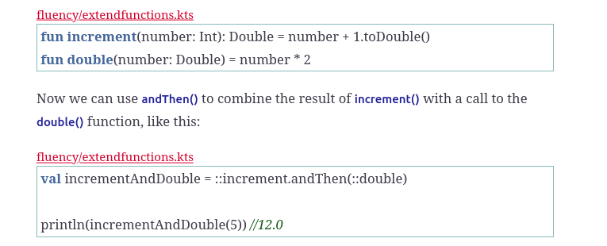

Function fluency – inflix notation

infix notation, where an operator is infixed or implanted in the middle of its operands.
That syntax is nice, but in Java such fluency is limited to predefined operators. In Kotlin you can use the infix notation—that is, leave out dots and parenthesis—for your own code and thus make the code expressive, less noisy, and easier to read.

If we mark a method with infix annotation, then Kotlin will allow us to drop the dot and parenthesis. infix may be combined with operator, but operator isn’t required for infix—they are orthogonal to each other.
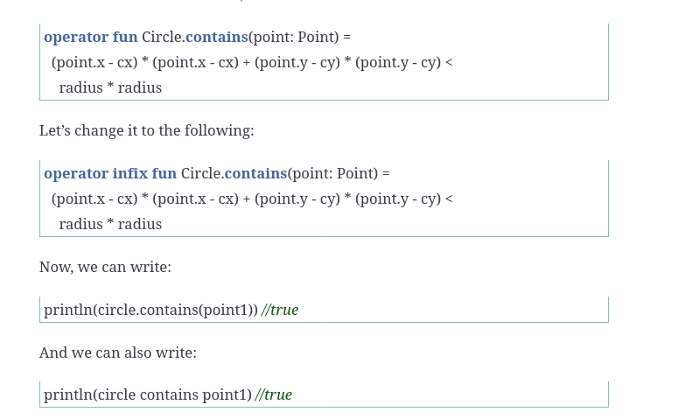
infix methods are required to take exactly one parameter—no vararg and no default parameters

Any Object

Specifically, Kotlin has four significant methods that can make code fluent: also(), apply(), let(), and run() (Scope functions are nothing but the functions which define to the scope of the calling object. We can apply operations on that object within that scope and return the object itself from that scope function or we can even return the result of operation or operations from the scope function. ) . Each of these methods takes a lambda expression as a parameter and returns something back after invoking the given lambda. The format of a call to one of these methods, on a context object, looks like this:

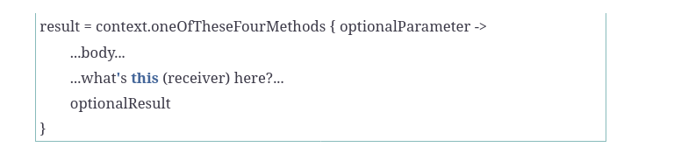

Depending on the method you call, the optionalParameter and this, the receiver of the call, will be assigned differently. The optionalResult received from the call will differ as well.

More info here
https://kotlinlang.org/api/latest/jvm/stdlib/kotlin/-any/
and
https://blog.mindorks.com/using-scoped-functions-in-kotlin-let-run-with-also-apply
and
https://medium.com/@fatihcoskun/kotlin-scoping-functions-apply-vs-with-let-also-run-816e4efb75f5
and
https://stackoverflow.com/questions/45977011/example-of-when-should-we-use-run-let-apply-also-and-with-on-kotlin

data class Citizen(var name: String, var age: Int, var residence: String)

Decision depends on your needs. The use cases of different functions overlap, so that you can choose the functions based on the specific conventions used in your project or team.
Although the scope functions are a way of making the code more concise, avoid overusing them: it can decrease your code readability and lead to errors. Avoid nesting scope functions and be careful when chaining them: it's easy to get confused about the current context object and the value of this or it.

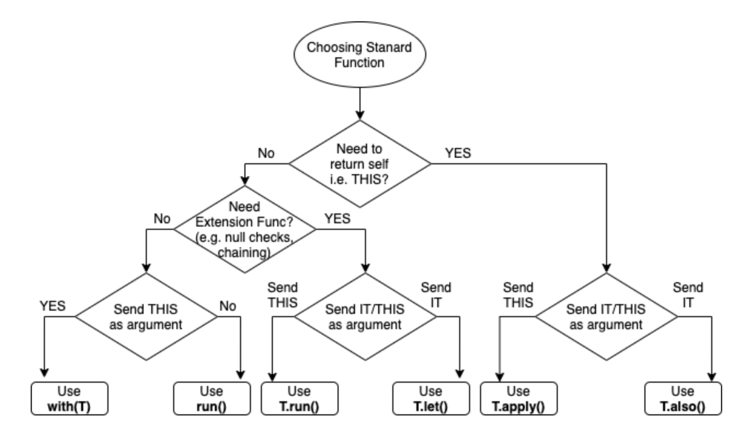

Implicit Receivers

val printIt: (Int) → Unit ) = { n:Int → print(“jlakfal”) }
printIt(6)

In this code, printIt refers to a lambda, which receives an Int as its parameter and returns nothing

val printIt: String.(Int) → Unit = {n: Int → println(“jfklsa”)}

The syntax String.(Int) says that the lambda will execute in the context of an instance of String. If you have more than one parameter for the lambda, for example, (Int, Double), then to say that the lambda will get a receiver during a call, write it as Type.(Int, Double), where Type is the type of the receiver. When resolving the scope of variables, the compiler will first look for the variable in the scope of the receiver, if present. If the receiver isn’t present or if the variable isn’t in the receiver, then the compiler looks for the variable in the lexical scope

When calling a lambda that expects a receiver, we need to pass an additional argument—that is, the context or the receiver that will be bound to this inside the lambda. Here’s one way, though not the most elegant way, to achieve that goal:

​"Hello"​.printIt(6)

The lambda acts like it’s an extension function for the receiver. In fact, that’s exactly what Kotlin did. It treated the lambda as an extension function of the receiver.

Internl DSLs

You have external and internal DSL. For external you have a lot of freedom but you need to create parser. But if you design internal you don’t need to write parser.
DSL are context-driven and highly fluent and you can reduce possibility of errors. The same thing may have different meaning in different context

Kotlin capabilitues for DSL
- no need for semicolon (;)
- with infix no dot and parameters
- extension function with infix
- no parenthesis to pass lambda
- pass implicit receivers to lambda expression String.(Int) → Unit
- scope functions
- operator overloading (with caution)

More info here: https://www.raywenderlich.com/2780058-domain-specific-languages-in-kotlin-getting-started

Create a fluent syntax without dots, parenthesis, and this

With some extension functions, we can make the words roll off our tongues and emerge as code—Kotlin code, that is

inflix fun Int.days(in: n) = Date(this, n) // Date is custom class // this is left argument

val ago = 1;
println(2 days ago)

Goal
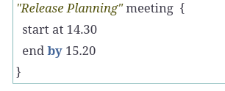

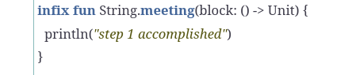
First step: inject a meeting() method into the String class (extension function) and make it an infix so that we can drop the dot

Second step: Create meeting class that will be holder of the state Since the lambda will populate the state for an instance of Meeting, we might as well run it in the context of the instance. To accomplish this, we should change the lambda’s signature.

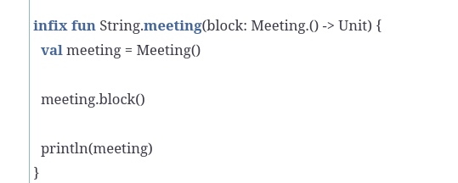

let’s create at and by methods in the Meeting class and run them both from within the lambda.
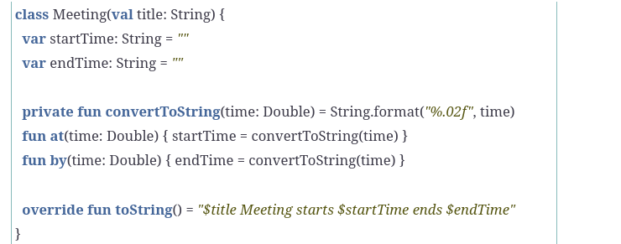

So now looks like

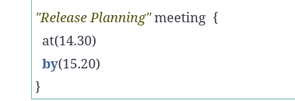

Third step: make at and by inline functions
a

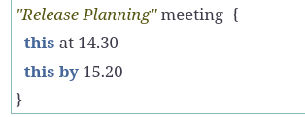

Fourth step: add start and end
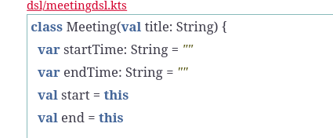

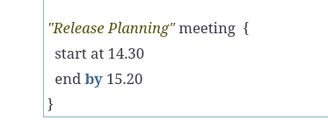

Create a type safe builder for internal DSL

fun xml(block: XMLBuilder.() → Node): Node = XMLBuilder().run(block)

The function creates an instance of XMLBuilder class. The parameter to the xml() function is a block—a lambda—with a receiver of type XMLBuilder.

he reason we used run() is that it executes the given block of code in the context of the receiver and returns the result of the block​. Since the lambda parameter specifies the return type to be an instance of a Node class, the result of calling the xml() function is an instance of Node. We’ll soon create both the XMLBuilder class and the Node class.
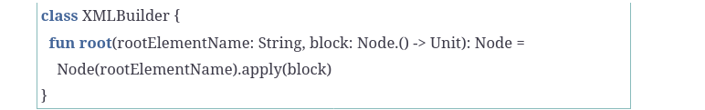

The root() method takes two parameters: rootElementName of type String to receive the name of the root elementt and block for a lambda that will run in the context of a Node instance as receiver.

The reason we use apply() here instead of run() is we don’t care to return anything from the block passed to apply(), we merely want to run the lambda in the context of the Node instance and return that Node instance.
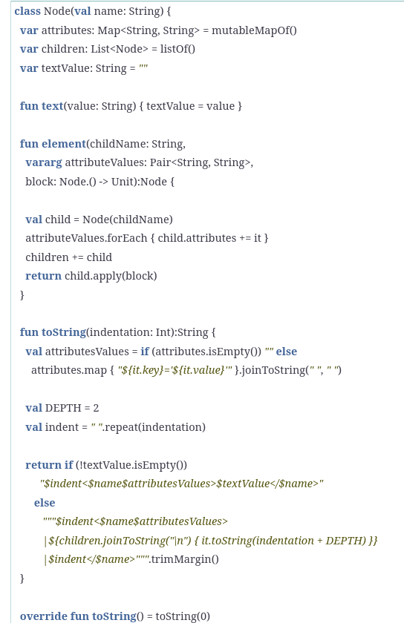

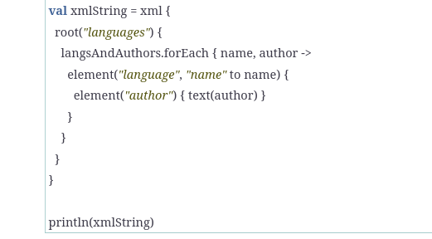

Resoult
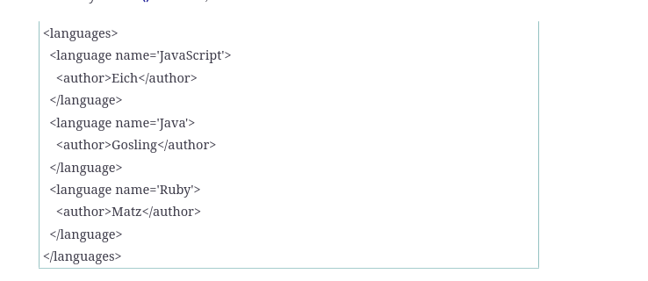

Narrowing access with scope control

However, anything that’s possible in the host language, like property access or calls to arbitrary functions and methods in scope are all permitted within the DSL code. That freedom may be too much at times. Kotlin makes an effort to narrow that access a little with a scope control annotation.

In spite of the facility Kotlin offers, there’s no way to tell the compiler to reject calls to a top-level function or an access to a variable that’s in lexical scope. But, with a special @DSLMarker annotation, you can tell the compiler to disallow implicit access to the members within the parent receiver of a nested lambda.

we may want to limit a lambda to accessing only the immediate implicit receiver and disallow automatic access to the members of the parent receiver

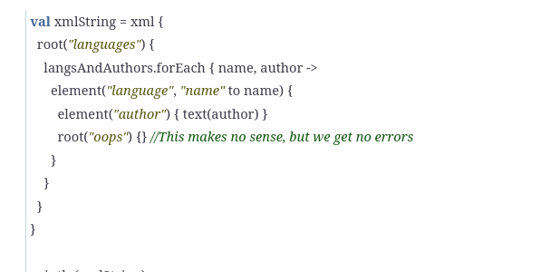

Of course, that doesn’t make sense (picture), and you can ask Kotlin to reject that call. To do that, you have to annotate either the classes or the base classes that partake in building the DSL with a custom DSL Marker annotation. Such a custom annotation itself is annotated with a @DslMarker annotation.

 | @DslMarker
​ | ​annotation​ ​class​ XMLMarker

put on

 | @XMLMarker
​ | ​class​ XMLBuilder {

and

 | @XMLMarker
​ | ​class​ Node(​val​ name: String) {

When designing DSLs, most certainly use DSL Marker annotations. While the annotation won’t help reject calls to top-level methods or access to variables and members in lexical scope, it will help reject automatic calls to methods that are part of the parent receivers. This is a useful feature to control scope a little within DSLs.

Concrete example here https://kotlinexpertise.com/create-dsl-with-kotlin/

Recursion and Memoization

While recursion is very powerful, it unfortunately runs into runtime stack overflow for large-size problems, making it ineffective when it is much needed. A techniques called tail call optimization can solve this problem and Kotlin provides support for this. You must recursive procedure compile into an iterative process. The code can be expressed as recursion but it can enjoy the runtime behavior or iterations. You need to
- add tailrec keyword to function
tailrec fun refcursiveFun()
- write functino so the recursion call is the last expression that’s evaluated (if the recursion is complex that my not be easy or event possible)

You can call a memoize() function on any lambda expression and it will return a memoized lambda. We’ll follow a similar approach here in Kotlin.

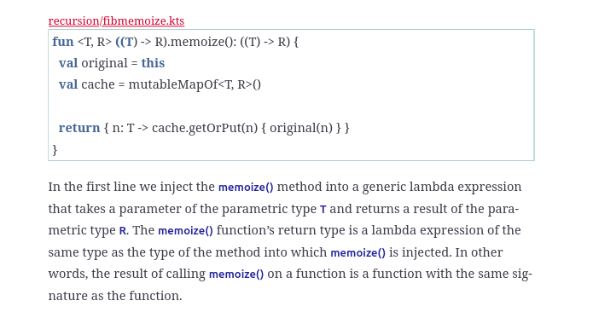

Within the memoize() function, we save the reference to the original function by assigning this to a local variable original. Then we initialize an empty cache. Finally, we return a lambda expression that takes a parameter of type T and returns a result of type R. Within this returned function, we look up the cache, to see if the result already exists. If it doesn’t exist, we compute the result, and store it before returning. If the result already exists, we skip the computation and return the stored value.

Coroutines

Sequential execution is clear; we perform one task to completion before beginning the next. As multithreading on a multi-core processor generally is parallel, while coroutines are generally used more often for concurrent execution rather than parallel execution.

In general, we can eat and listen in parallel, but we eat and speak concurrently.

First, the Producer coroutine calls the Consumer coroutine. After executing part of its code, the Consumer saves its current state and returns or yields to the caller. The Producer performs some more steps and calls back into the Consumer. This time, however, instead of the call starting in the beginning, the call resumes from the point where the previous execution left off, with the state of the previous call restored.
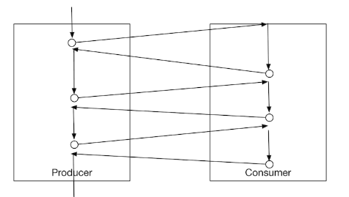

The runBlocking() function takes a lambda as an argument and executes that within a coroutine.

runBlocking {
task1()
task2()
println(“end”)
}
Coroutines run code concurrently—thus, the code within the lambda ran in the main thread interleaved between the code before the call to runBlocking() and the code after the call to that function.

Kotlin coroutines library comes with suspension points—a function that will suspend execution of the current task and let another task execute. Calling such a function is like you pointing the microphone toward a colleague, in the middle of your speech, for them to say a few words. There are two functions to achieve this in the kotlinx.coroutines library: delay() and yield().

The delay() function will pause the currently executing task for the duration of milliseconds specified. The yield() method doesn’t result in any explicit delays. But both these methods will give an opportunity for another pending task to execute.

Kotlin will permit the use of suspension points only in functions that are annotated with the suspend keyword. Marking a function with suspend doesn’t automatically make the function run in a coroutine or concurrently, however
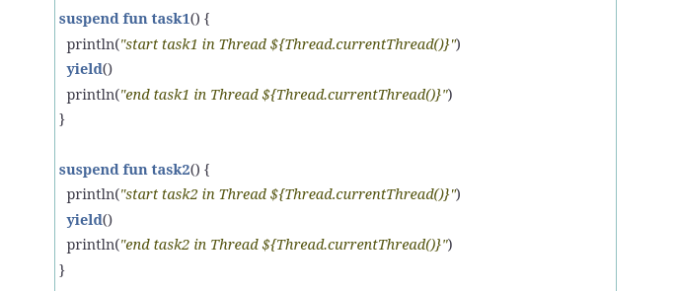

Now, each of the functions will yield the flow of execution to other tasks, if any. Within the lambda passed to the runBlocking() function, we launch the two tasks, in two separate coroutines,

println(“start”)
runBlocking {
launch { task1() }
launch { task2() }
println(“end”)
}
println(“done”)

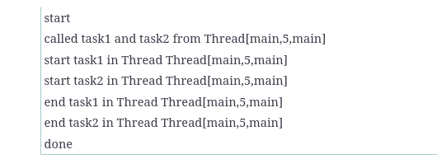

The previous example showed how the single thread main is running all that code, but the function calls aren’t executed sequentially. We can clearly see the interleaving of execution—that served as a good example of concurrent execution. The examples illustrated the behavior of coroutines

Suppose we have multiple tasks that can’t be run in parallel, maybe due to potential contention of shared resources used by them. Running the tasks sequentially one after the other may end up starving all but a few tasks. Sequential execution is especially not desirable if the tasks are long running or never ending. In such cases, we may let multiple tasks run cooperatively, using coroutines, and make steady progress on all tasks.

Coroutine Context and Threads

You may pass a CoroutineContext to the launch() and runBlocking() functions to set the execution context of the coroutines these functions start. The value of Dispatchers.Default for the argument of type CoroutineContext instructs the coroutine that is started to execute in a thread from a DefaultDispatcher pool.

The value of Dispatchers.IO can be used to execute coroutines in a pool that is dedicated to running IO intensive tasks.
Dispatchers.Main can be used on Android devices and Swing UI, for example, to run tasks that update the UI from only the main thread.

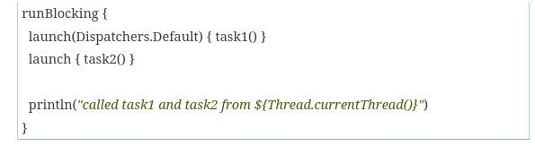

After this change, the code in task1() will run in a different thread than the rest of the code that still runs in the main thread. We can verify this in the output—the output you see may be slightly different since the order of multiple threads running in parallel is nondeterministic:

If you’d like to run your coroutines in your own single thread pool, you can do that as well. Since you’ll have a single thread in the pool, the coroutines using this context will run concurrently instead of in parallel
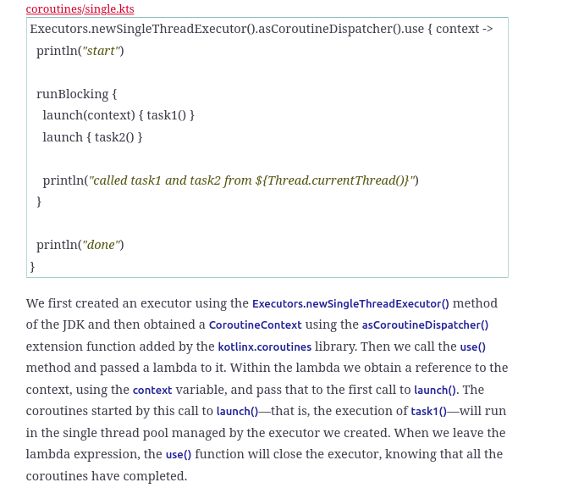

Also withContext(). Using this function you can take a part of code and run it in an entirely different context than the rest of the code in the coroutine.

Creating a infinite Sequences

Since coroutines are useful for creating cooperating tasks, we can use them to create an infinite series or unbounded values and process the generated values at the same time. A function may create a value in the series and yield it to the code that is expecting the value. Upon consuming the value, the calling code can come back asking for the next value in the series. These steps can continue in tandem until either the code that produces the series exits or the caller doesn’t bother asking for another value in the series

Asynchronous

To improve program efficiency we may want to execute such operations asynchronously, in a non-blocking manner. Coroutines are intended to exactly solve that problem.

We can start the coroutine by telling async() to use a different context, and thus a different pool of threads. We can easily do this by passing a CoroutineContext, like Dispatchers.IO, to async().

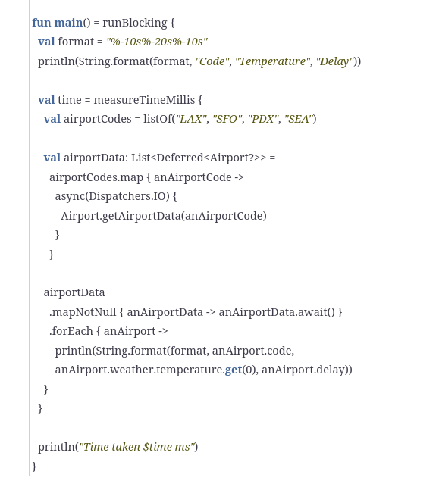

First, instead of a List<Airport> we create a List<Deferred<Airport?>>, because the result of a call to async() is an instance of Deferred<T>. Within the first iteration we called the getAirportData() method inside of the lambda passed to the async() call. The call to async() returns immediately with the result of Deferred<Airport?>, which we store in the list.

we go over the Deferred<Airport?> list and invoke await() to get the data. Calls to await() will block the flow of execution but won’t block the thread of execution. Had we used async() directly without the argument, the main thread would be executing the coroutines after reaching the call to await(). In our case, since we used async() with the Dispatchers.IO context, the main thread can chill, get a beverage, and stare at the stars, while the worker threads in the Dispatchers.IO pool take care of making the call to the web service.

Exception Handling in corutines

If you’re using launch(), then make sure to set up an exception handler. An exception handler CoroutineExceptionHandler, if registered, will be triggered with the details of the context and the exception.

The async() function, however, returns a Deferred<T> instance, which will carry the exception and deliver to the caller when await() is called. It makes no sense to register an exception handler to async() if the handler, if registered, will be ignored.
async() and await() not only make it easier to make asynchronous calls, they also deal well with exceptions.

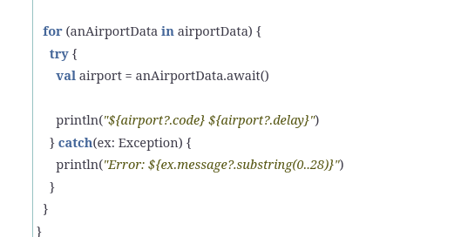

Coroutines can be cancelled, which will stop the code within the coroutine from further execution. Coroutine cancellations aren’t related to the thread terminations that we’re used to in Java. Cancellations are lightweight and have effect across the hierarchy of coroutines that share context.

If we don’t care for the completion of a task that we started in a coroutine, we may cancel it by calling cancel() or cancelAndJoin() on the Job or the Deferred<T> instance. However, the coroutine may not budge to that command right away. If the coroutine is busy executing, the command doesn’t interrupt it. On the other hand, if the coroutine is parked in a suspension point, like in a call to yeild(), delay(), or await(), then it will be interrupted with a CancellationException.

When designing a coroutine, keep the previous constraints in mind. If you’re performing a long-running computation, you may want to structure it so that you take a break frequently to check if the isActive property of the coroutine is still true. If you find it to be false, you can break out of the computation, honoring the request to cancel.

If your critical task doesn’t have any suspension points, you don’t have to worry. When a coroutine is busy running that non-interruptible code, no cancellation command will affect it. You don’t have to write any extra code to prevent cancellation in this case.
But if your critical code contains a suspension point, like a yield(), delay(), or await(), then you may want to convey that you’re in the middle of a critical section and don’t want to be interrupted. The withContext(NonCancellable) function call is like hanging a Do Not Disturb sign outside the door.

When a coroutine runs into an unhandled non-cancellation exception, it’s automatically cancelled. When a coroutine cancels, its parent is cancelled. When a parent is cancelled, all its children are then cancelled. All this behavior is automatically built-in to how coroutines cooperate.

