Code quality intro

Parameters to measure the quality of code

Maintainability – is it easy to fix errors and implement new feature
Efficient – good code should not have any performaces issuees.
Readability – is code easy to read even for beginner programmers. Do you have coding convention (established standards) that is used on hole project, Do you have tests

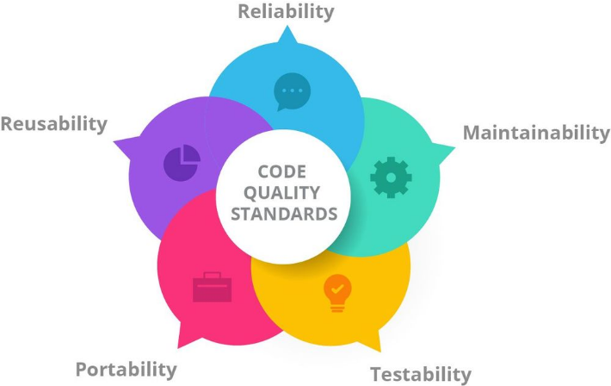

Code quality analysis tools

Embold assess the robustness, maintainability, stability and security of your code.
PVS-Studio: It is a software quality analysis tool that is used to check for bugs and any security vulnerabilities
SonarQube: It is an online code reviewing tool that makes sure all your coding modules are analyzed for their quality. Packed with a range of features, it helps you write good quality code without much hassle.
Also: https://codescene.io/
Also: https://en.wikipedia.org/wiki/List_of_tools_for_static_code_analysis
Also: https://www.softwaretestinghelp.com/code-review-tools/
Also: https://duecode.io/blog/code-quality-tools/
Also: https://analysis-tools.dev/tag/kotlin
Also: https://www.sonarsource.com/kotlin/

Matrices

Defects Matrices
Various defects matrices can be employed to check the exact number and the nature of defects found in software. No software has perfect coding, but if we have a calculation of defects or bugs found, we can work to reduce them.

Efficiency, Maintainability & Extensibility Matrices:
These matrices ensure that running the code is less time-taking, as well as the code is simple enough to work with and make amendments and additions.

Documentation Matrix:
Whether software is documented properly provides a lot of information about its quality. Therefore a quality check cannot be completed without weighing the software for documentation.

Quantitative Matrices
Halstead Complexity Measures, Weighted Micro Function Points, and Cyclomatic Complexity.

Halstead Complexity Measures

Is code hard to read More info here: https://en.wikipedia.org/wiki/Halstead_complexity_measures
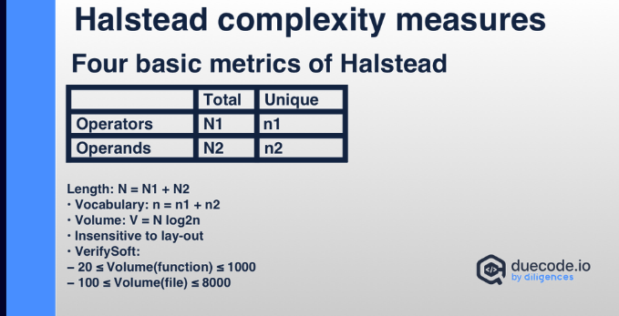

Weighted Micro function points
Metrics displaying various levels of complexity
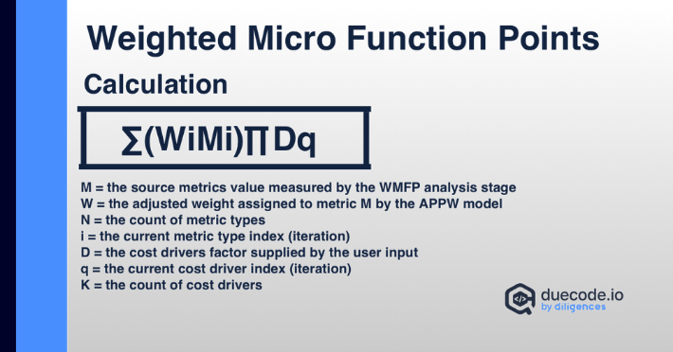

Cyclomatic Complexity
If complexity is above 10, it means the quality needs to be corrected.
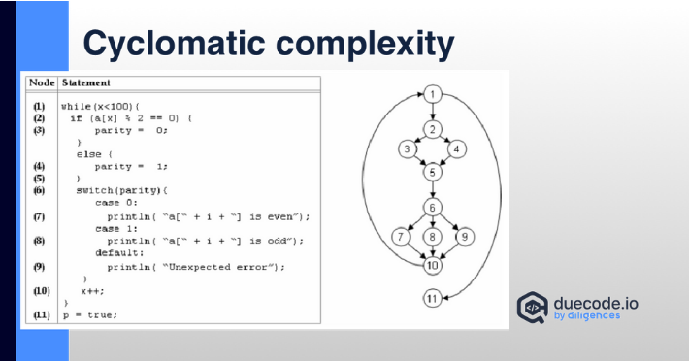

Other things that can improve code quaity

Clear requirements
Well-documented
Regular Code Reviews
Testability (Keep track of test coverage)
Use continuous integration tools
Clear code is better than clever code
Comment why not what

Coding concepts

- BDD
- CAP theorem
- DDD
- DRY
- EAV
- GRASP
- KISS
- Make it run, make it right, make it fast
- OOP
- SOLID
- TDD
- YAGNI

