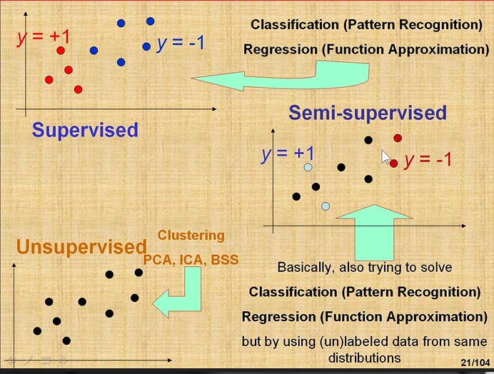

Supervised
– for each data point I have class (label)

Semi-supervisot
- do not have class (label) for all data

Unsupervised data
–data is not labeld (classified)
- use PCA, clustering

Data sets can be anyting

Learning – decision tree
- first model for clasification
- baziran na statistici

Learning – pseudoinverse
- first model base on learning weights (learning is finding the weights)
- kako prinaći dobru linuju

- d dessision function
- idead is to have to smaller errot → cost function

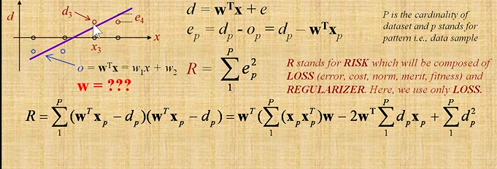
best w is one where R is the smallest → to do It find derivate of function → derivate

→ algoritma for model
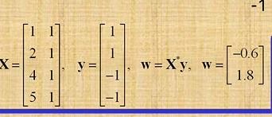
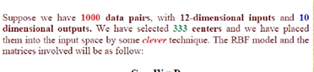

12 – dimesional inputs – 12 dimenzija input
10 – dimensional outpus – 10 dimenzija rezultat

what if appromaximation functon is no linear (nije linearna funkcija – možda parboal, set funkcija ..itd)

solution first → kreiraj nolinera funkciju za izracuun w
solution second
→ funkcija(w, x) = 0
→ feature 1, x on x crti
→ x2 na y crti
→ ideja mapiraj u novi prostor (plan iznad 2-d prostora)

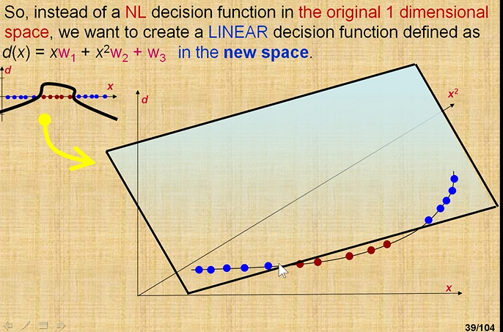

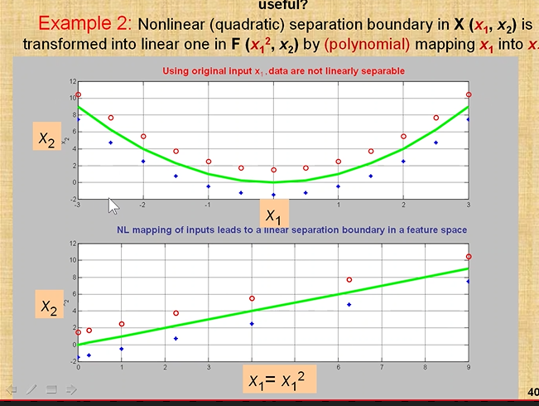
instead of x1 uzmi x1 na kvadrat I onda imam ravnu linuju → parabola convert into linera function

example 2:

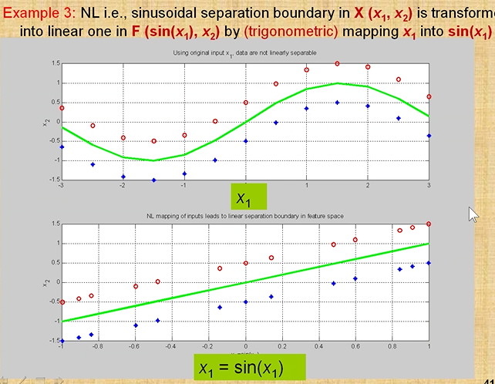

example 1. - MAP X INTO X2
example 2. - (MAP X INTO SIN(X1)

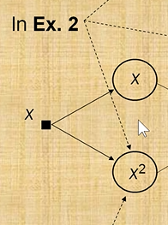
hidden laser → sigmodial function, radial bassic function, gaussian
→ these functons are activiation functoins

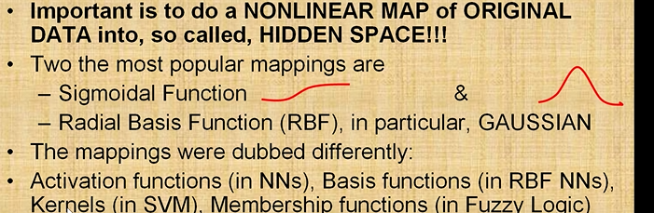

Fourier series and Polynomial approximations → simple neurall netwoek

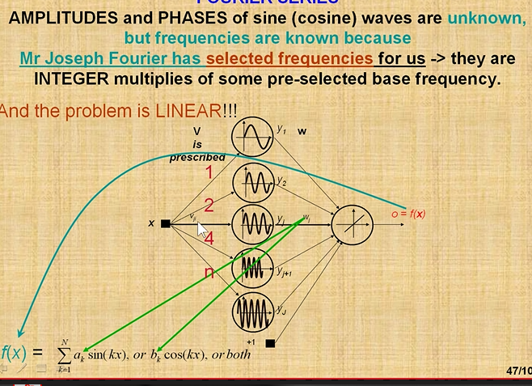

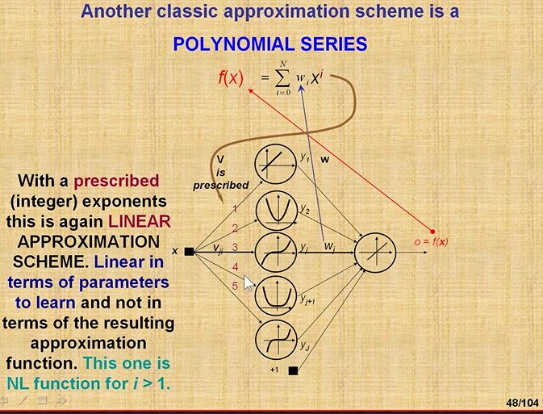
za x racuna se svaka funkcija 1, 2, 3, 4, 5 I dalje y → te zavrse u matricu u stupcu →

koliko x toliko dimenzija inputa

variance – koliko model varira ovisno o setovima podataka
bias – data and appromaximation kolika je razlika →

hight bias – low variance
low bias – highr variance
good model →

Gradient method
→ make derivate → only in wich diretino go →
→ lančano pravilo u deriviranju

→ change of W (weight) → expected labael value – output * derivatei of activation function
→ EBP → Generallized delta learning rule

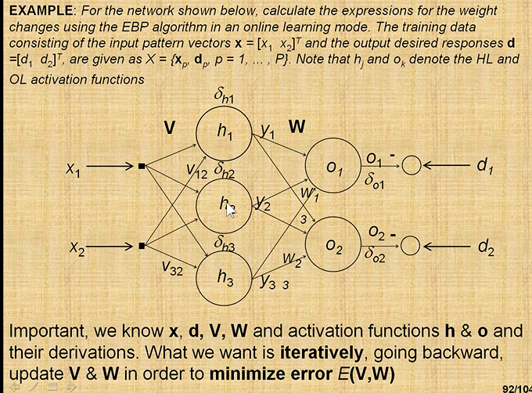

error back propagaion

