Docker
Resources:
https://docs.docker.com/get-started/
https://docs.docker.com/develop/develop-images/dockerfile_best-practices/

Container
Is sandboxed process on your machine that is isolated from all other processes on the host machine. That isolation leverages kernel namespaces and cgroups
is a runnable instance of an image. You can create, start, stop, move, or delete a container
is portable (can be run on any OS)
Containers are isolated from each other and run their own software, binaries, and configurations

Container image
an isolated filesystem
it must contain everything needed to run an application - all dependencies, configuration, scripts, binaries, etc. The image also contains other configuration for the container, such as environment variables, a default command to run, and other metadata.

A Dockerfile is simply a text-based script of instructions that is used to create a container image

The container’s filesystem
When a container runs, it uses the various layers from an image for its filesystem. Each container also gets its own “scratch space” to create/update/remove files. Any changes won’t be seen in another container, even if they are using the same image.

While containers can create, update, and delete files, those changes are lost when the container is removed and all changes are isolated to that container. With volumes, we can change all of this.
Volumes provide the ability to connect specific filesystem paths of the container back to the host machine
By creating a volume and attaching (often called “mounting”) it to the directory the data is stored in, we can persist the data. As our container writes to the todo.db file, it will be persisted to the host in the volume.

Named volume. Think of a named volume as simply a bucket of data. Docker maintains the physical location on the disk and you only need to remember the name of the volume.

The Mountpoint is the actual location on the disk where the data is stored. Note that on most machines, you will need to have root access to access this directory from the host.

Volumes are the preferred mechanism for persisting data generated by and used by Docker containers. While bind mounts are dependent on the directory structure and OS of the host machine, volumes are completely managed by Docker.
In addition, volumes are often a better choice than persisting data in a container’s writable layer, because a volume does not increase the size of the containers using it, and the volume’s contents exist outside the lifecycle of a given container.

If your container generates non-persistent state data, consider using a tmpfs mount to avoid storing the data anywhere permanently, and to increase the container’s performance by avoiding writing into the container’s writable layer.

With bind mounts, we control the exact mountpoint on the host. We can use this to persist data, but it’s often used to provide additional data into containers. When working on an application, we can use a bind mount to mount our source code into the container to let it see code changes, respond, and let us see the changes right away.

Using bind mounts is very common for local development setups. The advantage is that the dev machine doesn’t need to have all of the build tools and environments installed. With a single docker run command, the dev environment is pulled and ready to go. We’ll talk about Docker Compose in a future step, as this will help simplify our commands (we’re already getting a lot of flags

Multi container apps

In general, each container should do one thing and do it well. A few reasons
- to scale differently
- version update in isolation
- do not ship together

Running multiple processes will require a process manager (the container only starts one process) which adds complexity to container startup/shutdown
So, how do we allow one container to talk to another? The answer is networking.

There are two ways to put a container on a network:
1) Assign it at start or
2) connect an existing container

docker network create todo-app // create the network
Start a MySQL container and attach it to the network

Start a new container using the nicolaka/netshoot image.

Use Docker Compose

Docker Compose is a tool that was developed to help define and share multi-container applications. With Compose, we can create a YAML file to define the services and with a single command,

The big advantage of using Compose is you can define your application stack in a file, keep it at the root of your project repo (it’s now version controlled), and easily enable someone else to contribute to your project.

When you have built an image, it is a good practice to scan it for security vulnerabilities using the docker scan

Learn Docker in A Month of Lunches

Intro

Celean up docker commands
docker container rm -f $(docker container ls -aq)
to reclaim disk space
docker image rm -f $(docker image ls -q)

Running Hello world

docker container run [container name]
todo zuto iz knjige
docker container run --interactive --tty diamol/base
docker container ls

Understanding Docker container and images

Before you begin

running applications in lightweight units called containers.

Migrating app to the cloud
IaaS – infrastructure as a service. Every component runs in its own VM
PaaS – platform as a service. Every component gets mapped to a managed service to the cloud provider.
Containers on cloud (Azure Kubernetes or Amazon’s Elastic Container Service) on your own Docker cluster in the data center

Legacy apps
Moving your app to Docker is a great first step to modernizing the architecture, adopting new patterns without needing a full rewrite of the app.
First put monolith in a container. Then start breaking your application moving features into their own containers, so gradially your monolith can evolve into a distributed application

Build new cloud native apps (microservices)
The Cloud Native Computing Foundation (CNCF) characterizes these new architecture as using “an open source software stack to deploy applications as microservices.
Demo apps: GitHub at https://github.com/microservices-demo.

Serverless
The goal of serverless is for developer to write function code, push it to the service and that service builds and packages the code. When consumers use the function the service starts an instance of the function to process the request. There are no build servers, pipelines or production server to manager it’s all take care of by the plafform. Under the hood all the cloud serverless options use Docker to package the code and containers to run functions

Digital transformation with DevOps
DevOps is mainly about cultural change, and it can take organizations from huge quarterly releases to small daily deployments.
There’s powerful framework for implementing DevOps called CALMS – Culture, Automation, Lean and Sharing

Understanding Docker and running Hello World

Hello World
Docker container run xyz
→ tells Docker to run an application in a container. (has already been packaged to run, and has been published)
→ application = container package = image (all the component for the app to run along with the instruction (docker image) for Docker on how to start app)
→ image need to be on local machine before Docker can run a container with image inside
Someone package app so that can be run in a container and then publishes it, then anyone with acess can run app in a container → build, share, run. Docker image can be packaged to run on any computer that supports Docker, which makes the app completely protable

What is a container
A Docker container is the same ideas as a physical container – think of it like a box with an app in it. Inside the box app seems to have a computer all to itself (has own machine name, IP address, disk drive). Those things are all virtual resources and they’re logical objects that are managed by Docker. The app inside the box can’t see anything outside the box, but the box is running on a computer and that computer can also be running lots of other boxes. The app in those boxes have their own separate environments managed by Docker, but they all share the CPU and memory of the computer and they all share the computer’s OS.
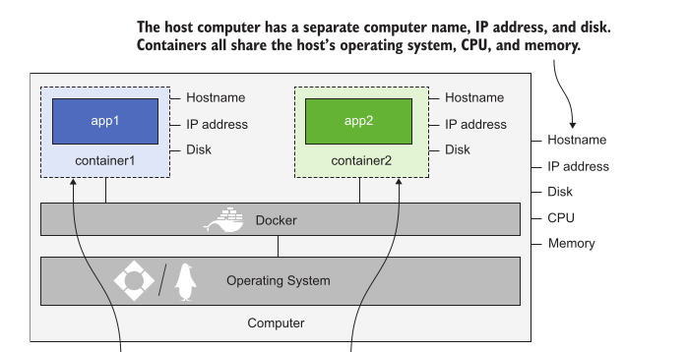

Connecting to a container
How you can run a container and connect to a terminal inside the container just as if you were connecting to a remote machine. Solution pass –interactive flag and –tty flag
docker container run –interactive -tty diamol/base
Interactive flag tells Docker you want to set up a connection to the container
Tty flag mean you want to connect to a terminal session inside the container
Remember that the container is sharing your computer’s operating system, which is why you see a Linux shell if you’re running Linux and a Windows command line if you’re using Windows. Docker itself has the same behavior regardless of which operating system or processor you’re using. It’s the application inside the container that sees it’s running on an Intel-based Windows machine or an Arm-based Linux one.

Run container
docker container run img_name

Run container in background
Docker container run img_name --detach

Get details of all containers
Docker container ls --all

Get details of all the running containers
docker container ls

List the processes running in the container
docker container top container_id

Show container status (CPU, memory, network)
Docker container stats name

Show logs
Docker container logs container_id
Output from the application in the containers

Remove container
Docker container rm name –force

Remove all containers
docker container rm --force $(docker container ls --all –quiet)
The $() syntax sends the output from one command into another command

See details of a container
docker compose inspect
Lots of low-level info like paths of the container’s virtual file system, virtual docker network info

Hosting a website in a container
Containers are running only while the app inside the container is running. As soon as the app process ends, the container goes into the exited state.
Containers in the exited state still exist, which means you can start them again. So Docker doesn’t remove exited container unless you explicitly tell it to do so, be careful about memory

Export port
Docker container run –publish 8080:80 xyz
Publish – publishes a port from the container to the computer
Traffic coming into your computer can be intercepted by Docker and then Docker can send that traffic into a container. Containers aren’t exposed to the outside world by default. Each has its own IP address, but that’s an IP address that Docker creates for an network that Docker manages – the container is not attached to the physical network of the computer. Publishing a container port means Docker listens for network traffic on the computer port and then sends it into the container.
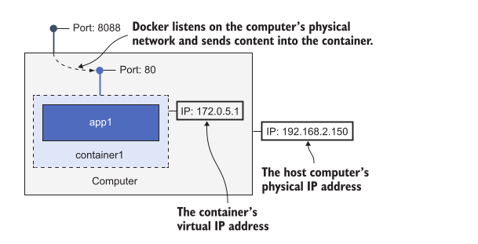
In this example my computer is the machine running Docker, and it has the IP address 192.168.2.150 . That’s the IP address for my physical network, and it was assigned by the router when my computer connected. Docker is running a single container on that computer, and the container has the IP address 172.0.5.1 . That address is assigned by Docker for a virtual network managed by Docker. No other computers in my network can connect to the container’s IP address, because it only exists in Docker, but they can send traffic into the container, because the port has been published.

How Docker runs containers
The Docker engine it the management component of Docker. It looks after the local image cache, downloading images when you need them and reusing them. It also works with OS to create containers, they virtual networks and all other Docker resources.
The Docker Engine makes all the features available through the Docker API, which is just a standard HTTP-based REST API. You can configure the Engine to make the API accessible only from the local computer (which is the default), or make it available to other computers on your network.
The Docker command-line interface (CLI) is a client of the Docker API. When you run Docker commands, the CLI actually sends them to the Docker API, and the Docker Engine does the work.
There are several graphical user interfaces that connect to the Docker API and give you a visual way to interact with your containers

Running distributed applications in containers

Running multiple environments with Docker Compose

Docker Compose is a tool for running multi-container applications on a single Docker Engine. It’s great for developers, and it’s also heavily used for non-production environments. Organizations often run multiple versions of an app in different environments—maybe version 1.5 is running in production, version 1.5.1 is being tested in a hotfix environment, version 1.6 is finishing up user testing, and version 1.7 is in system test

Problem: run two or more instance of the application on a single Docker Engine:
# run the to-do list app from chapter 6:
docker-compose -f ./todo-list/docker-compose.yml up -d
# and try another copy of the to-do list:
docker-compose -f ./todo-list/docker-compose.yml up -d

you can’t start a second instance of an application by running up from the same folder. Docker Compose thinks you’re asking it to run an application that is already running, so it doesn’t start any new containers.

Why ?
name of the directory that contains the Compose file is used as the default project name (for containers adds a numeric counter as a suffix)
example:
compose file is in a folder app1, defines service web and volume disk
→ app1_disk
→ app1_web_1

Solution
override the default project name
Use -p to specify a project name
docker-compose -f ./todo-list/docker-compose.yml -p todo-test up -d
The naming pattern is predictable container will be called todo-test_todo-web_1
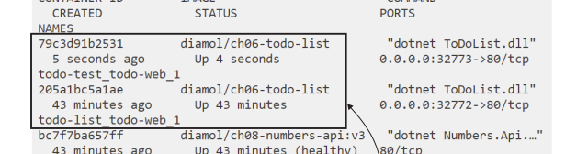
This approach lets you run many copies of many different applications. To support different setups in different environments, you could create duplicate Compose files and edit the properties that need to change, but Compose has a better way of managing that with overrides

Docker Compose lets you merge multiple files together, with properties from later files overriding those from earlier in the merge.

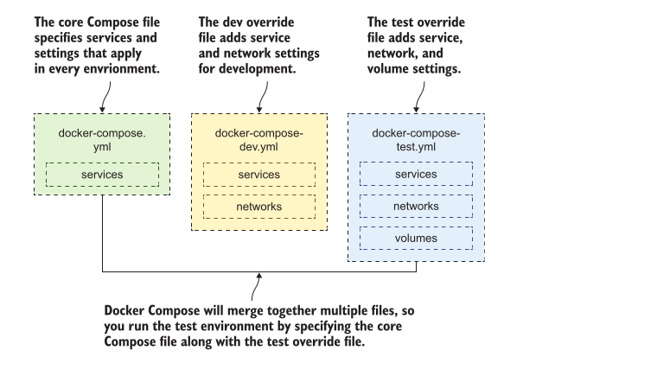

You start with a core docker-compose.yml file that contains the basic structure of the app, with the services defined and configured with properties that are common for all environments. Then each environment has its own override file that adds specific settings, but it doesn’t duplicate any of the configuration from the core file.

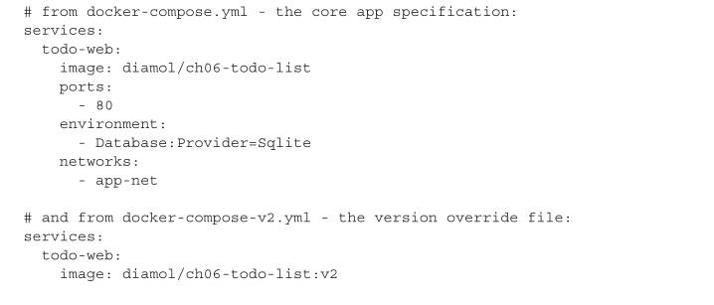

In the override file you just specify the properties you care about, but you need to pre-serve the structure of the main Compose file so that Docker Compose can link the definitions together.

Docker Compose merges files together when you specify multiple file paths in docker-compose commands.
docker-compose -f ./todo-list/docker-compose.yml -f ./todo-list/docker-compose-v2.yml config
(The config command doesn’t actually deploy the app; it just validates the configuraion.)
applies overrides in the order that the files are listed in the command

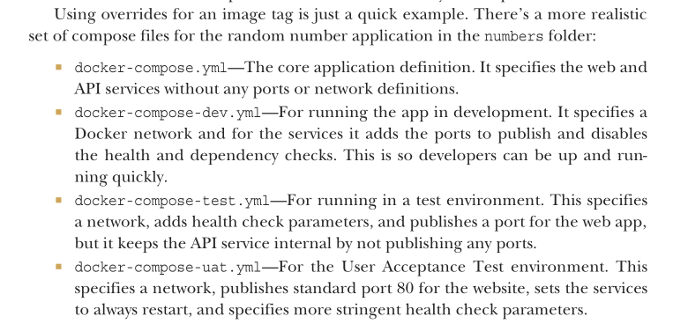
You could automate that command as part of your deployment process and commit the merged files to source control—then the alphabetical order makes it easy to compare releases.

You could automate that command as part of your deployment process and commit the merged files to source control—then the alphabetical order makes it easy to compare releases.
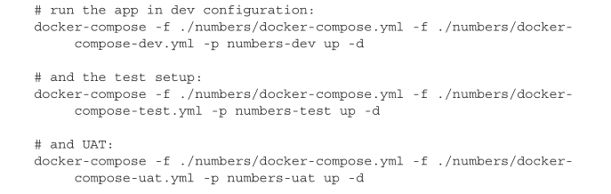

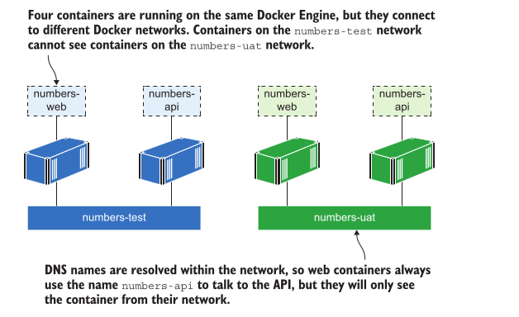

Now you have three copies of the application running, which are all isolated from each other because each deployment is using its own Docker network. In an organization, these would be running on one server, and teams would use the environment they want by browsing to the correct port. For example, you could use port 80 for UAT, port 8080 for system test, and port 8088 for the development team’s integration environment.

If you want to clear down the test environment, removing containers and the network, you would normally just run docker-compose down ,but that won’t work for these environments because Compose needs all the same file and project information you used in the up command to match the resources

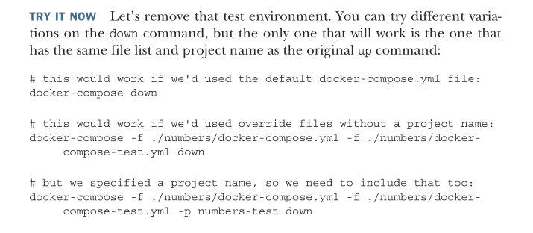
Injecting configuration an secrets

You can isolate applications using Docker networks and capture the differences between environments with Compose overrides, but you’ll also need to change the application configuration between environments. Most applications can read configuration settings from environment variables or files, and Compose has good support for both those approaches.

1. environment adds an environment variable inside the container
2. env_file contains the path to a text file, and the contents of the text file will be loaded into the container as environment variables.
3. configuration file set up as a secret.

The source is the place where the secret is loaded from the container runtime, and the target is the file path where the secret is surfaced inside the container.
The source of the secret could be a local file when you’re using Compose, or it could be an encrypted secret stored in a Docker Swarm or Kubernetes cluster. Whatever the source, the contents of the secret get loaded into a file in the container for the application to read.

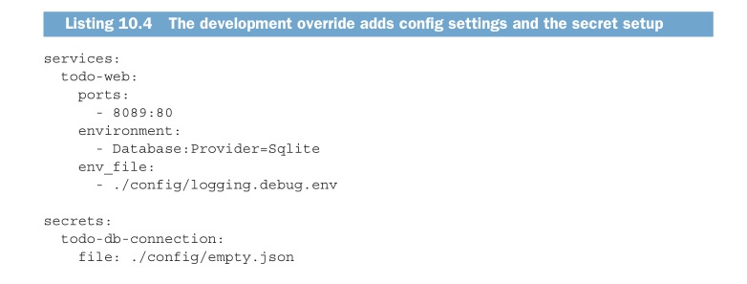
another approach using environment file, .env (default environment variables in an environment file named .env)
.env file from the project directory
you can use the --env-file command line option to override the default .env and specify the path to a custom environment file.
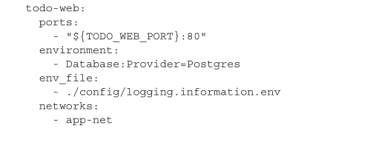

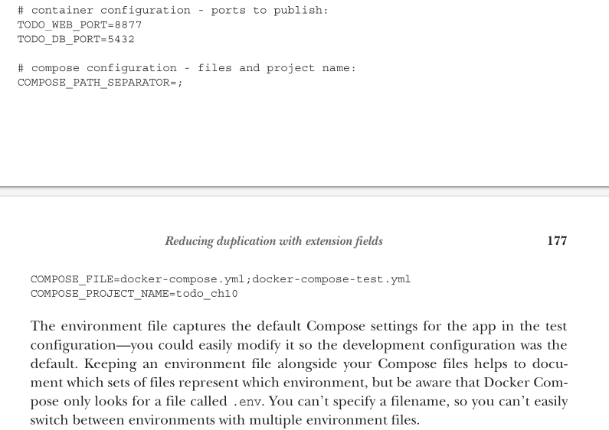

Configuration workflow with Docker
at defining different environments with Docker Compose and focused on three key areas
Application composition —Not every environment will run the whole stack. Features like the monitoring dashboard may not be used by developers for local set up. Override files let you do this.
Container configuration – Published ports need to be unique so they don’t collide with other containers, and volume paths may use local drives in the test environment but shared storage in production. Override files let you do this.
Application configuration—The behavior of applications inside containers will change between environments. You can do this using Compose with any combination of override files, environment files, and secrets.

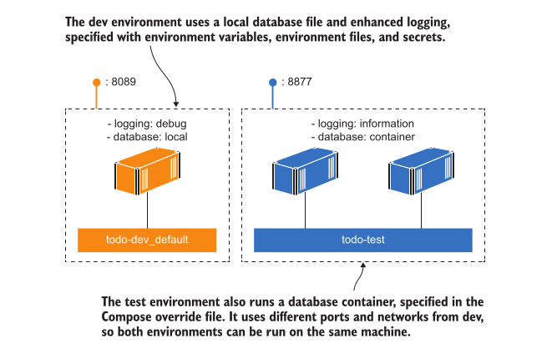
The most important takeaway from this is that the configuration workflow uses the same Docker image in every environment. The build process will produce a tagged version of your container images, which have passed all the automated tests. That’s a release candidate that you deploy to the smoke-test environment using the configuration in your Compose files. When it passes the smoke test, it moves on to the next environment, which uses the same set of images and applies new configuration from Compose. Ultimately you’ll release that version if the tests all pass, when you’ll deploy those same container images to production using your Docker Swarm or Kubernetes deployment manifests. The software that gets released is exactly the same software that has passed all the tests, but now it has production behavior supplied from the container platform

Building and testing applications with Docker and Docker Compose

Automation is at the heart of Docker. You describe the steps to package your component in a Dockerfile and use the Docker command line to execute them; you describe the architecture of your app in a Docker Compose file and use the Compose command line to start and stop the app.

how to do continuous integration (CI) with Docker ? CI is an automated process that runs regularly to build applications and execute a suite of tests

The CI process is a pipeline that starts with code, executes a set of steps, and finisheswith a tested deployable artifact. One of the challenges with CI is that pipelines become unique for each project—different technology stacks do different things the steps and produce different types of artifacts. The CI server needs to work for all those unique pipelines, so every combination of programming language and build framework can get installed on the server, and it can easily become unmanageable.

Docker brings consistency to the CI process because every project follows the same steps and produces the same type of artifact. Figure 11.1 shows a typical pipeline with Docker—it is triggered by a code change or a timed schedule, and it produces a set of Docker images.

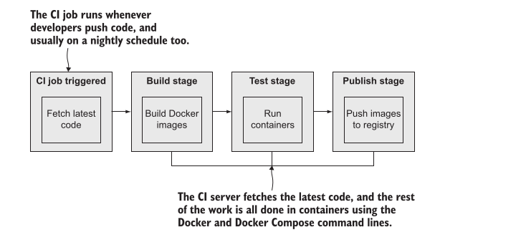
Each step in the CI pipeline runs with Docker or Docker Compose, and all the work happens inside containers. You use containers to compile applications, so the CI server doesn’t need to have any programming languages or build SDKs installed. Automated unit tests run as part of the image build, so if the code is broken, the build fails and the CI job stops. You can also run more sophisticated end-to-end tests by starting the whole application with Docker Compose alongside a separate container that runs tests to simulate user workflows.
In a Dockerized CI process, all the hard work happens in containers, but you still need some infrastructure components to hold everything together:
- a centralized source code system
- Docker registry to store images
- an automation server to run the CI jobs.

The three components you need can easily be run in containers
- using Gogs Git server for source control
- open source Docker registry for distribution
- Jenkins as the automation server

you can use that consistency to add many useful features to your pipeline. Figure 11.14 shows a more extensive CI process that includes security-scanning container images for known vulnerabilities and digitally signing images to assert their provenance.

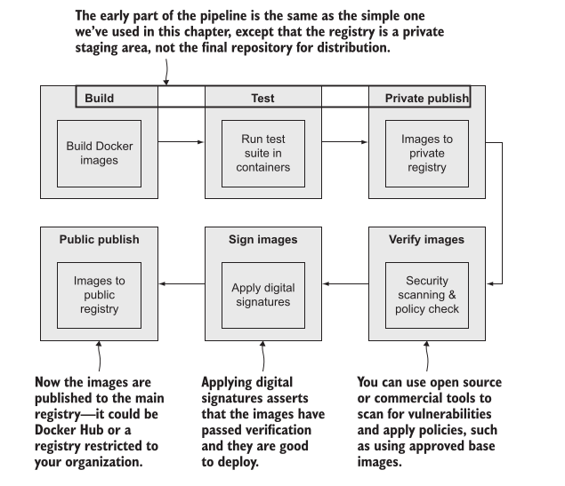
Docker calls this approach the secure software supply chain, and it’s important for all sizes of organizations because it gives you confidence that the software you’re about to deploy is safe

