Basic of Refactoring

Refactoring is a systematic process of improving code without creating new functionality that can transform a mess into clean code and simple design

Checklist
- The code should become cleaner
- New functionality shouldn't br created during refactoring
- All existing test must pass (Write BDD style tests)

Automatic unit tests should be set up before refactoring to ensure methoda still behave as expected. ( Also chech BDD testing). Refactoring is then an iterative cycke if nakubg a small program transfomration, testing it to ensuer correcntness and making another small transformations

Techinques (see Martin Fowler refactoring book)

For more understanding what is going on:
- Program Dependence Graph - explicit representation of data and control dependencie
- System Dependence Graph - representation of procedure calls
- Software intelligence - reverse engineers the initial state to understand existing
- UML from source code

For more abstraction
- Encapsulate field
- Generalize type
- Replace type-checking code with state/strategy (Replace type-checking code with State/Strategy )
- replace conditional with polymorphism (Replace conditional with polymorphism )

For breaking code apart
- Componentization breaks code
- Extract class moves part of the code from an existing class into a new clas
- Extract method, to turn part of a larger method into a new method.

Improve naming
Automatic clone detection softwares (Duplicate code: ttps://en.wikipedia.org/wiki/Duplicate_code)

Although refactoring code has been done informally for decades, William Griswold's 1991 Ph.D. dissertation[23] is one of the first major academic works on refactoring functional and procedural programs, followed by William Opdyke's 1992 dissertation[24] on the refactoring of object-oriented programs,[25] although all the theory and machinery have long been available as program transformation systems
Books: http://cseweb.ucsd.edu/~wgg/Abstracts/gristhesis.pdf
https://web.archive.org/web/20191216212919/https://dl.acm.org/citation.cfm?id=169783
https://dl.acm.org/doi/book/10.5555/169783
Martin Fowler's book Refactoring: Improving the Design of Existing Code

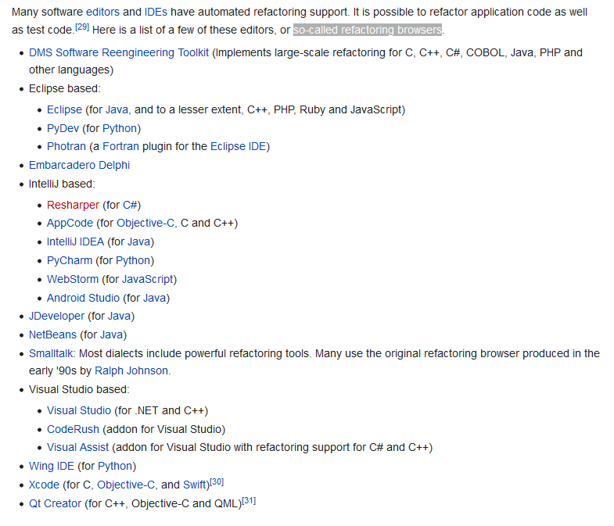
Refactoring browsers ( Automated refactoring support)

List od tools for static code analysis
https://en.wikipedia.org/wiki/List_of_tools_for_static_code_analysis

Code smelles

Bloaters are code, methods and classes that have increased to such gargantuan proportions that they are hard to work with.
- Long Method
- Large Class
- Primite Obsession
- Long parameter lis
- Data clumps (different parts of the code contain identical groups of variables)

Object Orientation Abusers
- Alternative Classes with different Interface (Two classes perform identical functions but have different method name)
- Refuesd Bequest (If a subclass uses only some of the methods and properties inherited from its parents, the hierarchy is off-kilte )
- Switch Statements (If a switch is based on type code, such as when the program’s runtime mode is switched, use Replace Type Code with Subclasses or Replace Type Code with State/Strategy. )
- Temporary Field (Temporary fields and all code operating on them can be put in a separate class via Extract Class, introduce Null Object)
Change Preventers (if you need to change something in one place in your code, you have to make many changes in other places too)
- Divergent Change (You find yourself having to change many unrelated methods when you make changes to a class, introduce new class)
- Parallel Inheritance Hierarchies
- Shotgun Surgery (Making any modifications requires that you make many small changes to many different classes, move methods, files, introduce new class)

Dispensables (A dispensable is something pointless and unneeded whose absence would make the code cleaner, more efficient and easier to understand)
- Comments
- Duplicate Code
- Dead Code (if code is not longer used)
- Lazy Class (too small class or only specific funtionality used in one place, cosider inline class)
- Speculative Generality (progaraming for future, you end up with class and methods that you do not use)

Couplers
- Feature Envy ( method acesses that of another obj more than its own dana, move method)
- Inappropriate Intimacy (class uses private fileds and methods or another class)
- Incomplete Library Class (use existing libary indetad of crating you own)
- Message Chains ($a->b()->c()->d(), use Hide Delegate )
- Middle Man (If a class performs only one action, delegating work to another class, why does it exist at all )

also
https://en.wikipedia.org/wiki/Data_deduplication
https://en.wikipedia.org/wiki/Don%27t_repeat_yourself
https://en.wikipedia.org/wiki/Redundant_code
https://en.wikipedia.org/wiki/Rule_of_three_(computer_programming)
Program_transformation

TODO https://en.wikipedia.org/wiki/Program_transformation

Anti paterns
https://en.wikipedia.org/wiki/Anti-pattern

From
-> https://refactoring.guru/refactoring
-> https://en.wikipedia.org/wiki/Code_refactoring
-> https://refactoring.com/ STAO, knjige procitaj
-> https://refactoring.guru/store chech this hmm
-> https://sourcemaking.com
-> https://www.sciencedirect.com/topics/computer-science/refactoring https://www.agilealliance.org/glossary/refactoring/#q=~(infinite~false~filters~(postType~(~'page~'post~'aa_book~'aa_event_session~'aa_experience_report~'aa_glossary~'aa_research_paper~'aa_video)~tags~(~'refactoring))~searchTerm~'~sort~false~sortDirection~'asc~page~1)
-> https://wiki.c2.com/?WhatIsRefactoring

