Computer Network

form: NYUx FCS.NET.1Introduction to Networking

Internet
Conencted Computing deviced = host
Comunication links – fiber, copper, radio, satelite
Transmission rate: bandwidth (how fast we move throught Internet)
Packet switcher (foward packets) – routers and switches

Internate is infrastructure that provides services to applications (web, voip, games, email=
provides interface to apps

Protocol defines
- format,
- order
- action on actions

Network edge (end systemd, access networks, links)
Hosts: server and clients
Acess network wired. Wireless
Network core; Interconnected routers

Kepp in mind when conecting
- bandwidth (bits per seond)
- shared or dedicated

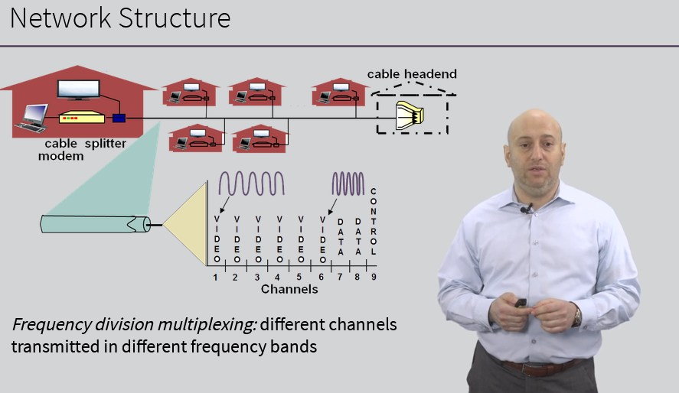

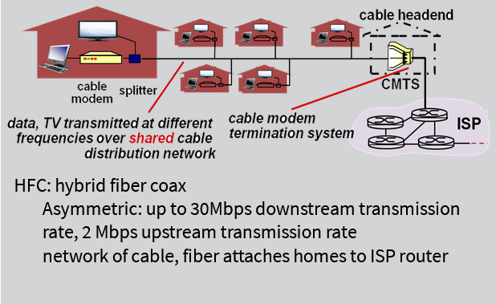

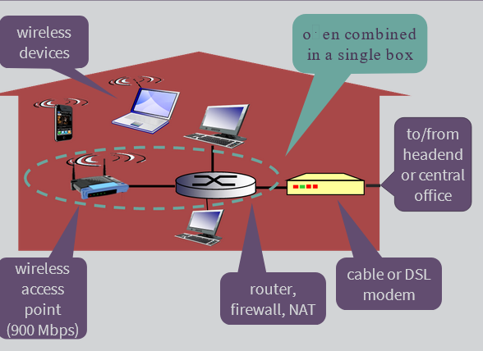

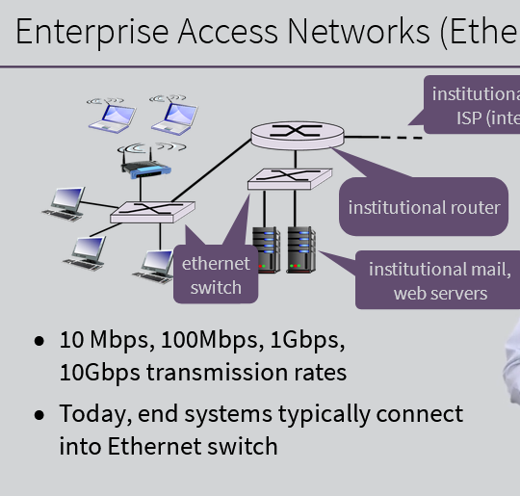

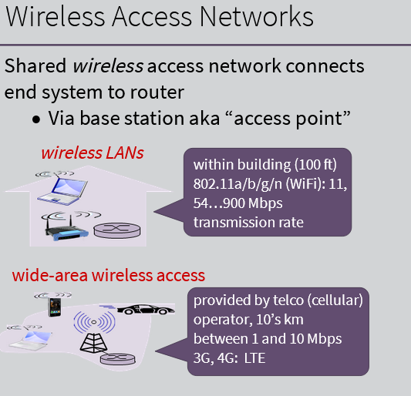

Physicla Media
Guided where signals propagate in solid media (copper, fiver, coax)
Unguided media where signals propagate freely (radio)

Physical link – what lies between transmitter and reciver

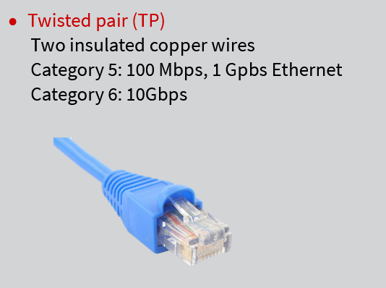

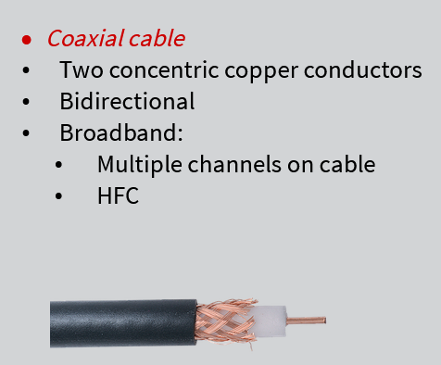

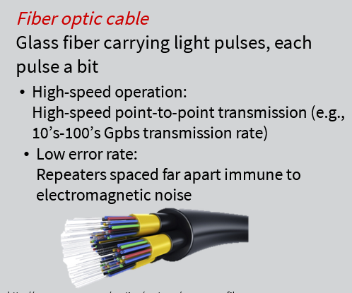

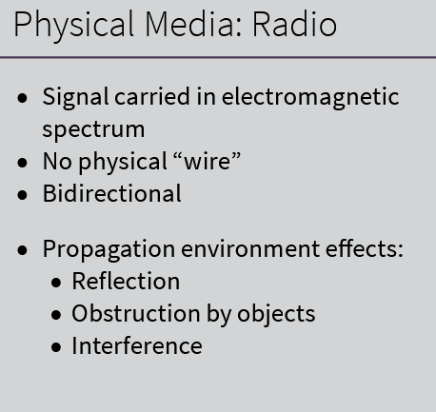

Network core is mesh of interconnected routed
Packet – swiitching: host break application layer messaged into packages forwar packets form one router to the next across links on path to the next across links on path from source to destination

Store and Forward technicke in packet switching
Entire packet must arrive at router before it can be transmitted on next link
L – dužina poruke
R – brzina kroz žicu
formla : 2L/R (assuming zero propagation delay)

Queuing delay and loss
If arrival rate in bits to link exceeds transmission rate of link for a period of time
-> packed will queue (wait to be transmittd on link)
-> packed can be dropped (lost) if memeory (buffer) fills up

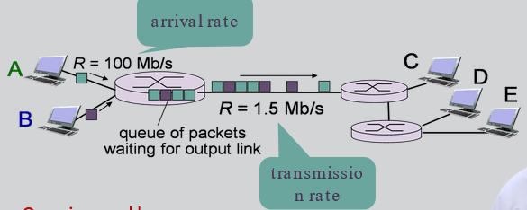
Routing: detemnines source-desttinatio route taken by packets.
Forwarding: move packets from router's input to appropriate router output

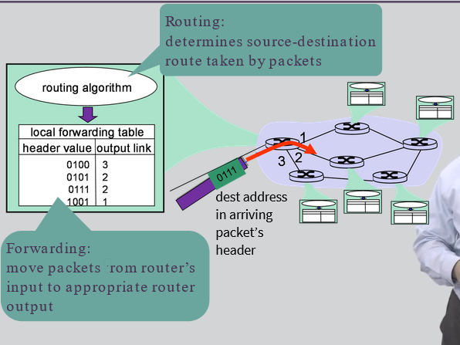

Network of Networks
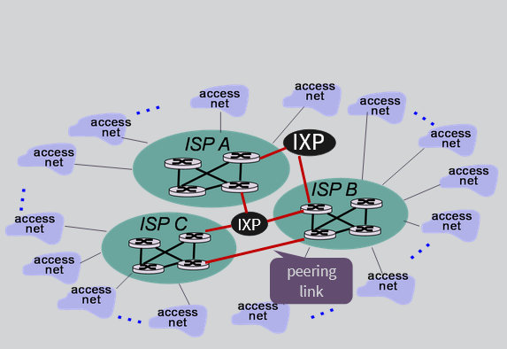
IXP – internat excgange ips

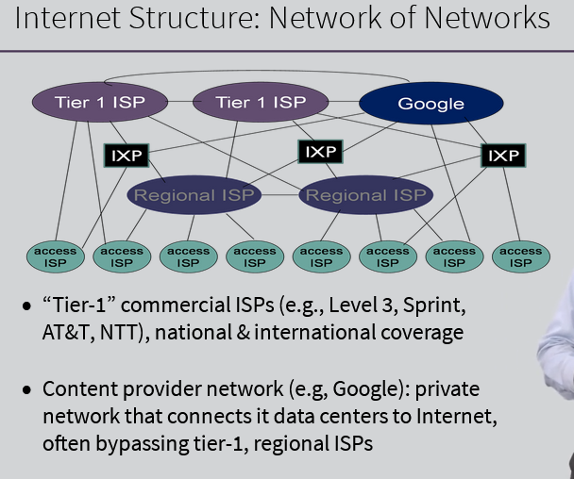

Delay Loss Throughout In Networks

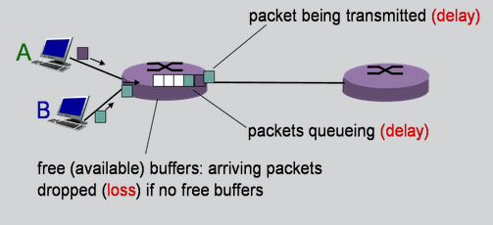

Packet arrival rate to link (temporarily) exceede output link capacity, then packects are stored in packets queue and wait for their turn (like trains station it can accept only n passengerts oterh are waithing)
There are four sorces of packet delay
-> Nodal proessing
Check bit errors, determin outout link, very slow
-> Queueing delay
Time waiting at output link for transmission. It depends on congestion level of router
As trafic increaces queueing delay can be higher
-> Transmission delay
L packet lengtht (bit) link bandwidth (bps) d = L/R
how much time to get pakect on link
-> Propagation delay
d lenght of physical link, s propagatino spedd in medium
formula = d /s
how much time to get packet throught physicla link

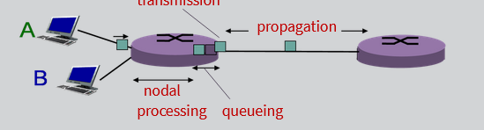

Buffer in router have limited capacity (queue /preceding link). Throughput: rate (bits/time) at which bit transferrf between sender/recver . You need to look at avarge

Protocol Layers
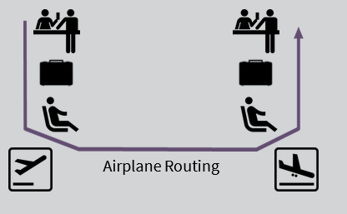

Layer idea. -> Each layer implements a service via its own internal layer actions relying on services provided by layer below. You fet ease of maintance, updating of system, change of implemenatation of laye's service transparent ot rest of system

Internet protocol stack
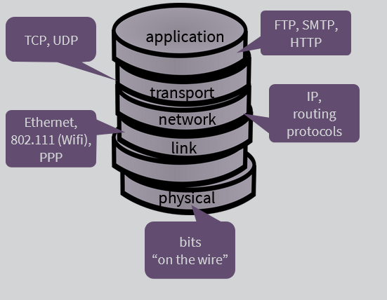

Presentation (encryption, comperssion) and session layer (synchronization, checkpointing) are implemente in application layer

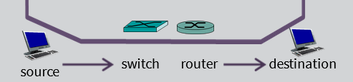

every layer adds header and at end its all on source compacted where on destitanon is done decompaction from end to start

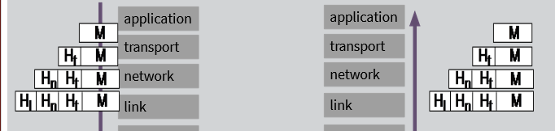
Switch use link and physical layer
Router use network, link and physical layers

Network Security
- how computer can be attacked, how defend against attacks
- how create architecture that are immune to attacks
- security consideration in all layers

Application Layer

Network App is app that compunicate with other apps ovet the netwotk. No need to write software for network-core devices and network core device do not run users app.
Application architecture: Client – Servet and Peet to Peer

Client Server Arhitecture
Server is always on host, permanent IP address and dana centers for scaling
Client communicat with server may be intermittently connected, can have dynamic IP addresses
Client do not communicate directly with each other

Perr to Perr
No server. Perrs request service from other peers, provide service in retun to other peers. Complex managment

Processes Communication
Client process init communication
Server process waith to be contacted. Within same host two processes communicate using inner-process communication (defined by OS)
Processes in different hosts communicat by exchanging messages
Peer have client and server processes

Socket
Process send and recive msg throught socket
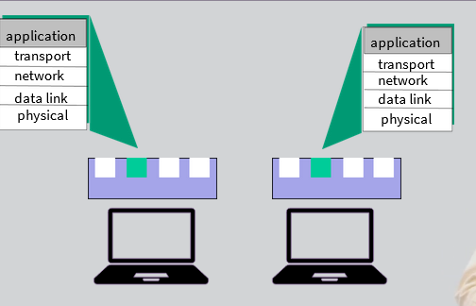

Socket can be viewed as door then go to the Internet and to the serve door where he recive msg.

To revice messga process must have id
host deice has uniques 32.bit IP address. Identifier includes IP dress and port number associated with process on host. Example HTTP server: 80 Mail server: 25. You can configure server to recive dana on specific port (example 4300)

App layer Protocol defines
- types of messages exchanged (req, res)
- mesage syntax (fields in message)
- semantix (meaning of information in fields)
- rules for when and how processes work with msg
- as programer you must know as much as possible app layer protoclos
- open protocolso and propreitary protools (skype)

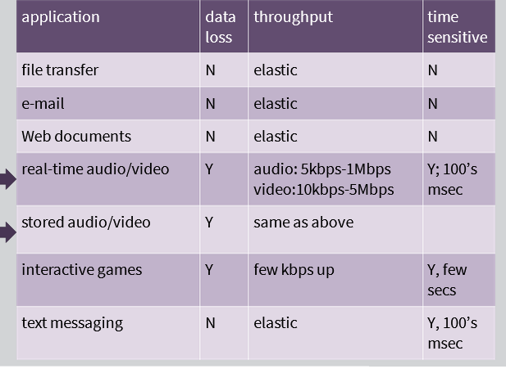
Diferent app need diferent transpor service

Transport Layer

TCP service
Reliable transport
Flow control sender won't overwhelme reciver
Congestion control throttle sender when network overloaed
Do not have timing, mini throughput, guarantee, security
Connection oriented (requires setup between client and server process)

UDP service
Unrealiable dana transfer
Does not provide flow control, congression, timing, connectio setup
It need 40% less bandwidth (faster)

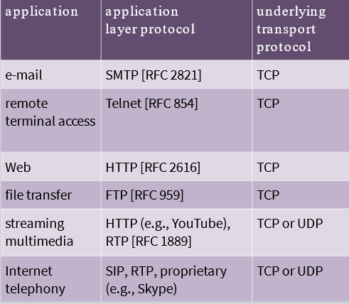

Web and http
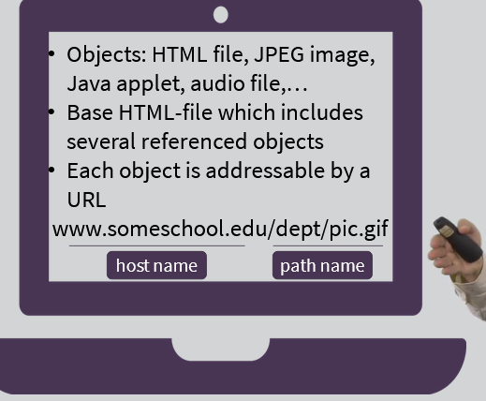

HTTP: hypertext transfer protocol (web application layer protocol)
stao week 2 2 ili 3 video on next

