Modern Operating Systems

Processes and threads

Central conept in os is the process (an abstraction of a runnung program) A process is just an instance of an executing program, including the current values of the program counter, registers, and variables. Conceptually, each process has its own virtual CPU. In reality, of course, the real CPU switches back and forth from process to process, but to understand the system, it is much easier to think about a collection of processes running in (pseudo) parallel than to try to keep track of how the CPU switches from program to program. This rapid switching back and forth is called multiprogramming.
The key idea here is that a process is an activity of some kind. It has a program, input, output, and a state. The fact that two processes happen to be running the same program does not matter; they are distinct processes

Process Creation
Four principal events cause processes to be created:
1. System initialization.
2. Execution of a process-creation system call by a running process.
3. A user request to create a new process.
4. Initiation of a batch job.
Processes that stay in the background to handle some activity are called demons

In UNIX, there is only one system call to create a new process: fork. This call creates an exact clone of the calling process. After the fork, the two processes, the parent and the child, have the same memory image, the same environment strings, and the same open files. That is all there is. Usually, the child process then executes execve or a similar system call to change its memory image and run a new program.

In Windows, in contrast, a single Win32 function call, CreateProcess, handles both process creation and loading the correct program into the new process. This call has 10 parameters, which include the program to be executed, the command-line parameters to feed that program, various security attributes...

In both UNIX and Windows systems, after a process is created, the parent and child have their own distinct address spaces.

Process will terminate due to one of the following condiditons:
1. Normal exit (voluntary).
2. Error exit (voluntary).
3. Fatal error (involuntary).
4. Killed by another process (involuntary).

In some systems, when a process creates another process, the parent process and child process continue to be associated in certain ways. The child process can itself create more processes, forming a process hierarchy. (can have 1 parent and many child)
In unix process and all of its childern form a process grout. When a user sends a signel from the keyboard, the signal is delivered to all members of the process group currently associated with the keyboaard
Unix
-> after the computer is booted. A special process, called init, is present in the boot image. When it starts running, it reads a file telling how many terminals there are. Then it forks off a new process per terminal. These processes wait for someone to log in. If a login is successful, the login process executes a shell to accept commands. These commands may start up more processes, and so forth. Thus, all the processes in the whole system belong to a single tree, with init at the root.
Wind
-> All processes are equal. The only hint of a process hierarchy is that when a process is created, the parent is given a special token (called a handle) that it can use to control the child
Process States
1. Running (actually using the CPU at that instant).
2. Ready (runnable; temporarily stopped to let another process run).
3. Blocked (unable to run until some external event happens).

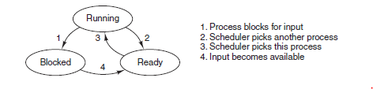
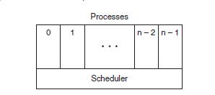

To implement the process model, the operating system maintains a table (an array of structures), called the process table, with one entry per process. (Some authors call these entries process control blocks.) This entry contains important information about the process’ state, including its program counter, stack pointer,
memory allocation, the status of its open files, its accounting and scheduling information, and everything else about the process that must be saved when the process is switched from running to ready or blocked state so that it can be restarted later as if it had never been stopped.

Associated with each I/O class is a location (typically at a fixed location near the bottom of memory) called the interrupt vector. It contains the address of the interrupt service procedure. Suppose that user process 3 is running when a disk interrupt happens..
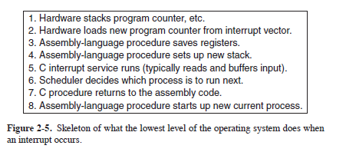

Actions such as saving the registers and setting the stack pointer cannot even be expressed in high-level languages such as C, so they are performed by a small assembly-language routine, usually the same one for all interrupts since the work of saving the registers is identical, no matter what the cause of the interrupt
is.

When multiprogramming is used, the CPU utilization can be improved. Crudely put, if the average process computes only 20% of the time it is sitting in memory, then with fiv e processes in memory at once the CPU should be busy all the time. This model is unrealistically optimistic, however, since it tacitly assumes
that all fiv e processes will never be waiting for I/O at the same time.
CPU utilization = 1 − p^n
n – number of proccesses
p^n - the probability that all n processes are waiting for I/O (in which case the CPU will be idle)

Threads

In many situations, it is desirable to have multiple threads of control in the same address space (from once process) running in quasi-parallel, as though they were (almost) separate processes

Why would anyone want to have a kind of process within a process (miniprocesses, called threads). The main reason for having threads is that in application can have multiple activities are going on at once. Some of these may block from time to time. By decomposing such an application into multiple sequential- Thread is the ability for the parallel entities to share an address space and all of its dana among themselves. Also creating and destroying is very fast. Threads are useful on systems with multiple CPUs, where real parallelism is possible. Thread is good for backgroud taks (autosave, do some work will main thread interacte with user) also consider example with web server (one thread, the dispatcher, reads incoming requests for work from the network. After examining the request, it chooses an idle (i.e., blocked) worker thread ) This model allows the server to be written as a collection of sequential threads. The dispatcher’s program consists of an infinite loop for getting a work request and handing it off to a worker

Fine state machine as server - simulating the threads
The server records the state of the current request in a table and then goes and gets the next event. The next event may either be a request for new work or a reply from the disk about a previous operation. If it is new work, that work is started. If it is a reply from the disk, the relevant information is fetched from the table and the reply processed. The state of the computation must be explicitly saved and restored in the table every time the server switches from working on one request to another. A design like this, in which each computation has a saved state, and there exists some set of ev ents that can occur to change the state, is called a finite-state machine
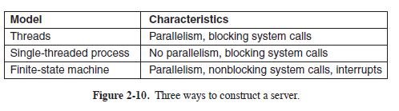
Reasrch on program (that must process very large amounts of data): process have input thread processing thread and an output thread (The input thread reads data into an input buffer. The processing thread takes data out of the input buffer, processes them, and puts the results in an output buffer.

Thread Model
The process model is based on two independent concepts: resource grouping and execution. Process is that it is a way to group related resources together. A process has an address space containing program text and data, as well as other resources. These resources may include open files, child processes, pending alarms, signal handlers, accounting information, and more. The other concept a process has is a thread of execution, usually shortened to just thread. The thread has a program counter that keeps track of which instruction
to execute next. It has registers, which hold its current working variables. It has a stack, which contains the execution history, with one frame for each procedure called but not yet returned from. Processes are used to group resources together; threads are the entities scheduled for execution on the CPU.
When a multithreaded process is run on a single-CPU system, the threads take turns running. Multithreading works the same way. The CPU switches rapidly back and forth among the threads, providing the illusion that the threads are running in parallel

Different threads in a process are not as independent as different processes. All threads have exactly the same address space, which means that they also share the same global variables. Since every thread can access every memory address within the process’ address space, one thread can read, write, or even wipe out another thread’s stack.

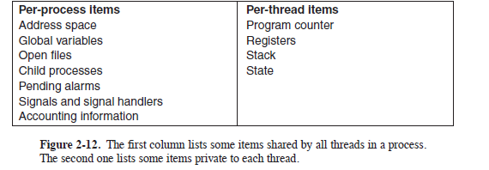
Item in the first column are process properties, not thread properties. Like a traditional process (i.e., a process with only one thread), a thread can be in any one of several states: running, blocked, ready, or terminated. A running thread currently has the CPU and is active. In contrast, a blocked thread is waiting
for some event to unblock it. It is important to realize that each thread has its own stack. Each thread’s stack contains one frame for each procedure called but not yet returned from. This frame contains the procedure’s local variables and the return address to use when the procedure call has finished. For example, if procedure
X calls procedure Y and Y calls procedure Z, then while Z is executing, the frames for X, Y, and Z will all be on the stack. Each thread will generally call different procedures and thus have a different execution history

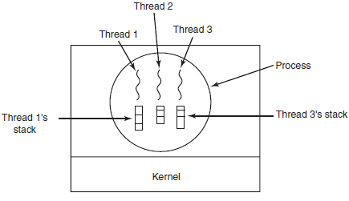
thread yield, which allows a thread to voluntarily give up the CPU to let another thread run.
thread joinblocks the calling thread until a (specific) thread has exited. one thread can wait for a (specific) thread to exit

If the parent process has multiple threads, should the child also have them (UNIIX fork – new thread) ?
However, if the child process gets as many threads as the parent, what happens if a thread in the parent was blocked on a read call, say, from the keyboard? Another class of problems is related to the fact that threads share many dana structures. What happens if one thread closes a file while another one is still reading from it?

There are two main places to implement threads: user space and the kernel and a hybrid implementation is also possible.
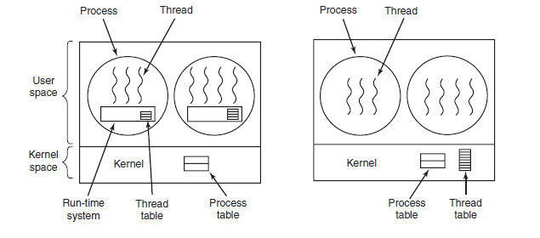
The first method is to put the threads package entirely in user space. The kernel knows nothing about them. As far as the kernel is concerned, it is managing ordinary, single-threaded processes. All operating systems used to fall into this category, and even now some still do. With this approach, threads are implemented by a library. When threads are managed in user space, each process needs its own private thread table to keep track of the threads in that process. This table is analogous to the kernel’s process table, except that it keeps track only of the per-thread properties, This table is analogous to the kernel’s process table, except that it keeps track only of the per-thread properties, User-level threads also have other advantages. They allow each process to have its own customized scheduling algorithm. Despite their better performance, user-level threads packages have some major problems. First among these is the problem of how blocking system calls are implemented.

The secon methos is to implement threads in the kernel. Instead, the kernel has a thread table that keeps track
of all the threads in the system. When a thread wants to create a new thread or destroy an existing thread, it makes a kernel call, which then does the creation or destruction by updating the kernel thread table. When a thread blocks, the kernel, at its option, can run either another thread from the same process
(if one is ready) or a thread from a different process. With user-level threads, the run-time system keeps running threads from its own process until the kernel takes the CPU away from it (or there are no ready threads left to run). Their main disadvantage is that the cost of a system call is substantial, so if thread operations (creation, termination, etc.) a common, much more overhead will be incurred.

Hybrid implementaton. Their main disadvantage is that the cost of a system call is substantial, so if thread operations (creation, termination, etc.) a common, much more overhead will be incurred.
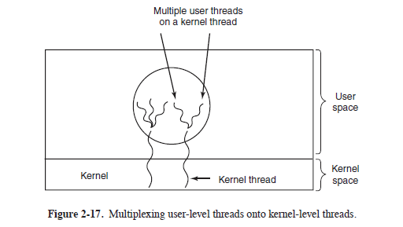
When this approach is used, the programmer can determine how many kernel threads to use and how many user-level threads to multiplex on each one. This model gives the ultimate in flexibility. The goals of the scheduler activation work are to mimic the functionality of kernel threads, but with the better performance and greater flexibility usually associated with threads packages implemented in user space. Efficiency is achieved by avoiding unnecessary transitions between user and kernel space.

When scheduler activations are used, the kernel assigns a certain number of virtual processors to each process and lets the (user-space) run-time system allocate threads to processors. This mechanism can also be used on a multiprocessor where the virtual processors may be real CPUs. The number of virtual processors
allocated to a process is initially one, but the process can ask for more and can also return processors it no longer needs. The kernel can also take back virtual processors already allocated in order to assign them to more needy processes

The basic idea that makes this scheme work is that when the kernel knows that a thread has blocked (e.g., by its having executed a blocking system call or caused a page fault), the kernel notifies the process’ run-time system, passing as parameters on the stack the number of the thread in question and a description of the event that occurred. The notification happens by having the kernel activate the run-time system at a known starting address, roughly analogous to a signal in UNIX. This mechanism is called an upcall.

When a hardware interrupt occurs while a user thread is running, the interrupted CPU switches into kernel mode. If the interrupt is caused by an event not of interest to the interrupted process, such as completion of another process’ I/O, when the interrupt handler has finished, it puts the interrupted thread back in the
state it was in before the interrupt. If, however, the process is interested in the interrupt, such as the arrival of a page needed by one of the process’ threads, the interrupted thread is not restarted. Instead, it is suspended, and the run-time system is started on that virtual CPU, with the state of the interrupted thread on the stack. It
is then up to the run-time system to decide which thread to schedule on that CPU: the interrupted one, the newly ready one, or some third choice

Pop Up Threads
arrival of a message (request) causes the system to create a new thread to handle the message. Such a thread is called a pop-up thread (they do not have any history-registers, stack, whatever—that must be restored.) Some advance planning is needed when pop-up threads are used. For example, in which process does the thread run? Having the pop-up thread run in kernel space is usually easier and faster than putting it in user space. Also, a pop-up thread in kernel space can easily access all the kernel’s tables and the I/O devices, which may be needed for interrupt processing.

Code to mulithreaded
the code of a thread normally consists of multiple procedures, just like a process. These may have local variables, global variables, and parameters. Local variables and parameters do not cause any trouble, but variables that are global to a thread but not global to the entire program are a problem.

Next, consider signals. Some signals are logically thread specific, whereas others are not. For example, if a thread calls alar m, it makes sense for the resulting signal to go to the thread that made the call. However, when threads are implemented entirely in user space, the kernel does not even know about threads and can
hardly direct the signal to the right one. An additional complication occurs if a process may only have one alarm pending at a time and several threads call alar m independently.

Other signals, such as keyboard interrupt, are not thread specific. Who should catch them? One designated thread? All the threads? A newly created pop-up thread? Furthermore, what happens if one thread changes the signal handlers without telling other threads? And what happens if one thread wants to catch a particular
signal (say, the user hitting CTRL-C), and another thread wants this signal to terminate the process? This situation can arise if one or more threads run standard library procedures and others are user-written. Clearly, these wishes are incompatible. In general, signals are difficult enough to manage in a single-threaded environment. Going to a multithreaded environment does not make them any easier to
handle.

One last problem introduced by threads is stack management. In many systems, when a process’ stack overflows, the kernel just provides that process with more stack automatically. When a process has multiple threads, it must also have multiple stacks. If the kernel is not aware of all these stacks, it cannot grow them
automatically upon stack fault. In fact, it may not even realize that a memory fault is related to the growth of some thread’s stack.. For additional information about threads, see Hauser et al. (1993), Marsh et al. (1991), and Rodrigues et al. (2010).

Interprocess communication stao 119 (150 of 1137)

