JavaScript advanced

Resources:
https://developer.mozilla.org/en-US/docs/Web/JavaScript/Reference
https://github.com/ssakethraj/33-js-concepts
https://javascript.info/
https://www.javascripture.com
https://google.github.io/styleguide/jsguide.html

web browiser architecture: https://www.slideshare.net/quangntta/web-browser-architecture-49196378

Call Stack

The tooling that is required to build a modern web app is overwhelming with Webpack, Babel, ESLint, Mocha, Karma, Grunt…

V8, chrome’s Runtime

Javascript is a single threaded single concurrent language, meaning it can handle one task at a time or a piece of code at a time. It has a single call stack (Last In, First Out (LIFO) ) which along with other parts like heap, queue constitutes the Javascript Concurrency Model (implemented inside of V8).

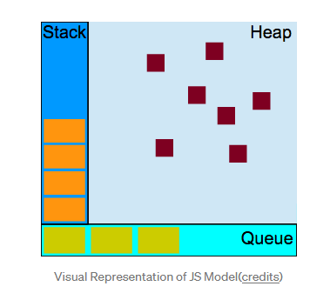
Heap is where the memory is (memory alocation is done)
Web Apis (https ... othter)

Java Script one time at time single thread (have one call stack)

What happens when things are slow ? (blocking)
-> things that need tiime to execute other comands are waithing)
-> Solution is async callbacks

Async Callback in the Call Stack
-> method (code) is passed in webapis when is done then goes to TASK QUEUE
-> event loop checks if stack is empty it returns to stach first metoh (code) from task queue

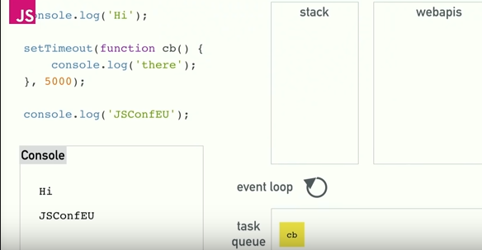

The decoupling of the caller from the response allows for the JavaScript runtime to do other things while waiting for your asynchronous operation to complete and their callbacks to fire. This is where browser APIs kicks in and call its APIs, which are basically threads created by browser implemented in C++ to handle async events like DOM events, http request, setTimeout, etc.(After knowing this, in Angular 2, Zones are used which monkey patches these APIs to cause runtime change detection, which I can get a picture now, how they were able to achieve it.)

The JavaScript engine (which is found in a hosting environment like the browser), is a single-threaded interpreter comprising of a heap and a single call stack. The browser provides web APIs like the DOM, AJAX, and Timers.

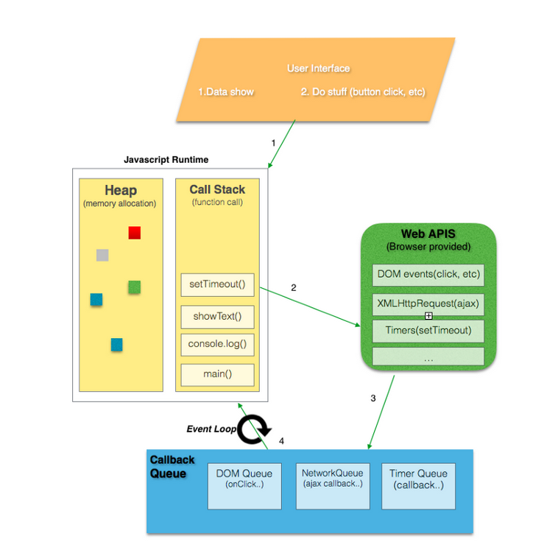

When the JavaScript engine first encounters your script, it creates a global execution context and pushes it to the current execution stack. Whenever the engine finds a function invocation, it creates a new execution context for that function and pushes it to the top of the stack.

Types of Execution Context
There are three types of execution context in JavaScript.
- Global Execution Context — This is the default or base execution context. The code that is not inside any function is in the global execution context. It performs two things: it creates a global object which is a window object (in the case of browsers) and sets the value of this to equal to the global object. There can only be one global execution context in a program.
- Functional Execution Context — Every time a function is invoked, a brand new execution context is created for that function. Each function has its own execution context, but it’s created when the function is invoked or called. There can be any number of function execution contexts. Whenever a new execution context is created, it goes through a series of steps in a defined order which I will discuss later in this article.
- Eval Function Execution Context — Code executed inside an eval function also gets its own execution context, but as eval isn’t usually used by JavaScript developers, so I will not discuss it here.

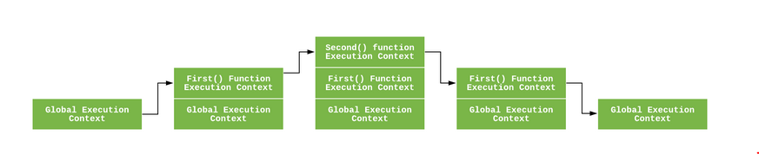

The execution context is created during the creation phase. Following things happen during the creation phase:
- LexicalEnvironment component is created.
- VariableEnvironment component is created.

A lexical environment is a structure that holds identifier-variable mapping. (here identifier refers to the name of variables/functions, and the variable is the reference to actual object [including function object and array object] or primitive value)

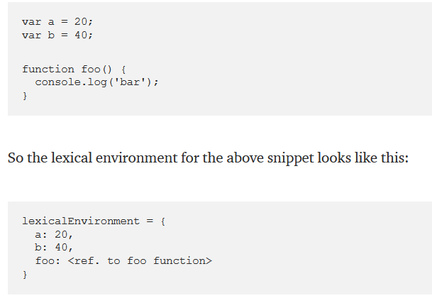

Each Lexical Environment has three components:
- Environment Record
- Reference to the outer environment,
- This binding.

The environment record is the place where the variable and function declarations are stored inside the lexical environment.
There are also two types of environment record :
- Declarative environment record — As its name suggests stores variable and function declarations. The lexical environment for function code contains a declarative environment record.
- Object environment record — The lexical environment for global code contains a objective environment record. Apart from variable and function declarations, the object environment record also stores a global binding object (window object in browsers). So for each of binding object’s property (in case of browsers, it contains properties and methods provided by browser to the window object), a new entry is created in the record.

For the function code, the environment record also contains an arguments object that contains the mapping between indexes and arguments passed to the function and the length(number) of the arguments passed into the function

The reference to the outer environment means it has access to its outer lexical environment. That means that the JavaScript engine can look for variables inside the outer environment if they are not found in the current lexical environment.

In this component, the value of this is determined or set.
In the global execution context, the value of this refers to the global object. (in browsers, this refers to the Window Object )

Variable Environment: It’s also a Lexical Environment whose EnvironmentRecord holds bindings created by VariableStatements within this execution context.

Note — As you might have noticed that the let and const defined variables do not have any value associated with them during the creation phase, but var defined variables are set to undefined .
This is because, during the creation phase, the code is scanned for variable and function declarations, while the function declaration is stored in its entirety in the environment, the variables are initially set to undefined (in case of var) or remain uninitialized (in case of let and const).
From: https://blog.bitsrc.io/understanding-execution-context-and-execution-stack-in-javascript-1c9ea8642dd0

The Event Loop

The decoupling of the caller from the response allows for the JavaScript runtime to do other things
while waiting for your asynchronous operation to complete and their callbacks to fire.

JavaScript runtimes contain a message queue which stores a list of messages to be processed and their associated callback functions. These messages are queued in response to external events (such as a mouse being clicked or receiving the response to an HTTP request) given a callback function has been provided

Web Workers
Using Web Workers enables you to offload an expensive operation to a separate thread of execution, freeing up the main thread to do other things. The worker includes a separate message queue, event loop, and memory space independent from the original thread that instantiated it. Communication between the worker and the main thread is done via message passing, which looks very much like the traditional, evented code
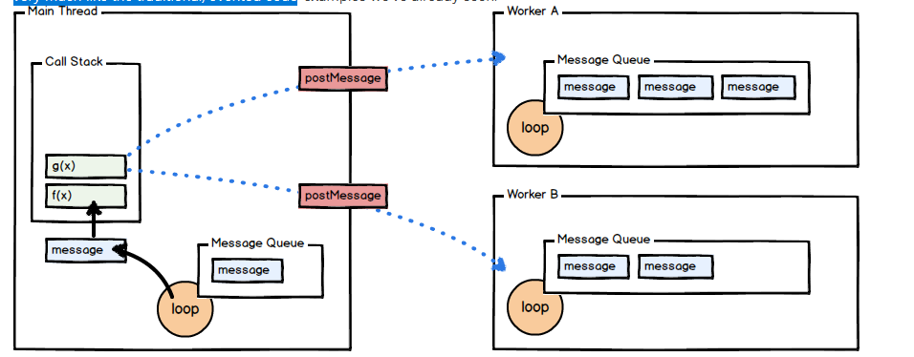
Closures and event block
JavaScript’s support for closures allow you to register callbacks that, when executed, maintain access to the environment in which they were created even though the execution of the callback creates a new call stack entirely. This is particularly of interest knowing that our callbacks are called as part of a different message than the one in which they were created. Consider the following example:

How numbers are encoded in JavaScript

All numbers in JavaScript are floating point. This blog post explains how those floating point numbers are represented internally in 64 bit binary

- How numbers are encoded in JavaScript — Dr. Axel Rauschmayer
- ? What You Need to Know About JavaScript Number Type — Max Wizard K
- ? What Every JavaScript Developer Should Know About Floating Point Numbers — Chewxy
- ? The Secret Life of JavaScript Primitives — Angus Croll
- ? Primitive Types — Flow
- ? (Not) Everything in JavaScript is an Object - Daniel Li
- ? JavaScript data types and data structures - MDN

Value Types and Reference Types

Javascript has 5 data types that are passed by value: Boolean, null, undefined, String, and Number. We’ll call these primitive types.
When we assign these variables to other variables using =, we copy the value to the new variable. They are copied by value

Javascript has 3 data types that are passed by reference: Array, Function, and Object. These are all technically Objects, so we’ll refer to them collectively as Objects.
Variables that are assigned a non-primitive value are given a reference to that value. That reference points to the object’s location in memory. The variables don’t actually contain the value.

When a reference type value, an object, is copied to another variable using =, the address of that value is what’s actually copied over as if it were a primitive. Objects are copied by reference instead of by value.

When the equality operators, == and ===, are used on reference-type variables, they check the reference. If the variables contain a reference to the same item, the comparison will result in true.

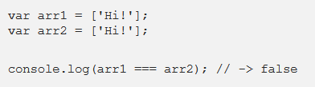

If we have two distinct objects and want to see if their properties are the same, the easiest way to do so is to turn them both into strings and then compare the strings
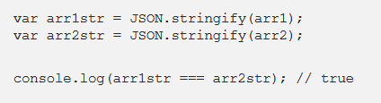

When we pass primitive values into a function, the function copies the values into its parameters. It’s effectively the same as using =

Remember that assignment through function parameters is essentially the same as assignment with =

Pure Functions
Functions in JavaScript are objects.
We refer to functions that don’t affect anything in the outside scope as pure functions. As long as a function only takes primitive values as parameters and doesn’t use any variables in its surrounding scope, it is automatically pure, as it can’t affect anything in the outside scope. All variables created inside are garbage-collected as soon as the function returns.
A function that takes in an Object, however, can mutate the state of its surrounding scope. If a function takes in an array reference and alters the array that it points to, perhaps by pushing to it, variables in the surrounding scope that reference that array see that change. After the function returns, the changes it makes persist in the outer scope. This can cause undesired side effects that can be difficult to track down.
Many native array functions, including Array.map and Array.filter, are therefore written as pure functions. They take in an array reference and internally, they copy the array and work with the copy instead of the original.

Implicit, Explicit, Nominal, Structuring and Duck Typing

Javascript's implicit coercion simply refers to Javascript attempting to coerce an unexpected value type to the expected type. So you can pass a string where it expects a number, an object where it expects a string etc, and it will try to convert it to the right type. This is a Javascript feature that is best avoided.

Double Equals vs. Triple Equals

When using triple equals === in JavaScript, we are testing for strict equality. This means both the type and the value we are comparing have to be the same.

When using double equals in JavaScript we are testing for loose equality. Double equals also performs type coercion. Type coercion means that two values are compared only after attempting to convert them into a common type.

77 === '77'
// false (Number v. String)
77 == '77'
// true
There are only six falsy values in JavaScript you should be aware of:
- false — boolean false
- 0 — number zero
- “” — empty string
- null
- undefined
- NaN — Not A Number

When comparing null and undefined, they are only equal to themselves and each other:
null == null // true
undefined == undefined// true
null == undefined // true

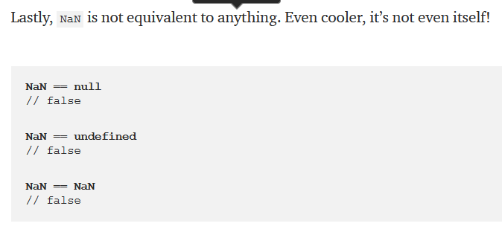
loose equality can lead to more headaches than it’s worth. Memorizing the six falsy values and the rules associated with them can go a long way towards understanding loose equality.
Triple Equals is superior to double equals. Whenever possible, you should use triple equals to test equality. By testing the type and value you can be sure that you are always executing a true equality test.

undefined is one of JavaScript’s primitive types which means checking its type using the typeof operator returns the string 'undefined'
It is the default value of any declared, but unassigned variable:
var x
console.log(x) // undefined
It is the value returned when trying to access an undeclared object property:
var obj = {}
console.log(obj.a) // undefined
It is the default return value of a function which does not return:
function f() {}
console.log(f()) // undefined
null is also a JavaScript primitive type, but checking its type using the typeof operator does not return what you’d expect:
console.log(typeof null) // object
null does not show up as a default value anywhere. Instead it is usually returned by functions which are expected to return an object when one could not be retrieved from the given parameters.

For example, in browsers document.getElementById returns null if no element with the given ID was found in the HTML document:
console.log(document.getElementById('some-id-which-no-element-has')) // null

null represents a lack of identification.

undefined and null represent the absence of a value. Therefore, any code we write which aims to check for the absence of a value should account for both undefined and null.

console.log(null === undefined) // false
var obj = {}
console.log(obj === {}) // false (because objects are compared by reference)
console.log(obj === obj) // true (because reference to same object)
console.log({} == {}) // false (because objects are compared by reference)

you this to check is everytinh ok with variale
console.log(typeof value === 'undefined' || value === null)
from: https://tomeraberba.ch/html/post/checking-for-the-absence-of-a-value-in-javascript.html

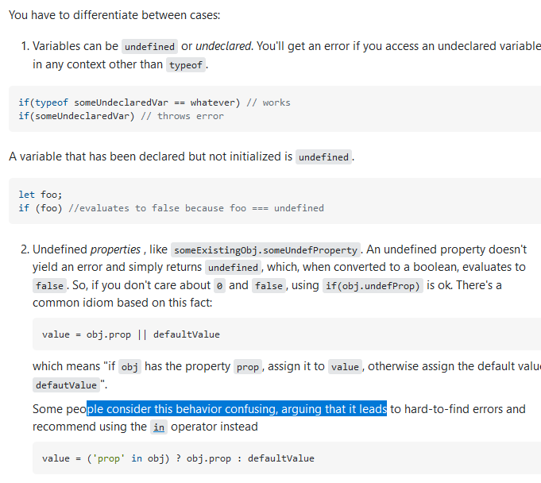
also check https://webbjocke.com/javascript-check-data-types/

Articles on topic
- ? JavaScript Double Equals vs. Triple Equals — Brandon Morelli
- ? What is the difference between =, ==, and === in JS? — Codecademy
- ? Should I use === or == equality comparison operator in JavaScript? — Panu Pitkamaki
- ? == vs === JavaScript: Double Equals and Coercion — AJ Meyghani
- ? Why Use the Triple-Equals Operator in JavaScript? — Louis Lazaris
- ? What is the difference between == and === in JavaScript? — Craig Buckler
- ? Why javascript's typeof always return "object"? — Stack Overflow
- ? Checking Types in Javascript — Toby Ho
- ? How to better check data types in JavaScript — Webbjocke
- ? Checking for the Absence of a Value in JavaScript — Tomer Aberbach

Expression vs Statement

Expressions are Javascript code snippets that result in a single value. Expressions can be as long as you want them to be, but they would always result in a single value.
2 + 2 * 3 / 2

(Math.random() * (100 - 20)) + 20

functionCall()

window.history ? useHistory() : noHistoryFallback()

Statements are the headache of functional programming ðŸ˜„. Basically, statements perform actions, they do things.
In javascript, statements can never be used where a value is expected. So they cannot be used as function arguments, right-hand side of assignments, operators operand, return values…
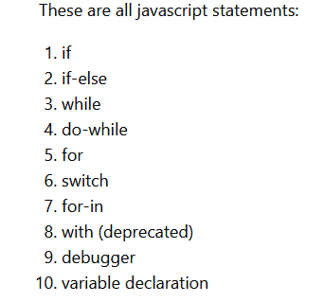
A function declaration is a statement

whenever you declare a function where Javascript is expecting a value, it will attempt to treat it as a value, if it can’t use it as a value, an error will be thrown.
Whereas declaring a function at the global level of a script, module, or top level of a block statement (that is, where it is not expecting a value), will result in a function declaration.

(function () {}) // this returns function () {}

r: 2+2 // valid
foo()

const foo = () => {}

setTimeout, setInterval and requestAnimationFrame

setTimeout allows us to run a function once after the interval of time.

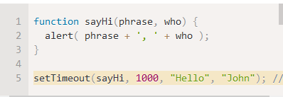
setTimeout expects a reference to a function.

setInterval allows us to run a function repeatedly, starting after the interval of time, then repeating continuously at that interval
All arguments have the same meaning. But unlike setTimeout it runs the function not only once, but regularly after the given interval of time.

In case of asynchronous operations, setTimeInterval will create long queue of requests which will be very counterproductive.
In case of time intensive synchronous operations, setTimeInterval may break the rhythm.
Also, if any error occurs in setInterval code block, it will not stop execution but keeps on running faulty code. Not to mention they need a clearInterval function to stop it.
Alternatively, you can use setTimeout recursively in case of time sensitive operations
-> do not use setInterval

JavaScript Engines

Javascript Engine? It is a program that converts Javascript code into lower level or machine code that microprocessors can understand
There are different JavaScript engines including Rhino, JavaScriptCore, and SpiderMonkey. These engines follow the ECMAScript Standards. ECMAScript defines the standard for the scripting language. JavaScript is based on ECMAScript standards. These standards define how the language should work and what features it should have. You can learn more about ECMAScript here.

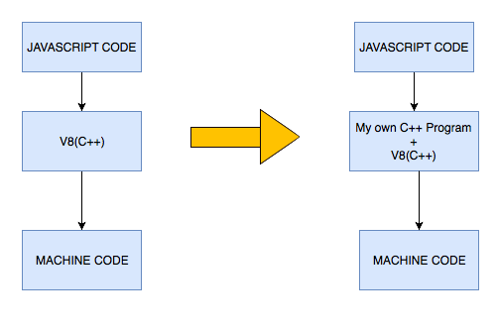

When V8 compiles JavaScript code, the parser generates an abstract syntax tree. A syntax tree is a tree representation of the syntactic structure of the JavaScript code. Ignition, the interpreter, generates bytecode from this syntax tree. TurboFan, the optimizing compiler, eventually takes the bytecode and generates optimized machine code from it.
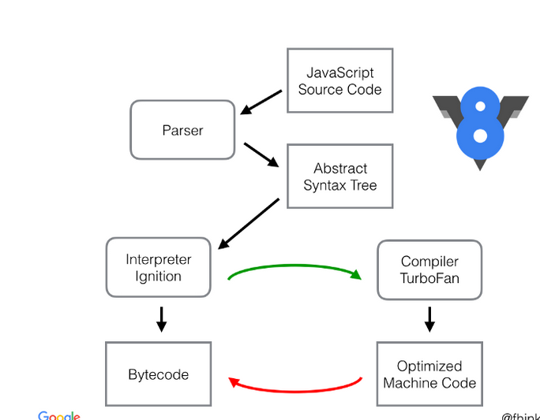
Bytecode is an abstraction of machine code. Compiling bytecode to machine code is easier if the bytecode was designed with the same computational model as the physical CPU. This is why interpreters are often register or stack machines. Ignition is a register machine with an accumulator register.
More here : https://medium.com/dailyjs/understanding-v8s-bytecode-317d46c94775

DOM and Layout Trees

The Document Object Model, usually referred to as the DOM, is an essential part of making websites interactive. It is an interface that allows a programming language to manipulate the content, structure, and style of a website. JavaScript is the client-side scripting language that connects to the DOM in an internet browser.

At the most basic level, a website consists of an HTML document. The browser that you use to view the website is a program that interprets HTML and CSS and renders the style, content, and structure into the page that you see.
In addition to parsing the style and structure of the HTML and CSS, the browser creates a representation of the document known as the Document Object Model. This model allows JavaScript to access the text content and elements of the website document as objects.

In fact a lot of what you might think of as a “JavaScript Thing” is more accurately a “DOM API”. For instance, we can write JavaScript that watches for a mouseenter event on an element. But that “element” is really a DOM node. We attach that listener via a DOM property on that DOM node. When that event happens, it’s the DOM node that emits that event.

Docuentation: https://www.w3.org/TR/DOM-Level-2-Core/introduction.html

When you create a script–whether it's inline in a <script> element or included in the web page by means of a script loading instruction–you can immediately begin using the API for the document or window elements to manipulate the document itself or to get at the children of that document, which are the various elements in the web page. Your DOM programming may be something as simple as the following, which displays an alert message by using the alert() function from the window object, or it may use more sophisticated DOM methods to actually create new con
tent, as in the longer example below.

Web browsers rely on layout engines to parse HTML into a DOM. Some layout engines, such as Trident/MSHTML, are associated primarily or exclusively with a particular browser, such as Internet Explorer. Others, including Blink, WebKit, and Gecko, are shared by a number of browsers, such as Google Chrome, Opera, Safari, and Firefox. The different layout engines implement the DOM standards to varying degrees of compliance.

DOM implementations:
- libxml2
- MSXML
- Xerces is a collection of DOM implementations written in C++, Java and Perl
- XML for <SCRIPT> is a JavaScript-based DOM implementation[10]
- PHP.Gt DOM is a server-side DOM implementation based on libxml2 and brings DOM level 4 compatibility[11] to the PHP programming language
- Domino is a Server-side (Node.js) DOM implementation based on Mozilla's dom.js. Domino is used in the MediaWiki stack with Visual Editor.
- SimpleHtmlDom is a simple HTML document object model in C#, which can generate HTML string programmtically.
APIs that expose DOM implementations:
- JAXP (Java API for XML Processing) is an API for accessing DOM providers
- Lazarus (Free Pascal IDE) contains two variants of the DOM - with UTF-8 and ANSI format
Inspection tools:
- DOM Inspector is a web developer tool

The CSSOM and DOM trees are combined into a render tree, which is then used to compute the layout of each visible element and serves as an input to the paint process that renders the pixels to screen. Optimizing each of these steps is critical to achieving optimal rendering performance.
In the previous section on constructing the object model, we built the DOM and the CSSOM trees based on the HTML and CSS input. However, both of these are independent objects that capture different aspects of the document: one describes the content, and the other describes the style rules that need to be applied to the document. How do we merge the two and get the browser to render pixels on the screen?
- The DOM and CSSOM trees are combined to form the render tree.
- Render tree contains only the nodes required to render the page.
- Layout computes the exact position and size of each object.
- The last step is paint, which takes in the final render tree and renders the pixels to the screen.

Factories and Classes

JavaScript is a prototype-based language, and every object in JavaScript has a hidden internal property called [[Prototype]] that can be used to extend object properties and methods.

To find the [[Prototype]] of this newly created object, we will use the getPrototypeOf() method.
Let x = {}
Object.getPrototypeOf(x);
output: {constructor: ƒ, __defineGetter__: ƒ, __defineSetter__: ƒ, …}

let y = [];
Object.getPrototypeOf(y);
[constructor: ƒ, concat: ƒ, pop: ƒ, push: ƒ, …]

These prototypes can be chained, and each additional object will inherit everything throughout the chain. The chain ends with the Object.prototype

Constructor functions are functions that are used to construct new objects. The new operator is used to create new instances based off a constructor function. We have seen some built-in JavaScript constructors, such as new Array() and new Date(), but we can also create our own custom templates from which to build new objects.
To begin, a constructor function is just a regular function. It becomes a constructor when it is called on by an instance with the new keyword. In JavaScript, we capitalize the first letter of a constructor function by convention
// Initialize a constructor function for a new Hero
function Hero(name, level) {
this.name = name;
this.level = level;
}
let hero1 = new Hero('Bjorn', 1);
Object.getPrototypeOf(hero1);
output: constructor: ƒ Hero(name, level)

We can add a method to Hero using prototype. We’ll create a greet() method.
// Add greet method to the Hero prototype
Hero.prototype.greet = function () {
return `${this.name} says hello.`;
}
hero1.greet();
We can use the call() method to copy over properties from one constructor into another constructor. Let’s create a Warrior and a Healer constructor.
...
// Initialize Warrior constructor
function Warrior(name, level, weapon) {
// Chain constructor with call
Hero.call(this, name, level);
// Add a new property
this.weapon = weapon;
}

Prototype properties and methods are not automatically linked when you use call() to chain constructors. We will use Object.create() to link the prototypes, making sure to put it before any additional methods are created and added to the prototype.
Warrior.prototype = Object.create(Hero.prototype);
Healer.prototype = Object.create(Hero.prototype);
// All other prototype methods added below

Since Javascript is a functional programming language where everything is just a function, in order to have a class like (creating a blueprint for the objects to be created) functionality in javascript, constructor functions are used

Whenever a new function is created in javascript, Javascript engine by default adds a prototype property to it, this property is an object and we call it “prototype object”. By default this prototype object has a constructor property which points back to our function, and another property __proto__ which is an object

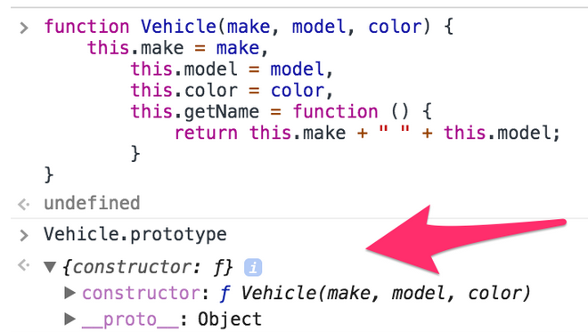

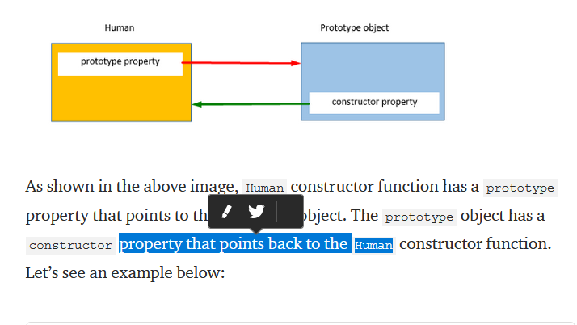

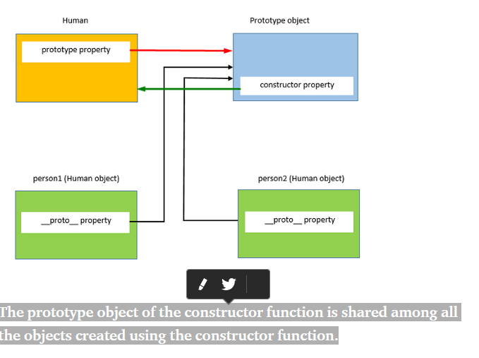

Now, this prototype object can be used to add new properties and methods to the constructor function using the following syntax
car.prototype.year = "2016";
Prototype properties and methods are shared between all the instances of the constructor function, but when any one of the instances of a constructor function makes any change in any primitive property, it will only be reflected in that instance and not among all the instances:

The prototype object of the constructor function is shared among all the objects created using the constructor function.

Javascript classes are nothing but just a new way of writing the constructor functions by utilizing the power of prototype

Static methods class

Static methods are functions on class itself, and not on its prototype, unlike the other methods in the class, which are defined on its prototype.
Static methods are declared using static keyword, and are mostly used to create utility functions. They are called without creating the instance of the class. See an example below.

In traditional class-oriented languages, you create classes, which are templates for objects. When you want a new object, you instantiate the class, which tells the language engine to copy the methods and properties of the class into a new entity, called an instance. The instance is your object, and, after instantiation, has absolutely no active relation with the parent class.
But JavaScrip
Rather, it creates an object that is linked to a prototype. Changes to that prototype propagate to the new object, even after instantiation

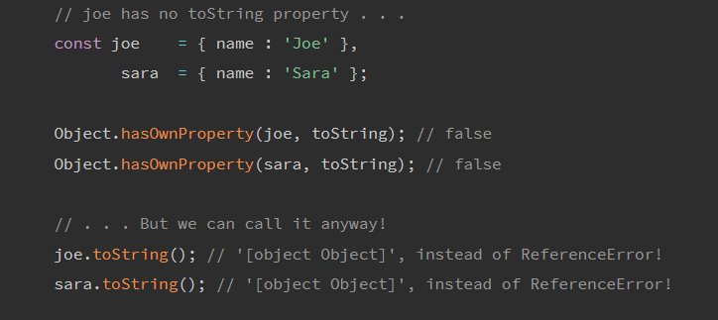
Explanation:
The output from our toString calls is utterly useless, but note that this snippet doesn't raise a single ReferenceError! That's because, while neither joe or sara has a toString property, their prototype does.
When we look for sara.toString(), sara says, "I don't have a toString property. Ask my prototype." JavaScript, obligingly, does as told, and asks Object.prototype if it has a toString property. Since it does, it hands Object.prototype's toString back to our program, which executes it.

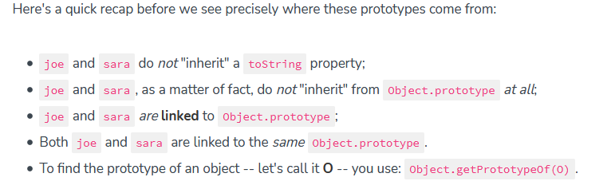
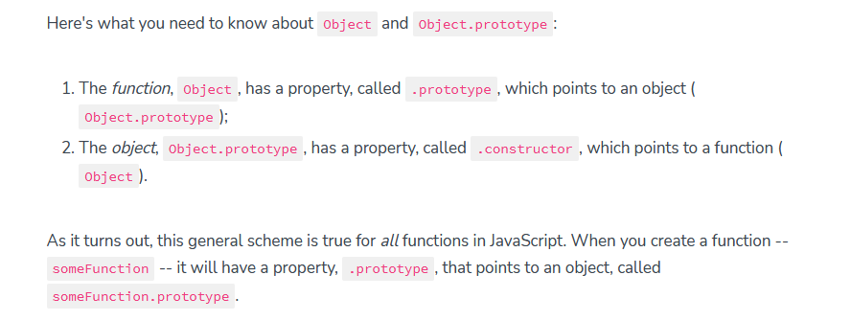
More info here: https://scotch.io/tutorials/better-javascript-with-es6-pt-ii-a-deep-dive-into-classes

https://scotch.io/tutorials/better-javascript-with-es6-pt-ii-a-deep-dive-into-classes

Factory Design Pattern.
In a nutshell, if we implement instance creation inside the function itself and don’t require user to use Object.create or new keyword, then we have a factory.
More here: https://medium.com/@SntsDev/the-factory-pattern-in-js-es6-78f0afad17e9

this, call, apply and bind

You can use call()/apply() to invoke the function immediately. bind() returns a bound function that, when executed later, will have the correct context ("this") for calling the original function. So bind() can be used when the function needs to be called later in certain events when it's useful.

//Demo with javascript .call()

var obj = {name:"Niladri"};

var greeting = function(a,b,c){
return "welcome "+this.name+" to "+a+" "+b+" in "+c;
};

console.log(greeting.call(obj,"Newtown","KOLKATA","WB"));
// returns output as welcome Niladri to Newtown KOLKATA in WB

Similarly to call() method the first parameter in apply() method sets the "this" value which is the object upon which the function is invoked. In this case it's the "obj" object above. The only difference of apply() with the call() method is that the second parameter of the apply() method accepts the arguments to the actual function as an array.

var obj = {name:"Niladri"};

var greeting = function(a,b,c){
return "welcome "+this.name+" to "+a+" "+b+" in "+c;
};

//creates a bound function that has same body and parameters
var bound = greeting.bind(obj);

console.dir(bound); ///returns a function

console.log("Output using .bind() below ");

console.log(bound("Newtown","KOLKATA","WB")); //call the bound function
for bind() we are returning a bound function with the context which will be invoked later.

One thing that is confusing about Javascript is that this‘s value will change depending on the context that this is called in. By default it refers to the global scope, but when called within a function, it refers to that function

Different objects can share methods without rewriting them for each individual object.
Apply, call, and bind are sometimes called function methods, since they are called alongside a function.

More here: https://dev.to/kbk0125/javascripts-apply-call-and-bind-explained-by-hosting-a-cookout-32jo

Using call to invoke an anonymous function
const animals = [
{ species: 'Lion', name: 'King' },
{ species: 'Whale', name: 'Fail' }
];

for (let i = 0; i < animals.length; i++) {
(function(i) {
this.print = function() {
console.log('#' + i + ' ' + this.species
+ ': ' + this.name);
}
this.print();
}).call(animals[i], i);
}
from: https://developer.mozilla.org/en-US/docs/Web/JavaScript/Reference/Global_Objects/Function/call
https://developer.mozilla.org/en-US/docs/Web/JavaScript/Reference/Global_objects/Function/bind
https://developer.mozilla.org/en-US/docs/Web/JavaScript/Reference/Global_Objects/Function/apply

new, Constructor, instanceof and Instances

Introduction:
https://codeburst.io/javascript-for-beginners-the-new-operator-cee35beb669e
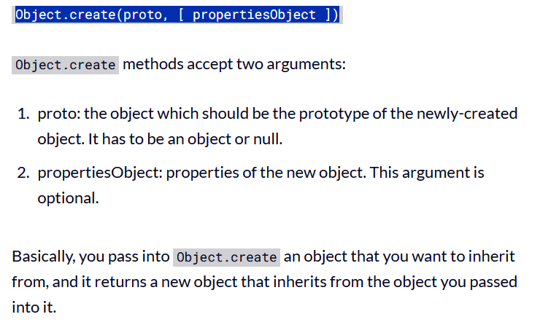
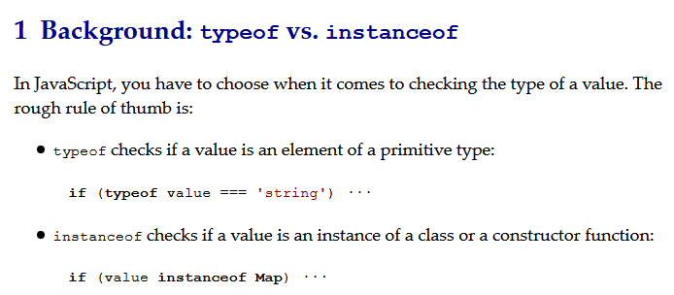

Object api
hasOwnProperty is a method available on object instances that allows to check if an object has a property directly on its instance.

The Object.keys static method returns an array with the property keys on an object:

Object.assign. This new method allows to easily copy values from one object to another

Object.freeze to shallowly freeze an object to prevent its properties from being changed

defineProperty
Defines a new property with name equal to propertyName on obj with the supplied descriptor.

entries Returns an Array of key/value pairs for the properies of obj.

See: https://www.javascripture.com/Object also
https://developer.mozilla.org/en-US/docs/Web/JavaScript/Guide/Meta_programming
and reflacton (https://developer.mozilla.org/enUS/docs/Web/JavaScript/Reference/Global_Objects/Reflect)
and proxy
(https://www.javascripture.com)

map, reduce, filter

Map, Filter and Reduce are chainable and, together, you hold an unlimited amount of mystical power! ? ✨ ✨
Given these more complex arrays of songs where we have an array of arrays with songs from Spotify and LastFM. Each song has a duration in seconds.
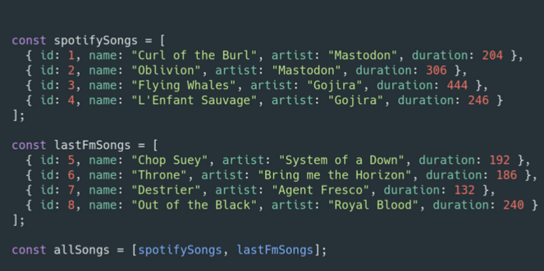
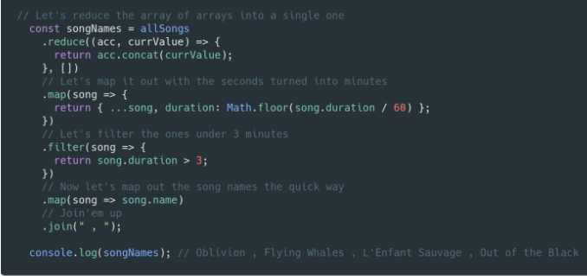
Now we must get a string separated by commas with all the songs that have a duration superior to 3 minutes.

Closures

The use of closures is associated with languages where functions are first-class objects, in which functions can be returned as results from higher-order functions, or passed as arguments to other function calls; if functions with free variables are first-class, then returning one creates a closure. This includes functional programming languages such as Lisp and ML, as well as many modern, multi-paradigm languages, such as Python and Rust. Closures are also frequently used with callbacks, particularly for event handlers, such as in JavaScript, where they are used for interactions with a dynamic web page.

function makeAdder(x) {
return function(y) {
return x + y;
};
}
var add5 = makeAdder(5);
var add10 = makeAdder(10);
console.log(add5(2)); // 7
console.log(add10(2)); // 12

In this example, we have defined a function makeAdder(x), that takes a single argument x, and returns a new function. The function it returns takes a single argument y, and returns the sum of x and y.
In essence, makeAdder is a function factory. It creates functions that can add a specific value to their argument. In the above example, the function factory creates two new functions—one that adds five to its argument, and one that adds 10.
add5 and add10 are both closures. They share the same function body definition, but store different lexical environments. In add5's lexical environment, x is 5, while in the lexical environment for add10, x is 10.

Closures are useful because they let you associate data (the lexical environment) with a function that operates on that data. This has obvious parallels to object-oriented programming, where objects allow you to associate data (the object's properties) with one or more methods.
Consequently, you can use a closure anywhere that you might normally use an object with only a single method.

Every closure has three scopes:
- Local Scope (Own scope)
- Outer Functions Scope
- Global Scope

It is unwise to unnecessarily create functions within other functions if closures are not needed for a particular task, as it will negatively affect script performance both in terms of processing speed and memory consumption.
For instance, when creating a new object/class, methods should normally be associated to the object's prototype rather than defined into the object constructor. The reason is that whenever the constructor is called, the methods would get reassigned (that is, for every object creation).

1: function createCounter() {
2: let counter = 0
3: const myFunction = function() {
4: counter = counter + 1
5: return counter
6: }
7: return myFunction
8: }
9: const increment = createCounter()
10: const c1 = increment()
11: const c2 = increment()
12: const c3 = increment()
13: console.log('example increment', c1, c2, c3)
outout: 1, 2 3, Look up at execution context ; global, funciton , state
createCounter() retuns function but save sate of the counter in the increment varibable

The closure is a collection of all the variables in scope at the time of creation of the function.

When a function returns a function, that is when the concept of closures becomes more relevant. The returned function has access to variables that are not in the global scope, but they solely exist in its closure.

High Order Functions

Functions that operate on other functions, either by taking them as arguments or by returning them, are called higher-order functions.
Higher-order functions allow us to abstract over actions, not just values.

function unless(test, then) {
if (!test) then();
}

repeat(3, n => {
unless(n % 2 == 1, () => {
console.log(n, "is even");
});
});

One area where higher-order functions shine is data processing. To process data, we’ll need some actual data. This chapter will use a data set about scripts

Recursion

Loosely defined, recursion is the process of taking a big problem and sub-dividing it into multiple, smaller instances of the same problem.
Put into practice, that generally means writing a function that calls itself.

All recursive functions should have three key features:
- A Termination Condition
Fail-safe. Think of it like your emergency brake. It’s put there in case of bad input to prevent the recursion from ever running. In our factorial example, if (x < 0) return;
- A Base Case
Stops recursion, s the goal of our recursive function
- Recursion
Function call itself.
Exampple:
function factorial(x) {
// TERMINATION
if (x < 0) return; // BASE
if (x === 0) return 1; // RECURSION
return x * factorial(x - 1);
}

It will create stack of exeecuton and then go back and call every methos in stack from fist (last added) to last (first added)

Collections and Generators

A plain Object, after all, is pretty much nothing but an open-ended collection of key-value pairs. You can get, set, and delete properties, iterate over them—all the things a hash table can do.
Set
A Set is a collection of values. It’s mutable, so your program can add and remove values as it goes.
a set never contains the same value twice (uniqe)
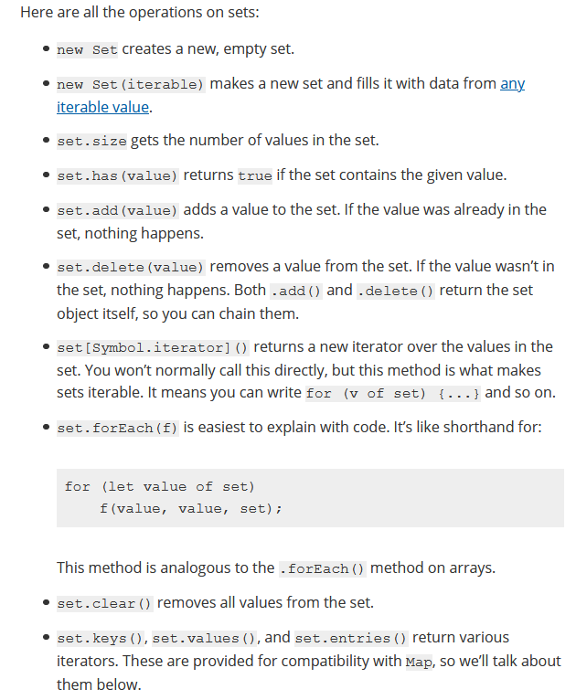
can contain any type of JS value doest not have indexing advanced
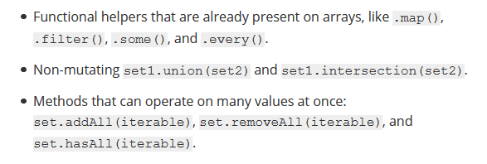

Map
A Map is a collection of key-value pairs.

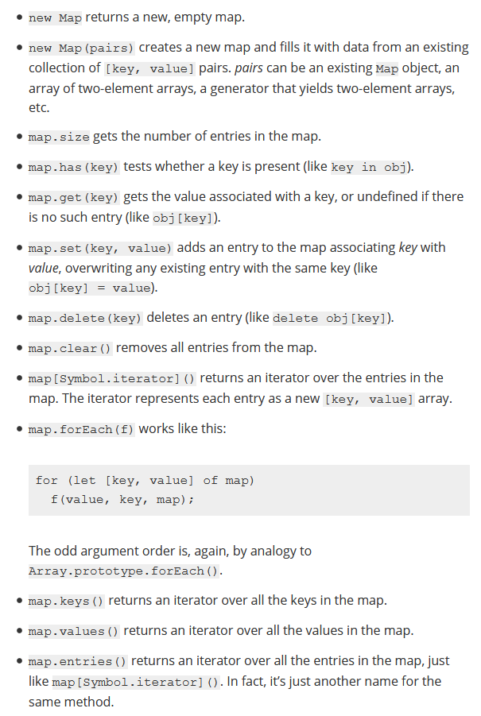

Map and Set objects keep a strong reference to every key and value they contain. This means that if a DOM element is removed from the document and dropped, garbage collection can’t recover that memory until that element is removed from containg map or set

WeakMap and WeakSet

WeakMap and WeakSet are specified to behave exactly like Map and Set, but with a few restrictions:

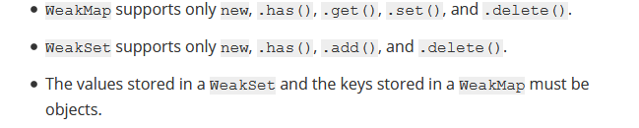
Note that neither type of weak collection is iterable. You can’t get entries out of a weak collection except by asking for them specifically, passing in the key you’re interested in.
These carefully crafted restrictions enable the garbage collector to collect dead objects out of live weak collections. The effect is similar to what you could get with weak references or weak-keyed dictionaries, but ES6 weak collections get the memory management benefits without exposing the fact that GC happened to scripts.

The main difference is that WeakSet can only contain objects & not any other type.
The other main difference between the two is that references to objects in a WeakSet are held “weakly”. This means that if there is no other reference to an object in the WeakSet it will get garbage collected. The same is not true for Set. An object stored in a Set will not be garbaged collected even if nothing is referencing it.

Generators are functions that you can use to control the iterator. They can be suspended and later resumed at any time.

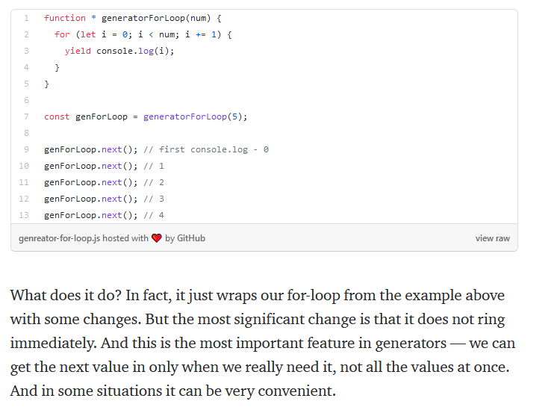

How can we declare the generator function? There is a list of possible ways to do this, but the main thing is to add an asterisk after the function keyword.

Yield returns a value only once, and the next time you call the same function it will move on to the next yield statement.

Also in generators we always get the object as output. It always has two properties value and done. And as you can expect, value - returned value, and done shows us whether the generator has finished its job or not.

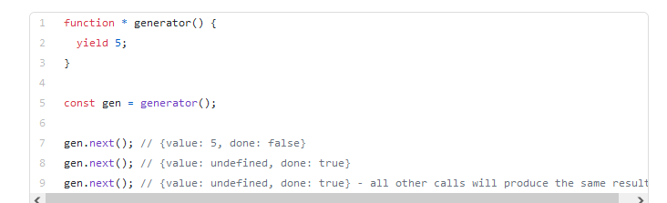
Previously, we used generators with a known number of iterations. But what if we don’t know how many iterations are needed. To solve this problem, it is enough to create an infinite loop in the function generator. The example below demonstrates this for a function that returns a random number.

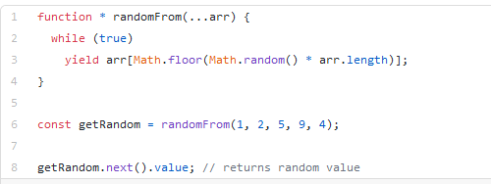
There are many more possible ways to use generators. For example, they can be useful when working with asynchronous operations. Or iterate through an on-demand item loop

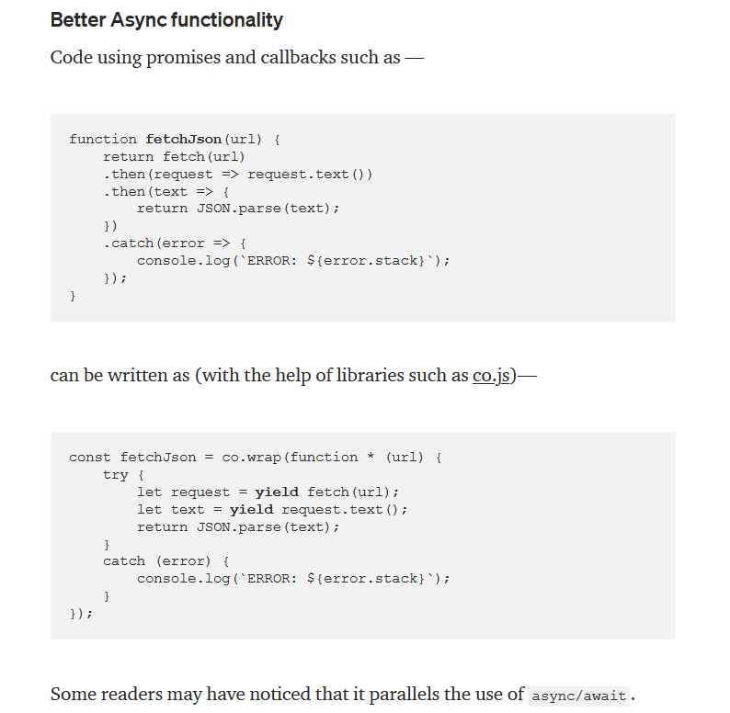

Generators as observers
Generators can also receive values using the next(val) function. Then the generator is called an observer since it wakes up when it receives new values. In a sense, it keeps observing for values and acts when it gets one. You can read more about this pattern here.

Lazy Evaluation
As seen with Infinite Data Streams example, it is possible only because of lazy evaluation. Lazy Evaluation is an evaluation model which delays the evaluation of an expression until its value is needed. That is, if we don’t need the value, it won’t exist. It is calculated as we demand it. Let’s see an example —
function * powerSeries(number, power) {
let base = number;
while(true) {
yield Math.pow(base, power);
base++;
}
}

Generator objects are one-time access only. Once you’ve exhausted all the values, you can’t iterate over it again. To generate the values again, you need to make a new generator object

Promises

Good example with http get: https://www.sitepoint.com/overview-javascript-promises/
Good basic example: https://ponyfoo.com/articles/es6-promises-in-depth
A Promise is a proxy for a value not necessarily known when the promise is created. It allows you to associate handlers with an asynchronous action's eventual success value or failure reason. This lets asynchronous methods return values like synchronous methods: instead of immediately returning the final value, the asynchronous method returns a promise to supply the value at some point in the future.

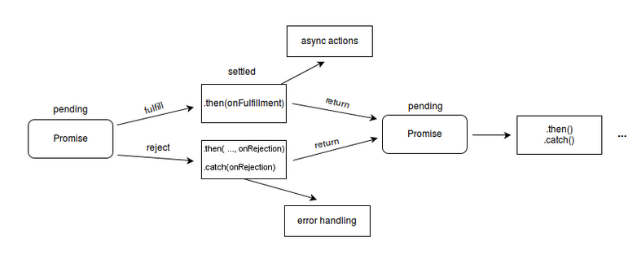
The methods promise.then(), promise.catch(), and promise.finally() are used to associate further action with a promise that becomes settled.
The .then() method takes up to two arguments; the first argument is a callback function for the resolved case of the promise, and the second argument is a callback function for the rejected case. Each .then() returns a newly generated promise object, which can optionally be used for chaining; for example:

----
Imagine you are a kid. Your mom promises you that she’ll get you a new phone next week.”
You don’t know if you will get that phone until next week. Your mom can really buy you a brand new phone, or she doesn’t.
That is a promise. A promise has three states. They are:
- Pending: You don’t know if you will get that phone
- Fulfilled: Mom is happy, she buys you a brand new phone
- Rejected: Mom is unhappy, she doesn’t buy you a phone

// ES5: Part 1
var isMomHappy = false;

// Promise
var willIGetNewPhone = new Promise(
function (resolve, reject) {
if (isMomHappy) {
var phone = {
brand: 'Samsung',
color: 'black'
};
resolve(phone); // fulfilled
} else {
var reason = new Error('mom is not happy');
reject(reason); // reject
}

}
);

Now that we have the promise, let’s consume it:
// ES5: Part 2

var willIGetNewPhone = ... // continue from part 1

// call our promise
var askMom = function () {
willIGetNewPhone
.then(function (fulfilled) {
// yay, you got a new phone
console.log(fulfilled);
// output: { brand: 'Samsung', color: 'black' }
})
.catch(function (error) {
// oops, mom didn't buy it
console.log(error.message);
// output: 'mom is not happy'
});
};

askMom();

Read more here: https://hackernoon.com/understanding-promises-in-javascript-13d99df067c1

Thumb Rules for using promises
- Use promises whenever you are using async or blocking code.
- resolve maps to then and reject maps to catch for all practical purposes.
- Make sure to write both .catch and .then methods for all the promises.
- If something needs to be done in both the cases use .finally
- We only get one shot at mutating each promise.
- We can add multiple handlers to a single promise.
- The return type of all the methods in Promise object whether they are static methods or prototype methods is again a Promise
- In Promise.all the order of the promises are maintained in values variable irrespective of which promise was first resolved.

A promise is an object that may produce a single value some time in the future: either a resolved value, or a reason that it’s not resolved (e.g., a network error occurred). A promise may be in one of 3 possible states: fulfilled, rejected, or pending. Promise users can attach callbacks to handle the fulfilled value or the reason for rejection.

More advices: https://medium.com/javascript-scene/master-the-javascript-interview-what-is-a-promise-27fc71e77261 and here https://medium.com/datafire-io/es6-promises-patterns-and-anti-patterns-bbb21a5d0918 and here: https://exploringjs.com/es6/ch_promises.html

async/await

Async and Await are extensions of promises.
The word “async” before a function means one simple thing: a function always returns a promise. Other values are wrapped in a resolved promise automatically.
The keyword await makes JavaScript wait until that promise settles and returns its result.
If we try to use await in a non-async function, there would be a syntax error:

The async keyword before a function has two effects:
- Makes it always return a promise.
- Allows await to be used in it.
The await keyword before a promise makes JavaScript wait until that promise settles, and then:
- If it’s an error, the exception is generated — same as if throw error were called at that very place.
- Otherwise, it returns the result.
Together they provide a great framework to write asynchronous code that is easy to both read and write.
function loadJson(url) {
return fetch(url)
.then(response => {
if (response.status == 200) {
return response.json();
} else {
throw new Error(response.status);
}
});
}

loadJson('no-such-user.json')
.catch(alert); // Error: 404
new version wieh async and await

async function loadJson(url) { // (1)
let response = await fetch(url); // (2)

if (response.status == 200) {
let json = await response.json(); // (3)
return json;
}

throw new Error(response.status);
}

loadJson('no-such-user.json')
.catch(alert); // Error: 404 (4)

Data Structures

At a high level, there are basically three types of data structures. Stacks and Queues are array-like structures that differ only in how items are inserted and removed. Linked Lists, Trees, and Graphs are structures with nodes that keep references to other nodes. Hash Tables depend on hash functions to save and locate data.

In terms of complexity, Stacks and Queues are the simplest and can be constructed from Linked Lists. Trees and Graphs are the most complex because they extend the concept of a linked list. Hash Tables need to utilize these data structures to perform reliably. In terms of efficiency, Linked Lists are most optimal for recording and storing of data, while Hash Tables are most performant for searching and retrieving of data.

Stack
-> array with two operations: push and pop
Push add element on top
Pop removes elelemts from top
It is Last In First Out

Queue
-> array with two primary operations: unshift and opo
Unshit puts element at the end of the array
Pop remove elements from the beginning of the arra<
First In First Out

Linked List
Like arrays, Linked Lists store data elements in sequential order. Instead of keeping indexes, linked lists hold pointers to other elements. The first node is called the head while the last node is called the tail. In a singly-linked list, each node has only one pointer to the next node. Here, the head is where we begin our walk down the rest of the list. In a doubly-linked list, a pointer to the previous node is also kept. Therefore, we can also start from the tail and walk “backwards” toward the head.

Linked lists have constant-time insertions and deletions because we can just change the pointers. To do the same operations in arrays requires linear time because subsequent items need to be shifted over. Also, linked lists can grow as long as there is space. However, even “dynamic” arrays that automatically resize could become unexpectedly expensive. Of course, there’s always a tradeoff. To lookup or edit an element in a linked list, we might have to walk the entire length which equates to linear time. With array indexes, however, such operations are trivial.

Like arrays, linked lists can operate as stacks or queue

Tree
A Tree is like a linked list, except it keeps references to many child nodes in a hierarchical structure. In other words, each node can have no more than one parent. The Document Object Model (DOM) is such a structure
The Binary Search Tree is special because each node can have no more than two children.
Traversal through the tree can happen in a vertical or horizontal procedure. In Depth-First Traversal (DFT) in the vertical direction, a recursive algorithm is more elegant than an iterative one. Nodes can be traversed in pre-order, in-order, or post-order.
In Breadth-First Traversal (BFT) in the horizontal direction, an iterative approach is more elegant than a recursive one. This requires the use of a queue to track all the children nodes with each iteration. The memory needed for such a queue might not be trivial, however. If the shape of a tree is wider than deep, BFT is a better choice than DFT.

Graph
If a tree is free to have more than one parent, it becomes a Graph. Edges that connect nodes together in a graph can be directed or undirected, weighted or unweighted. Edges that have both direction and weight are analogous to vectors
A social network and the Internet itself are also graphs. The most complicated graph in nature is our human brain, which neural networks attempt to replicate to give machines superintelligence

Hash Table
Hash Table is a dictionary-like structure that pairs keys to values. The location in memory of each pair is determined by a hash function, which accepts a key and returns the address where the pair should be inserted and retrieved. Collisions can result if two or more keys convert to the same address. For robustness, getters and setters should anticipate these events to ensure that all data can be recovered and no data is overwritten. Usually, linked lists offer the simplest solution. Having very large tables also helps.

On both the client and server, many popular libraries utilize memoization to maximize performance. By keeping a record of the inputs and outputs in a hash table,

No one data structure is perfect for every situation because optimizing for one property always equates to losing another. Some structures are more efficient at storing data while some others are more performant for searching through them. Usually, one is sacrificed for the other. At one extreme, linked lists are optimal for storage and can be made into stacks and queues (linear time). At the other, no other structure can match the search speed of hash tables (constant time). Tree structures lie somewhere in the middle (logarithmic time), and only a graph can portray nature’s most complex structure: the human brain (polynomial time). Having the skillset to distinguish when and articulate why is a hallmark of a rockstar engineer.

Code examples: https://github.com/trekhleb/javascript-algorithms and here
https://github.com/barretlee/algorithms/tree/master/chapters
and here : https://github.com/humanwhocodes/computer-science-in-javascript

Expensive Operation and Big O Notation

Big O notation it is the mathematical expression of how long an algorithm takes to run depending on how long is the input, usually talking about the worst case scenario. In practice, we use Big O Notation to classify algorithms by how they respond to changes in input size, so algorithms with the same growth rate are represented with the same Big O Notation. The letter O is used because the rate of growth of a function is also called order of the function.

Sometimes we want to focus on using less memory instead of (or in addition to) using less time (iterations) and usually there’s a trade-off between saving time and saving space

O(1) — “Order 1”
On this order, regardless of the complexity (number of items), the time (iterations) is constant.

O(N) — “Order N”
In this order, the worst case time (iterations) grows on par with the number of items

O(N 2 ) — “Order N squared”
For this kind of order, the worst case time (iterations) is the square of the number of inputs. The time grows exponentially related to the number of inputs. (For loop inside for loop)

O(2^n)
For each additional input, the time to run the algorithm doubles.

O(n log n) — “Order N log N”
These are the holy grail of search/sort algorithms, they are usually the most efficient approach when dealing with large collections. Instead of looking through the components one by one, they split the data in chunks and discard a large amount on every iteration, usually the half, or log base 2

Assuming we are using a log base 2, we could -ideally- find a specific element in a collection of one million elements using less than 20 iterations, if we scale the size of the collection to a billion we would require only less than 30 iterations.
The most popular of this algorithms is the Quicksort algorithm, which can be used to find a specific element or sort a list very efficiently. Another popular example of this order is the Merge-Sort algorithm

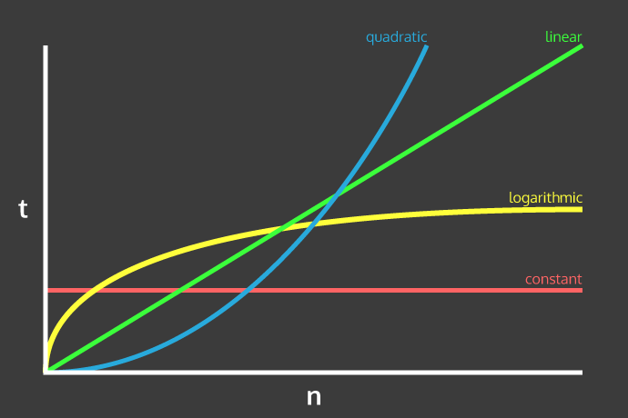
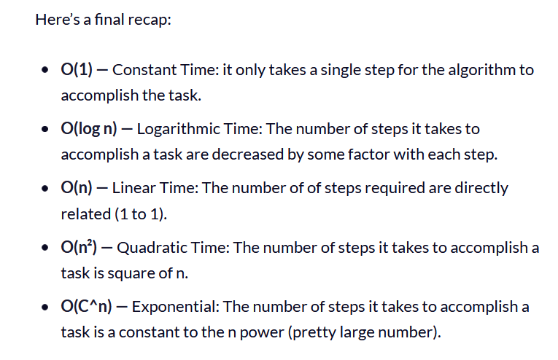

Algorithms in JavaScript

Code example: https://github.com/trekhleb/javascript-algorithms

stao: https://github.com/trekhleb/javascript-algorithms

Inheritance, Polymorphism and Code Reuse

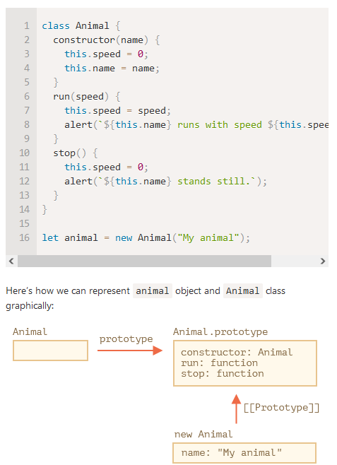
Class inheritance is a way for one class to extend another class.

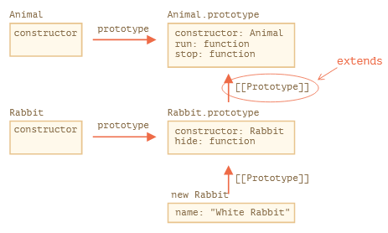

Object of Rabbit class have access both to Rabbit methods, such as rabbit.hide(), and also to Animal methods, such as rabbit.run().
Internally, extends keyword works using the good old prototype mechanics. It sets Rabbit.prototype.[[Prototype]] to Animal.prototype. So, if a method is not found in Rabbit.prototype, JavaScript takes it from Animal.prototype
For instance, to find rabbit.run method, the engine checks (bottom-up on the picture):
- The rabbit object (has no run).
- Its prototype, that is Rabbit.prototype (has hide, but not run).
- Its prototype, that is (due to extends) Animal.prototype, that finally has the run method.

Constructors in inheriting classes must call super(...), and (!) do it before using this

Old na new way: https://developer.mozilla.org/en-US/docs/Learn/JavaScript/Objects/Inheritance

Design Patterns

Book: https://addyosmani.com/resources/essentialjsdesignpatterns/book/#designpatternsjavascript
Code: https://github.com/fbeline/Design-Patterns-JS

TODO functional design patterns: https://www.youtube.com/watch?v=srQt1NAHYC0
and here:
Using the concepts of pure function, function composition, currying/partial application and middlewares skillfully can alleviate a lot of design concern while making the application clean and concise. Functional libraries like Ramda and persistent immutable data structures library like Immutable-js greatly take away the burden of reimagination. Learning the concepts of functional programming is fun and inspiring. To further explore, fantasyland/fantasy-land is a great resource to understand the functional beauty in true sense.

Creational |  |  |  | Based on the concept of creating an object.
Class
Factory Method |  |  |  |  | This makes an instance of several derived classes based on interfaced data or events.
Object
Abstract Factory |  |  |  |  | Creates an instance of several families of classes without detailing concrete classes.
Builder |  |  |  |  | Separates object construction from its representation, always creates the same type of object.
Prototype |  |  |  |  | A fully initialized instance used for copying or cloning.
Singleton |  |  |  |  | A class with only a single instance with global access points.
Structural |  |  |  | Based on the idea of building blocks of objects.
Class
Adapter |  |  |  |  | Match interfaces of different classes therefore classes can work together despite incompatible interfaces.
Object
Adapter |  |  |  |  | Match interfaces of different classes therefore classes can work together despite incompatible interfaces.
Bridge |  |  |  |  | Separates an object's interface from its implementation so the two can vary independently.
Composite |  |  |  |  | A structure of simple and composite objects which makes the total object more than just the sum of its parts.
Decorator |  |  |  |  | Dynamically add alternate processing to objects.
Facade |  |  |  |  | A single class that hides the complexity of an entire subsystem.
Flyweight |  |  |  |  | A fine-grained instance used for efficient sharing of information that is contained elsewhere.
Proxy |  |  |  |  | A place holder object representing the true object.
Behavioral |  |  |  | Based on the way objects play and work together.
Class
Interpreter |  |  |  |  | A way to include language elements in an application to match the grammar of the intended language.
Template  Method |  |  |  |  | Creates the shell of an algorithm in a method, then defer the exact steps to a subclass.
Object
Chain of  Responsibility |  |  |  |  | A way of passing a request between a chain of objects to find the object that can handle the request.
Command |  |  |  |  | Encapsulate a command request as an object to enable, logging and/or queuing of requests, and provides error-handling for unhandled requests.
Iterator |  |  |  |  | Sequentially access the elements of a collection without knowing the inner workings of the collection.
Mediator |  |  |  |  | Defines simplified communication between classes to prevent a group of classes from referring explicitly to each other.
Memento |  |  |  |  | Capture an object's internal state to be able to restore it later.
Observer |  |  |  |  | A way of notifying change to a number of classes to ensure consistency between the classes.
State |  |  |  |  | Alter an object's behavior when its state changes.
Strategy |  |  |  |  | Encapsulates an algorithm inside a class separating the selection from the implementation.
Visitor |  |  |  |  | Adds a new operation to a class without changing the class.

Also read here: https://betterprogramming.pub/javascript-design-patterns-25f0faaaa15

Partial Applications, Currying, Compose and Pipe

Here’s another example of a higher-order function that returns a function:
function makeAdder(constantValue) {
return function adder(value) {
return constantValue + value;
};
}
var add10 = makeAdder(10);
console.log(add10(20)); // prints 30
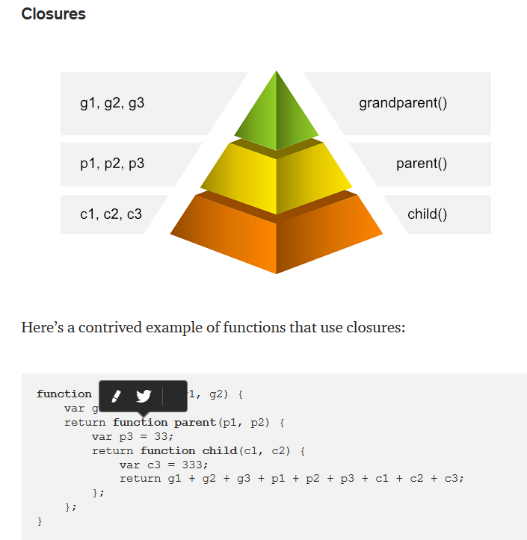
Closures

function composition in JavaScript

Function composition is a mechanism of combining multiple simple functions to build a more complicated one. The result of each function is passed to the next one. In mathematics, we often write something like: f(g(x)). So this is the result of g(x) that is passed to f

Simple example:
const add = (a, b) => a + b;
const mult = (a, b) => a * b;
add(2, mult(3, 5))

So our goal in this section is to create a high order function that take two or more functions and compose them
compose(function1, function2, ... , functionN): Function
implementation:
const compose = (...functions) => args => functions.reduceRight((arg, fn) => fn(arg), args);
const filter = cb => arr => arr.filter(cb);
const map = cb => arr => arr.map(cb);

compose(
map(u => u.name),
filter(u => u.age >= 18)
)(users) //["Jack", "Milady"]

In Functional Programming, functions are our building blocks. We write them to do very specific tasks and then we put them together like Lego™ blocks.
This is called Function Composition

Fat arow notation for funtions
var add10 = function(value) {
return value + 10;
};
var mult5 = function(value) {
return value * 5;
};

go to
var add10 = value => value + 10; // no name => and lamba to from param and body
var mult5 = value => value * 5;

function value plus 10 then multiplay by 5
var mult5AfterAdd10 = value => 5 * (value + 10)
or
var mult5AfterAdd10 = value => mult5(add10(value));

In math, f ∘ g is functional composition and is read “f composed with g” or, more commonly, “f after g”. So (f ∘ g)(x) is equivalent to calling f after calling g with x or simply, f(g(x))

What is Currying?

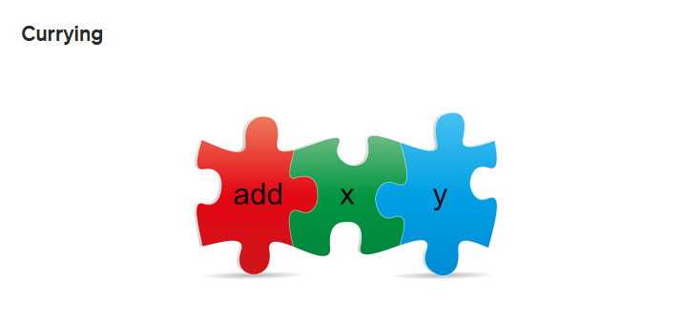

We simply write an add function that uses 2 parameters but only takes 1 parameter at a time. Curried functions allow us to do this.
A Curried Function is a function that only takes a single parameter at a time.

Example:
var add = x => y => x + y
or
function add(x) {
return function(y) {
return x + y;
}
}
In detail, the add function takes a single parameter, x, and returns a function that takes a single parameter, y, which will ultimately return the result of adding x and y
Read more: https://stackoverflow.com/questions/36314/what-is-currying/62166542#62166542
and here
https://stackoverflow.com/questions/40675740/javascript-functional-programming-functions/40675883#40675883

example of usage: https://stackoverflow.com/questions/113780/javascript-curry-what-are-the-practical-applications
and here
https://softwareengineering.stackexchange.com/questions/384529/a-real-life-example-of-using-curry-function
ad
https://stackoverflow.com/questions/39835395/currying-practical-implications

Parameter order is important to fully leverage currying.

There is a way to reduce functions of more than one argument to functions of one argument, a way called currying after Haskell B. Curry. [1]
Currying is a process to reduce functions of more than one argument to functions of one argument with the help of lambda calculus
f(n, m) --> f'(n)(m)
multiply = (n, m) => (n * m)
multiply(3, 4) === 12 // true
curryedMultiply = (n) => ( (m) => multiply(n,m) )
triple = curryedMultiply(3)
triple(4) === 12 // true

Compose performs a right-to-left function composition since Pipe performs a left-to-right composition. So let's write the pipe high-order function
const pipe = (...functions) => args => functions.reduce((arg, fn) => fn(arg), args);
pipe(
filter(u => u.age >= 18),
map(u => u.name),
)(users) //["Jack", "Milady"]

pipe(mapWords, reduceWords)(['foo', 'bar', 'baz']);
Some people prefer using pipe over compose because they find it more readable. At least, we can all agree that it is more natural!

Partial application means that you pre-applied a function partially regarding to any of its arguments.
f(n, m) --> f'(m)

multiply = (n, m) => n * m
multiply(3, 4) === 12 // true
triple = (m) => multiply(3, m)
triple(4) === 12 // true

Usage:
const handleChange = (fieldName) => (event) => {
saveField(fieldName, event.target.value)
}
<input type="text" onChange={handleChange('email')} ... />

renderHtmlTag = tagName => content => `<${tagName}>${content}</${tagName}>`
renderDiv = renderHtmlTag('div')
renderH1 = renderHtmlTag('h1')
console.log(
renderDiv('this is a really cool div'),
renderH1('and this is an even cooler h1')
)

Curry as a term has been living for almost 40 years now and is an essential transformation in lambda calculus.
JavaScript is being used more as a functional language nowadays especially with native promises and arrow functions. To master the language you should have some knowledge in the field of lambda calculus and functional programming. JavaScript is being used more as a functional language nowadays especially with native promises and arrow functions. To master the language you should have some knowledge in the field of lambda calculus and functional programming

Partial application can be described as taking a function that accepts some number of arguments, binding values to one or more of those arguments, and returning a new function that only accepts the remaining, un-bound arguments.
What this means is that, given any arbitrary function, a new function can be generated that has one or more arguments "bound," or partially applied. And if you've been paying attention, you've realized by now that the previous examples have demonstrated partial application in a practical, albeit somewhat limited way. More here: http://benalman.com/news/2012/09/partial-application-in-javascript/#partial-application

also: https://towardsdatascience.com/javascript-currying-vs-partial-application-4db5b2442be8

---

JavaScript is being used more as a functional language nowadays especially with native promises and arrow functions. To master the language you should have some knowledge in the field of lambda calculus and functional programming. First thinkg you must to know is Pure Function

But in Javascript when writing pure functions one has to fight the temptation of mutating the non-persistent data structures. If you are someone who doesn’t want to let go of the temptation, you can be rescued by immutable.js. Immutable.js provides many persistent immutable data structures which are highly efficient as it uses structural sharing via hash maps tries and vector tries as popularized by Clojure and Scala
-> Avoid array mutations
-> map and filter return a new array when applied upon an existing array which saves the
existing array from mutation
-> using concat(), slice() and …spread

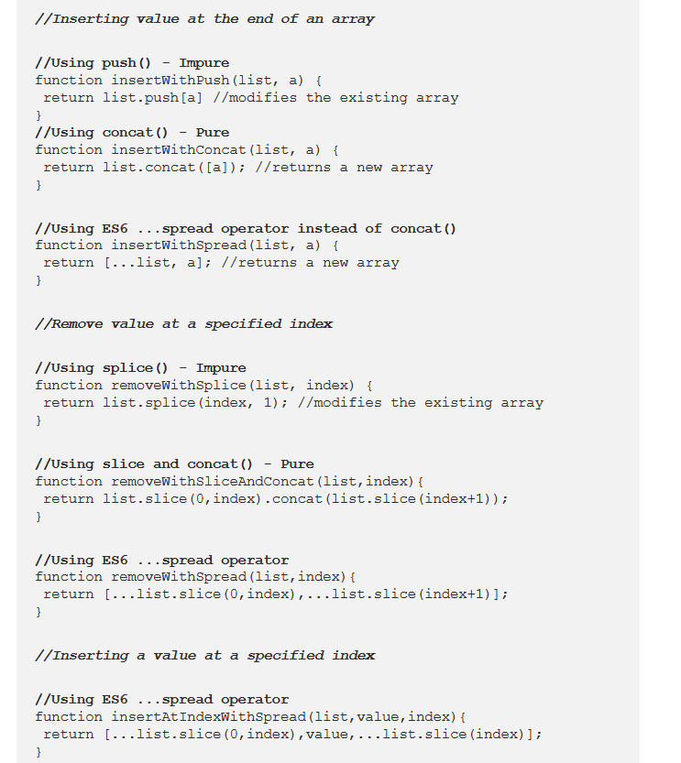

Using Object.assign() and …spread
The Object.assign()method(ES6) is used to copy the values of all enumerable own properties from one or more source objects to a target object. It will return the target object. Properties in the target object will be overwritten by properties in the sources if they have the same key. Later sources’ properties will similarly overwrite earlier ones.

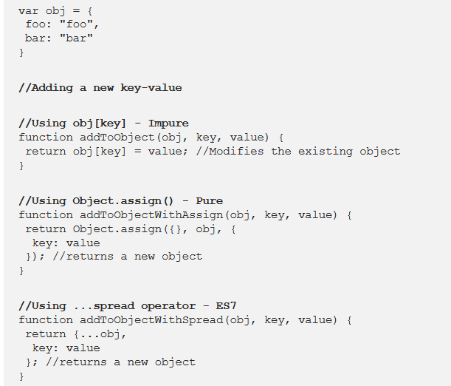

Read more here: https://medium.com/javascript-scene/master-the-javascript-interview-what-is-a-pure-function-d1c076bec976#.bm3rjd9c3

Function composition is the act of pipelining the result of one function, to the input of another, creating an entirely new function.

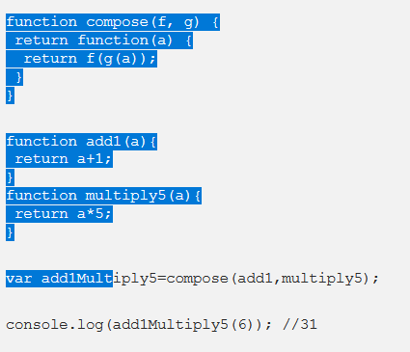

pipe which takes an array of functions to produce a new composed function.

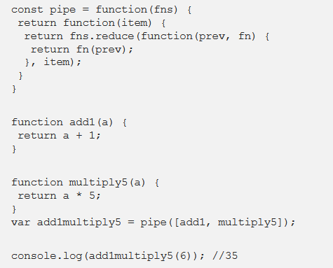

Functional programing middleware
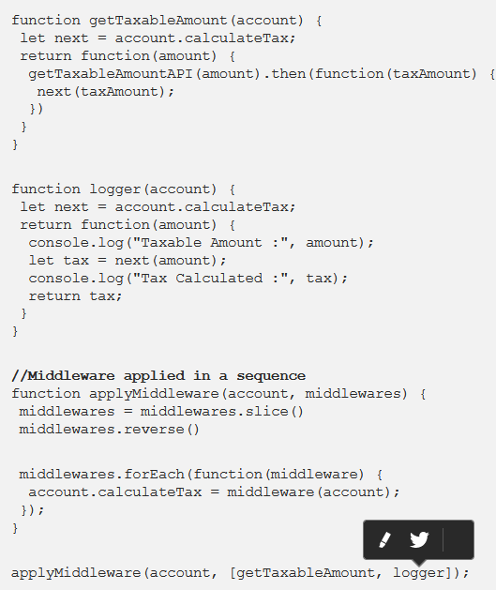

Using the concepts of pure function, function composition, currying/partial application and middlewares skillfully can alleviate a lot of design concern while making the application clean and concise. Functional libraries like Ramda and persistent immutable data structures library like Immutable-js greatly take away the burden of reimagination. Learning the concepts of functional programming is fun and inspiring. To further explore, fantasyland/fantasy-land is a great resource to understand the functional beauty in true sense.

Referential Transparency is a fancy term to describe that a pure function can safely be replaced by its expression. An example will help illustrate this.

Functional programing
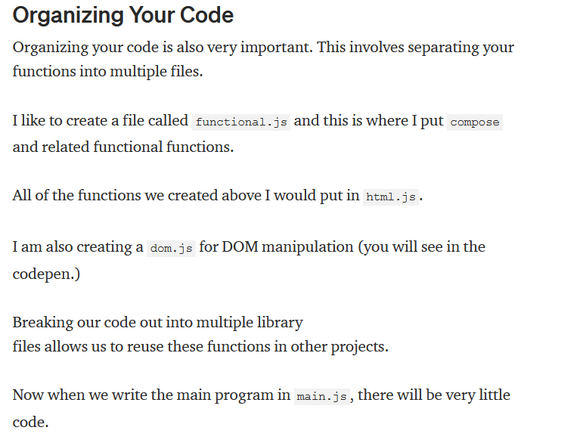

Code exmple here: https://codepen.io/joelnet/pen/QdVpwB

Ramda libary in js for functional progaming.
Also see: https://www.telerik.com/blogs/practical-functional-javascript-ramda
also: https://hackernoon.com/the-beauty-in-partial-application-currying-and-function-composition-d885bdf0d574

FP project code example:
https://github.com/xodio/xod/tree/master/packages/xod-project/src/
-> https://hackernoon.com/two-years-of-functional-programming-in-javascript-lessons-learned-1851667c726

TODO in FP
-> Memoization
-> Arity

todo -> https://jrsinclair.com/articles/2016/gentle-introduction-to-functional-javascript-functions/

todo
-> https://eloquentjavascript.net/Eloquent_JavaScript.pdf
-> https://www.quora.com/What-are-some-of-the-biggest-projects-or-products-implemented-using-functional-programming-languages
-> https://www.quora.com/What-project-can-I-build-that-lends-itself-specifically-to-functional-programming

todo
-> https://softwareengineering.stackexchange.com/questions/79608/what-would-be-a-good-first-functional-programming-project

