DB Management systems

History

Storing dana in a DBMS

Transactios

Resources: http://pages.cs.wisc.edu/~dbbook/openAccess/thirdEdition/supporting_material.htm
History

The first general-purpose DBMS, designed by Charles Bachman at General Electric in the early 1960s, was called the Integrated Data Store. It formed the basis for the network data model, which was standardized by the Conference on Data Systems Languages (CODASYL) and strongly influenced database systems through the 1960s.

In the late 1960s, IBM developed the Information Management System (IMS) DBMS, used even today in many major installations. IMS formed the basis for an alternative data representation framework called the hierarchical data model

In 1970, Edgar Codd, at IBM's San Jose Research Laboratory, proposed a new data representation framework called the relational data model.

the most widely used form of concurrent programming is the concurrent execution of database programs (called transactions). Users write programs a." if they are to be run by themselves, and the responsibility for running them concurrently is given to the DBl\/IS. James Gray won the 1999 Turing award for his contributions to database transaction management

An interesting phenomenon is the emergence of several enterprise resource planning (ERP) and management resource planning (MRP) packages which add a substantial layer of application-oriented features on top of a DBMS. Baan, Oracle, PeopleSoft, SAP, and Siebel. These packages identify a set of common tasks (e.g., inventory management, human resources planning, financial analysis) encountered by a large number of organizations and provide a general application layer to carry out these ta.'3ks.

Storing dara in a DBMS

A data model is a collection of high-level data description constructs that hide many low-level storage details. A DBMS allows a user to define the data to be stored in terms of a data model. Most database management systems today are based on the relational data model.

A semantic data model is a more abstract, high-level data model that makes it easier for a user to come up with a good initial description of the data in an enterprise. These models contain a wide variety of constructs
that help describe a real application scenario. A widely used semantic data model called the entity-relationship (ER) model.

Relation Model

Relation which can be thought of as a set of records.A description of data in terms of a data model is called a schema. Each row in the relation is a record.
Intergrity constraints -> which are conditions that the records in a relation must satisfy.

In addition to the relation dana model, other importan dana models include
- hieararchical model
- network model
- object orijented model (Objectstore and Versant)
- object relational model (ObjectStore, Oracle, Versant)

Levels of Abstraction in DBMS

The database description consists of a schema at each of these three levels of abstraction: the conceptual, physical, and external.

A data definition language (DDL) is used to define the external and coneeptual schemas. Information about the conceptual, external, and physical schemas is stored in the system catalogs

The conceptual schema (sometimes called the logical schema) describes the stored data in terms of the data model. conceptual schema describes all relations that are stored in the database. The choice of relations, and the choice of fields for each relation, is not always obvious, and the process of arriving at a good conceptual schema is called conceptual database design.

The physical schema specifies additional storage details.Essentially, the physical schema summarizes how the relations described in the conceptual schema are actually stored on secondary storage devices such as disks and
tapes.

External schemas, which usually are also in terms of the data model of the DBMS, allow data access to be customized (and authorized) at the level of individual users or groups of users. Any given database has exactly one conceptual schema and one physical schema because it has just one set of stored relations, but it may have several external schemas, each tailored to a particular group of users. Each external schema consists of a collection of one or more views and relations from the conceptual schema.

Transactios

A very important advantage of using a DBMS is that it offers data independence. That is, application programs are insulated from changes in the way the data is structured and stored.

Relational calculus is a formal query language based on mathematical logic, and queries in this language have
an intuitive, precise meaning. Relational algebra is another formal query language, based on a collection of operators for manipulating relations, which is equivalent in power to the calculus.

A transaction is anyone execution of a user program in a DBMS. (Executing the same program several times will generate several transactions.) This is the basic unit of change as seen by the DBMS: Partial transactions are not allowed, and the effect of a group of transactions is equivalent to some serial execution
of all transactions.

An important task of a DBMS is to schedule concurrent accesses to data so that each user can safely ignore the fact that others are accessing the dana concurrently.

A locking protocol is a set of rules to be followed by each transaction (and enforced by the DBMS) to ensure that, even though actions of several transactions might be interleaved, the net effect is identical to executing all transactions in some serial order. A lock is a mechanism used to control access to database objects. Two kinds of locks are commonly supported by a DBMS: shared locks on an object can be held by two different transactions at the same time, but an exclusive lock on an object ensures that no other transactions hold any lock on this object.

Example:
Suppose that the following locking protocol is followed: Every transaction begins by obtaining a shared lock on each data object that it needs to read and an exclusive lock on each data object that it needs to rnod~fy, then releases all its locks after completing all actions. Consider two transactions T1 and T2 such that T1 wants to modify a data object and T2 wants to read the same object. Intuitively, if T1's request for an exclusive lock on the object is granted first, T2 cannot proceed until T1 relea..':les this lock, because T2's request for a shared
lock will not be granted by the DBMS until then. Thus, all of T1's actions will be completed before any of T2's actions are initiated.

DBMS maintains a log of all writes to the database. A crucial property of the log is that each write action must be recorded in the log (on disk) before the corresponding change is reflected in the database itself--otherwise, if
the system crcLShes just after making the change in the datab(Lse but before the change is recorded in the log, the DBIVIS would be unable to detect and undo this change. This property is called Write-Ahead Log, or WAL.

Concurrency contrl
1. Every object that is read or written by a transaction is first locked in shared or exclusive mode, respectively. Placing a lock on an object restricts its availability to other transactions and thereby affects performance.

2.For efficient log maintenance, the DBMS must be able to selectively force
a collection of pages in main memory to disk. Operating system support
for this operation is not always satisfactory.

3. Periodic checkpointing can reduce the time needed to recover from a crash.
Of course, this must be balanced against the fact that checkpointing too
often slows down normal execution.

Structure of a DBMS

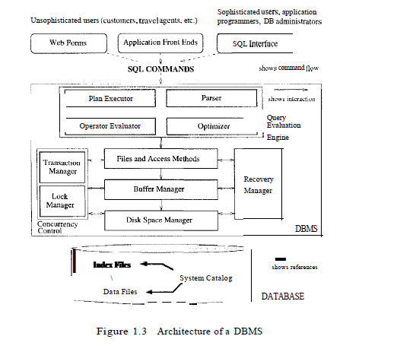

The DBMS accepts SQL commands.
When a user issues a query, the parsed query is presented to a query optimizer, which uses information about how the data is stored to produce an efficient execution plan for evaluating the query.
An execution plan is a blueprint for evaluating a query, usually represented as a tree of relational operators
(with annotations that contain additional detailed information about which access methods to use, etc.).

The code that implements relational operators sits on top of the file and access methods layer. This layer supports the concept of a file, which, in a DBMS, is a collection of pages or a collection of records. Heap files, or files of unordered pages, a:s well as indexes are supported. In addition to keeping track of the pages in a file, this layer organizes the information within a page.

The files and access methods layer code sits on top of the buffer manager, which brings pages in from disk to main memory ct." needed in response to read requests.

The lowest layer of the DBMS software deals with management of space on disk, where the data is stored. Higher layers allocate, deallocate, read, and write pages through (routines provided by) this layer, called the disk space
manager.

The DBMS supports concurrency and crash recovery by carefully scheduling user requests and maintaining a log of all changes to the database

DBMS components associated with concurrency control and recovery include the transaction manager, which ensures that transactions request and release locks according to a suitable locking protocol and schedules the execution transactions; the lock manager, which keeps track of requests for locks and grants locks on database objects when they become available; and the recovery manager, which is responsible for maintaining a log and restoring the system to a consistent state after a crash. The disk space manager, buffer manager, and file and access method layers must interact with these components

Intro to DB Design

The entity relationship(ER) data 'model allows us to describe the data involved in a real-world enterprise in terms of objects and their relationships and is widely used to (levelop an initial database design.

ER model is used in a phase called conceptual database design

DB design and ER

Database design process
- Requirements Analysis. In other words, we must find out what the users want from the database
- Conceptual Database Design This step is often carried out using the ER model. The goal is to create a simple description of the data that closely matches how users and developers think of the data (and the people and processes to be represented in the data).
- Logical Database Design. We must choose a DBMS to implement our databctse design, and convert the conceptual database design into a database schema in the data model of the chosen DBMS
- Schema Refinement Analyze the collection of relations in relational database schema to identify potential problems
- Physical Database Design. Consider typical expected workload that DB must suport and further refine the DB to ensure that it meets desired performance criteria (create indexex, custering tables, redesign of the schema).
- Application and Security Design. Consider aspects of the app that uses DB, try to address the complete software design and development cycle. Briefly, we must identify the entities (e.g., users, user groups, departments) and processes involved in the application. We must describe the role of each entity in every process that is reflected in some application task

A more careful analysis can often refine the ER and logical schema.

Entities

For each attribute associated with an entity set, we must identify a domain of possible values.

A relationship can also have descriptive attributes. Descriptive attributes are used to record information about the relationship, rather than about any one of the participating entities;

A weak entity can be identified only by considering some of its attributes in conjuction with the primary key of another entity, wich is called the identifying owner. The owner entity set and the weak entity set must have one to many or one to one relationship (each weak entity has a single owner)

Class Hierarchies

Classify the entities in an entity set into subclasses. (Hourly_emps and ContractEmps are distinguish the basis on which they are paid and we want the semantics that every entity in one of there sets is also an Employes entity, We say that we have inheritance (IS a relationship). Query that asks for ll employees must condisr all hourlyEmps and ContractEmps.

Two kinds of constrains with respect of ISA hiearchies
- overlap
- covering

Overlap constraint determine whether two subclasses are alowed to contain the same entity. Example can HourlyEmps be ContractEmps. If the absebce of such a statenement, we asume by default that entity sets are constrained to have no overlap.

Convering constraints determine wheather the entities in the sublcasses collectively include all entities in the superclass

Example of disjoint rule: Instance of Super-type Animal can only be member of exactly one of these Sub-types being Panda, Cheetah and Dog Disjoint Union , (An animal can either be Panda or be Dog or be Cheetah but can't be any two or more at the same time)
Example of overlap rule: Instance of Super-type Person can be member of multiple Sub-types being Woman, Driver and Engineer Overlapping Union , (A person can be a Woman and that same Woman can be Driver and that same Woman can be Engineer at the same time)
see: https://stackoverflow.com/questions/43658020/how-to-check-overlap-constraints-in-oracle
http://www.orafaq.com/wiki/ARC_relationship

also caled generalization : https://www.javatpoint.com/dbms-generalization and specialization : https://www.javatpoint.com/dbms-specialization

Aggregation

Aggregation allows us to indicate that a relationship set (identified through a dashed box) participates in another
relationship set. Relationship set is looked as one table from perspective another relationship.
Model a relationship between a collection of entities and relationships,,.

see:https://www.javatpoint.com/dbms-aggregation

Conceptual design with the ER model

ER diagram choices
- should problem be modeled as an entity or an attribute ?
- Should problem be modeled as an entity or relationship ?
- What are relationships sets and their participating entity set
- should we use aggregation

Befre going to th cnceptual design you must have a set of requirements.

UML, like the ER model, has the attractive feature that its constructs can be drawn as diagrams. It encompasses a broader spectrum of the software design process.
- Business Modeling (describe the business processes involved in the software app being developed)
- System Modeling (idetfiy requirement for the software application
- Conceptual DB Modeling (ER diagram for DB)
- Physical DB modeling (UML)
- Hardware System Modeling

Stao vjezbe page 87 / 1098 see http://www.turingmachine.org/courses/2005/csc370K05/assign/db-ch2.pdf

Relational model

In the relation model a database is a collection of one or more relations where each relation is a table with rows and columns.
Data Definition Languare (DDL) is languare for creating, manipulating and querying dana in relational DBMS

A database is only as good as the information stored in it. An integrity constrain is a condition specified on a database schema that restrist the dana that can be stored in an instalce of the database,

DB can have many integrity constrains, some of them are
- Domain constrainst
- Key constraints
- Referntial constrainst
- Entity Integrity constraint
- Domain Constraint

Domain constraints are definition of a valid set of values for attribute. You can set dana type of domain (string, integer, date, time). Used to constraint the value of a single column
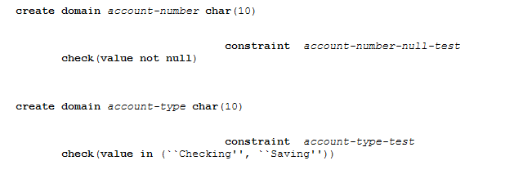

Key Constraints is a statement that a certain minimal subset of the fields of a relation is a unique identifier. A set of fields that uniquely identifies a tuple according to a key constraint is celled a candidate key. Values must be uniqe.

From wikipedia.
candidate key, or simply a key, of a relation schema is a minimal superkey of the relation schema.[1] In other words, it is a set of attributes such that each instance relation of the relation schema does not have two distinct tuples with the same values for these attributes (which means that the set of attributes is a superkey) and there is no proper subset of these attributes which is a superkey of the relation schema (which means that the set is minimal). It defines a functional dependency constraint from the candidate key to all the attributes of the relation schema.
Candidate keys are also variously referred to as primary keys, secondary keys or alternate keys.
Out of all the available candidate keys, a database designer can identify a primary key. sing the primary key is preferable because it is what the DBMS expects this is the significance of designating a particular
candidate key as a primary key and optimizes for

Foreing Key Constraints
Sometimes the information stored in a relation is linked to the information stored in another relation. If one of the relations is modified, the other must be checked, and perhaps modified, to keep the data consistent

Insertion will not work if keys do not match. Delection can not be done if key in other table exist.
foreign key could refer to the same relation. For example, we could extend the Students relation with a column called partner and declare this column to be a foreign key referring to Students

The appernca of null in a foreign key field does not violate the foreign key constraint. However, null values are not allowed to appear in a primary key field (because the primary key fields are used to identify a tuple
uniquely).

The impact of foreign key constraints is more complex because SQL sometimes tries to rectify a foreign key constraint violation instead of simply rejecting the change.

What should bed one when row is insetet -> command is simply rejected
What should we do if row is deleted, there are options
-> delete all enrolled rows
-> disallow the deletion
-> set to default value
What to the on update
-> same as delete

The options are specified as part of the foreign key declaration. The default option is NO ACTION, which means that the action (DELETE or UPDATE) is to be rejected, Thus, the ON UPDATE clause in our example could be omitted, with the same effect. The CASCADE keyword says that, if a Students row is deleted, all Enrolled rows that refer to it are to be deleted as well. If the UPDATE clause specified CASCADE, and the sid column of a Students row is updated, this update is also carried out in each Enrolled row that refers to the updated Students row. Also we have option ON DELETE SET DEFAULT or SET NULL

Transactions and Constraints

By default, a constraint is checked at the end of every SQL statement that could lead to a violation, and if there is a violation, the statement is rejected -> immediate mode
A constraint in deferrd mode is checked at commit time.

ER to Relational – Translating class hierarchies

Each entiy map as relation (table) and they are connected by PK and FK
Or create two relations (concrete classes) have all atributes from superclass that do not exist

ER to Relational – Translating Aggregation

Create table that will have PK from tables we want to see in aggregation and additonal fields we want to have.

Intro to Views

A View is a table whose rows are not explicitly stored in the database but are computer as needed from a view definition. Updated on viwes cam be maded on viwes that are defined on a single base table using just section and projection.

Stao page 129 review questions and exercises

SQL: queries, constaints, triggers

SQL
- DML data manipulation language (inser, delete, modify rows)
- DDL data definition language (create, delete, modification on tabels and views)
- triggers (actions executed by the dbms on specified condition)
- embedded sql
- dynamic sql
- transaction management
- security
- features: object-oriented, recursive queries, decision support queries, data mining, spatial dana, text and xml data management

Form of a basic sql query
1.1
SELCET [DISTINCT] select-list
FROM from-list
WHERE qualification (conditions)

FORM clause is list of table names (more than one)

how DBMS process query (for 1.1.)
- computer the cross product of the tables in the form lis
- delete rows in the corss product tat fails the qualification conditions in where part
- delete all columns that do not appear in select-list
- if distinct is specified, eliminate duplicate rows

1.2
SELECT S.sname
FROM Sailors S, Reserves R
WHERE S.sid = R.sid AND R.bid=103

how DBM process query (for 1,2)
- construct the cross-product of Sailor and Reserves
- Apply conditions from where part (S.sid = R.sid AND R.bid=103)
- Eliminate unwante collums (only S.name appears in the select part)

Table names can be used implicitly as row variables
1.3
SELECT S.sname
FROM Sailors S, Reserves R, Boats
WHERE S.sid = R.sid AND R.bid = 13.bid AND B.color = 'red'

query contains a join of three tables followed by a section on the color of boats

Expressions and Strings in the SELECT Command
Each item in a selet-list can be of the form expression where expression is any arithemtic or string operation over column names

1.4
SELECT S.sname, S.rating+1 AS rating
FROM Sailors S, Reserves R1, Reserves R2
WHERE S.sid = R1.sid AND S.sid = R2.sid
AND R1.day = R2.day AND R1.bid <> R2.bid

For string comparisson we can use the ( = < > ...)
pattern matching throught LIKE operator

Sqk set operatons
- IN ( to check if an elememnt is in a given set)
- ANY / ALL (to compare a value with the elelemnst in given set)
- EXIST (to check if a set is empty)
- NOT
- set operations (union, intersect, except)

Be careful when using OR and AND opertors
1.5
SELECT S.sname
FROM Sailotrs S, Reserves R, Boats B
WHERE S.sid = R.sid AND R.bid = B.bid
AND (B.color = 'red' OR B.color = 'green')
-> find the names of sailors who have reserved a red or a green boat

better solution is to use UNION
- union of the set of sailors who have reserved red boats and the set of sailor wo have reserved green boats

SELECT S.sname
FROM Sailors S, Reserves R, Boats B
WHERE S.sicl = R.sid AND R.bid = B.bid AND B.color = 'red'
UNION
SELECT S2.sname
FROM Sailors S2, Boats B2, Reserves H2
WHERE S2.sid = H2.sid AND R2.bid = B2.bicl AND B2.color = 'green'

conslusion: for perforamance replace OR with UNION

1.6
SELECT S.sname
FROM Sailors S, Reserves RI, Boats BI, Reserves R2, Boats B2
WHERE S.sid = Rl.sid AND R1.bid = Bl.bid
AND S.sid = R2.sid AND R2.bid = B2.bid
AND B1.color='red' AND B2.color = 'green'
-> find the names of sailros who have resrved both a red and a green boat

better solution is to use INTERSELECT
SELECT S.snarne
FROM Sailors S, Reserves R, Boats B
WHERE S.sid = R.sid AND R.bid = B.bid AND B.color = 'red'
INTERSECT
SELECT S2.sname
FROM Sailors S2, Boats B2, Reserves R2
WHERE S2.sid = R2.sid AND R2.bid = B2.bid AND B2.color = 'green'

In quers for id do not use attribues (name) use primary key

1.7
SELECT S.sid
FROM Sailors S, Reserves R, Boats B
WHERE S.sid = R.sid AND R.bid = B.bid AND B.color = 'red'
EXCEPT
SELECT S2.sid
FROM Sailors S2, Reserves R2, Boats B2
WHERE S2.sid = R2.sid AND R2.bid = B2.bid AND B2.color = 'green'

find the sids of all sailors who have reserved red boats but not green boats

Not that UNION, INTERSECTION AND EXCEPT can be used on any tow table sthat are unio-compatible, ( have the same number of columena and the columns taken in orer have the same types).
UNION -> duplicates are eliminated
UNION ALL -> to retain duplicates
same form INTERSELETION ADN EXPECT

Nested queries
A nedted query is a wuery that has another query embedded within it. -> it is subquery.
Deeply nedted structures are possible

1.8
SELECT S.sname
FROM Sailors S
WHERE S.sid IN (
SELECT R.sid
FROM Reserves R
WHERE R.bid = 103)

IN operator allows us to test wheatehe a value is in a given set of elements

For each row in query eveluate the subqurey

how DBMS process subquery
- construct the cross-product of the tables in the FORM of the top-level query
- for each row in the cross-product test the where cause and recompute (compute the subquery)

1.9
SELECT S.sname
FROM Sailors S
WHERE S.sid IN (
SELECT R.sid
FROM Reserves R
WHERE R. bid IN (
SELECT B.bid
FROM Boats B
WHERE B.color = 'red'))
-> find the names of sailors who have reserved a red boat

Correlated nested queries
Inner subquery depend on row currently being examined in the outer query (in terms or our conceptual evaluation strategy)
1.10
SELECT S.sname
FROM Sailors S
WHERE EXISTS (
SELECT *
FROM Reserves R
WHERE R.bid = 103
AND R.sid = S.sid )

Subquery depends on the current row and mubt be re-evaluated for each row in main query

Set comparions operators
Sql also supports ANY op na ALL op where op is one of the arithmetic comparison oprators (<; > = )

Find sailors whose rating is better than some sailor called Horatio
SELEC S.sid
FROM Sailors S
WHERE S.rating > ANY (
SELEC S2.rating
FROM Sailors S2
WHERE S2.name = 'Horatio')

S.rating is compared with each rating value that is an answer to the nested query

Find sailors whose rating is better than every sailor called Horatio. Replace ANY with ALL.

Comparisson must be true for every return row for S.rating -> All

Note that IN and NOT IN are equivalent to = ANY and <> ALL, respectively

You can use subqueries to revirtite INTERSELECT and EXCEPT if system do not support them

Aggregate operators
To perform some computataion or summarization.
- COUNT –the number of values in the column
- SUM – the numner of values in the column
- AVG – the average of values in the column
- MAX – max value in the column
- MIN – min value in the column

Example
-> Find tha average age of sailors with a rating of 10
SELECT AVG (S.age)
FORM Sailors S

-> Find the name and age of the olders sailor
SELECT clause can have only aggregate operation unless the query contains GROUP BY so we have to use nedted query
SELECT S.name, S.age
FROM Sailors S
WHERE S.age = (
SELECT MAX (S2.age)
FROM Sailors S2
)
-> Count the number of different sailor names
SELECT COUNT ( DISTINCT (S.name))
FROM Sailors S

GROUP BY and HAVING Clauses

basic sql
SELECT [ DISTINCT] select-list
FROM from-list
WHERE 'qualification
GROUP BY grouping-list
HAVING group-qualification

Find the age of the youngest sailor for each rating level
SELECT S.rating, MIN (S.age)
FORM Sailors S
GROUP BY S.rating

Each row in the result of the query correspondes to one gropus, so every colum that appers mut also appera in GROUP BY

Find the age of the youngest sailor who is eligbe to vote (at lest is 18 years old) for each rating level witj at least two such sailors
SELECT S.rating, MIN (S.age) AS minage
FROM Sailors S
WHERE S.age >= 18
GROUP BY S.rating
HAVING COUNT (*) > 1

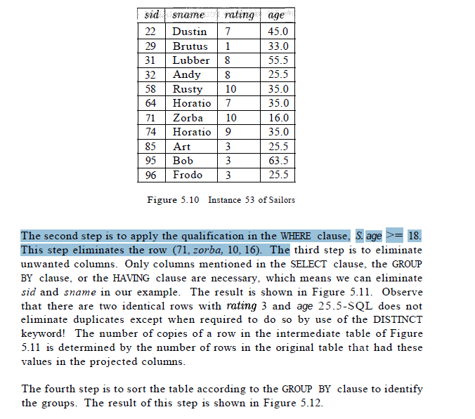

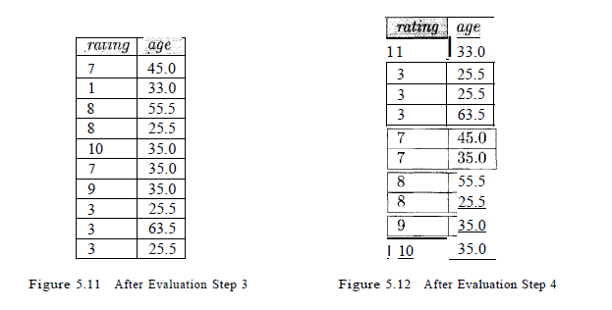

The fifth step ,-is to apply the group-qualification in the HAVING clause, that
is, the condition COUNT (*) > 1. This step eliminates the groups with rating
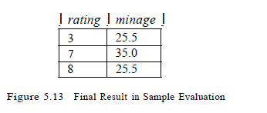
equal to 1, 9, and 10.

SQL:1999 ha.s introduced two new set functions, EVERY and ANY. To illustrate
these functions, we can replace the HAVING clause in our example by
HAVING COUNT (*) > 1 AND EVERY ( S.age <= 60 )

-> Find each read boad ant the number of reservatons form this boat
SELECT B.bid, COUNT (*) AS reservationcount
FROM Boats B, Reserves R
WHERE R.bid = B.bid AND B.color = 'red'
GROUP BY B.bid
or
SELECT B.bicl, COUNT (*) AS reservationcount
FROM Boats B, Reserves R
WHERE R.bid = B.bid
GROUP BY B.bid
HAVING B.color = 'red'

-> Find the average age of sailor for each rating level has st least two sailors

SELECT S.rating, AVG (S.age) AS avgage
FROM Sailors S
GROUP BY S.rating
HAVING COUNT (*) > 1
alternative
SELECT S.rating, AVG ( S.age ) AS avgage
FROM Sailors S
GROUP BY S.rating
HAVING 1 < ( SELECT COUNT (*)
FROM Sailors S2
WHERE S.rating = S2.Hl,ting )

NULL values
When column value is either unknown or inapplicable
USE comparisoini operator IS NULL to test wheathe a colum value is null

Therefore, in the presence of null values, any row that evaluates to false or unknown is eliminated. Eliminating
rows that evaluate to unknown h&') a subtle but signifieant impaet on queries, especially nested queries involving EXISTS or UNIQUE.

COUNT(*) handles 'null values just like other values; that is, they get counted. All the other aggregate operations (COUNT, SUM, AVG, MIN, MAX, and variations using DISTINCT) simply discard null values

Because of the null we have special joins (outer join, left outer join, right outer join...)

Disallow null values by specifying NOT NULL as part of the field definition

Constraint over a single table
Use CHECK conditional-experssion

To ensuer that rating column must be an interger in the range 1 to 10
CHECK (rating >= 1 AND rating <= 10)

To enfore that Interlake boats cannot be reserve we couls use:
CHECK ( 'Interlake' <>
(SELECT B.bname
FORM Boats B
WHERE B.bid = Reservers.bid)
-> When a row is inserted into Reserves or an existing row is modified, the conditional
expression in the CH

Domain Constraint and disticnt types
A user can define a new domain using the CREATE DOMAIN statement, which
uses CHECK constraints.
CREATE DOMAIN ratingval INTEGER DEFAULT 1
CHECK ( VALUE >= 1 AND VALUE <= 10 )

Once a domain is defined, the name of the domain can be used to restrict column values in a table
rating ratingval

CREATE TYPE ratingtype AS INTEGER
This statement defines a new distinct type called ratingtype, with INTEGER as its source type. Values of type ratingtype can be compared with each other, but they cannot be compared with values of other types.

Assertion is constraint not associated with anyone table

CREATE ASSERTION smallClub
CHECK (( SELECT COUNT (S.sid) FROM Sailors S )
+ ( SELECT COUNT (B. bid) FROM Boats B)
< 100 )

-> constraint that the number of boats plus the number of sailors should be less than 100
Triggers and active DB
A trigger is a procedure that is automatically inviked by the DBMS in response to specified changes to the DB, and is typically specified by the DBA
DB that has a seto of associated triggers is called an active DB

Trigger has
- event ( change to DB that activated the trigger)
- condition (query or test that is run when the trigger is activated)
- action (procedure that is executed when the trigger is activated and condition is true)

A trigger can be thought of as a 'daemon' that monitors a databa.se, and is executed when the database is modified in a way that matches the event specification. An insert, delete, or update statement could activate a trigger, regardless of which user or application invoked the activating statement; users may not
even be aware that a trigger wa.'3 executed as a side effect of their program.

A condition in a trigger can be a true/false statement.

Depending on exactly what the trigger does, we may want its action to execute before changes are made to the table form orginal query or afterwards:

Examples
CREATE TRIGGER iniLeount BEFORE INSERT ON Students // Event
DECLARE
count INTEGER:
BEGIN // Action
count := 0:
END

CREATE TRIGGER incLcount AFTER INSERT ON Students //
WHEN (new.age < 18) // Condition; 'new' is just-inserted tuple
FOR EACH ROW
BEGIN // Action; a procedure in Oracle's PL/SQL syntax *1
count := count + 1;
END

Trigger can be
- staatemen level
- row level

Triggers offer a powerful mechanism for dealing with changes to a database, but they must be used with caution. The effect of a collection of triggers can be very complex, and maintaining an active database can become very difficult.

A common use of triggers is to maintain db consistency, and in such cases, we should always consider whether using an integrity constraint (e.g., a foreign key constraint) achieves the same goals.
With trigger user have flexible but constraint easy to understans, prevents dana from being made inconsisten by any kind of statemen.
Trggger give as way to perform some additionl action when action od BD happens, aslo then can put alert ro unusal evenet

