Javascript-algorithms

from: https://github.com/trekhleb/javascript-algorithms

Linked list

linear collection of data elements, in which linear order is not given by their physical placement in memory. Instead, each element points to the next.

It is a data structure consisting of a group of nodes which together represent a sequence. Under the simplest form, each node is composed of data and a reference (in other words, a link) to the next node in the sequence.

This structure allows for efficient insertion or removal of elements from any position in the sequence during iteration. More complex variants add additional links, allowing efficient insertion or removal from arbitrary element references.

A drawback of linked lists is that access time is linear (and difficult to pipeline). Faster access, such as random access, is not feasible. Arrays have better cache locality as compared to linked lists.

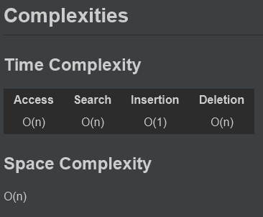

Doubly Linked List

linked data structure that consists of a set of sequentially linked records called nodes. Each node contains two fields, called links, that are references to the previous and to the next node in the sequence of nodes

linked data structure that consists of a set of sequentially linked records called nodes. Each node contains two fields, called links, that are references to the previous and to the next node in the sequence of nodes. The beginning and ending nodes' previous and next links, respectively, point to some kind of terminator, typically a sentinel node or null, to facilitate the traversal of the list.

The two node links allow traversal of the list in either direction. While adding or removing a node in a doubly linked list requires changing more links than the same operations on a singly linked list, the operations are simpler and potentially more efficient (for nodes other than first nodes) because there is no need to keep track of the previous node during traversal or no need to traverse the list to find the previous node, so that its link can be modified.
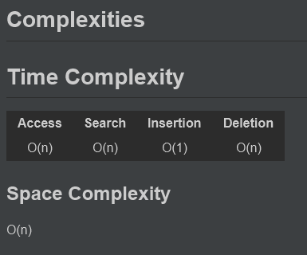

Queue

particular kind of abstract data type or collection in which the entities in the collection are kept in order and the principle (or only) operations on the collection are the addition of entities to the rear terminal position, known as enqueue, and removal of entities from the front terminal position, known as dequeue. This makes the queue a First-In-First-Out (FIFO) data structure

In a FIFO data structure, the first element added to the queue will be the first one to be removed. This is equivalent to the requirement that once a new element is added, all elements that were added before have to be removed before the new element can be removed. Often a peek or front operation is also entered, returning the value of the front element without dequeuing it. A queue is an example of a linear data structure, or more abstractly a sequential collection

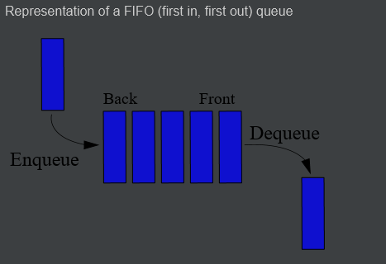
Stack

An abstract data type that serves as a collection of elements, with two principal operations:
- push, which adds an element to the collection, and
- pop, which removes the most recently added element that was not yet removed.
- a peek operation may give access to the top without modifying the stack.
The order in which elements come off a stack gives rise to its alternative name, LIFO (last in, first out).

Hash Table

hash table (hash map) is a data structure which implements an associative array abstract data type, a structure that can map keys to values. A hash table uses a hash function to compute an index into an array of buckets or slots, from which the desired value can be found

Ideally, the hash function will assign each key to a unique bucket, but most hash table designs employ an imperfect hash function, which might cause hash collisions where the hash function generates the same index for more than one key. Such collisions must be accommodated in some way.
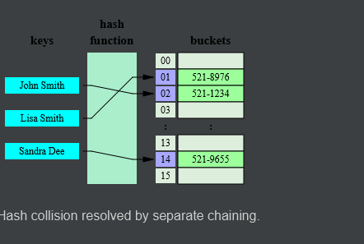
Heap

Specialized tree-based data structure that satisfies the heap property described below

In a min heap, if P is a parent node of C, then the key (the value) of P is less than or equal to the key of C.
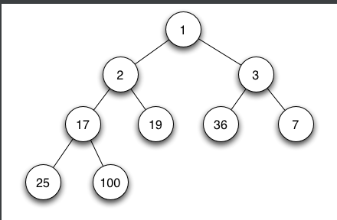

In a max heap, the key oF P is greater than or equal to the key of C

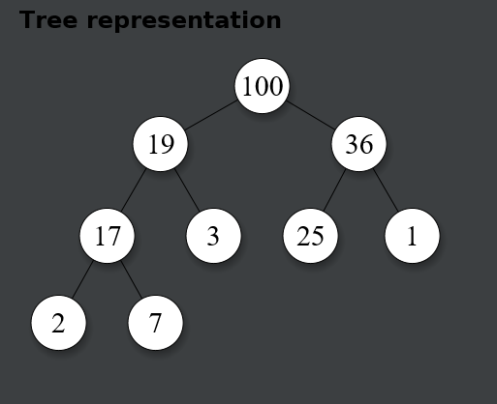
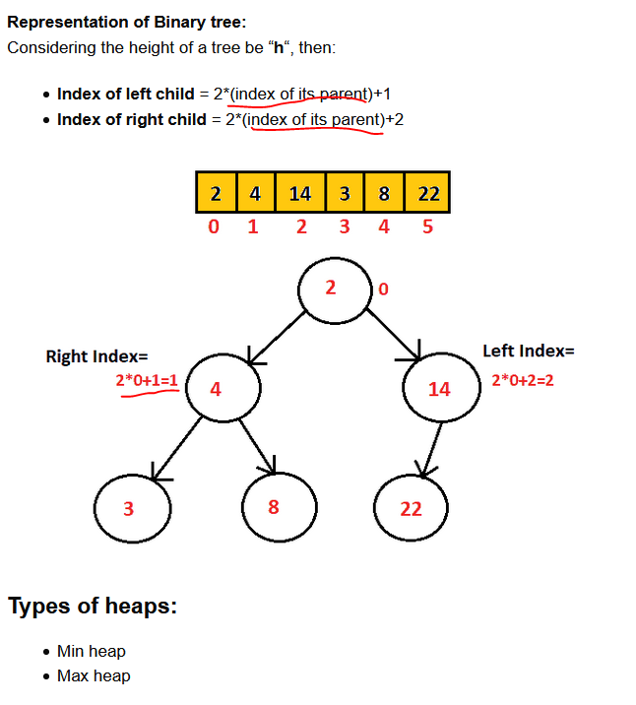

Priority Queue
An abstract data type which is like a regular queue or stack data structure, but where additionally each element has a "priority" associated with it. In a priority queue, an element with high priority is served before an element with low priority. If two elements have the same priority, they are served according to their order in the queue.

While priority queues are often implemented with heaps, they are conceptually distinct from heaps. A priority queue is an abstract concept like "a list" or "a map"; just as a list can be implemented with a linked list or an array, a priority queue can be implemented with a heap or a variety of other methods such as an unordered array.

Trie

In computer science, a trie, also called digital tree and sometimes radix tree or prefix tree (as they can be searched by prefixes), is a kind of search tree—an ordered tree data structure that is used to store a dynamic set or associative array where the keys are usually strings. Unlike a binary search tree, no node in the tree stores the key associated with that node; instead, its position in the tree defines the key with which it is associated.
All the descendants of a node have a common prefix of the string associated with that node, and the root is associated with the empty string.
Values are not necessarily associated with every node. Rather, values tend only to be associated with leaves, and with some inner nodes that correspond to keys of interest. For the space-optimized presentation of prefix tree, see compact prefix tree.

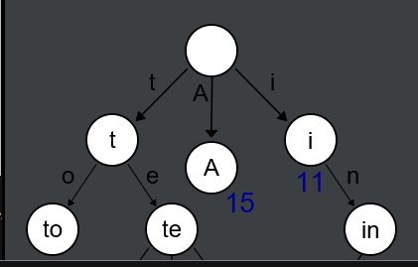

Tree

In computer science, a tree is a widely used abstract data type (ADT) — or data structure implementing this ADT—that simulates a hierarchical tree structure, with a root value and subtrees of children with a parent node, represented as a set of linked nodes.
A tree data structure can be defined recursively (locally) as a collection of nodes (starting at a root node), where each node is a data structure consisting of a value, together with a list of references to nodes (the "children"), with the constraints that no reference is duplicated, and none points to the root.
A simple unordered tree; in this diagram, the node labeled 7 has two children, labeled 2 and 6, and one parent, labeled 2. The root node, at the top, has no parent.

