Containers in 4 Hours: Docker and Podman OReilly online course

best book: read docker documentation
Container starts app with all depenecies inclued, it is not virtual ma
chine.
Two types
- system (OS) -> like command,
- application (replacement of system) -> like demo proces

Docker runtime is layer betwen host os and container.
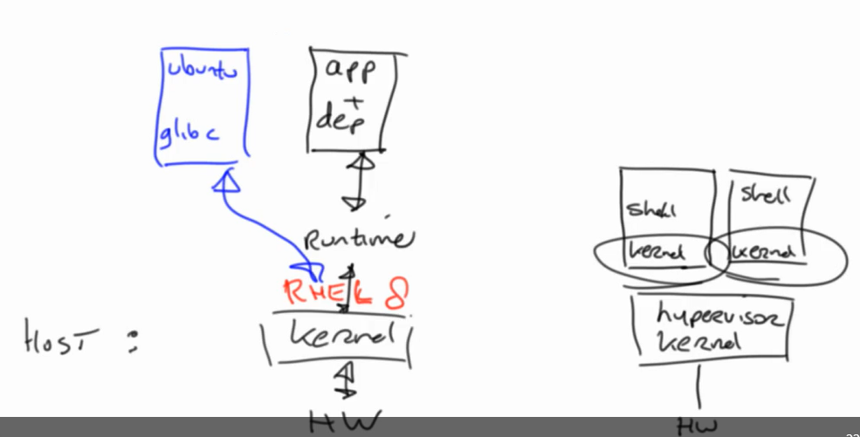
Container rely upon features by the Linuy kernel: namespacesm chroot, Cgroups
App container is build on system container.
When you run two contaner on one machine, they are not have same file system.

Container image
is running instance that contains app code, language runtime libraries, external libraries
read only instance of the application and add writeable layer on the top to store any changes

Docker image are typicall shared throught public registers.
OCI standardized boy for the Docker container image format (universal standard)

Registries (hub.docker.com)
- take care of distribution of images
- image in tar ball is possible NOT recomended

Docker desktop
- working enviroment
- docker ps (show containers that are curently working)
- docker CONTAINER_NAME stop to stop image
- docker run -it fedora bash
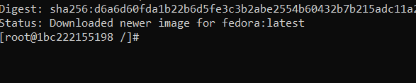
- -> -it run interactive terminal, so in example above in interactive terminal you are runing bas In the image is visible that I am in fedora os, runing bash
- docker help (list of all avalible commands)

Container is all about running isloated processes in a protevted enviroment
-> 1970 chroot
-> 2000 partitoin file systems, networkk addresses, memory
-> 2004 Solaris containers for combine system resoures control and zone-based boundar separation
-> 2007 Control Groups in Linux kernel
-> 2008 Linux based containers by LXC
-> 2013 Docker started
-> 2014 Kubernetes started as default container management platform
-> OCI open container initiative
-> CNCF Cloud Native Computing Foundation promotes the apoption of cloud-native computing

Container runtime is the app (software) that execute contaieres and manages containers images (Docker is the most common, hight-level)
runc – low level, writen in C
Alternatives to Docker: Podman (RHEL (Red Hat)), Mesos Containers

Container Orchestration
- fleibile and scalable networking, scalable and flexible storage, methods to connect containers together, monitoring... -> Kubernetes also have OpenShift and Rancer (based on Kubernetes)

TODO: https://learning.oreilly.com/playlists/330a1112-13ee-4e72-8b2a-6fd8766fddae/, https://learning.oreilly.com/videos/linux-fundamentals/9780135560396,
search: Sander van Vugt

docker run -> to run docker image
busybox -> minimal image for linux (one layer)
in docker images we have layers

System images (ubuntu, busybox) are used for run app images ( nginx)

docker kill -9 kill odmah not save what is working in moment
docker kill kill and save changes
doker stop – need to waith

docker rm – remove images to clean it, best way to save memory also docker rmi
docker inspect to get details
docker logs to get access to primary application stoduout
-> logs of your application
docker stats for top-like intrfaces about real time container
docker run -d xys -d (deomon)

app container image haves enty point
to pass enviroment variavle
docker run -d mysql -e mysqenvortment varible

docker stats info about images (waht are they are doing)
docker is the process on the machine (less siguran than virtual machine), but one container image can not access to other

see SELinux: for security

OpenShift is Red Hat replacement for Kubernetes

see: https://docs.docker.com/get-started/part2/ for example of build docker images
see: https://github.com/docker/labs/tree/master/developer-tools/java/ (other, angular. https://docs.docker.com/develop/)

Buildah is a tool that helps in building images (only on linux red hat, fedora, sentes)

Voluems
- persitance storage (example file (nfs files system (server))
- live outside images
- live on drivers (comuniti edition limited)

Networks
- based on brige (you can access images in the same brige unit)
- docker network ls to see default networking
- see network namspace

