NoSqlForDummies (https://learning.oreilly.com/library/view/nosql-for-dummies/)

also todo: https://learning.oreilly.com/library/view/nosql-for-mere

CH01 Introduction NoSQL

History of NoSql

Carlo Strozzi in 1998 database was accessed via shell scripts

In 2006, Google released a paper that described its Bigtable distributed structured database.
Bigtable stores rows with a single key and stores data in the rows within related column families
Therefore, accessing all related data is as easy as retrieving a record by using an ID rather than a complex join, as in relational database SQL.

Amazon released a paper of its own in 2007 describing its Dynamo data storage application. The first globally distributed key-value store

Many open-source NoSQL databases had emerged by 2009. Riak, MongoDB, HBase, Accumulo, Hypertable, Redis, Cassandra, and Neo4j
Each problem resulted in its own solution — and its own NoSQL database, which is why so many new databases emerged

NoSQLfeatures
Schema isn't required
Nonrelation. Single record (agregate) contains everything about the transaction.
Cheap harddware
Highly distributable can store and process set of infomration on more than one device

Alternatice intepration of schema agnostic is schema on read. You need to know how dana is stored only when constructing a query

NoSQL databases don’t have this concept of relationships between their records. They instead denormalize data. This means that in a NoSQL database would have an Order structure with the Delivery Address embedded. This means the delivery address is duplicated in every Order row that uses it. This approach has the advantage of not requiring complex query time joins across multiple data structures (tables) though
Do you really need relationships if all your data is stored in a single record?” For a lot of applications, especially ones that need to store exact state for a point in time, such as financial transactions, the answer is often “No.” However, if you're experienced with relational databases, you may have stored the same information more than once, so there’s an obvious drawback to storing information in this way. So you have better query speed.

Triple stores and graph databases have the basic concept of relationships. The difference is that every single record (a triple consisting of three things — subject, predicate, and object — such as “Adam likes Cheese”) contains a relationship
In order to effectively answer certain graph queries in a timely fashion, data needs to be stored on a single server

Not many NoSQL databases have ACID transactions. Exceptions to that norm are FoundationDB, Neo4j, and MarkLogic Server, which do provide fully serializable ACID transactions

Usage: NoSQL databases are often used as high-speed caches for web-accessible data on mission-critical systems. If one of these NoSQL systems goes down, though, you lose only a copy of the data — the mission-critical store is often an RDBMS!

Why NoSql
Not everything fits well into rows and columns — for example, a book with a tree structure of cover, parts, chapters, main headings, and subheadings. Likewise, what if a particular record has a field that could contain two or more values? Breaking this out into another sheet or table is a bit of overkill, and makes it harder to work with the data as a single unit.
This is where the schema agnostic, or schema on read, feature of NoSQL databases really pays for itself — being able to handle any form of data.
Using an RDBMS requires a null value be placed into unused columns. NoSQL -> they store and index only what is provided by the client application. No nulls stored.
Triple and graph store NoSQL databases are designed with dynamically changing relationships in mind

CH02 NoSql Database Design and Teminology

Each type of NoSQL database is designed to manage different types of data. Understanding the data you want to manage will help you apply the right NoSQL solution
NoSql have big speed, but the trade off is dana consistency (Thats thai has just beedn added or updated may not be immediately available for all users).
NoSQL databases are commonly paired with partivular complemnentary computer software, from serach engines to semantic web tech nlogies and Hadoop.

Managing Data Types
NoSql designed to havle a great variesty of dana, including dana whose structure changes over time and whose interrelationships aren't yet known.

Four types of NoSql
-> Columnar (variable sets of columns)
-> Key-value
-> Triple (subject, name of propery/relationship, value)
-> Document (xml, json, test, vinary blov, treelike structures)

Also see in DB world:
-> Inmemory and flash databases (OLTP)
-> newSQL databess access paradigm

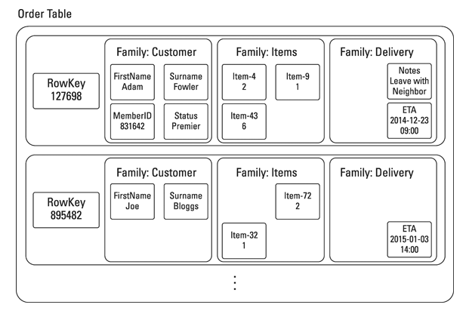
Columnar db
Have rows and columns
Define column families before loading dana into db (structure of data must be known in advance)

each record (think row in an RDBMS) doesn’t require a single value per column. Instead, it’s possible to model column families. A single record may consist of an ID field, a column family for “customer” information, and another column family for “order item” information.
The great thing about column stores is that you can retrieve all related information using a single record ID, rather than using the complex Structured Query Language (SQL) join as in an RDBMS. Doing so does require a little upfront modeling and data analysis, thoug

Key-Value
Think of it as a shared mailbox in an apartment building. All you see from the outside is a set of numbered holes. Using a key, you access whatever is in the mailbox. After looking at the mail, you decide what to do with it (probably just throw it away, if it’s junk like most of my mail)
Some key-value stores support typing (such as integers, strings, and Booleans) and more complex structures for values (such as maps and lists).
If you have numerous maps in your key-value store, consider a document store instead
Key-value stores are optimized for speed of ingestion and retrieval. If you need very high ingest speed on a limited numbers of nodes and can afford to sacrifice complex ad hoc query support, then a key-value store may be for you

Triple and Graph
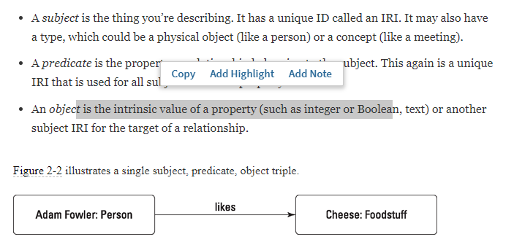
You can quickly build this simple data structure into a web of facts, which is called a directed graph in computer science
These directed graphs can contain complex and changing webs of relationships, or triples. Being able to store and query them efficiently, either on their own or as part of a larger multi-data structure application, is very useful for solving particular data storage and analytics problems
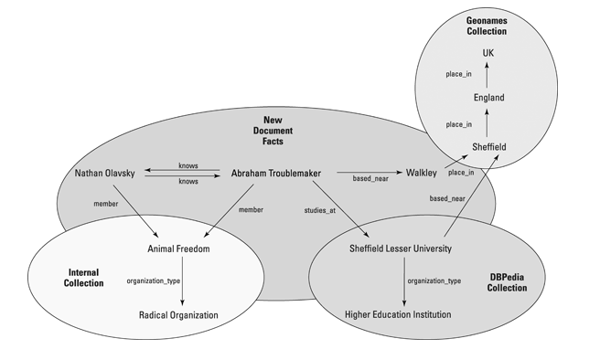
If you need to store facts, dynamically changing relationships, or provenance information, then consider a triple store. If you need to know statistics about the graph (such as how many degrees of separation are between two subjects or how many third level social connections a person has), then you should consider a graph store

Document
called aggregate databases because they tend to hold documents that combine information in a single logical unit — an aggregate.You might have a document that includes a TV episode, series, channel, brand, and scheduling and availability information, which is the total set of result data you expect to see when you search an online TV catch-up service.
A document is any unstructured or tree-structured piece of information

At my last count, there were more than 250 databases described by analysts in the NoSQL field here are some of them:
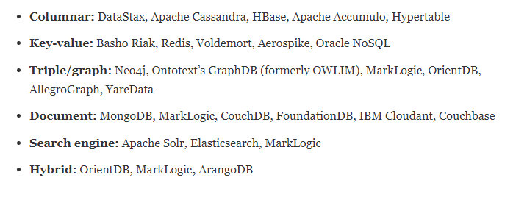
NoSql key terms

