Foundation DB introduction

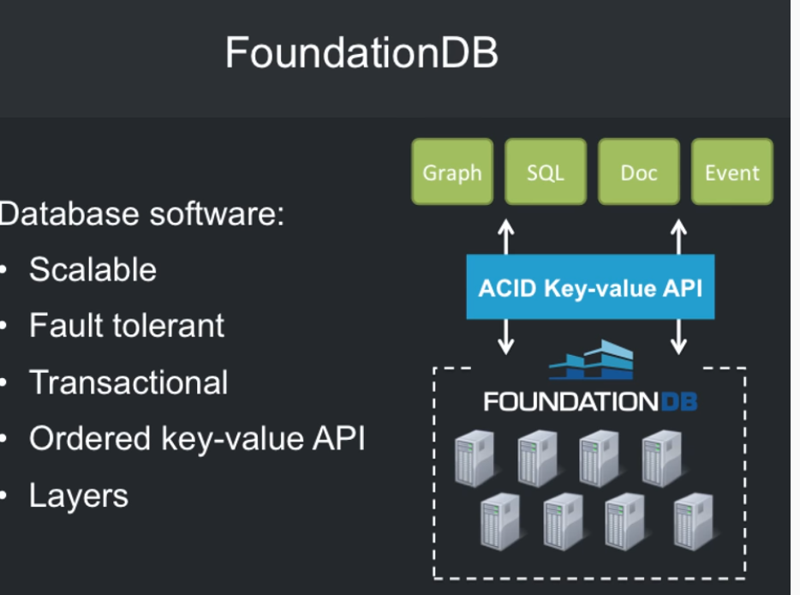
Transactinal
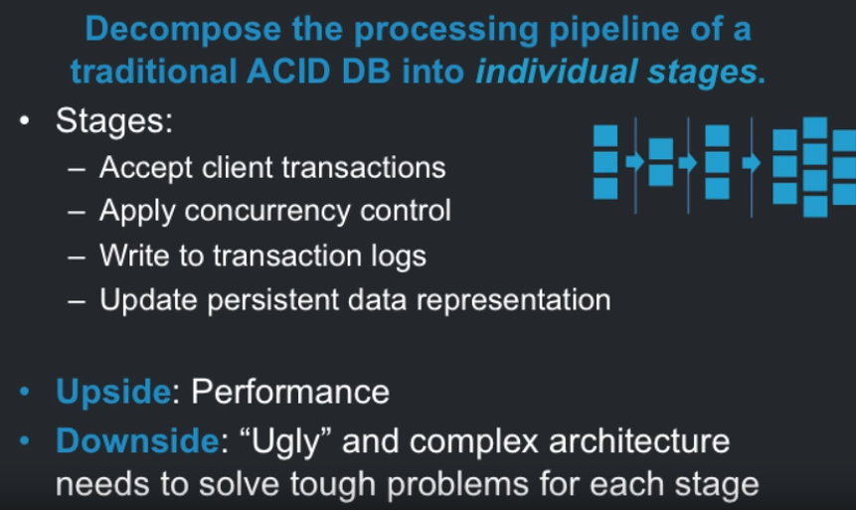
FoundatonDB
- scalability without sacrificing performance or consistency
- wide variety of data models
- operational ease of use

see: bitmap Indexes (roaring bitmap libary)
get there Foundation db
1. Replicate auror binlog into FoundationDb
2. Write volume not high enought to worry avout shaarding
3. chunk bit maps into small segments 2^18
see: https://www.youtube.com/watch?v=SKcF3HPnYqg
Tuple Encoding of db table
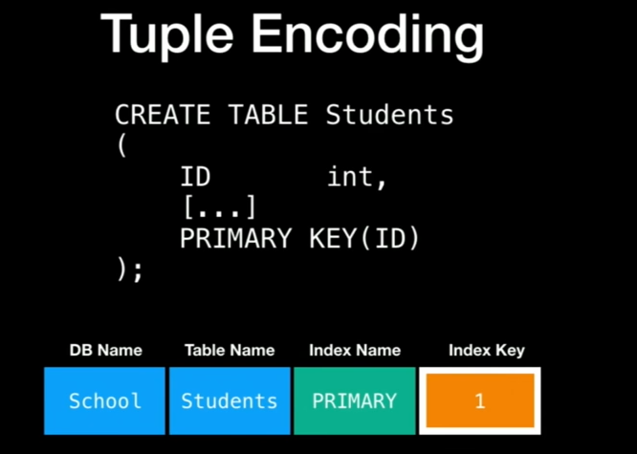

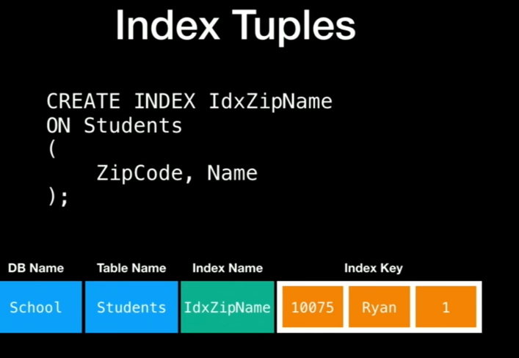
Index
- rule for transforming recod into key
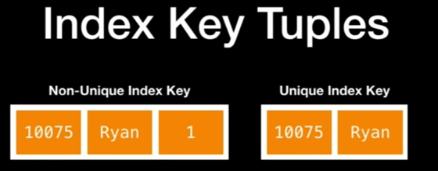

Last value in Index Key tuple is the record's primary key
What out for collation and case sensitivity if you care
see: CockroachDB

Read google paper Online Asynchronous Schema Change in F1
Adding an Index

Change Data Capture
- before and after version of every record

see: https://www.youtube.com/watch?v=Pq2Awy7KS2o

Foundation db
- orderd (ordered keys and values)
- key value
- transactional

