Algorithms

Resources: https://algs4.cs.princeton.edu/home/

Content:
- Fundamentals
- Sorting
- Searching
- Graphs
- Strings

Fundamentals
- Programming model
- Data Abstraction
- Bags, Queues, Stack
- Analysis
- Case Study: Union – Find

Programming model

Binary search
Given a sorted array arr[] of n elements.

Search a sorted array by repeatedly dividing the search interval in half. Begin with an interval covering the whole array. If the value of the search key is less than the item in the middle of the interval, narrow the interval to the lower half. Otherwise, narrow it to the upper half. Repeatedly check until the value is found or the interval is empty.

The idea of binary search is to use the information that the array is sorted and reduce the time complexity to O(Log n)

Recursion→ Method that calls itself either directly or indirectly. There are three rules:
- base case
- recursive call address sub problem so that recursive calls converge to the base case
- exit case

Memoization
In computing, memoization or memoisation is an optimization technique used primarily to speed up computer programs by storing the results of expensive function calls and returning the cached result when the same inputs occur again. Memoization has also been used in other contexts (and for purposes other than speed gains), such as in simple mutually recursive descent parsing.[1] Although related to caching, memoization refers to a specific case of this optimization, distinguishing it from forms of caching such as buffering or page replacement. In the context of some logic programming languages, memoization is also known as tabling.

More info and example here https://en.wikipedia.org/wiki/Memoization

How important is it to use a good shuffling algorithm?
More info here: https://www.datamation.com/applications/how-to-cheat-at-online-poker-a-study-in-software-security/
Sattolo's algorithm (Shuffle problem and random number generation problems)

Generates a unifomly distributed cycle of length N
More info here: https://en.wikipedia.org/wiki/Fisher%E2%80%93Yates_shuffle#Sattolo.27s_algorith

Basic of parsing:
https://themightyprogrammer.dev/article/parsing
- convert input into tokens (make validation)
- form tokens create abstract syntax tree
- for simpler user case you can use regex

Phases of parsing
- scanning (input into tokens)
- syntactic analysis (examines the structure of tokens; validation)

Data Abstraction

abstract data type (ADT) is a model for data types. An abstract data type is defined by its behavior (semantics) from the point of view of a user, of the data, specifically in terms of possible values, possible operations on data of this type, and the behavior of these operations.

Bags Queues and Stacks

Bags. A bag is a collection where removing items is not supported—its purpose is to provide clients with the ability to collect items and then to iterate through the collected items.

Bag
- void add(item)
- Iterator iterate()

A FIFO queue is a collection that is based on the first-in-first-out .

Queue
- void enqueue() → add an item to back
- Item dequeue() → remove the last added item

The policy of doing tasks in the same order that they arrive is one that we encounter frequently

Stack is a collection that is based on the last-in-first-out (LIFO) policy. (Pushdown stack)

Stack
-void push(item) → add an item to top
item pop() → remove an first item from top

Format of Arithmetic Expressions
infix: 3 + 4
prefix: + 3 4
postfix: 3 4 +

Arithmetic expression evaluation (Simple interpreter using stack and queue). Is a example of stack usage that evaluates fully parenthesized arithmetic expression. It can be implemented using Dijkstra's 2-stack algorithm: https://switzerb.github.io/imposter/algorithms/2021/01/12/dijkstra-two-stack.html

A linked list is a recursive data structure that is either empty (null) or holds a reference to a next node.
The easiest place to insert/remove a new node in linked list is at beginning. Can implement stack, queue and bag
Node also have item.
private class Node {
Item item;
Node next;
}

stao task 10: https://algs4.cs.princeton.edu/13stacks/

// todo DODATI BROJEVE POGLAVLJA

Graphs
1. Undirected
2. Directed
3. Minimum spanning tree
4. Shortest paths
Undirected Graphs
Grap is set of vertices and collection of edges that each connect a pair of vertices..
An undirected graph is graph, i.e., a set of objects (called vertices or nodes) that are connected together, where all the edges are bidirectional. An undirected graph is sometimes called an undirected network. In contrast, a graph where the edges point in a direction is called a directed graph

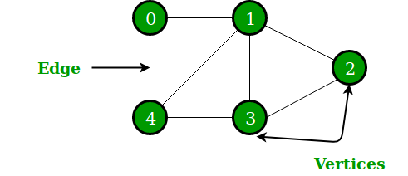

The degree of a vertex is the number of edges incident on it.
When an edge connects two vertices, we say that the vertices are adjacent to one another and that the edge is incident on both vertices
A simple path is a path with no repeated vertices.
A path in a graph is a sequence of vertices connected by edges, with no repeated edges.
The length of a path or a cycle is its number of edges
Two edges are parallel if they connect the same pair of vertices.
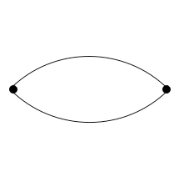

A simple cycle is a cycle with no repeated vertices (other than the requisite repetition of the first and last vertices).
A cycle is a path (with at least one edge) whose first and last vertices are the same.
We say that one vertex is connected to another if there exists a path that contains both of them.
A graph is connected if there is a path from every vertex to every other vertex.
An acyclic graph is a graph with no cycles. A tree is an acyclic connected graph.
A forest is a disjoint set of trees.
A forest is an undirected, disconnected, acyclic graph. In other words, a disjoint collection of trees is known as forest. Each component of a forest is tree.
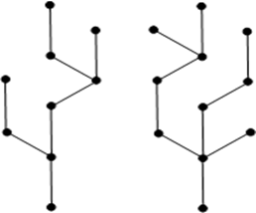

The above graph looks like a two sub-graphs but it is a single disconnected graph. There are no cycles in the above graph. Therefore it is a forest.

A spanning tree of a connected graph is a subgraph that contains all of that graph's vertices and is a single tree. A spanning forest of a graph is the union of the spanning trees of its connected components.
A spanning tree is a subset of Graph G, which has all the vertices covered with minimum possible number of edges. Hence, a spanning tree does not have cycles and it cannot be disconnected..
By this definition, we can draw a conclusion that every connected and undirected Graph G has at least one spanning tree. A disconnected graph does not have any spanning tree, as it cannot be spanned to all its vertices.
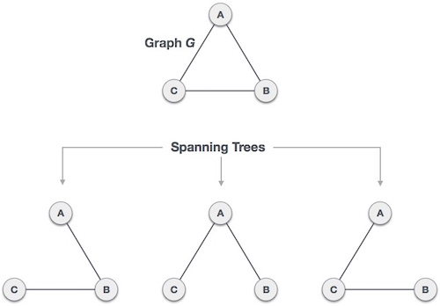
We found three spanning trees off one complete graph. A complete undirected graph can have maximum nn-2 number of spanning trees, where n is the number of nodes. In the above addressed example, n is 3, hence 33−2 = 3 spanning trees are possible.

A bipartite graph is a graph whose vertices we can divide into two sets such that all edges connect a vertex in one set with a vertex in the other set.
a bipartite graph (or bigraph) is a graph whose vertices can be divided into two disjoint and independent sets and such that every edge connects a vertex in to one in . Vertex sets and are usually called the parts of the graph. Equivalently, a bipartite graph is a graph that does not contain any odd-length cycles
A bipartite graph also called a bi-graph, is a set of graph vertices, i.e, points where multiple lines meet, decomposed into two disjoint sets, meaning they have no element in common, such that no two graph vertices within the same set are adjacent.
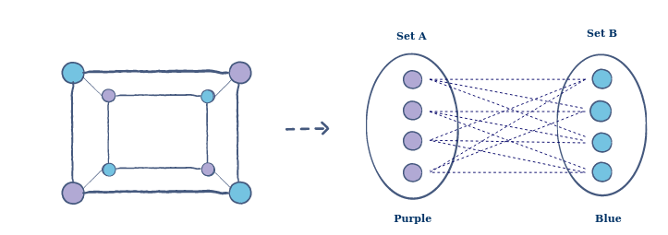

Implement graph data type
→ We use the adjacency-lists representation, where we maintain a vertex-indexed array of lists of the vertices connected by an edge to each vertex.

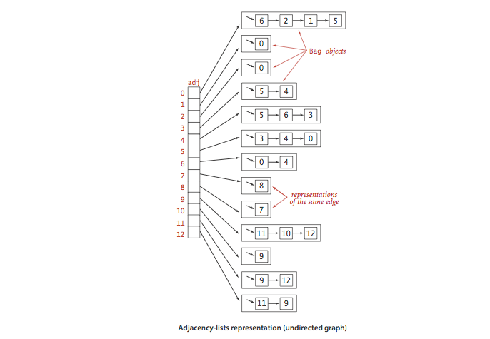
Also graph can be implemented using adjacency-matrix representation. in adjacency matrix is a square matrix used to represent a finite graph. The elements of the matrix indicate whether pairs of vertices are adjacent or not in the graph.
Adjacency Matrix is a 2D array of size V x V where V is the number of vertices in a graph

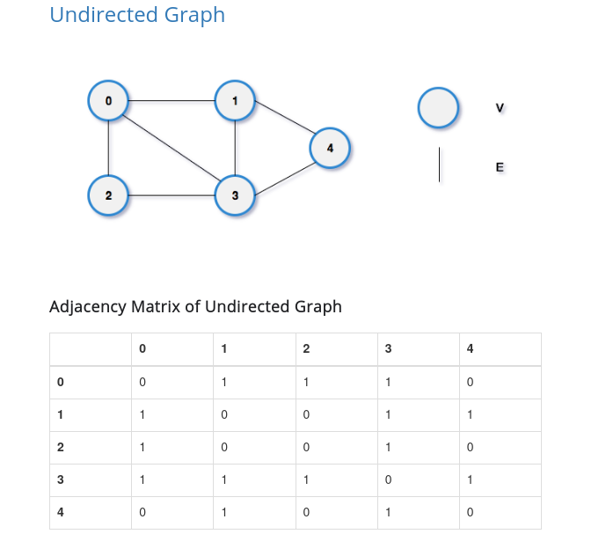
todo
https://en.wikipedia.org/wiki/Graph_traversal
and
https://cs.stanford.edu/people/abisee/gs.pdf
TODO
https://www.geeksforgeeks.org/difference-between-bfs-and-dfs/
ALSO
Uniform Cost Search (UCS)
IDS: Iterative deepening search
→ https://www.ccs.neu.edu/home/camato/5100/graph_search.pdf
→ https://en.wikipedia.org/wiki/Pathfinding
→ https://medium.com/@urna.hybesis/pathfinding-algorithms-the-four-pillars-1ebad85d4c6b
https://www.oreilly.com/library/view/graph-algorithms/9781492047674/ch04.html
https://www.hindawi.com/journals/ijcgt/2015/736138/

