Redis in Action

resources: https://redis.com/ebook/part-1-getting-started/chapter-1-getting-to-know-redis/

Start

Redis into
Redis is an in-memory remote database that offers high performance, replication, client-side sharding, and a unique data model. Supports five different types of data structures.
Redis is a very fast non-relational database that stores a mapping of keys to five different types of values. Redis supports in-memory persistent storage on disk, replication to scale read performance, and client-side sharding to scale write performance.
Sharding is a method by which you partition your data into different pieces. In this case, you partition your data based on IDs embedded in the keys, based on the hash of keys, or some combination of the two. Through partitioning your data, you can store and fetch the data from multiple machines, which can allow a linear scaling in performance for certain problem domains.
In Redis, there are no tables, and there’s no database-defined or -enforced way of relating data.
Redis supports the writing of its data to disk automatically in two different ways, and can store data in four structures in addition to plain string keys. Redis can be used either as a primary database or as an auxiliary database. Many users will choose to store data in Redis only when the performance or functionality of Redis is necessary, using other relational or non-relational data storage for data where slower performance is acceptable, or where data is too large to fit in memory economically

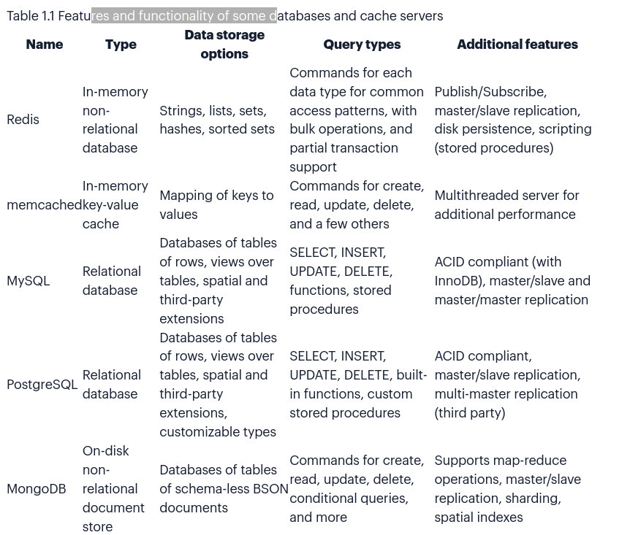
What happens when my server gets turned off (in-memory DB) ?
- point-in-time dump
- append-only file
Point in time dump when certain conditions are met (a number of writes in a given period) or when one of the two dump-to-disk commands is called.
Append only file writes every command that alters data in Redis to disk as it happens. Can be configured to never sync, sync once per second, or sync at the completion of every operation.
To support higher rates of read performance (along with handling failover if the server that Redis is running on crashes) has master/slave replication.
Slaves connect to the master and receive an initial copy of the full database. As writes are performed on the master, they’re sent to all connected slaves for updating the slave datasets in real time. With continuously updated data on the slaves, clients can then connect to any slave for reads instead of making requests to the master
Redis solves a problems in real time (except for task queues in chapter 6).
Data structures in Redis
Store keys that map to any of five diff data structures: String, List, Set. Hash, Zset.
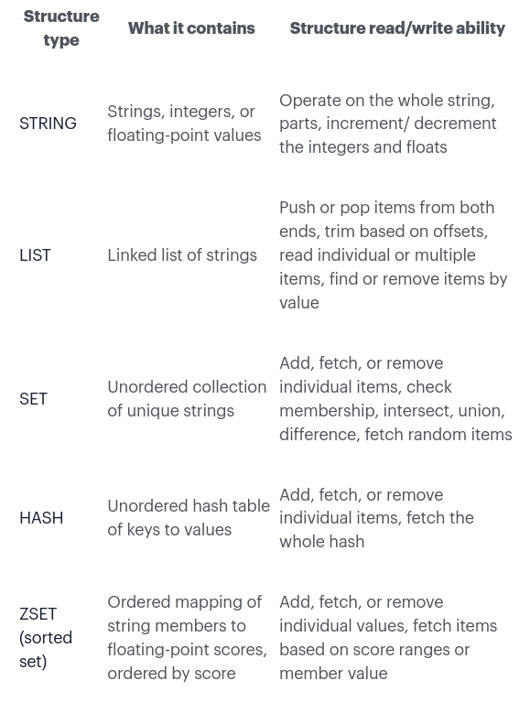

The operations available to STRING: get, set, del (delete), there are a handful of other commands for reading and writing parts of strings, and other commands.
LIST is linked list structure (an ordered sequences of strings). Some of the operations available are push(lpush/rpush) pop (lpop/rpop) fetch an intem at a given position (lindex) fetch a range of items (lrange)
SETS same as list but Redis use hash table to keep all strings unique, also values are unordered. Some of the operations: sadd, smembers, sismember, srem, sinter, sunion, sdiff.
HASH store a mapping of keys and values.
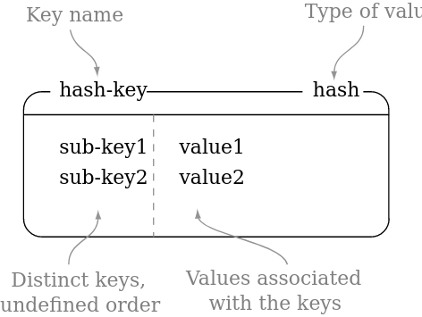

Hashes in Redis as miniature versions of Redis itself. Some of the commands hset, hget, hgetall, hdell

ZSET hold a type of key and value. The keys (called members) are unique, and the values (called scores) are limited to floating-point numbers. Have the unique property in Redis of being able to be accessed by member (like a Hash), but items can also be accessed by the sorted order and values of the scores. Figure 1.5 shows an example with two items.
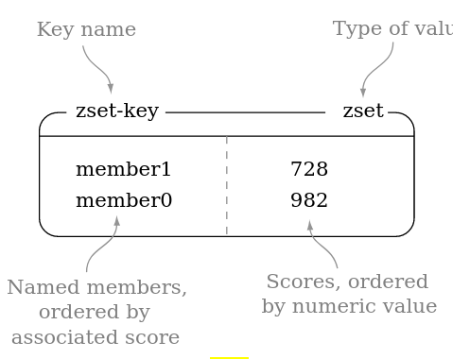

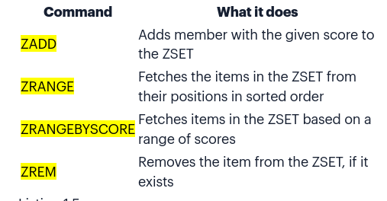

Use case vote on web page
Vote on web page (links, articles, questions). By taking into consideration the votes that were cast posts are ranked and displayed based on a score.
Problem. 1000 articles are submitted each day. 50 are interested and they need to be in the 100 articles on daily base. To be in top 50 (or top 100) article must receive at least 200 up votes. When dealing with scores we need take into account posting time, current time. score of an item is a function of the time that the article was posted, plus a constant multiplier times the number of votes that the article has received. Other article info id, title, link, time, votes.
Solution
Store article info (title, link, post time) in Redis HASH. To store a sorted set of articles use ZSET (keeps items ordered by the item scores) Aso use one more ZSET value is time so we can also order they by time. To prevent users from voting on the same article more then once store unique list of users who have voted for each article, use SET for this. For the sake of memory use after a week users can no longer vote on an article and its score is fixed.
Code solution and commands:
- https://redis.com/ebook/part-1-getting-started/chapter-1-getting-to-know-redis/1-3-hello-redis/1-3-1-voting-on-articles/
- https://redis.com/ebook/part-1-getting-started/chapter-1-getting-to-know-redis/1-3-hello-redis/1-3-2-posting-and-fetching-articles/
- https://redis.com/ebook/part-1-getting-started/chapter-1-getting-to-know-redis/1-3-hello-redis/1-3-3-grouping-articles/

Redis is another tool that you can use to solve problems. Redis has structures that no other database offers, and because Redis is in-memory (making it fast), remote (making it accessible to multiple clients/servers), persistent (giving you the opportunity to keep data between reboots), and scalable (via slaving and sharding) you can build solutions to a variety of problems in ways that you’re already used to.
How your approach to solving problems changes. You may find that your way of thinking about data-driven problems moves from “How can I bend my idea to fit into the world of tables and rows?” to “Which structures in Redis will result in an easier-to-maintain solution?”

Anatomy of a Redis web app
By reducing traditional database load by offloading some processing and storage to Redis, web pages were loaded faster with fewer resources.
Login and cookie caching
Cookies are small pieces of data that websites ask our web browsers to store and resend on every request to that service. For login cookies, there are two common methods of storing login information in cookies: a signed cookie or a token cookie.
Signed cookies typically store the user’s name, maybe their user ID, when they last logged in, and whatever else the service may find useful. Along with this user-specific information, the cookie also includes a signature that allows the server to verify that the information that the browser sent hasn’t been altered
Token cookies use a series of random bytes as the data in the cookie. On the server, the token is used as a key to look up the user who owns that token by querying a database of some kind.
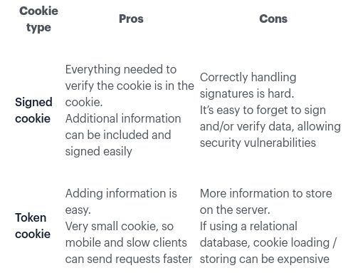

Due to the relatively large load of cookie data through the day storing data in relational DB can be replaced with Redis DB. You can use a Redis HASH type to store our mapping from login cookie tokens to the user that’s logged in. To check the login, we need to fetch the user based on the token and return it, if it’s available.
Checking the token isn’t very exciting, because all of the interesting stuff happens when we’re updating the token itself. For the visit, we’ll update the login for the user and record the current timestamp for the token in the of recent users. If the user was viewing an item, we also add the item to the user’s recently viewed and trim that if it grows past 25 items. We’ve now recorded when a user with the given session last viewed an item and what item that user most recently looked at. Over time, memory use will grow, and we’ll want to clean out old data. As a way of limiting our data, we’ll only keep the most recent x sessions,

TODO: https://redis.com/ebook/part-1-getting-started/chapter-2-anatomy-of-a-redis-web-application/2-2-shopping-carts-in-redis/

Core concepts

Commands

Safe data and performance

Redis for app support

Application components

Search based app

Building simple social network

Reducing memory use

Next steps

Scaling

Scripting

