Lesson 1 – Deep Learning for coders

Neural networks: a brief history
1943 Warren McCulloch and Walter Pitts developed a mathematical model of an artificial neuron
A logical Calculus of the Ideas Immanent in Nervous Activity
http://www.cse.chalmers.se/~coquand/AUTOMATA/mcp.pdf
1950 Frank Rosebnlatt few changes to get machine to work without any human training or control
Marvin Minsky – Perception about Rosenblatt's invention”
1986 Parallel Distributed Processing book
- processing units
- state of activation
- output function
- pattern of connectivity
- propagation rule
- activation rule
- learning rule
- environment
deep learning adding more layers of neurons

Machine learning is a way to get computers to complete a specific task.
General idea. Write function: Input → program → result. Human write steps.
1962 Arthur Samuel Artificial Intelligence: A frontier of Automation Show computer examples of the problem to solve and let it figure out how to solve it itself.
Have inputs and weights -> model (program) → results → performance ( go back and adjust weights so that we get better result). Learning from expirience. Then we got trained model that can be used as program. So Machine Learning is the training of programs developer by allowing a computer to learn from its experience rather than through manually coding the individual steps.
Model (function / program) is neural network. → universal approximation theorem (this function can solve any problem to any level of accuracy)

finding good weight → Stochastic gradient descent (SGD) → way to update the weights to make them improve model (any given task)

Today is the same idea but diff terminology.

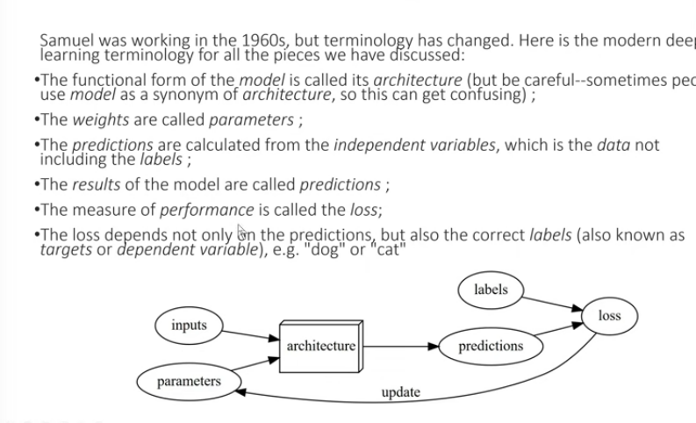

Architecture (model / function). We adjust weights (parameters) to get good model.
Prediction (result) depends on the inputs (data) and independent variables (labels) and the measure of performance is called the loss

Limitations
- model can not be created without data
- a model can only learn to operate on the pattern seen in the input data
- only creates predictions, not actions
- we need labels for input data saying which ones are example: dogs, cats

How model operate in environment

