Short Summary of the Last Decades of Data Management
From: https://www.youtube.com/watch?v=-wCzn9gKoUk

1968 – ICS / DL / IMS
IMS – infomration management systems
hiearcical structure (you have path)

1970 – A relation model of Data
1979 – Oracle
1983 – IBM DB/2
1996 – Postgre SQL (table sql acid)
transactional use case (row based)
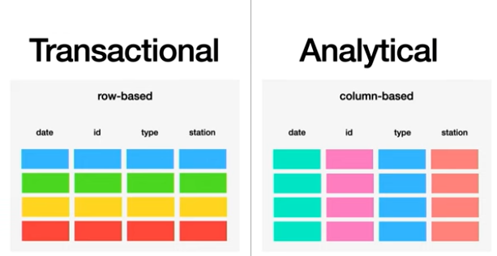

analitical use cases (column based representation of data)
also on analytical preference is speed not data correcntes and seq that will not break
so NoSql→ hadoop → mapReduce → 2006 (because it will scale)

2010 Hive project – SQL again for big data

2009 no schema for scale → mongoDB (2017 schema validation)

2008 no ACID transaction for scale → cassandra (move eventiual consistencly to app – to developer) (2023 – support for ACID after all)

SQL lite - table sql acid – most deployed DB (might be used in phones)
2014 no internal storage for freedom – Spark (Databriks) s3 bitbuckets – developer is responsbile for update delete schema evolution (2024 internal storage variant)

ETL → ELT data systems

Predictions:
Relational eats everything
- Key / Value stores (key-value, key-json)
- time series - database
- Vector data bases
- graphs (source – node Property graph queries SQL/PGQ)
- data frames

except
- Full Text Search
- array data (images, videos)

