Continuous Delivery with Docker and Jenkins - Third Edition

Table of Contents
TODO 3
Intro 4
Docker 5

TODO
- Configuration management tools (such as Ansible, Chef, and Puppet)
- truck-based development
- docker file instructions https://docs.docker.com/.

Intro
Traditional delivery process shortcomings:
- slow delivery
- long feedback cycle
- lack of automation

How long would it take your organization to deploy a change that involves just a single line of code?

Continuous delivery is all about changing traditional deliver process into a sequence of scripts called the automated deployment pipeline (CD pipeline), benefits:
- fast delivery
- fast feedback cycle
- low risk releases

A release is less risky if the delta of code changes is small and the process is repeatable.

CD pipeline is a sequences of scripts that is executed after every code change is committed to the respo. Steps:
- continues integration (CI): checks the code from the repo, compiles it, run test, verifies code quality
- automated acceptance testing: build quality into the product instead of verifying it later (acceptance tests)
- configuration management: scripts configure the env and deploys the software, also scaling number of services instances

DevOps means a single person or team is responsible for development, QA and operations.

Continuous delivery is not the same as continuous deployment (each commit is automatically released to production)

Technical prerequisites for CD
- automated build, test, package and deploy operations
- quick pipeline exe
- quick failure recovery
- truck-based development

Docker
Software container – running app with the complete env (files, libs, tools). App is packaged into an image that can be run everywhere.
Virtualization drawbacks:
- low performance (emulates the whole computer – OS)
- big resource consumption
- large image size (app is delivered with a full OS)

Containerization
a type of virtualization in which all the components of an application are bundled into a single container image and can be run in isolated user space on the same shared operating system
Each app is delivered with its dependencies but no OS and it is run on Docker Engine. isolation happens at the level of the host OS process. Docker Engine creates a set of Linux namespaves and control groups for each container - security based on Linux kernel process isolation -> less secure than virtualization.

docker run hello-world
- ran the Docker client in terminal
- client pinged Docker daemon and asked to create a container from the image hello-world
- Docker deamon checked has it image locally (it did not) so it requested image from remote Docker Hub registry
- image was pulled from Docker Hub registry into the daemon
- daemon created a new container form the hello-world image and started it
- daemon streams output to the Docker client
- client streams output to the terminal
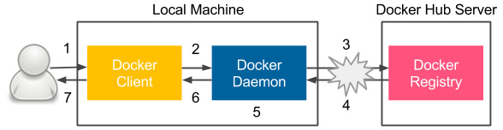

Docker components

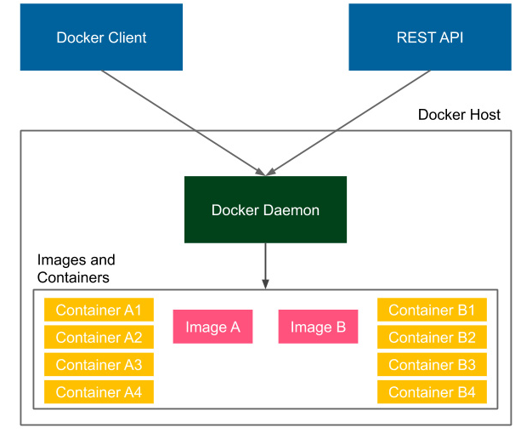
Docker engine
- daemon (server) running in the background
- client running as a command tool
- REST api – Docker Representational state transfer

Docker image is a collection of all the files necessary to tun your applicationn + recipe how to run it- It is stateless (it can be sent over the network, stored in the registry, version it) Also images are layered - you can build an image on top of another image: There is always the base image, in mosta casses this represents an OS: They are cached layers
Docker container running instance of an image. Can create many containers from the same image (if you want to have many instance of the same app). They are stateful
Build docker images
- docker commit – creates a new image from a container’s changes
- dockerfile

Docker commit
- docker run -i -t ubuntu:20.04 /bin/bash (run a container from ubuntu and connect it to its command (-i interactive)
- you are now inside the container install the git (apt-get update; apt-get install -y git)
- exit the container (type exit)
- docker comit dee2cb192c6 ununtu_with_git (commit the container to the image (dee2cb192c6 - container id)
- to check run docker images
- run it docker run -i -t ubuntu_with_git /bin/bash

Dockerfile
Use build in language (save instructions to file) to specify all the instructions that should be executed to build a Docker image
1. Create dockerfile
FROM ubuntu:20.04
RUN apt-get update && \
apt-get install -y python
2. docker build -t ubuntu_with_python (run in the same directory)
3. check that image was created docker images
Dockerfile instructions
- FROM - defines an image on top of which the new image will be build
- RUN - specifies the commands to run inside the container
- COPY/ADD - copies a file or a directory into the filesystem of the image
- ENTRYPOINT defines which application should be run in the executable container

Build and run application
docker build -t hello_world_python . → in the directory where Dockerfile is
docker run hello_world_python
docker run -d hello_world_python → run as demon (in background)
Env variables
- as param when starting container
docker run -e NAME=Rafal hello_world_python ( -e to say we have param)
- in Dockerfile
ENV NAME Rafal

Docker file container state
docker ps -> prints all container that are in a running state
docker ps -a → prints all containers
There are two more state of containers: paused and restarting

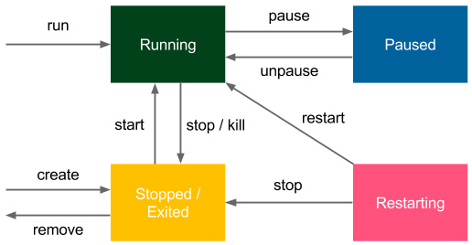
Pausing container is done by freeing the process using the SIGSTOP signal.
Restarting specify –restart option when you run container to define restarting strategy
Stop running container use docker stop containerName
docker run - creates and starts container
docker create – creates docker container

Networking
→ stao https://learning.oreilly.com/library/view/continuous-delivery-with/9781803237480/B18223_02_ePub.xhtml#_idParaDest-57

