Computer vision nanodegree

Introduction

Udacity git: https://github.com/udacity/cd0360-Introduction-to-Computer-Vision

Image Representation and classification
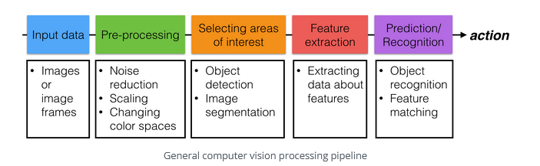
Computer vision pipline
Pre-processing images is all about standardizing input images so that you can move further along the pipeline and analyze images in the same way. In machine learning tasks, the pre-processing step is often one of the most important.

Traning a Neurak network
To train a computer vision neural network, we typically provide sets of labeled images, which we can compare to the predicted output label or recognition measurements. The neural network then monitors any errors it makes (by comparing the correct label to the output label) and corrects for them by modifying how it finds and prioritizes patterns and differences among the image data
This is a convolutional neural network that learns to recognize

Gradient descent is a a mathematical way to minimize error in a neural network. More information on this minimization method can be found here

Convolutional neural networks are a specific type of neural network that are commonly used in computer vision applications. They learn to recognize patterns among a given set of images. If you want to learn more, refer to this resource,

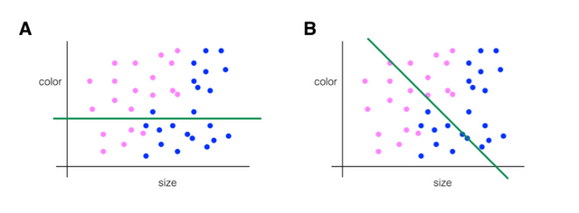
A neural network can effectively learn how to draw a line that separates two kinds of data based on their unique shapes. Deep neural networks are similar, only they can draw multiple and more complex separation lines. Deep neural networks layer separation layers on top of one another to separate complex data into groups.

How does a comouter see image data ?

Image 2.d representation
- color detal
- shape
- lighting
- size (base od distance)

Every pixel in an image is just a numerical value so Treating images as grids of numbers is the basis for many image processing techniques. In grayscale image value range 0 – 255 (0 -> black , 225 -> white) and location x, y
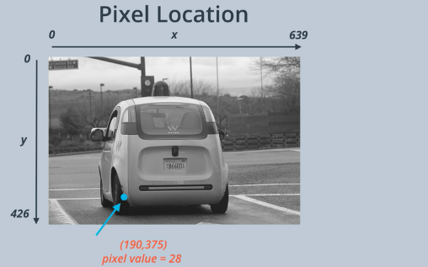
Color images are intepreted as 3D cubes of values with width, height and depth
The depth is the number of colors.
Most images can be represented by combinations of only 3 colors (red, green and blue) so for RGB images the depth is 3

It’s helpful to think of the depth as three stacked, 2D color layers. One layer is Red, one Green, and one Blue. Together they create a complete color image.

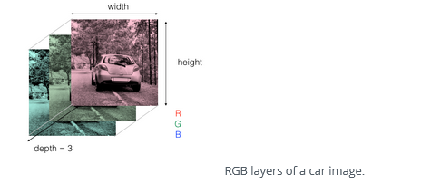
When doing image recogintion ask are color info important if for humans is eaier to use color to recognite then it is also better for computer
// image value at location
print(image[0,0]) -> []114, 156, 196]

# Isolate RGB channels
r = image[:,:,0]
g = image[:,:,1]
b = image[:,:,2]
Color thresholds – select area of intreset using information about color. Example bule /green screen
- set up blue/green backgroud
- isolate image
- chage blue/green backgourd with your own background image

OpenCV reads in images in BGR format (instead of RGB) because when OpenCV was first being developed, BGR color format was popular among camera manufacturers and image software providers . However, now the standard has changed and most image software and cameras use RGB format, which is why, in these examples, it's good practice to initially convert BGR images to RGB before analyzing or manipulating them.
To select the most accurate color boundaries, it's often useful to use a color picker and choose the color boundaries that define the region you want to select

Color spaces
- RGB (red, green, blue)
- HSV (hue, saturation, value)
- HLS (hue, lightness, saturation)

HSV
value varies the most under different lighting conditions
h channel stays consistent in shadow or execssive brigthness
todo check value rand for hue, saturation, value

Day and Night Classificaion
Visualizing the image data you’re working with is the first step in identifying any patterns in image data and being able to make predictions about the data!

Labeling
A classifier takes in an image as input and should output a predicted_label that tells us the predicted class of that image. Now, when we load in data, like you’ve seen, we load in what are called the true_labels which are the correct labels for the image.
To check the accuracy of a classification model, we compare the predicted and true labels. If the true and predicted labels match, then we’ve classified the image correct

After looking at many images, the accuracy of a classifier is defined as the number of correctly classified images (for which the predicted_label matches the true label) divided by the total number of images.
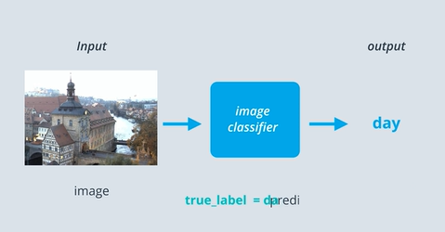
It’s good practice to use numerical labels instead of strings or categorical labels. They're easier to track and compare.

Pre-process and standardize image

It's important to make all your images the same size so that they can be sent through the same pipeline of classification steps! Every input image should be in the same format, of the same size, and so on. Example (Resize each image to the desired input size: 600x1100px (hxw). )

Integer encoding means to assign each category value an integer value. So, day = 1 and night = 0. This is a nice way to separate binary data
One-hot encoding is often used when there are more than 2 values to separate. A one-hot label is a 1D list that's the length of the number of classes.
In order of [cat value, tiger value, hippopotamus value, dog value].If we have an image and it's one-hot label is [0, 1, 0, 0], what does that indicate
that label indicates that it's an image of a tiger!

Feature extraction
When you approach a classification challenge, you may ask yourself: how can I tell these images apart? What traits do these images have that differentiate them, and how can I write code to represent their differences? Adding on to that, how can I ignore irrelevant or overly similar parts of these images?
There are lots of measurable traits that distinguish these images, and these measurable traits are referred to as features.

average brightness of an image
Here were the steps we took to extract the average brightness of an image.
- Convert the image to HSV color space (the Value channel is an approximation for brightness)
- Sum up all the values of the pixels in the Value channel
- Divide that brightness sum by the area of the image, which is just the width times the height.
This gave us one value: the average brightness or the average Value of that image.

Simple classifier.
I can create a complete classifier by writing a function that takes in an image, extracts the brightness feature, and then checks if the average brightness is above some threshold X. If it is, this classifier returns a 1 (day), and if it’s not, this classifier returns a 0 (night)!

Data
Test data is previously unseen image data. The data you have seen, and that you used to help build a classifier is called training data, which we've been referring to. The idea in creating these two sets is to have one set that you can analyze and learn from (training), and one that you can get a sense of how your classifier might work in a real-world, general scenario

Convolutional Filters and Edge detection

In addition to taking advantage of color information, we also have knowledge about patterns of grayscale intensity in an image. Intensity is a measure of light and dark similar to brightness, and we can use this knowledge to detect other areas or objects of interest. For example, you can often identify the edges of an object by looking at an abrupt change in intensity, which happens when an image changes from a very dark to a light area, or vice versa.

Frequency actually refers to how fast a sound wave is oscillating; oscillations are usually measured in cycles (high pitches and are made by high-frequency waves ). Frequency in images is a rate of change. high frequency image is one where the intensity changes a lot. And the level of brightness changes quickly from one pixel to the next High-frequency components also correspond to the edges of objects in images, which can help us classify those objects.
The Fourier Transform (FT) is an important image processing tool that is used to decompose an image into its frequency components. The output of an FT represents the image in the frequency domain.So, for images with a lot of high-frequency components (edges, corners, and stripes), there will be a number of points in the frequency domain at high frequency values. In fact, an FT treats patterns of intensity in an image as sine waves with a particular frequency, and you can look at an interesting visualization of these sine wave components on this page.

Filters are used to applify featrues like object boundaries or filter out irelevant data.
Hight pass filter sharpen an image, anhance high-frequnency pars of an image. (Opreate on grayscall images bacuse we are looking at intensity)
Filter or convolution kernels are a matrix of numbers that modifies an image (matrix is applied on every pixel in image) Convolution operation not multiplaying

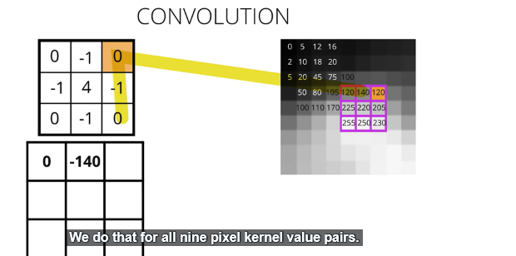

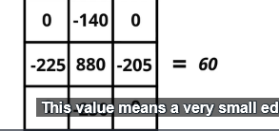
Use OpenCV's filter2D function, which is documented here and it can be used to filter images in a variety of ways,

Gradients are a measure of intensity change in an image, and they generally mark object boundaries and changing areas of light and dark. If we think back to treating images as functions, F(x, y), we can think of the gradient as a derivative operation F ’ (x, y). Where the derivative is a measurement of intensity change.

The Sobel filter is very commonly used in edge detection and in finding patterns in intensity in an image. Applying a Sobel filter to an image is a way of taking (an approximation) of the derivative of the image in the xxx or yyy direction. The operators for Sobelx and Sobely look like this:

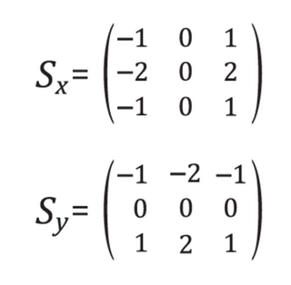
Sobel also detects which edges are strongest. This is encapsulated by the magnitude of the gradient; the greater the magnitude, the stronger the edge is. The magnitude, or absolute value, of the gradient, is just the square root of the squares of the individual x and y gradients. For a gradient in both the xxx and yyy directions, the magnitude is the square root of the sum of the squares

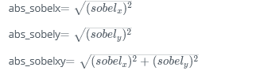
​

In many cases, it will be useful to look for edges in a particular orientation (direction). For example, we may want to find lines that only angle upwards or point left. By calculating the direction of the image gradient in the x and y directions separately, we can determine the direction of that gradient!
The direction of the gradient is simply the inverse tangent (arctangent) of the yyy gradient divided by the xxx gradient:
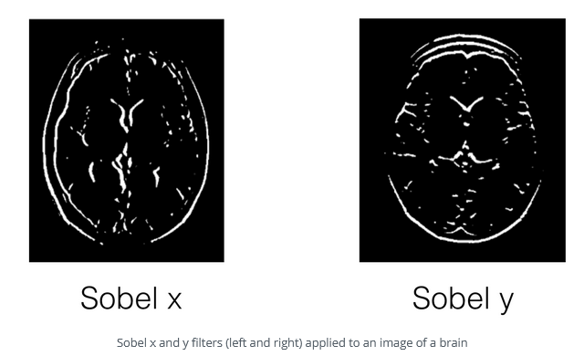

Low pass filter
- blure/smooth an image (removing noise)
- block high frequwncy parts of an image

Averaging filter – soften and blure an image

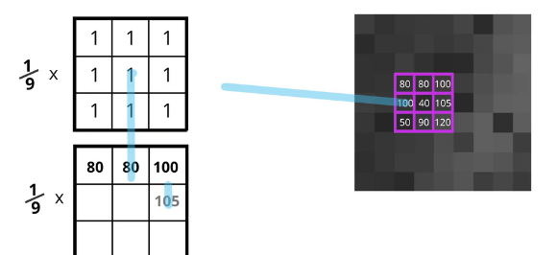

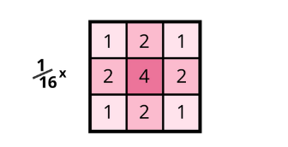
Gaussian Blur – blure image and preserve edges
The OpenCV function GaussianBlur is documented on this page.
Filtering images first low pass (gaussian) to remove noise then hight pass to empahise edges

Stao: https://learn.udacity.com/nanodegrees/nd891/parts/cd0360/lessons/27d928b1-0019-432d-8907-868cf5959c30/concepts/4e02ff6f-9dcc-4fba-88be-401686a077ad

