R in action
Table of Contents
Introduction to R 2
Getting started 2
The Workspace 3
Packages 4
Creating a dataset 4
Data structures 5
Data input 7
Graphs 8
Basic data management 12
Working with variables 12
Missing values 12
Date 13
Converting 14
Working with data 14
Numerical functions 15
reshape2 package todo 19

Introduction to R
Analyzing data in R. One on the approaches. The process has become highly interactive, with the output from each stage serving as input for the next stage. At any point the cycles may include transforming the data and looping back through the whole process again.
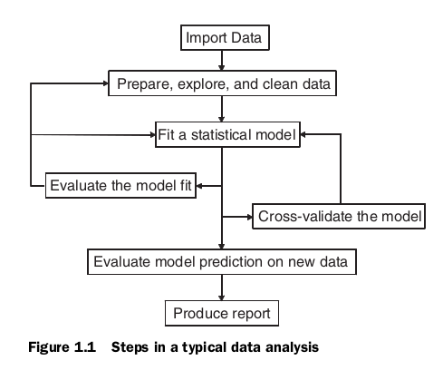

Getting started
R is case sensitive, interpreted language
Data types_ vector, matrices, data frames, lists
An object is anything that can be assigned a value (data, function, graphs..). Every object has a an object has a mode (which describes how the object is stored) and a class (which tells generic functions like print how to handle it)
Objects are kept in memory during an interactive session. Because R holds objects in memory, you’re generally limited by the amount of RAM. But there are two issues to consider: the size of the data and the statistical methods that are be applied
available. (todo heap or ? )
Typical statement.
x ← rnorm(5) (← assign)
R in terminal. Just type R for start and q() to quit
Help:
- help(“function”) or ?function
- help.search(“topic”)
- example(“test”)
The period (.) has no special significance in object names.
“R Language for Programmers” (http://mng.bz/6NwQ). Programmers looking for stylistic guidance may also want to check out “Google’s R Style Guide” (http://mng.bz/i775).

The Workspace
The workspace is your current R working environment and includes any user-defined objects. At the end of an R session, you can save an image of the current workspace that’s automatically reloaded the next time R starts.
Getwd() - list the current working directory
setwd() - set working directory
ls() - list the objects in the current workspace
rm(object_or_object_list) - remove objects
save.image(“file”) – saves the workspace to file
load(“file”) – loads workspace form file
The session history is saved to the file .Rhistory() workspace is saved to the file .Rdata in the current direcotry.
Best practice.
- Keep projects in separate directories
- start session issuing the sedwd() command
- load(.Rdata) command
source(“script.R”) → add a script to the current session, automatically run
sink(“filename”) → output program result (only text) to file (option append to append result, option split = TRUE, also display in console)
bpm(), jpeg(), pdf, png(), …. redirect graphic output
First set up output then run statements
R CMD BATCH → run program from terminal as batch.

Packages
Packages are collections of R functions and data
The directory where packages are stored on your computer is called the library.
The .libPaths() shows you where your library is located, and library() shows you what packages you’ve saved in your library.
Steps
- Install → install.packages("gclus") saves it into library on computer
- load into the session → library(gclus)
Can you search() to see which packages are loaded and ready to use. You only need to install a package once.

Creating a dataset
Data types: numeric, character, logical, complex, bytes (raw data)
Structure for holding data: scalars, vector, array, matrix, data frame, list
Contents or data types (need to specify this):
- case identifier
- data variable
- continuous variables
- nominal variable
- ordinal variable

A dataset is usually a rectangular array of data with rows representing observations and columns representing variables.
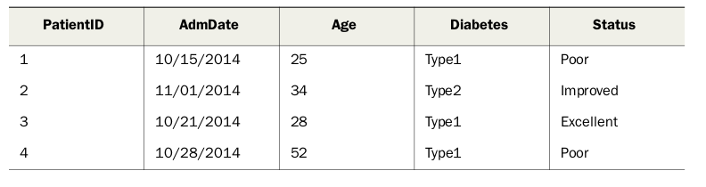
Data types of the dataset
- id is identifier (case identifier)
- admDate date variable
- age → continuous variables
- diabetes → nominal variable
- status → ordinal variable
Data types – skip

Data structures
Vector
Vectors are one-dimensional arrays that can hold numeric data, character data, or logical data. The combine function c() is used to form the vector.
Note that the data in a vector must be only one type or mode (numeric, character, or logical).
Scalar
One-element vectors
Matrix
A matrix is a two-dimensional array in which each element has the same mode
myymatrix <- matrix(vector, nrow=number_of_rows, ncol=number_of_columns,
byrow=logical_value, dimnames=list(char_vector_rownames, char_vector_colnames))
where vector contains the elements for the matrix
Arrays
Arrays are similar to matrices but can have more than two dimensions. They’re created with an array function of the following form
myarray <- array(vector, dimensions, dimnames
Data frames
Two-dimensional array but in that different columns can contain different modes of data (numeric, character, and so on)
mydata <- data.frame(col1, col2, col3,...)
where col1 , col2 , col3 , and so on are column vectors of any type (such as character, numeric, or logical). Names for each column can be provided with the names function.
Each column must have only one mode, but you can put columns of different modes together to form the data frame. Because data frames are close to what analysts typically think of as datasets,
The $ notation is used used to indicate a particular variable from a given data frame.
To simplify your code you can use either the attach() and detach() or with().
case identifiers can be specified with a rowname option
patientdata <- data.frame(patientID, age, diabetes, status, row.names=patientID)
Factors
Nominal variables are categorical, without an implied order.
Ordinal variables are categorical, with an order but no amount.
Continuous variables can take on any value within some range, and both order and amount are implied
Categorical (nominal) and ordered categorical (ordinal) variables in R are called factors.
The function factor() stores the categorical values as a vector of integers in the range [1… k], (where k is the number of unique values in the nominal variable) and an internal vector of character strings (the original values) mapped to these integers.
diabetes <- c("Type1", "Type2", "Type1", "Type1")
The statement diabetes <- factor(diabetes) stores this vector as (1, 2, 1, 1) and associates it with 1 = Type1 and 2 = Type2 internally (the assignment is alphabetical). For vectors representing ordinal variables, you add the parameter ordered=TRUE to the factor().
You can override the default ordering by specifying a levels option
Numeric variables can be coded as factors using the levels and labels options.
TODO: Listing 2.6 Using factors
Lists
a list is an ordered collection of objects (components). A list allows you to gather a variety of (possibly unrelated) objects under one name. For example, a list may contain a combination of vectors, matrices, data frames, and even other lists
mylist <- list(object1, object2, …)

Notes
Assigning a value to a nonexistent element of a vector, matrix, array, or list expands that structure to accommodate the new value. For example, consider
the following:
x <- c(8, 6, 4)
x[7] <- 10
x
[1] 8 6 4 NA NA NA 10

Data input
R provides a wide range of tools for importing data. The definitive guide for importing data in R is the R Data Import/Export manual available at http://mng.bz/urwn. Also you can import from csv. Excel, xml
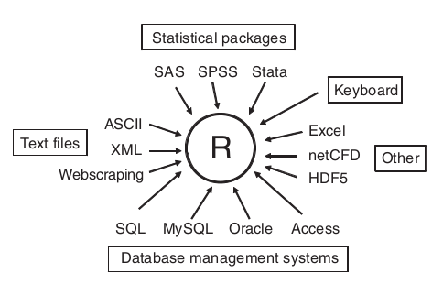

Graphs
In a typical interactive session, you build a graph one statement at a time, adding features, until you have what you want
attach(mtcars)
plot(wt, mpg)
abline(lm(mpg~wt))
title("Regression of MPG on Weight")
detach(mtcars)
Creating a new graph by issuing a high-level plotting command such as plot() , hist() (for histograms), or boxplot() typically overwrites a previous graph. How can you create more than one graph and still have access to each?
First, you can open a new graph window before creating a new graph:
dev.new()
statements to create graph 1
dev.new()
statements to create a graph 2
You can use the functions dev.new() , dev.next() , dev.prev() , dev.set() , and dev.off() to have multiple graph windows open at one time and choose which output is sent to which windows.
R creates attractive graphs with a minimum of input on your part. But you can also use graphical parameters to specify fonts, colors, line styles, axes, reference lines, and annotations. This flexibility allows for a wide degree of customization.
plot(dose, drugA, type="b")
The option type="b" indicates that both points and lines should be plotted.
You can customize many features of a graph (fonts, colors, axes, and labels) through options called graphical parameters. One way is to specify these options through the par() function. Values set in this manner will be in effect for the rest of the session or until they’re changed. The format is par(optionname=value , optionname=value ,...) .
opar <- par(no.readonly=TRUE)
par(lty=2, pch=17)
plot(dose, drugA, type="b")
par(opar)
A second way to specify graphical parameters is by providing the optionname=value pairs directly to a high-level plotting function.
plot(dose, drugA, type="b", lty=2, pch=17)
pch - Specifies the symbol to use when plotting points
cex - Specifies the symbol size, 1.5 is 50% larger, 0.5 is 50% smaller,
lty - line type
lwd - Specifies the line width. lwd=2 generates a line twice as wide as the default.
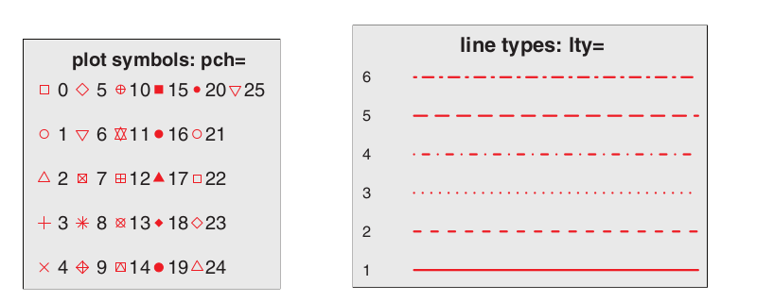

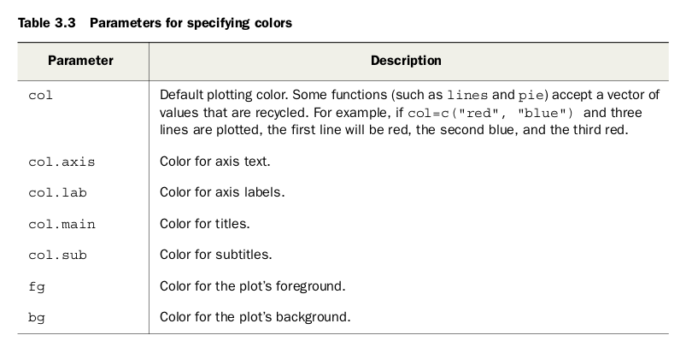

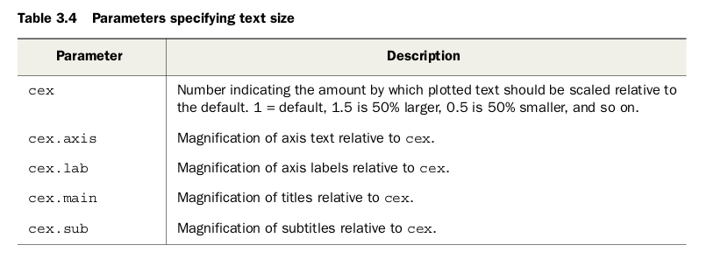
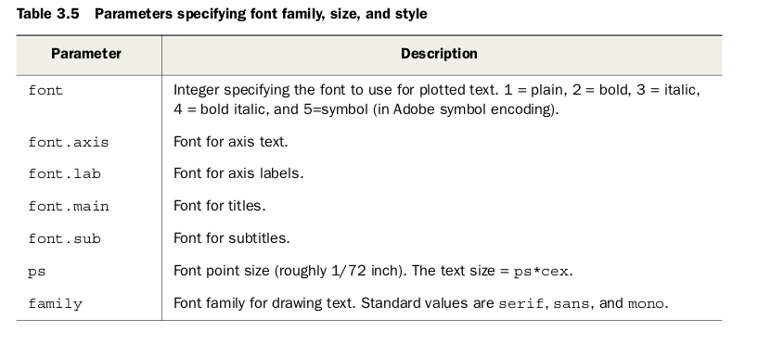

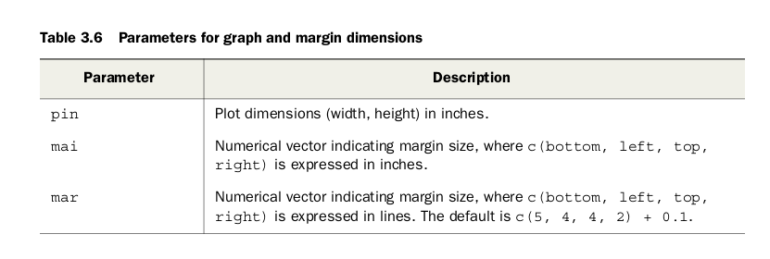
Example
dose <- c(20, 30, 40, 45, 60)
drugA <- c(16, 20, 27, 40, 60)
drugB <- c(15, 18, 25, 31, 40)
opar <- par(no.readonly=TRUE)
par(pin=c(2, 3))
par(lwd=2, cex=1.5)
par(cex.axis=.75, font.axis=3)
plot(dose, drugA, type="b", pch=19, lty=2, col="red")
plot(dose, drugB, type="b", pch=23, lty=6, col="blue", bg="green")
par(opar)
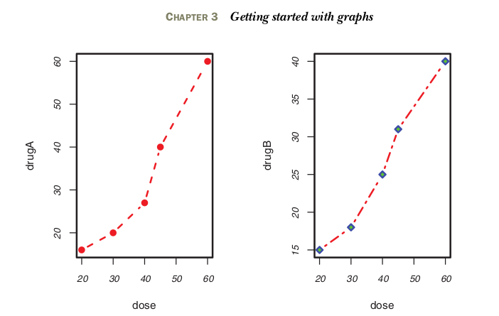

TODO →

Basic data management

Working with variables

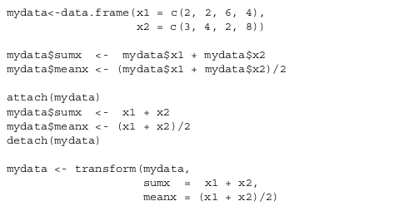

Recommend: transform function

The within() function is similar to the with() function but it allows you to modify the data frame. Example create new variable base on condition.

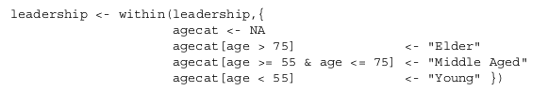
Programmatically, you can rename variables via the names() function. For example, this statement
names(leadership)[2] <- "testDate"

Missing values
is.na(param) # is not a number – missing value NA
Notice how the is.na() function works on an object. It returns an object of the same size, with the entries replaced by TRUE if the element is a missing value or FALSE if the element isn’t a missing value- Example: y <- c(1, 2, 3, NA) returns c(FALSE, FALSE, FALSE, TRUE) :
First, missing values are considered noncomparable, even to themselves. This means you can’t use comparison operators to test for the presence of missing values. For example, the logical test myvar == NA is never TRUE . Instead, you have to use missing-value functions like is.na() to identify the missing values in R data objects.
Second, R doesn’t represent infinite or impossible values as missing values. Positive and negative infinity are represented by the symbols Inf and –Inf , respectively. Thus 5/0 returns Inf . Impossible values (for example, sin(Inf) ) are represented by the symbol NaN (not a number). To identify these values, you need to use is.infinite() or is.nan()
na.omit() deletes any rows with missing data.
Most numeric functions have an na.rm=TRUE option that removes missing values prior to calculations and applies the function to the remaining values. be sure to check how that function handles missing data by looking at its online help (for example, help(sum) ).

Date

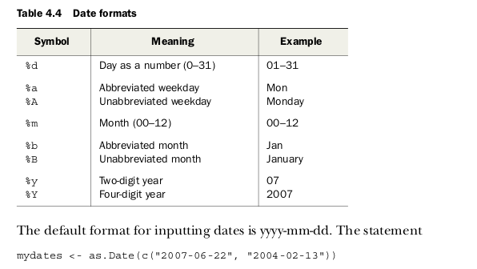
Dates are typically entered into R as character strings and then translated into date variables that are stored numerically. The function as.Date() is used to make this translation. The syntax is as.Date(x, "input_format")

Converting

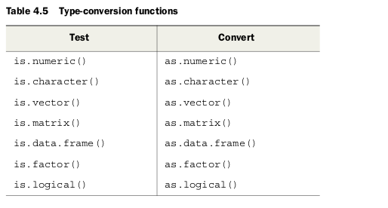

Working with data
Sorting
User order() function
newdata <- leadership[order(leadership$age),]
Merge
horizontally user the merge(). Horizontal joins are typically used to add variables to a data frame
total <- merge(dataframeA, dataframeB, by=c("ID","Country"))
If you’re joining two matrices or data frames horizontally and don’t need to specify a common key, you can use the cbind() function:
total <- cbind(A, B)
This function horizontally concatenates objects A and B. For the function to work properly, each object must have the same number of rows and be sorted in the same order.
Adding rows to a data frame
To join two data frames (datasets) vertically, use the rbind() function:
total <- rbind(dataframeA, dataframeB)
The two data frames must have the same variables, but they don’t have to be in the same order
Subselect variables
newdata <- leadership[, c(6:10)]
The statements accomplish the same variable selection.
myvars <- c("q1", "q2", "q3", "q4", "q5")
newdata <-leadership[myvars]
Selecting observations
newdata <- leadership[gender=='M' & age > 30,]
Recomend use subset function
newdata <- subset(leadership, age >= 35 | age < 24, select=c(q1, q2, q3, q4))
Use sql to manipulate data
library(sqldf)
sqldf("select * from mtcars where carb=1 order by mpg", row.names=TRUE)

Numerical functions
Math functions
- abs(x)
- sqrt(x)
- ceilling(x) smallest int not less than x
- floor(x) largets int not greater then x
- trunc
- round
- cos(x), sin(x), tan(x), exp(x), acos(x), asin(x), atan(x)
- log(x, base=n), log10(x)
Statistical functions
- mean(c(1, 2)) → arithmetic mean (sum of values divided by number of values)
- median(x) → center
- sd(x) → standard deviation. Measure of the amount of variation or dispersion-. A low standard deviation indicates that the values tend to be close to the mean (also called the expected value) of the set,
- var(x) → variance is a measure of dispersion that takes into account the spread of all data points in a data set.
- mad(x) → median absolute deviation https://en.wikipedia.org/wiki/Median_absolute_deviation
- quntiles(x, probs)
- range(x)
- sum(x), min(), max()
- scale(x, center=TRUE, scale=TRUE) → standardizes the specified columns of a matrix or
data frame to a mean of 0 and a standard deviation of 1
To standardize each column to an arbitrary mean and standard deviation, you can use
code similar to the following
newdata <- scale(mydata)*SD + M # OR tansform function
where M is the desired mean and SD is the desired standard deviation

standard deviation is affected by extreme values. A single extreme value can have a big impact on the standard deviation.
For two data sets with the same mean, the one with the larger standard deviation is the one in which the data is more spread out from the center
Variance is a method to find or obtain the measure of how the variables differ from one another. In contrast → measure how fat the outcome varies from the mean, standard deviation shows us how the data set or the variables differ from the mean or the average value of the data set … measures how far the normal standard deviation is from the expected value → may server as a measure of uncertainty.
Probability functions
where the first letter refers to the aspect of the distribution returned:
d = density
p = distribution function
q = quantile function
r = random generation (random deviates)

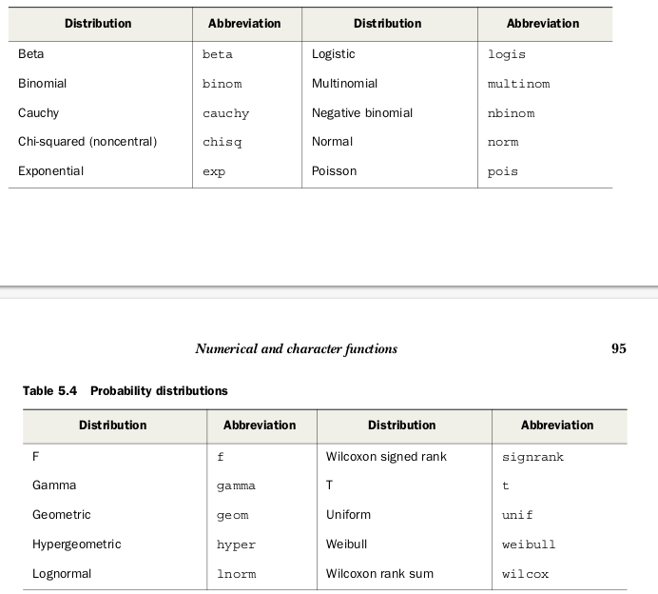
Each time you generate pseudo-random deviates, a different seed, and therefore different results, are produced. To make your results reproducible, you can specify the seed explicitly, using the set.seed(). Here, the runif() function is used to generate pseudo-random numbers from a uniform distribution on the interval 0 to 1

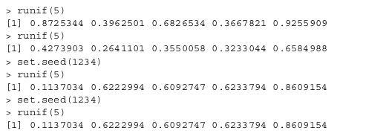
Character functions
- nchar(x) → counts the number of characters
- substr(x, start, stop)
- grep(pattern, x)
- sub
- strsplit
- toupper, tolower

Other
- length(x) → length of object x
- seq(from, to, by)
- rep(x, n) repeates x n times
- apply → apply function to any dimension of a matrix, array or data frame
apply(x, MARGIN, FUN, …)
where x is the data object, MARGIN is the dimension index, FUN is a function you specify,
and ... are any parameters you want to pass to FUN
Whereas apply() applies a function over the margins of an array, lapply() and sapply() apply a function over a list.
Transpose
reverse rows and columns → use the t() function
Aggregate data
aggregate(x, by, FUN)
where x is the data object to be collapsed, by is a list of variables that will be crossed to form the new observations, and FUN is the scalar function used to calculate summary statistics that will make up the new observation values
aggregate(mtcars, by=list(cyl,gear), FUN=mean, na.rm=TRUE)
the by variables must be in a list (even if there’s only one)

reshape2 package todo
Melt
dcast()

