Introduction to Micronaut
RESOURCES: https://www.youtube.com/watch?v=zyrp9BstEyE
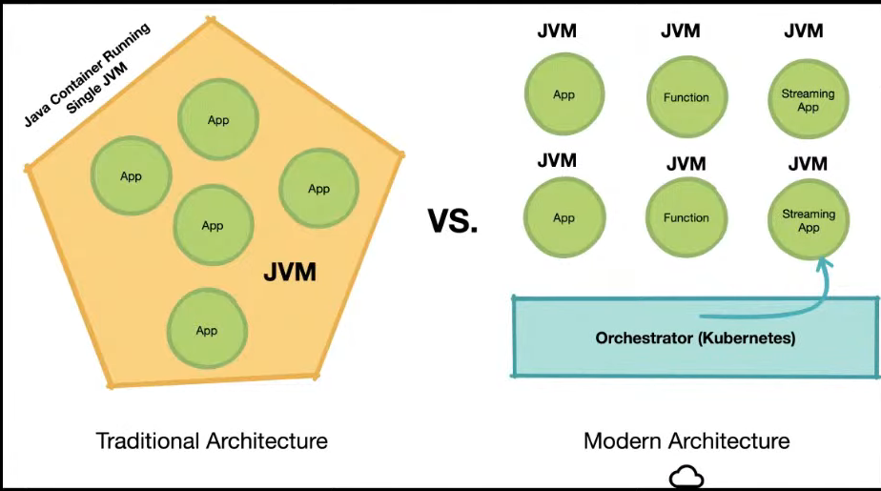

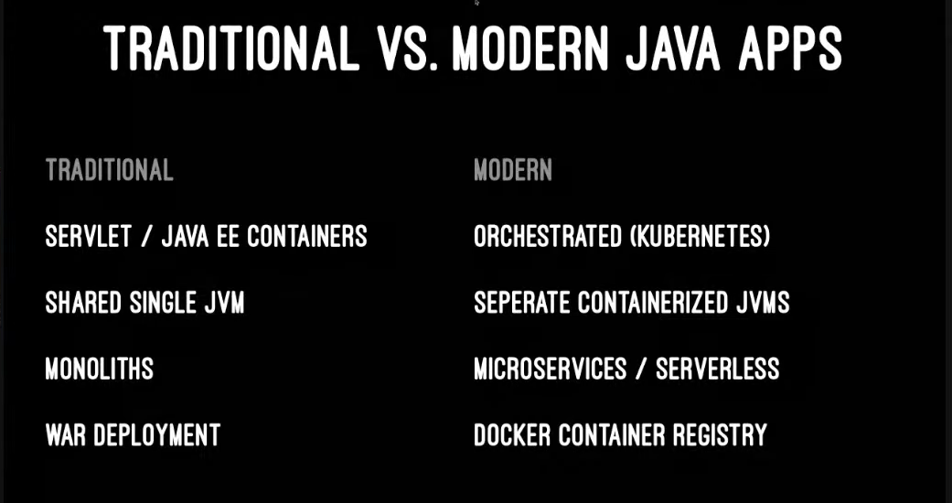

Traditional frameworks like Spring make extensive use of techniques that are bad for memory consumption and start up performance:
- reflection
- runtime bytecode generation
- dynamic class loading

Javas’s problems for frameworks
- limited annotation api
- type erasure
- slow reflection
- reflective data caches
- classpath scanning
- slow dynamic class loading

Why is reflection a problem ?
→ all reflective data is initialized on first access and held in soft reference (every field and method)

Solution → Micronaut
- a microservices and serverless focused framework
- also framework for any type of app (swing,, mobile)
- Java annotation processor that hooks into your compiler and computes your framework infra (annotations..) at compile time (Spring does this when app is running)
- lessons from building spring and grails
- build time framework infrastructure because it computes (all dependency and config info, annotation metadata, aop proxies, bean introspections, (reflection, runtime proxy and dynamic classloader free))
- compilation is complex

You can build
- microservices
- serverless apps
- message-driven apps kafka/rabbit
- cli apps
- anything with static void main

Using GraalVM
- increase app throughput up to 20%
- compile app into small self-contained native bin (good for cloud)
- seamlessly use multiple languages and libs
- good fit because GraalVM has to do less work to configure native img because micronaut eliminates reflection, runtime proxies, bytecode generation and dynamic classloading

