Observability of Java app with OpenTelemetry
Resouces:
- https://www.youtube.com/watch?v=wRdaxGo4DE4&list=PLy7t4z5SYNaRoQ4o40i6zfD0ZuoenX7ph&index=100
- https://opentelemetry.io/docs/getting-started/dev/

Tracking the health of applications is critical in DevOps, and observability, telemetry, and application performance management (APM) all make that possible.

Monitoring - tools/techniques that raise warning something bad happens like
- average response time is getting slower and slower
- HTTP 500 – internal server error
- application crash
Observability
- measure the internal states of a system by examining its outputs
- app must proved detail visibility into its behavior and allows identifying the root cause of an issuse

Observability is based on
- logs
- traces (track what happens within a request)
- metrics .
OpenTelemetry allows enabling traces, trace propagation and metrics in an existing Java app without coding changes. Idea: what we could manipulate bytecode of such libraries (instrumentation) is to inject telemetry behavior. Implement using Java agents.
OpenTelemetry collector is application that is used to collect data from your app and send it to Observability specific system: OpenZipkin, Jager… OpenTelemetry collector – grups data, filters data, reduces the number pushes to the specific system. You can skip collector (for development env.)

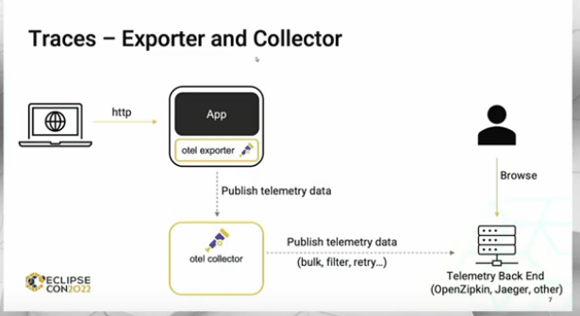
Enable tracing with OpenTelemety
1. Start Java app specifying the OpenTelemetry JVM Agent on the command line

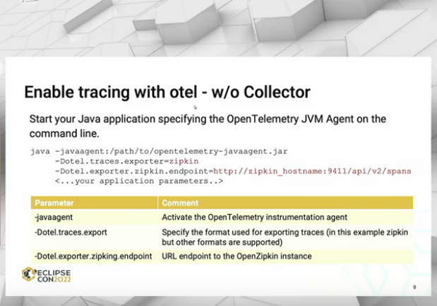

Trace propagation
- trace request from A → B → C service app
- in https headers create unique ids, each service (A, B, C) for same request use unique id
- configure this by adding params to cmd start

