Caching with Spring: Advanced Topics and Best Practices
Local and distributed caching at the app level with Spring framework
Resources: https://www.youtube.com/watch?v=3NLS7147UQo

Do not be too defensive or too offensive when caching (consistency of performance issues)
Types of Caches (lost’s of results)
- local cache
- data grid
- document store
- JPA first level cache, JPA second level cache ….
- HTTP cache –
- Database
- heap
- HTTP proxy
- browser
- off heap
- application cache
Questions

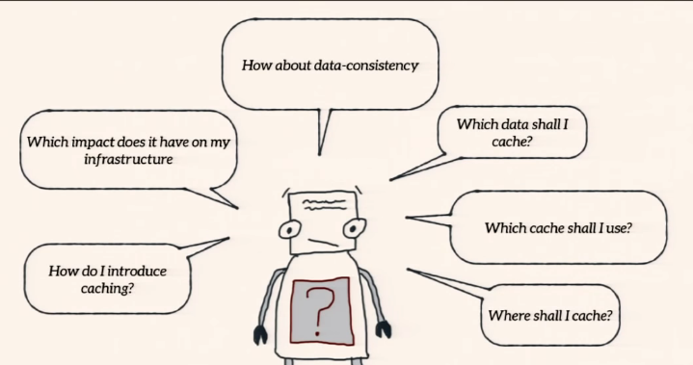

Where shall I cache
In Spring app
- Rest Controller → http caching
- Business Service – read operations cache
- Spring data Repository – read and maybe write operation (control on data)
Rest and Business Service should not do write operation cache because they do not know what will happened with write, but Repository layer has full control on write is it is ok
Stay local as long as possible
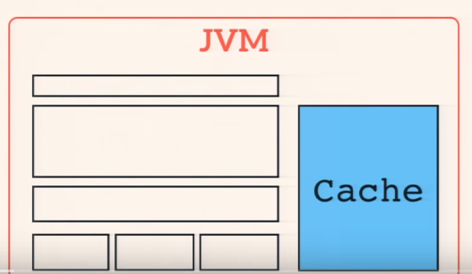
Cache in the same heap as the app. (Google guava example). If you app run in on JVM

Many applications run on several JVM. You have more then one instance of the app live. Like some cluster. You have consistency problem/chalange

Data consistency
Case: Many applications run on several JVM. You have more then one instance of the app live. Like some cluster
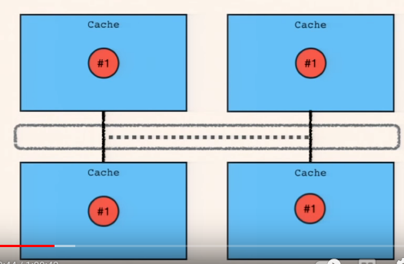
Solutions:
- Invalidation
- Replication
- Distributed Caches – for big amount of data
Invalidation – send notification that cache for key is changed (you have put) or expired to other JVM (app). They will remove item from cache.
Replication – send complete data to other nodes. Problem is network traffic.Avoid real replication where possible.

Heap size
Big heap leads to long major Gcs. So avoid big heap. Small caches are a bad idea, because we will have lot’s of miss → Many evictions fewer hits no “hot data”

Distributed Cache
Cache data externalized from app (hazelcast)
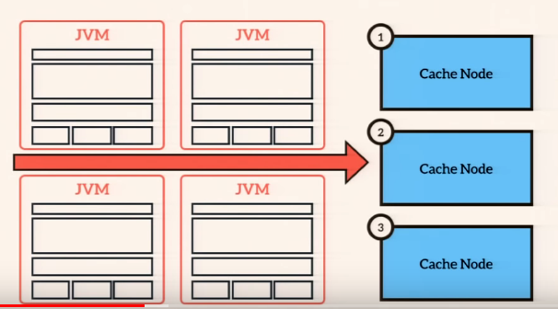
Provider like hazelcast is taking care of data and its replication and backoup. Proverd has nodes of cache (main; backup..)
With distributed cache you have smaller heaps, more capacity and easy to scale. But clustered caches are complex when comes to networking operations so network guys should be involved as early as possible (TCP/IP – multicasting).

Which data to cache
The best cache candidates are read-mostly data which are expensive to obtain. If you cache write intensive data make sure to use a distributed cache (do not use replication or invalidation strategy).
Never write your own cache implementation. Use existing solution. (Infinispan, EHCache, Hazelcast, Couchbase, Memcache, OSCache, SwarmCache, Xtreme ache, Apache DirectMemory, Terravor, Coherence, Gemfire, Oracle 12c ln memory database..)

Steps to implement cache
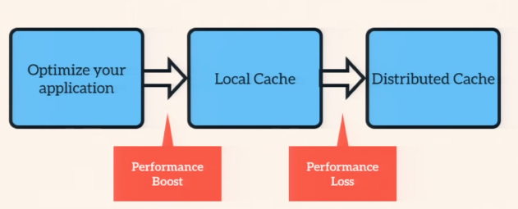

Local cache will make performance boost but you will lost one part when you go for distributed – because of the network.
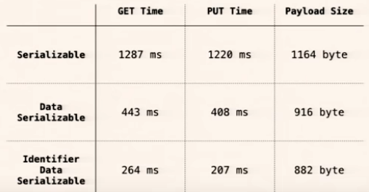
Optimize Serialization of data – Java standard lib is bad – for caching-> very bad. TODO check-Try to find specific ones

Use off-heap storage for cache instance if more than 4G is going for cache.

Security problem
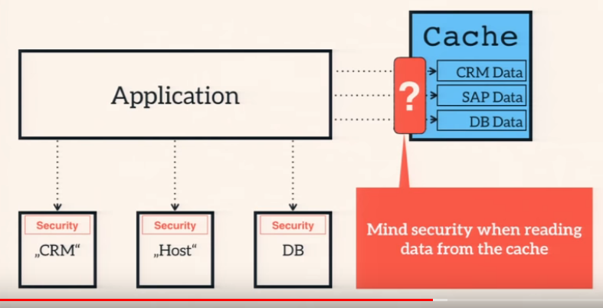

Spring
- abstracts cache provider
- cache code is not tightly coupled to business relevant code

Keys are generated based on method params. If no params then it is SimpleKey.Empthy (“{}”). Custom is to implement your own key generator (implements KeyGenerator). You can use Spring expresion language (key=”#param.id” key=”resulr.id” // id of result)
You can have multiple caches and Caches Mangers than can be configured (empty chat every 1 min or every 10 minutes). Can reference them with annotations (extends AbstractCacheResolver -> recommendation)

Caching in tests

implement CompositeCacheManager
disable – use fallbackToNOOPCache

