Collections

Table of Contents
Intro 2
Hierarchy 3
List 5
Queue 7
Set 8
Map 9
List vs Set 10

Intro
provides an architecture to store and manipulate the group of objects.
Prior to Java 2, Java provided ad hoc classes such as Dictionary, Vector, Stack, and Properties to store and manipulate groups of objects.
Advantages
- consistent api
- reduces effort
- increases performances – speed and quality

Hierarchy
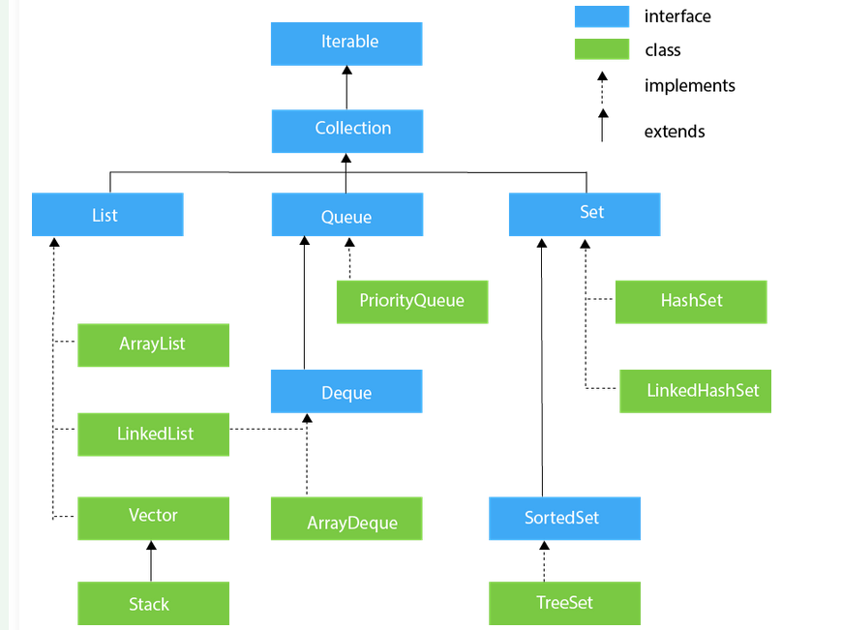

Iterable
- Iterator<T> iterator()

Iterator
- boolean hasNext()
- Object next()
- void remove() // remove last

Collection
- boolean add(E e)
- addAll(Collection<? extends E> c)
- boolean remove(Object element)
- boolean removeAll(Collection<?> c)
- removeIf(Predicate<? super E> filter)
- retainAll(Collection<?> c)
- int size()
- void clear()
- boolean contains(Object element)
- containsAll(Collection<?> c)
- Object[] toArray()
- boolean isEmpty()
- Stream<E> parallelStream()
- Stream<E> stream()
- Spliterator<E> spliterator()

List
- ordered collection
- duplicate ok
- add null ok (depended on the implementation)
- implemented: ArrayList, LinkedList, Vector, Stack
- add(Object o)
- set(index, Object o
- indexOf, lastIndexOf()
- remove(Object o) /remove(index x)
- get(index)
- contains(Object o)
ArrayList
- dynamic array
- duplicate ok
- null ok
- ordered (preserves the order of elements, allowing you to access elements in the order they were added) - maintains the insertion order
- slower than standard array but helpful where lots of manipulation is needed
- adding replace O(1)
- removing, traversing O(N)
- forEach
- sublist(startIndex, endIndex)
CopyOnWriteArrayList
- is an enhanced version of ArrayList in which all the modifications(add, set, remove, etc.) are implemented by making a fresh copy of the list.
LinkedList
- doubly linked list internally
- duplicate ok
- maintains the insertion order
- ease for access insertions and deletions
- not sorted
- addFirst, addLast
- descendingIterator
- elememnt (get first)
- getFirst, getLast
- offer (add on the end)
- afferFrist – add on the top
- TODO stao https://www.geeksforgeeks.org/linked-list-in-java/
https://www.geeksforgeeks.org/collections-in-java-2/
Vector
- dynamic array
- synchronized
- legacy class
Stack
- subclass of Vector
- last-in-first-out
- push , pop, three more function to empty search and peek

Queue
- first-in-first-out order
- ordered list
- implemented by PriorityQueue, Deque, and ArrayDeque
PriorityQueue
- holds the elements or objects which are to be processed by their priorities
- no null
Deque
- double-ended queue which enables us to perform the operations at both the ends
ArrayDeque
- faster than ArrayList and Stack
- no capacity restrictions

Set
unordered set of elements which doesn't allow us to store the duplicate items
We can store at most one null value in Set.
HashSet
- uses a hash table for storage
- unique items
LinkedHashSet
- maintains the insertion order
- permits null elements
- unique elements
SortedSet
- alternate of Set interface
- provides a total ordering on its elements
TreeSet
- uses a tree for storage
- contains unique element
- elements stored in ascending order

Map
Mapping between key and their corresponding value.
cannot contain duplicate keys
each key can map to at most one value
HashMap
- access via keys using hashing
- HashSet uses HashMap internally to store elements uniquely,

List vs Set

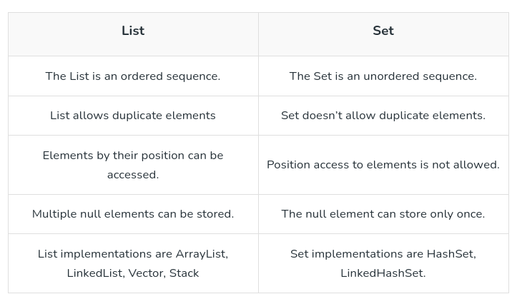
Stao: https://www.geeksforgeeks.org/linked-list-in-java/
https://www.geeksforgeeks.org/collections-in-java-2/

https://roadmap.sh/roadmaps
https://roadmap.sh/java

