HTTP
Table of Contents
TODO 2
Intro 3
Resources and URIs 4
Mime types 5
Overview of HTTP 8
HTTP msg 8
HTTP request msg 8
HTTP response msg 9
HTTP for complex applications 10
Http session 11
HTTP Security 12
Content-Security Policy 12
Script Transport Security (HSTS) 12
Cookie security 12
X-Content-Type-Options 12
X-Frame-Options 13
CORS 14

TODO
- s/wss (web socket connections – secure) https://developer.mozilla.org/en-US/docs/Web/API/WebSockets_API
- Mime Discrete types: application
- Mime multipart types → all of them
- canonical URL
- Http/2 -> https://web.dev/performance-http2/
- Server side events https://developer.mozilla.org/en-US/docs/Web/API/Server-sent_events
- Web sockets https://developer.mozilla.org/en-US/docs/Web/API/WebSockets_API
- HTTP/3 with QUIC
- https://developer.mozilla.org/en-US/docs/Web/HTTP
- Security guidelines: https://infosec.mozilla.org/guidelines/web_security

Intro
From: https://developer.mozilla.org/en-US/docs/Web/HTTP
HTTP
- app layer protocol
- for communication between web browsers (client) and web server
- client – server mode (client opening connection…)
- stateless protocol (server does not keep any data, state between two requests)

Resources and URIs

Target of HTTP request is called a “resources“. Can be document, photo or anything else. Each resources id identified by URI.
Example:
foo://techtarget.com:8042/over/there?name=parrot#beak
telnet://192.0.2.16:80
git@github.com:mdn/browser-compat-data.git
mailto:help@supercyberhelpdesk.info

URI Consist of the following elements
- scheme or protocol (should be registered in IANA)
- authority (host + optional authentication section + optional port number)
- query (?key1=value1&key2=value2)
- fragment (id that points somewhere in the resources)

Common schemes:
- data (embed small files inline in documents – lot of of security issues )
- file
- ftp
- http/https
- javasctipt
- mailto
- ssh
- tel
- urn
- ws/wss (web socket connections – secure) https://developer.mozilla.org/en-US/docs/Web/API/WebSockets_API

URI can be
- URL for web resources (subset of URI). Contains components such as the protocol, domain, subdomain)
Example: https://datatracker.ietf.org/doc/html/rfc3986
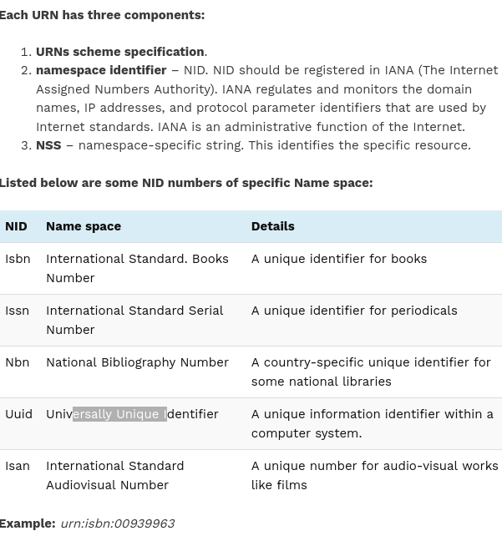
- URN location-independent and persistent (same resource over time)
Example: urn:oasis:names:specification:docbook:dtd:xml:4.1.2URN

In URL case, the user has to know where the resource is located. With a URN, the user only needs to know the name of a resource. One or more agencies will presumably be able to locate the nearest copy of the resource. urn:def://blue_laser where "def://" might indicate an agency

Mime types
Indicates the nature and format of a document. Consists of just two parts: a type and a subtype separated by a slash. Type is category and subtype type of the data. Example text/html.
An optional parameter can be added to provide additional details:
type/subtype;parameter=value
charset parameter to specify the character set used for the characters in the data (default is ASCII (US-ASCII) unless overridden by the user agent's settings)
Browsers use the MIME type, not the file extension, to determine how to process a URL, so it's important that web servers send the correct MIME type in the response's
Can be
- discrete
- multipart
Discrete types are types which represent a single file or medium,
A multipart type is one which represents a document of multiple component parts (composite like emails), each of which may have its own individual MIME type; or, a multipart type may encapsulate multiple files being sent together in one transaction
Discrete types:
- application (default for binnary files. binary data that doesn’t fall into other types). Generic binary data (or binary data whose true type is unknown) is application/octet-stream. Other common examples include application/pdf, application/pkcs8, and application/zip
- audio
- font
- image
- model
- text
- video
Multipart
- message
- multipart
- form-data (https://developer.mozilla.org/en-US/docs/Web/HTTP/Basics_of_HTTP/MIME_Types#multipartform-data)
- byteranges

Two primary MIME types are important for the role of default types:
- text/plain is the default value for textual files. A textual file should be human-readable and must not contain binary data.
- application/octet-stream is the default value for all other cases. An unknown file type should use this type. Browsers pay a particular care when manipulating these files, to protect users from software vulnerabilities and possible dangerous behavior.

Overview of HTTP
Protocol for fetching resources by exchanging individual messages (as opposed to a stream of data). Data is sent over TCP or TSL (encrypted TCP connection more info here: https://developer.mozilla.org/en-US/docs/Web/HTTP/Basics_of_HTTP/Evolution_of_HTTP#using_http_for_secure_transmissions).

A Client-server protocol. Between can be proxies ( gateways, caches, filtering (antivirus scan parental controls), load balancing, authentication, logging)
A server appears as only a single machine virtually; but it may actually be a collection of servers sharing the load (load balancing), or a complex piece of software interrogating other computers (like cache, a DB server, or e-commerce servers), totally or partially generating the document on demand. A server is not necessarily a single machine, but several server software instances can be hosted on the same machine. With HTTP/1.1 and the Host header, they may even share the same IP address.

Basic aspects
- simple human readable
- extensible throughout headers
- caching
- origin constraint (only pages from the same origin can access all the info of a web page)
- authentication
- sessions using http cookies

HTTP msg - textual information encoded in ASCII. In HTTP/2 are divided into byte frames because of performance improvements.

HTTP msg
Have
- first line
- headers
- body
Headers can be general (apply to the whole msg), request, response headers, representation headers (info about the body) and payload headers (representation-independent info about payload data)
more info here: https://developer.mozilla.org/en-US/docs/Web/HTTP/Headers

HTTP request msg

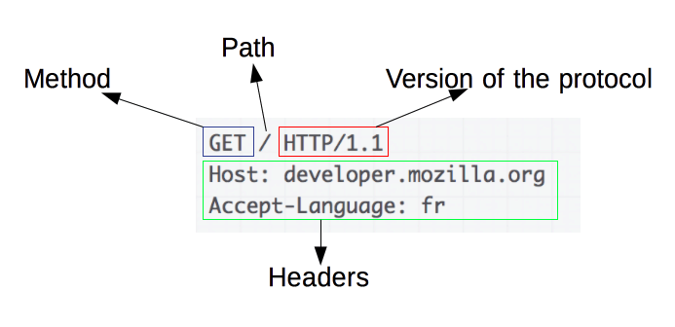

Path or request target is usally a URL can have query string
A complete URL, known as the absolute form, is mostly used with GET when connected to a proxy. GET https://developer.mozilla.org/en-US/docs/Web/HTTP/Messages HTTP/1.1

Example:
GET http://www.google.com.au HTTP/1.1
Host: www.example.com
Explanation:
HTTP servers which receive the absolute form of a URI in the request-line ignore the Host: header and use only that absolute URI for any further processing. The server then has to decide what to do with it.
Existing general purpose HTTP servers use virtual hosts to provide service for several different hostnames, and if the given hostname does not match an existing virtual host, they will attempt to serve it with the default virtual host. Unless the server has been explicitly configured to proxy such requests, but this isn't in your scenario.

HTTP response msg

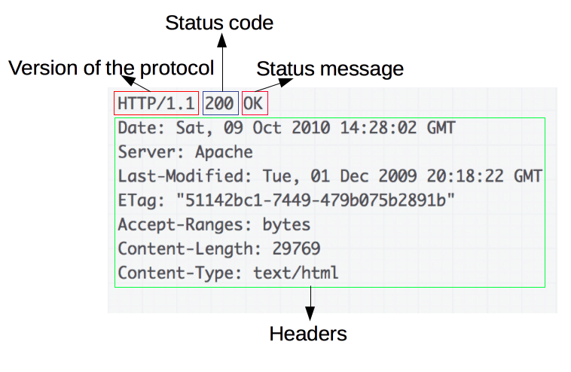

HTTP for complex applications
- RESTful API pattern for using HTTP
- Server side events https://developer.mozilla.org/en-US/docs/Web/API/Server-sent_events
- Web sockets nbvfrvjrfv

Http session
In client-server protocols, like HTTP, sessions consist of three phases:
- The client establishes a TCP connection (or the appropriate connection if the transport layer is not TCP).
- The client sends its request, and waits for the answer.
- The server processes the request, sending back its answer, providing a status code and appropriate data.
Opening a connection in HTTP means initiating a connection in the underlying transport layer, usually this is TCP.
Connection
- non-persistent – for each object new connection
- Persistent – connection open for some time,
- http pipelining – not active in modern browsers
Persistent connections also have drawbacks; even when idling they consume server resources, and under heavy load, DoS attacks can be conducted. In such cases, using non-persistent connections, which are closed as soon as they are idle, can provide better performance.

HTTP Security

You can use a tool like the SecurityHeaders scanner to check basic
Security guidelines: https://infosec.mozilla.org/guidelines/web_security

Content-Security Policy
Content Security Policy is the name of a HTTP response header that is used to enhance the security of the document. It allows you to restrict which resources (JavaScript, CSS, Images) can be loaded and the URL that they can be loaded from.
Was designed to reduce the attack surface of Cross Site Scripting (XSS) attacks. Problem. Malicious scripts are executed by the victim's browser because the browser trusts the source of the content, even when it's not coming from where it seems to be coming from. CSP makes it possible for server administrators to reduce or eliminate the vectors by which XSS can occur by specifying the domains that the browser should consider to be valid sources of executable scripts.
To enable it you need to configure your web server to return Content-Security-Policy HTTP header (https://developer.mozilla.org/en-US/docs/Web/HTTP/Headers/Content-Security-Policy).
More info here: https://content-security-policy.com/browser-test/ and
https://www.imperva.com/learn/application-security/content-security-policy-csp-header/
https://crashtest-security.com/content-security-policy-header/

Script Transport Security (HSTS)
Informs browsers that the site should only be accessed using HTTPS, ant that any future attempts to access it are converted to HTTPS
This is more secure than simply configuring a HTTP to HTTPS (301) redirect on your server, where the initial HTTP connection is still vulnerable to a man-in-the-middle attack.
More info here https://developer.mozilla.org/en-US/docs/Web/HTTP/Headers/Strict-Transport-Security

Cookie security
Covered in cookie part.
Reference: https://developer.mozilla.org/en-US/docs/Web/HTTP/Cookies#Secure_and_HttpOnly_cookies

X-Content-Type-Options
Designed to protect web applications from MIME type sniffing attacks.
MIME type sniffing is a technique used by some web browsers to determine the MIME type of a file based on its content rather than relying on the MIME type that is declared in the Content-Type header. This can be a security risk because it can allow an attacker to execute malicious code on a website by tricking the browser into interpreting a file as a different MIME type than what it actually is.
The X-Content-Type-Options header was introduced to address this security issue. When the X-Content-Type-Options header is set to "nosniff", it instructs the browser to always use the MIME type that is declared in the Content-Type header rather than trying to determine the MIME type based on the file's content.
First, it is important to ensure that the Content-Type header is set correctly for all files on your website.

X-Frame-Options
Used to indicate whether or not a browser should be allowed to render a page in a <frame> <iframe> <embed> <object>

CORS
Header based mechanism that allows a server to indicate any origins (domain, scheme or port - Two objects have the same origin only when the scheme, hostname, and port all match) that its own from which a browser should permit loading resources
TODO STAO
https://developer.mozilla.org/en-US/docs/Web/HTTP/CORS

Stao: https://developer.mozilla.org/en-US/docs/Web/HTTP/CSP

