An architect’s journal -Embracing Simplicity in Software Architecture Diagramming

Level 0 (L0)
Level 0 (L0) marks our starting point. This is the most abstract view of the target architecture. At this stage, a single shape might represent the entire system. It serves as an initial snapshot, an abstract encapsulation of the system we aim to build.
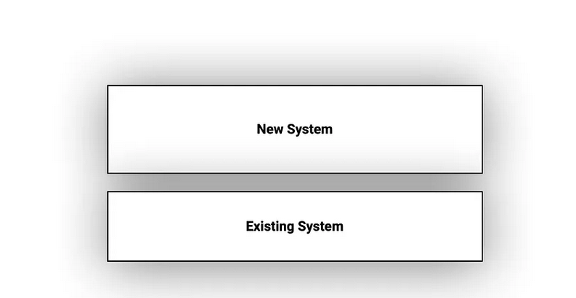

With Level 0 serving as our foundation, we will gradually progress to the following levels.

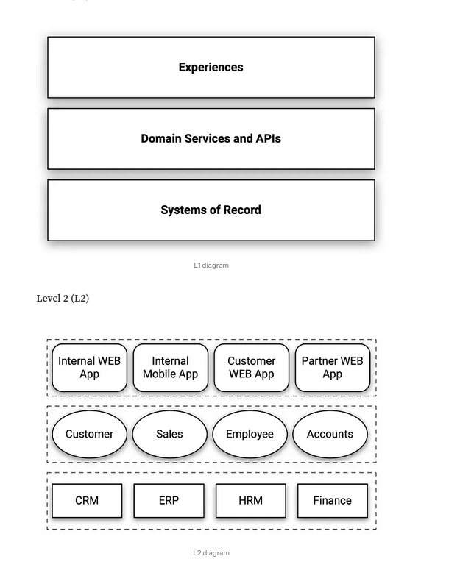

Level 3 (L3)
In Level 3 (L3), we utilize the principles of cell-based architecture to clearly define and encapsulate distinct domains and their corresponding (micro)services, enabling efficient and scalable system design.

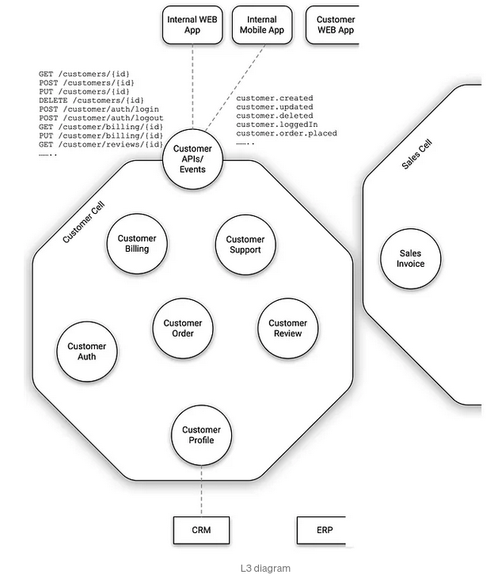

From https://blog.architect2architect.com/an-architects-journal-embracing-simplicity-in-software-architecture-diagramming-89aec930c47b

