Acing the System Design Interview

Table of Contents
TODO 3
A walkthrough of system design concepts 4
App used in book 4
Scaling with DNS 4
Caching 5
Scalability and going to production 5
Functional partitioning 6
Other common services 7
Hosting 7

TODO
- DNS, GeoDNS
- request rates
- cloud vs bare metal host
- Adopt CI/CD (Jenkins, unit testing, integration testing, Docker, Kubernetes, Ansible, Terraform)
- For UX experimentation approaches are A/B and multivariate testing, such as multi-armed bandit
- search service → Elasticserach (Elastic Stack (Elasticsearch, Logstash, Kibana, Beats). )
- distributed tracing system, such as Zipkin or Jaeger
- r distributed logging, to trace a request as it traverses through our numerous services
- service mesh Istio

A walkthrough of system design concepts

Goals of the interview
- ability to communicate and discuss system design with other
- technical knowledge
- asking questions
System design – it it not about perfection. We make tradeoffs and compromises to design the system we can achieve with the give resources and time. It is not about right answer, it is about ability to discuss multiple possible approached and weigh their tradeoffs to satisfy requirements.
The scalability of a service is the ability to easily and cost-effectively vary resources allocated to it

App used in book
Beigel: allows users to read and create posts about bagel cafes
Components
- FE app: A browser app: ReactJs, IOS and Android appp
- stateless BE (Go/Java)
- SQL DB in a single cloud host
On first launch have small number of users and low request rate. A single host is sufficient (DNS to redirect all request to this host).
Can host two services within the same data center each on a single cloud host. Configure DNS
- browser app → host A
- Mobile app → host B

Scaling with DNS
Situation: hundreds of thousands of active daily users in Asia, Europe, North America (1000 requests per seconds) we usually have 504 – timeout
Place host in different data center in different part of the world then we use GeoDNS to direct the client to the data center closest to it.
If service have lots of users from specific country or regrion → add host in nearby data center to minimize latency
If service is used on large geographically area use GeoDNS to return a user nearbay IP address (Assifne multiple A records to our domain for various locations and a default IP – A record is dns config)

Caching
Redis cache.
Select BE endpoints with heavy traffic to be served form the cache
CDN
Use 3party CDN to handle static content/files (JS, CSS, images, videos) instead of placing them on Node.js service
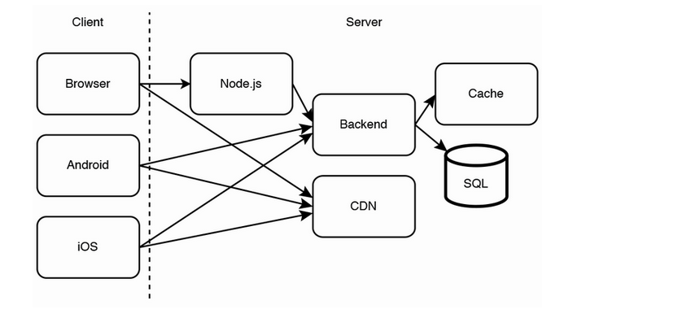
CDN stores copies of the static files in various data centers across the world, so a user can download these files from the data center that can provide them the lowest latency, which is usually the geographically closest one,
Improves latency, throughout, reliability and cost

Scalability and going to production
FE and BE services idempotent – we can have horizontally scale (have more hosts)
Adopt CI/CD (Jenkins, unit testing, integration testing, Docker, Kubernetes, Ansible, Terraform)
We may deploy the build to certain percentage of hosts then monitor them and increase the percentage until 100%. We can automatically roll back if we detect, bugs, crashes, timeouts, memory leaks, hight resource consumption (CPU, memory)
For UX experimentation approaches are A/B and multivariate testing, such as multi-armed bandit
Batch, streaming and load – also important topic is SD

Functional partitioning
Separating various functions into different services/hosts (Shared services) Example search service with Elasticserach
Also other
- Logging
- distributed tracing system, such as Zipkin or Jaeger

- Monitoring
- Alerting
API gateway and service mesh are two ways to centralize cross-cutting concerns. Other ways are the decorator pattern and aspect-oriented programming, which are outside the scope of this book.
API gateway – for exposing some of out APIs to external developers
An API gateway is a reverse proxy that routes client requests to the appropriate backend services. It provides the common functionality to many services, so individual services do not duplicate them
- Authorization and authentication, and other access control and security
- Logging, monitoring, and alerting at the request level
- Rate limiting
- Billing
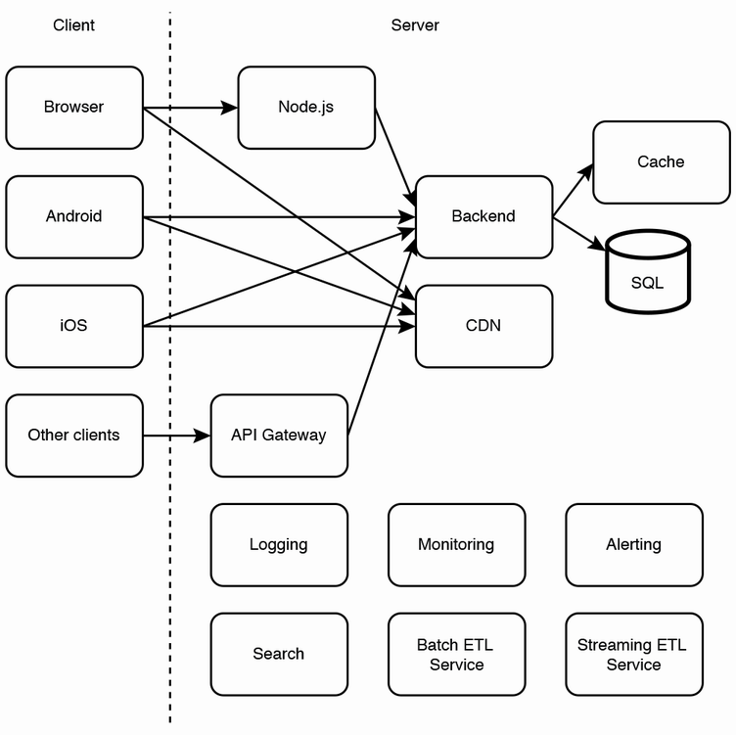
- Analytics

Drawbacks: adds latency requires a large cluster of hosts
Solution: service mesh
Service mesh (sidecar pattern): framework Istio with Kubernetes pods.
CQRS – command(/write operations and query/read operations are functionally partitioned in separate services. Message brokers and ETL jobs are examples of CQRS. Any design where data is written to one table and then transformed and inserted into another table is an example of CQRS

Other common services
- External user management
- storage services
- asynchronous processing
- Internal search and subproblems (e.g., autocomplete/typeahead service).
- Analytics and ML
- privacy compliance
- fraud detection

Hosting
- manage our own host
- cloud vendors
- serverless

