Apache Spark Course with Java

Content
Table of Contents
Content 2
Intro 3
RDD – Resilient Distributed Datasets 4
Creating RDD 4
Transformations 4
Actions 5
Important notes 5
Caching and Persistence 5
Spark Architecture 7
Components 8
Pair RDDs (key – value) 9
Accumulators 11
Broadcast Variables 12
Spark SQL 13
Spark SQL In action 13
Cluster 15
Spark submit 15

Intro
Apache Spark in a fast in memory data processing engine which allows data workers to efficiently execute streaming, machine learning or SQL workloads that require fast iterative access to datasets.
General purpose data processing engine. Users: data scientists and data processing app engineers (big data, advanced analytics)
Easy way to parallelize app across clusters and hides the complexity of distributed systems programming, network communication and fault tolerance

Computation engine
Speed
- run computations in memory
- DAG exe engine that supports acyclic data flow and in-memory computing
Programming model to write app by composing arbitrary operators (mappers, reducers, joins, group by, joins, filters)
Combine different processing models: iterative machine learning, streaming, batch processing. Example: Data classification with Spark machine learning lib, streaming data using Spark Streaming then query result in real time using Spark SQL

RDD – Resilient Distributed Datasets
Core abstraction when working with data.
Dataset – collection of data (list of strings, list of integers..)
- any types of objects (used defined classes also)
- wrapper around a very large datasets
- all work in done on RDD
- RDD data is distributed across cluster and operations you perform are parallelized
- operations: transformation (app function on the data (filter)) and actions (compute the result)
General workflow: generate initial RDDs from external data, apply transformations, launch actions
SparkConf
- setMaster (local – 1 core, local[*] - all available cores, local[2] - 2 cores) with local on local machine
- if 2 – then two results

Creating RDD
Approach 1 (not for production)
Use existing Java collection and pass it to SparkContext’s (connection to computing cluster). All elements are copied and distributed datasets are created (they can be operated in parallel). Not practical because all data has to fit in memory before it is transferred into cluster.
Approach 2
Load from external storage by calling textFile method on SparkContext. (can be local file system, distributed file system like Amazon S3 or HDFS)
Other data sources: JDBC, Cassandra, Elasticsearch ..

Transformations
Operations that return new RDD (existing is not changed)
filter, map, flatMap (1 to many relationship; input to output), set
Set operations
Mathematical sets
performed on one RDD
- sample (create a random sample from existing RDD)
- distinct – return distinict rows – expensive operations
performed on two RDD of the same type produce one
- union (all data from A and B – duplicates ok)
- intersection (common in A and B – remove duplicates) expensive operations
- subtract (only elements in first RDD) expensive operation
- cartesian product (all pars of elements in both A and B)

Actions
Operations that return a final value to the program or persist data to external storage system.
Actions force evaluation of the transformations
- collect (return list of XYZ – hole data set in memory – don’t use in production – used in unit tests), count)
- count (all valued), countByValue (uniqe values)
- take – take n elements from an RDD
- save as Text file . To write data out to distributed storage system such as HDFS or Amazon SE, or local file system
- reduce – takes two A, A and returns one A – for aggregations

Important notes
Each RDD is broken into multiple pieces called partitions which are divided across the clusters (done by Spark)
RDD are immutable.
RDD are resilient. They are deterministic function of the input. With immutabulity they can be recreated at any time (done by Spark)
Transformation are lazy operations, called only with actions.(RDD is set of instructions on how to compute the data)
Transformations return RDD, Actions returns other type

Caching and Persistence
Call actions on the same RDD multiple times.
If you want reuse an RDD in multiple actions call persist() on the RDD. First time when is computed in action it will be kept in memory across the modes. Future actions are 10x much faster
Storage levels_ Memory, memory and disk, memory as ser (serliazed java object), disk only
- trade-offs between memory usage and CPU efficiency if data can be hold in memory use MEMORY_ONLY because it most CPU efficient option – operatoins run as fast as possible
use MEMORY_ONLY_SER to make data smaller
don’t save to disk unless you can not save it all
if data can no be stored spark will evict old data

Spark Architecture
Master – slave approach
One master node and n worker nodes

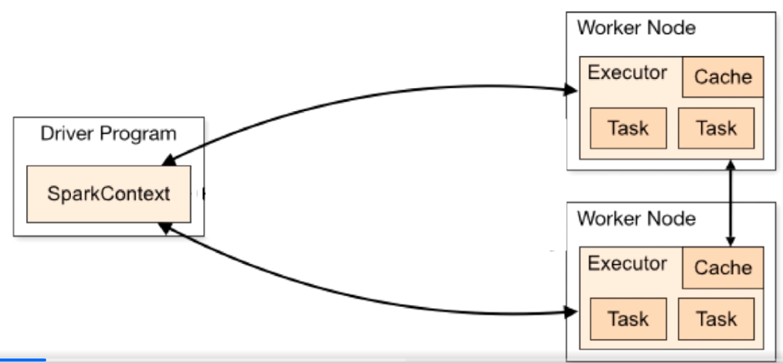
Master node is cordinator and communicates with distributed nodes (workers/executors)
Master is in Java main method
Is driver program execution is called job. Driver/master converts job into tasks which are executed by Spark executors. Executor is work node process that runs
Executors are workin node processes in charge of running individual tasks in a given spark job. They are launched at the beginning of a spark application and typically run for the entire lifetime of an application. Once they have run the task, they send the results to the driver driver program
Locally – all components run in the same process on the local machine.

Components
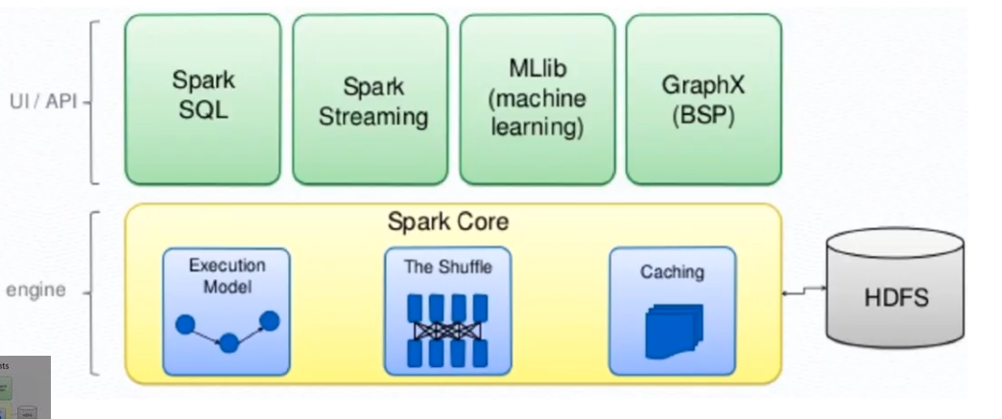

Spark core is the fundation of the project
Spark SQL – for working with structured data
Spark Streaming – process in real time
MLLib – classification, regression , clustering (ML algo)
GraphX – for graph structured data (vertex and edge)

Pair RDDs (key – value)
Data type key – value. Example: passportId: name of the passport holder
Pair RDD is type of RDD that can store key-value pairs.
Create them from a list key-value data structure (tuple) or turn regular RDD into Pair RDD
Transformations
- use all as regular RDD
- pass function that operates on Pair RDD
Aggregation
- aggregate statistics across all elements with the same key
- reduceByKey – one for each key where each operation combines values that have the same key. Not action is returns new RDD (key, plus reduced value for the key)
GroupByKey
- grouping data by key
- returns key and Iterable of values
SortByKey
- accepts comparator on Key as input for sorting
Data Partitioning
- avoid using groupByKey as much as possible
- use HashPartitioner to shufle data with same key (data with same key is on the same node)
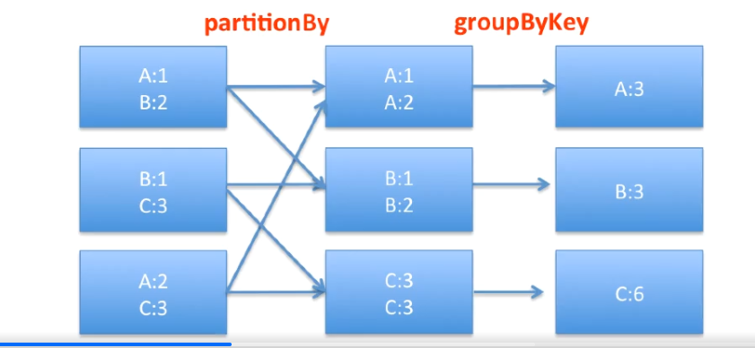
- good for: join, and all types of the join, groupByKey, reduceByKey, combineByKey, lookup (all opertations that requires shoufleing data across network) – and much more

Join operation
- join two RDD together on key
- innerJoin, outerjoin (left, right, full)

Accumulators
Variables that are used for aggregating information across the executors. We can calculate how many records are corrupted that occur during the job execution
To answer more questions by passing(iterating) data only once
- how many records do we have
- how many record are missing the value for x
- how many records has the value X for the field N
Write only values during the execution
Accumulator Types
Double, Long,
can define custom accumulator and custom aggregation operations

Broadcast Variables
Variables that we want to share (broadcast) through the cluster
Read only variable cached on each machine.
Can be used to give every node a copy of large input dataset in an efficient manner.
Done by using SparkContext.broadcast(T) T- has to be serializable because value goes across the wire (in the Spark cluster) – send to each node only once and should be treated as read-only (update is no propagated to other nodes)
Spark automatically sends all variables referenced in our closured to the worker nodes. While this is conveient it can also be inefficient because the default task launching mechanism is optimized for small task sizes.
Same variable in multiple parallel operations – Spark will send it separately for each operation. Can be problem is the size of data is significat
If we use the same postcode map later it would be sent again to each node (solution use broadcast variable)
Use to send lookup large data (data table)

Spark SQL
Infrastructure for working with structured data. Structured data is any data that has a schema – know set of fields for each record.
Datasets is similar to tables in a relations database.
DataFarme
- tabular data abstraction
- stored in more efficient manner than native RDD
- data between nodes are passed in much more efficient way than using Java serialization (because we have schema to the data)
- data is organized into named columns
Dataset
- OOP style
- compile type safety of the RDD API
- schema
- set of structured data (not necessarily a row but it could be of a particular type)
DataFrame is untyped view of a Dataset (which is a Dataset of Row were a Row is generic untyped JVM object)
Dataset is collection of strongly-typed JVM objects

Spark SQL In action
Import spark sql as library
For RDD use Spark context for sql use Spark Use SparkSession (start and stop) .
We use Datasets or DataFrames as data collection
for reading data do // from file TODO how to read from database
DataFrameReader reader = sprakSesion.reaad()
DataSet<Row> dataSet = reader…. // smalll DB in memory all data types nullable and string as default of mpt sšecofoed
dataSet has shchema and data
Use sql sintax
SparkSql use an optimizer called Catalyst makes queries run much faster than RDD
SQL join
same basic join as in core Spark join but Catalysit optimizer can optimize the join operation but we can’t manually avoid shuffles as in core Spark join (no control over the partitioner for Datasets as in core Spark join)
Joins
- inner
- outer
- left outer
- right outer
- left semin (for one table)
TODO pogledaj do kraja

Cluster
Writing app for parallel cluster execution use the same API (as for local).
Driver Program (look architecture) (master slave architecture) - central coordinator. Driver communicates with potentially large number of worker nodes/executors - were each is separate Java process
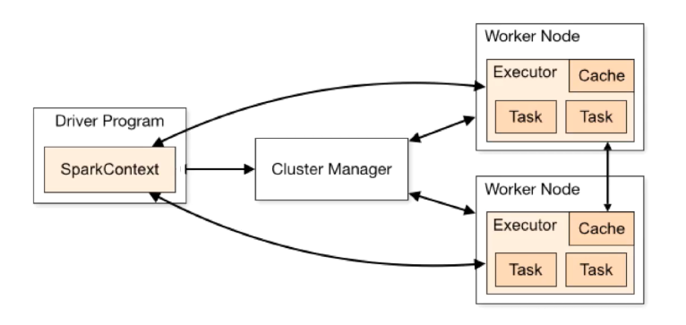
Driver Program – your application
Cluster Manager – master node
In each machine in the cluster there is worker node reports to the master (resources CPU, memory )
SparkContext conects cluster manger who allocates resources
Cluster manager
- pluggable compoment in Spark
- build-in called the Standalone cluster manager
- other managers: Haddop Yarn, Apache Mesos, Kubernetes
- abstracts away underlying cluster env so that you can use the same API to write the program which can run on different clusters
- single script for configuring cluster (spark-submit)

Spark submit
Export app to the jar so that it can be run on cluster and you also need spark-submit to submit app to cluster
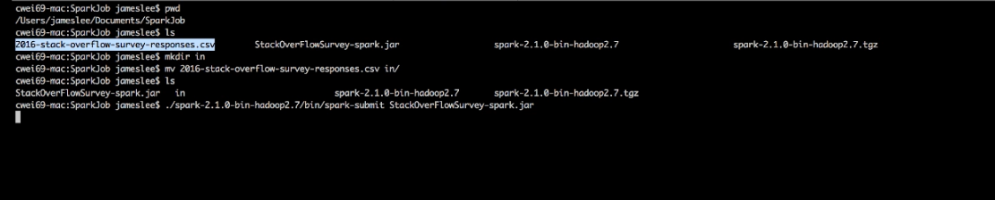
Is application stated in cmd as argument we pass jar file
Running App on Spark cluster
- user submit app using spark-submit tool
- spark-submit tool starts app (main method)
- app (driver program) contacts the cluster manager to ask for resources to start executors
- cluster manager launcher executors
- driver process runs throught app based on RDD dataset operations driver sends work to executors in the form of the task
- tasks are run on executor processes to computer and save result
- if the driver main merthod exits or it calls SparContext.stop() it terminate the executors
- params executor memory (be carrefful no bigger than app, total cores)

