Learning Spark, 2nd Edition

Book: Learning Spark, 2nd Edition By Jules S. Damji, Brooke Wenig, Tathagata Das, Denny Lee

Table of Contents
TODO 3
Introduction 4
From history 4
What is Apache Spark 4
Spark Application Concepts 7
API 10
RDD (Resilient Distributed Dataset) 10
DataFrame 10
Dataset API 11
Spark SQL 11
Built-in Data Sources 13
Spark SQL 13
DataFrameReader 13
DataFrameWriter 14
Data sources 14
External Data Sources 15
Spark SQL UDFs 15
JDBC and SQL DB 15
Manipulating complex data in select 17
Common DataFrames and Spark SQL Operations 18
Spark SQL and Datasets 19
JavaBeans for Datasets 19
Memory management for Datasets and DataFrames 20
Tuning Spark Applications 22

TODO
- The Google file system http://static.googleusercontent.com/media/research.google.com/en//archive/gfs-sosp2003.pdf
- http://static.googleusercontent.com/media/research.google.com/en//archive/mapreduce-osdi04.pdf
- http://static.googleusercontent.com/media/research.google.com/en//archive/bigtable-osdi06.pdf
- Hadoop: https://en.wikipedia.org/wiki/Apache_Hadoop; https://hadoop.apache.org/
- Apache Sparsk is Unified Engine for Big Data Processing https://cacm.acm.org/magazines/2016/11/209116-apache-spark/fulltext
- support for Apache Hadoop, YARN, Mesos and Kubernetes clusters
- RDD: https://www.usenix.org/system/files/conference/nsdi12/nsdi12-final138.pdf
- DataFrame inspired by python https://pandas.pydata.org/docs/reference/api/pandas.DataFrame.html
- https://www.databricks.com/blog/2016/07/14/a-tale-of-three-apache-spark-apis-rdds-dataframes-and-datasets.html
- https://docs.databricks.com/en/connect/index.html
- Delta Lake: https://docs.delta.io/latest/quick-start.html, https://docs.databricks.com/en/delta/index.html, https://github.com/delta-io/delta
- spark udf for java For a deeper dive into Pandas UDFs, refer to pandas user-defined functions documentation.
- see the Spark SQL documentation
- For the full list of SQL operations, see the Spark SQL documentation.
- Spark manages memory, check out the references provided in the text and the presentations “Apache Spark Memory Management” and “Deep Dive into Project Tungsten

Introduction

From history
Problem: Google search engine to index and search data. RDBMS or imperative programming were able to handle the scale of Google problem. New approaches led to creation of
- Google File System: fault tolerant distributed filesystem
- MapReducer: parallel programming paradigm based on functional lanfilage
- Bigtable sclable storage of structed data across GFS
GFS paper in April 2006 became part of the Apache Hadoop
MapReducer on HDFS (Hadoop file system) shortcomings
- hard to manage and administer
- lot of boilerpate setup code
- for general barch procesdsing
- new systems on Hadoop: Apache Hive, Storm, Impla, Giraph, Drill Mahout… operational complexity
Spark early years as solution for problems with MapReducer at UC Berkeley, started 2009 in the RAD Lab latter AMP Lab now as RISE Lab
Idea from Haddop MapRecude but system should be
- highly fault tolerant
- parallel
- in memory storage for intermediate result
- easy API
By 2013 Spark had good use company is formed calls Databricks. And in 2014 release of Apache Spark 1.0
2016 paper Apache Sparsk is Unified Engine for Big Data Processing

What is Apache Spark
Engine designed for large scale distributed data processing with in-memory storage for intermeditate computations. Has libraries for machine learning, sql, stream processing and graph processing.
Speed because query computations are directed acyclic grap (DAG) (DAG scheduler and query optimizer). Tungsten – physical execution engine
Ease of use because we have RRD (Resilient Distributed Dataset) – abstraction for data and transformations and actions as operations on RRD
Modularity because we can chose libraries and we have well defined API
Extensibility - focus on fast, parallel computation engine rather than on storage. Sparks decouples the two. That means you can use Spark to read data stored in myriad sources—Apache Hadoop, Apache Cassandra, Apache HBase, MongoDB, Apache Hive, RDBMSs, and more—and process it all in memory. Spark’s DataFrameReaders and DataFrameWriters can also be extended to read data from other sources, such as Apache Kafka, Kinesis, Azure Storage, and Amazon S3, into its logical data abstraction, on which it can operate.
Components
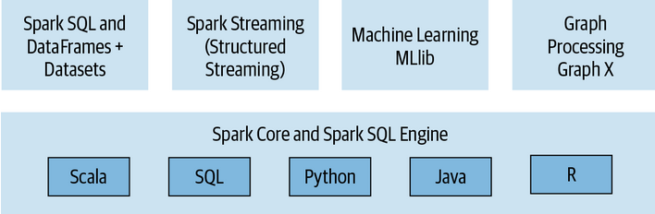
Distributed execution
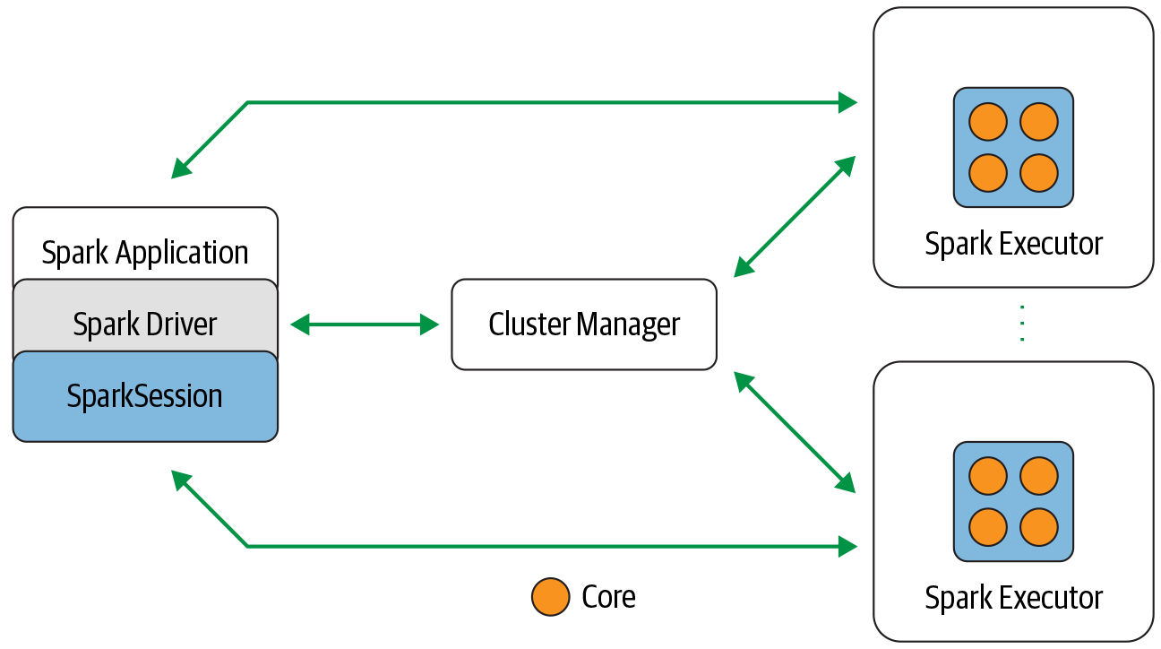
orchestration of parallel operations in the Spark cluster
The driver accesses the distributed components in the cluster (executors and cluster manager) through SprakSession
Spark driver
- communicates with the cluster manager (request for CPU, memory) from manager for executors
- transform operations into DAG computations, schedules them
- distributes DAG computations as tasks across executors
- communicates directly with the executoros
SparkSession
- single unified point to all Spark operations and data
- create JVM params
- define DataFrames and Datasets
- read data
Cluster manager
- managing and allocation resources for the cluster nodes on which Spark app runs
- support for Apache Hadoop, YARN, Mesos and Kubernetes clusters
Spark executor
- runs on each worker node in clusters
- exe tasks
- communicate with driver
Deployment modes
- local on single JVM (laptop, node) Executor runs on the same JVM as driver Cluster manager runs on the same host
- standalone: any node in the cluster: each node in cluster launch its own executror JVM, Cluster manager allocated arbitrarily to and hots
- YARN client
- YARN cluster
- Kubernetes: driver run in a pod, Each worker runs withing its own pod Kubernetesd master is manager
Distributed data
Data is distributed as partitions across the physical cluster, Each partition is treated as high-level logical data abstraction (DataFrame in memorey). Each executor is allocated a task that requires it to read the partition closest to it (not always possible).

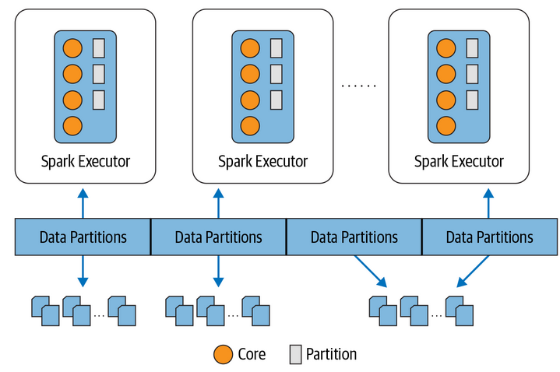
Example:
spark.read.text("path_to_large_text_file").repartition(8)
Break up the data stored across clusters into eight partitions and each executor will get one or more partitions to red into its memory.

Use Spark because it provides a simple way to parallelize computations and hides all the complexity of distribution and fault tolerance. This leaves them free to focus on using high-level DataFrame-based APIs and domain-specific language (DSL) queries to do ETL, reading and combining data from multiple sources.

Spark Application Concepts
Application user program build on Spark API, has driver program and executors on the cluster.
SparkSession entry point of Spark API (of its underlying functionality)
Job parallel computation of multiple tasks that gets spawned in response to a Spark action (save(), collect()). Driver converts you app into one or more Spark then transforms each job into a DAG (execution plan) where each node within DAG could be as single or multiple Spark stages.
Stage - job divided into smaller sets that depend on each other.
Task A single unit of work or execution that will be sent to Spark executor. Each stage is comprised of set Spark tasks (unit of execution) which are then federated across each Spark executor, each task maps to a single core and works on a single partition of data.
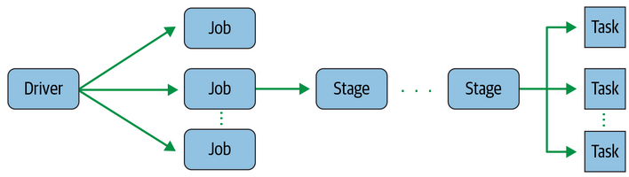
An executor with 16 cores can have 16 or more tasks working on 16 or more partitions in parallel.
Spark operations on distributed data can be
- transformations: new DataFrame is created, lazily evaluated
- actions:trigger the lazy evaluation

Lazy evaluation allows Spark to optimize your queries by peeking into your chained transformations, lineage and data immutability provide fault tolerance. (A recorded lineage allows Spark, at a later time in its execution plan, to rearrange certain transformations, coalesce them, or optimize transformations into stages for more efficient execution.) it can reproduce its original state by simply replaying the recorded lineage, giving it resiliency in the event of failures
Any transformation where a single output partition can be computed from a single input partition is a narrow transformation.
Transformations such as groupBy() or orderBy() instruct Spark to perform wide transformations, where data from other partitions is read in, combined, and written to disk.
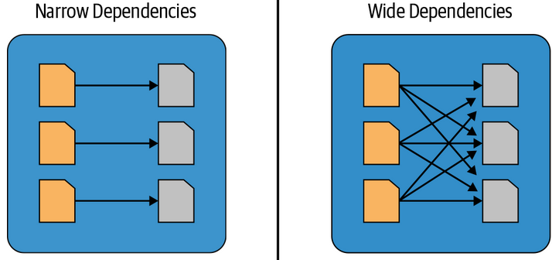
Spark includes a graphical user interface that you can use to inspect or monitor Spark applications in their various stages of decomposition.
Databricks is a company that offers a managed Apache Spark platform in the cloud.

API

RDD (Resilient Distributed Dataset)
Basic abstraction in Spark
Characteristics
- Dependencies: instructions how an RDD in constructed with inputs, when necessary to reproduce RDD can be recreated and replicated
- Partitions: split the work to parallelize computation across executors
- Compute function: partition → Iterator[T] for the data that will be stored in the RDD, can not be optimized because Spark it doesn’t know what are you doing
When using Dataframes and Datasets (high-level expressive DSL operators) Spark can inspect (parse) query and understand our intention it can optimize and arrange the operations for efficient execution.

DataFrame
Distributed in-memory tables with named columns and schemas where each column has a specific data type (int, string, array, map..)
Immutable and Spark keeps a lineage of all transformations (You can add or change the names and data types of the columns, creating new DataFrames while the previous versions are preserved)
Schema
- defines the column names and associated data types for a DataFrame.
- good practice is to define your schema up front – not allow Spark to read it automatically it’s and it is more efficient to define a schema than have Spark infer it
- declared can be: programmatically or the using DDL
Example in python
createDataFrame(data, schema)

Named columns are same as named columns in pandas or R or in RDBMS (describe a type of field). Based on the type you can use logival or mathematical expressions.
Row in an object (ordered collection of fields (columns)). Example in python:
rows = [Row("Matei Zaharia", "CA"), Row("Reynold Xin", "CA")]
authors_df = spark.createDataFrame(rows, ["Authors", "State"])
Operations
Load data using DataFrameReader interface (JSON, CSV, Parquet, Text, Avro, ORC, NoSQL, RDBMS, Kafka)
Write data use DataFrameReader interface
Projection – return only the rows matching a condition (select())
Filter - expressed using filter() or where() method
Rename column - withColumnRenamed("old", "new name")
Modify type of column - .withColumn("IncidentDate", to_timestamp(col("CallDate"), "MM/dd/yyyy"))
Drop column - drop("CallD”)
Example
.withColumn("IncidentDate", to_timestamp(col("CallDate"), "MM/dd/yyyy"))
.drop("CallDate")
Aggregations – grouping data by values in a column use groupBy, orderBy, count, min, max, sum, avg

Dataset API
DataFrame is an alias for a collection of generic objects Dataset<Row> where a ROW is a generic untyped JVM object that may hold different types/fields
Row is a generic object type in Spark holding a collection of mixed types that can be accessed using an index. Internally Spark manipulate Row object converting them to the its types (IntegerType..)
Dataset is a collection of strongly typed JVM objects. Make sense in Java and Scalar not in Python and R because they are not compile time type safe.
In Java and Scala each element in a Dataset maps to JVM object.
You define schema by defining class
When we use Datasets, the underlying Spark SQL engine handles the creation, conversion, serialization, and deserialization of the JVM objects. It also takes care of off-Java heap memory management with the help of Dataset encode

Spark SQL
You can make SQL compatible queries on structured data with a schema. It provides a bridge to and from external tools via standard database JDBC/ODBC connector. Generates optimized query plans and compact code for the JVM for the final execution.

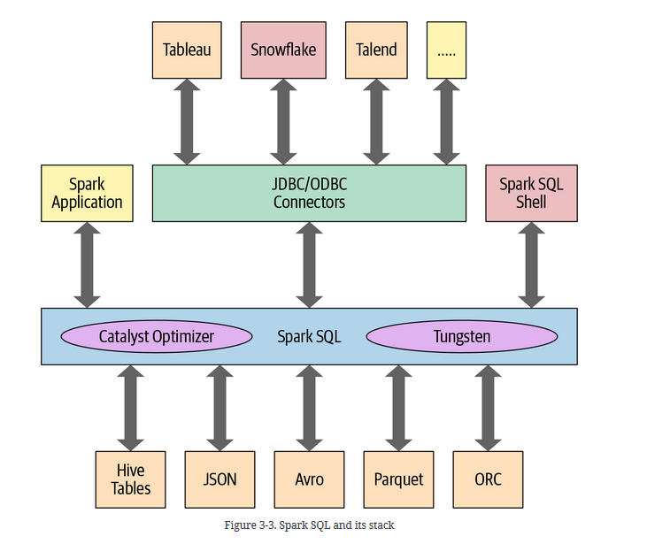
At the core is Catalyst optimizer and Project Tungsten. The Catalyst takes a query and converts it into a execution plan.
- Analysis: generates abstract syntax tree for the sql use internal Catalog to resolve columns and table names
- Logical optimization
- Physical planning: generates optimal plan for the selected logical plan
- Generates Javabytecode to run on each machine (park SQL can operate on data sets loaded in memory, Spark can use state-of-the-art compiler technology for code generation to speed up execution. In other words, it acts as a compiler. - Project Tungsten, which facilitates whole-stage code generation, plays a role here. )

Built-in Data Sources

Spark SQL
Spark Session is entry point for programming to issue any Sql query use the sql(). Queries are no different from those you might have on SQL table.
Associated with each table in Spark is its relevant metadata (info about the table and data – the schema description table name, database name, column names partition physical location) – all is stored in central metastore. Use the Apache Hive metastore (located at /user/hive/warehouse ).
Tables
- managed: metadata and the data in the file store (local system HDFS...)
- unmanaged: only metadata is managed by Spark while data is manage in external data source (Cassandra). On sql only metadata is updated not the actual data (from your own data source)
Views (on top of existing tables)
- global: visible across all SparkSession on a cluster
- session-scoped visible only to single SparkSession (they disappear after your app terminates)
- don’t hold data –
Tables persist after your Spark app terminates but views disappear.
A global temporary view you must use the prefix global_temp.<view_name>, because Spark creates global temporary views in a global temporary database called global_temp (session-scoped).
Metadata is captured in the Catalog (abstraction of Spark SQL for metadata).
Like DataFrames you can cache sql tables and views. (Additional option lazy: should be cached when it is first used)

DataFrameReader
Core for reading data from a source into DataFrame
Methods
- format: parquet, csv, txt, json, jdbc
- option: PERMISSIVE | FAILFAST
- schema
- load

DataFrameWriter
Saves or writes data to specified build-in data source.
Methods
- format
- option: append, overweite, ignore
- bucketBy
- save / saveAsTable

Data sources
- Parquet
Default data source.
Open source columnar file format that has many I/O optimizations (compression). Recomendation:
After data is transformed and cleaned save it as DataFrame in parquet format.
Parquet files are stored in a directory structure that contains the data files, metadata, a number of compressed files, and some status files. Metadata in the footer contains the version of the file format, the schema, and column data such as the path, etc.
- JSON
val df = spark.read.format("json").load(file)
- CSV
- Avro
- ORC
- Images

External Data Sources

Spark SQL UDFs
User defined functions for sql – operate per session
Spark SQL (this includes SQL, the DataFrame API, and the Dataset API) does not guarantee the order of evaluation of subexpressions.
he following query does not guarantee that the s is NOT NULL clause is executed prior to the strlen(s) > 1 clause
spark.sql("SELECT s FROM test1 WHERE s IS NOT NULL AND strlen(s) > 1")

JDBC and SQL DB
It simplifies querying these data sources as it returns the results as a DataFrame. To get started, you will need to specify the JDBC driver.
Using the data source API tables from the remote database can be loaded as DataFrame or Spark SQL temporary view
For large amount of data between Spark SQL and JDBC external source it is important to partition your data source. All data is going through one driver connection so is recommended to set
- numPartitions: use a multiple of the number of Spark workers
- partitionColumn. Chose one that can uniformly distribute data
- lowerBound
- upperBound
Lower bound and upper bound is based on the minimum and maximum partitionColum actual values.
Ex: lower: 0 upper: 1000, if all values between 2000 and 4000 then only 2 of the 10 queries will be doing all of the work Better config would be lower: 0 upper. 4000

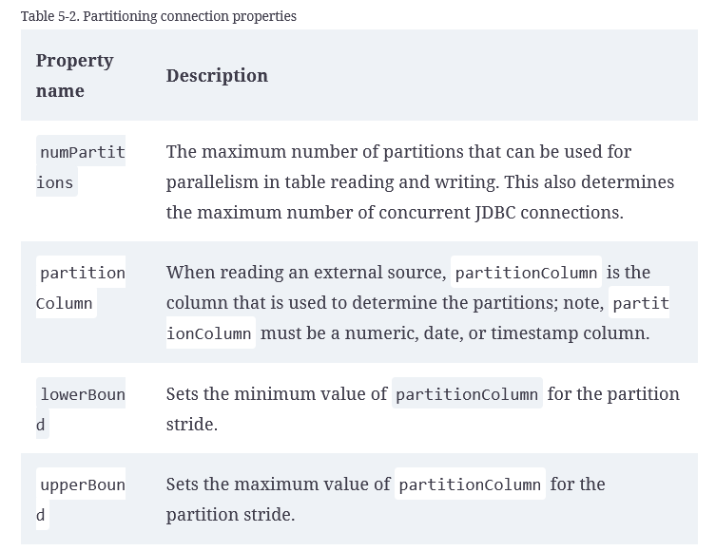
Example: numPartitions: 10, loweBound: 0, upperBound: 10000
Then the stride is equal to 1,000, and 10 partitions will be created. This is the equivalent of executing these 10 queries (one for each partition):
- SELECT * FROM table WHERE partitionColumn BETWEEN 0 and 1000
- SELECT * FROM table WHERE partitionColumn BETWEEN 1000 and 2000
Example

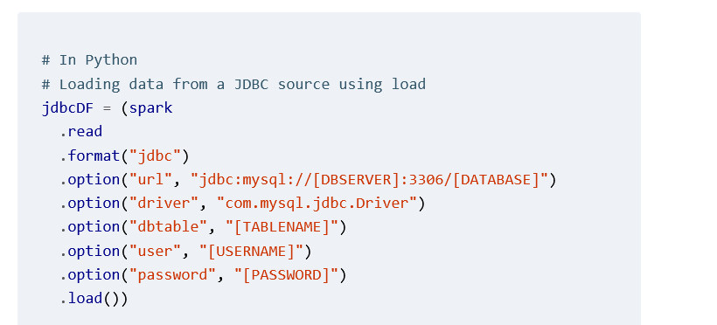
a
Other External Sources
- Apache Cassandra
- Snowflake
- MongoDB

Manipulating complex data in select
Options
- explode and collect: exploding a nested structure into individual rows, app function
- build a user defined function
- utility (build-it) functions
- higher order function
Explode and Collect
-- In SQL
SELECT id, collect_list(value + 1) AS values
FROM (SELECT id, EXPLODE(values) AS value
FROM table) x
GROUP BY id
we first explode(values), which creates a new row (with the id) for each element (value)
- can have out-of-memory issues for large data sets
User defined functions
// In Scala
def addOne(values: Seq[Int]): Seq[Int] = {
values.map(value => value + 1)
}
val plusOneInt = spark.udf.register("plusOneInt", addOne(_: Seq[Int]): Seq[Int])
- no ordering issues
- serialization and deserialization expensive
Built-in functions
- array_distinct → removes duplicates within an array
- array_intersect
- array_union
- array_except
- array_join
- array_max
- array_min
- same for map
Higher Order functions
take lambda function as argument
- transform(values, value -> lambda expression)
spark.sql("""
SELECT celsius,
transform(celsius, t -> ((t * 9) div 5) + 32) as fahrenheit
FROM tC
""").show()
- filter
- exist
- reduce

Common DataFrames and Spark SQL Operations
Wide range of DataFrame operations (know as untyped Dataset operations)
- aggregate functions
- collection functions
- datetime functions
- sorting
- rest: For the full list, see the Spark SQL documentation.
Modification operations
DataFrame is immutable you can create new from existing.
To add a new column use withColumn() method
To drop a column, use the drop() method.
You can rename a column using the withColumnRenamed()

Spark SQL and Datasets
Spark has internal data types such as StringType, BinaryType, IntegerType, BooleanType and MapType that uses to map to the language specific data types in Scala and Java during Spark operations. The mapping is done via encoders.
Unlike with DataFrames, where you can optionally let Spark infer the schema, the Dataset API requires that you define your data types ahead of time and that your case class or JavaBean class matches your schema.
Datasets are strongly typed collections of domain-specific objects.
Recall that a DataFrame is a Dataset[Row], where Row is a generic untyped JVM object that can hold different types of fields. The method signature takes expressions or functions that operate on Row, meaning that each Row’s data type can be input value to the expression or function.

JavaBeans for Datasets
To create Dataset<T> where T is typed object in Java.
Java class has to implement Serializable
The names of the fields in the class must match the order in the data source.
You have to use explicit Encoder.
Example:
// In Java
// Define an inline MapFunction
dsUsage.map((MapFunction<Usage, Double>) u -> {
if (u.usage > 750)
return u.usage * 0.15;
else
return u.usage * 0.50;
}, Encoders.DOUBLE()).show(5); // We need to explicitly specify the Encoder
+------+
Example 2:
// In Java
// Get the Encoder for the JavaBean class
Encoder<UsageCost> usageCostEncoder = Encoders.bean(UsageCost.class);

// Apply map() function to our data
dsUsage.map( (MapFunction<Usage, UsageCost>) u -> {
double v = 0.0;
if (u.usage > 750) v = u.usage * 0.15; else v = u.usage * 0.50;
return new UsageCost(u.uid, u.uname,u.usage, v); },
usageCostEncoder).show(5);
Notes:
- you are not forced to use functional programming with Datasets or DataFrames. Instead, you can simply use conditional DSL operators or SQL expressions: for example, dsUsage.filter("usage > 900") or dsUsage($"usage" > 900)
- or Datasets we use encoders, a mechanism to efficiently convert data between JVM and Spark’s internal binary format for its data types (more on that in “Dataset Encoders”).
DataFrames to Datasets
use as(SomeClass)
Example:
// In Scala
val bloggersDS = spark
.read
.format("json")
.option("path", "/data/bloggers/bloggers.json")
.load()
.as[Bloggers]
spark.read.format("json") returns a DataFrame<Row>, which in Scala is a type alias for Dataset[Row]. Using .as[Bloggers] instructs Spark to use encoders, discussed later in this chapter, to serialize/deserialize objects from Spark’s internal memory representation to JVM Bloggers objects.

Memory management for Datasets and DataFrames
Spark is an intensive in-memory distributed big data engine. Good use of memory is crucial to its executions speed
- Spark 1.0: RDD base Java objects on the Java heap at the mercy of the JVM GC for large data sets
- Spark 1.x: Project Tungsten. Row-based format to layout Dataset and DataFrames in off-heap memory using offsets and pointers. Encoders are use to serialize and deserialize between JVM and Tungsten format
- Spark 2.x: Whole stage code generation and vectorited column based memory layout
Dataset Encoders
Convert data in off-heap memory from Spark internal Tungsten format to JVM Java objects.
Has build in support for automatically generating encoders for primitive types
Insstead of creating JVM based object of Datasets or DataFrames Spark allocated off-heap Java memory to lay out their data and uses encoders to convert data from in-memory representation to JVM object.
Minimaze cost of serialization
Strategy to mitigate excessive serialization and deserialization is to use DSL expressions in your queries and avoid excessive use of lambdas as anonymous functions as arguments to higher-order functions see “The Catalyst Optimizer” in Chapter 3)
the following query uses only DSL and no lambdas. As a result, it’s much more efficien
personDS
.filter(year($"birthDate") > earliestYear) // Everyone above 40
.filter($"salary" > 80000) // Everyone earning more than 80K
.filter($"lastName".startsWith("J")) // Last name starts with J
.filter($"firstName".startsWith("D")) // First name starts with D
.count()

The second strategy is to chain your queries together in such a way that serialization and deserialization is minimized.

Tuning Spark Applications
Stao: https://learning.oreilly.com/library/view/learning-spark-2nd/9781492050032/ch07.html

