Resource

https://university.business-science.io/p/ds4b-101-r-business-analysis-r
https://university.business-science.io/

Matt Dancho

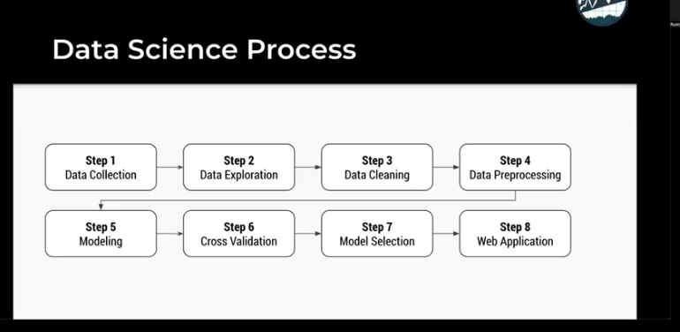
Data science process

Ask chat gpt for help in each step – not to ask him to do all from step 1 to step 8

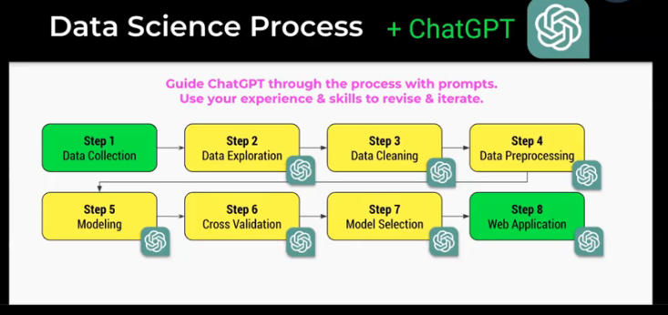

You have to know write code
Have domain problem kwnolage
have technical skills

ChatGPT – it’s is useful as an intern

Path

Foundational skills in R
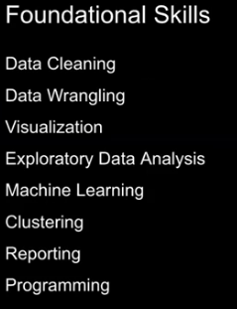
→ Data cleaning
→ Data wrangling
→ Visualization
→ Exploratory Data Analysis
→ Machine Learning
→ Clustering
→ Reporting
→ Programming

Business problem solving skills
→ correlation analysis
→ how to cost a problem
→ pre process the data
→ tell a story
→ automated machine learning
→ explainable AI/ML
→ sensitivity analysis
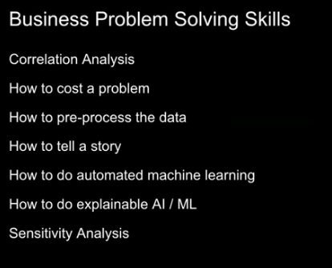

Time series forecasting
Nich
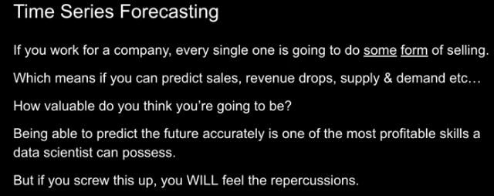

Build tools for yourself
repoducable/repeatable business analysis
get tools into production

Build tools for your company
Web application
automate entire business process

