Architecture Decisions

TODO
http://software-pattern.org/Book/30

Architecture Style

Microkernel or plugin architecture

https://medium.com/omarelgabrys-blog/plug-in-architecture-dec207291800

https://developer.apple.com/library/archive/documentation/Cocoa/Conceptual/LoadingCode/Concepts/Plugins.html

https://www.c-sharpcorner.com/article/an-overview-of-microkernel-architecture-pattern/

https://www.viralpatel.net/microkernel-architecture-pattern-apply-software-systems/

https://zahere.com/microkernel-architecture-how-it-works-and-what-it-offers

https://www.techtarget.com/searchapparchitecture/tip/What-is-a-microkernel-architecture-and-is-it-right-for-you

https://www.oreilly.com/library/view/software-architecture-patterns/9781491971437/ch03.html

https://priyalwalpita.medium.com/software-architecture-patterns-microkernel-architecture-97cee200264e

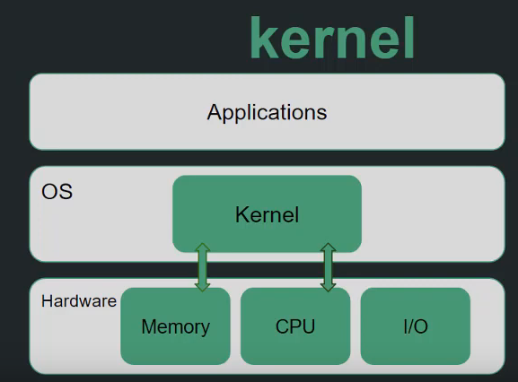
Kernel – has api for plugins
- micro – kernel (core is smaller)
- monolithic kernel (core systems bigger and less flexible)

Micro kernel pattern
- add custom service and functionality without affecting the core system
- avoid fail of the system when custom service fails
- socket for plugging extensions and coorfination of their collaboration

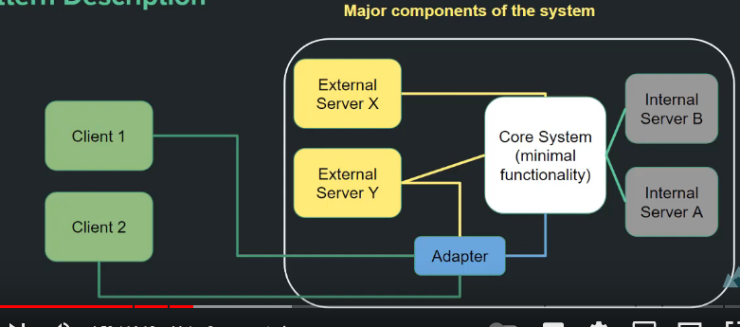

Core System
- minimal functions for application to run (monolithic mini – application; may be layered)
- provide plug-in mechanisam for extensions (management and coordination)

Internal Servers
- used for additional functionality
- core + internal servers can be used as app

External Servers
- interface of the BE system
- abstraction over the core
- used to create different versions of the systems (configuration ?)

Client
- communicate through an adapter to external service or directrly

My Idea 1.

- Minimal kernel: The minimal kernel provides the basic services required by the HTTP client, such as networking and inter-process communication.
- External components: The external components provide additional functionality required by the HTTP client, such as parsing HTTP responses and handling redirects.
Here's how the components might be implemented:
Minimal kernel:
- Provides a network interface API for the HTTP client to use, which includes functions such as net_open(), net_send(), net_receive(), and net_close().
- Provides an IPC mechanism for the HTTP client to communicate with external components, such as message passing or remote procedure calls.
External components:
- Provides a parser component that parses the HTTP response and extracts relevant information such as headers and response body.
- Provides a redirect handler component that handles redirects and updates the request accordingly.

Stack overflow idea

This is not an answer as much as a bunch of potentially useful remarks/examples.
- One effective way to make your application extensible is to expose its internals as a scripting language and write all the top level stuff in that language. This makes it quite modifiable and practically future proof (if your primitives are well chosen and implemented). A success story of this kind of thing is Emacs. I prefer this to the eclipse style plugin system because if I want to extend functionality, I don't have to learn the API and write/compile a separate plugin. I can write a 3 line snippet in the current buffer itself, evaluate it and use it. Very smooth learning curve and very pleasing results.
- One application which I've extended a little is Trac. It has a component architecture which in this situation means that tasks are delegated to modules that advertise extension points. You can then implement other components which would fit into these points and change the flow. It's a little like Kalkie's suggestion above.
- Another one that's good is py.test. It follows the "best API is no API" philosophy and relies purely on hooks being called at every level. You can override these hooks in files/functions named according to a convention and alter the behaviour. You can see the list of plugins on the site to see how quickly/easily they can be implemented.
A few general points.
- Try to keep your non-extensible/non-user-modifiable core as small as possible. Delegate everything you can to a higher layer so that the extensibility increases. Less stuff to correct in the core then in case of bad choices.
- Related to the above point is that you shouldn't make too many decisions about the direction of your project at the outset. Implement the smallest needed subset and then start writing plugins.
- If you are embedding a scripting language, make sure it's a full one in which you can write general programs and not a toy language just for your application.
- Reduce boilerplate as much as you can. Don't bother with subclassing, complex APIs, plugin registration and stuff like that. Try to keep it simple so that it's easy and not just possible to extend. This will let your plugin API be used more and will encourage end users to write plugins. Not just plugin developers. py.test does this well. Eclipse as far as I know, does not.

In my experience I've found there are really two types of plug-in Architectures.
- One follows the Eclipse model which is meant to allow for freedom and is open-ended.
- The other usually requires plugins to follow a narrow API because the plugin will fill a specific function.
To state this in a different way, one allows plugins to access your application while the other allows your application to access plugins.
---

I'll describe a fairly simple technique that I have use in the past. This approach uses C# reflection to help in the plugin loading process. This technique can be modified so it is applicable to C++ but you lose the convenience of being able to use reflection.
An IPlugin interface is used to identify classes that implement plugins. Methods are added to the interface to allow the application to communicate with the plugin. For example the Init method that the application will use to instruct the plugin to initialize.
To find plugins the application scans a plugin folder for .Net assemblies. Each assembly is loaded. Reflection is used to scan for classes that implement IPlugin. An instance of each plugin class is created.
(Alternatively, an Xml file might list the assemblies and classes to load. This might help performance but I never found an issue with performance).
The Init method is called for each plugin object. It is passed a reference to an object that implements the application interface: IApplication (or something else named specific to your app, eg ITextEditorApplication).
IApplication contains methods that allows the plugin to communicate with the application. For instance if you are writing a text editor this interface would have an OpenDocuments property that allows plugins to enumerate the collection of currently open documents.
This plugin system can be extended to scripting languages, eg Lua, by creating a derived plugin class, eg LuaPlugin that forwards IPlugin functions and the application interface to a Lua script.
This technique allows you to iteratively implement your IPlugin, IApplication and other application-specific interfaces during development. When the application is complete and nicely refactored you can document your exposed interfaces and you should have a nice system for which users can write their own plugins.

---
In my experience, the two best ways to create a flexible plugin architecture are scripting languages and libraries. These two concepts are in my mind orthogonal; the two can be mixed in any proportion, rather like functional and object-oriented programming, but find their greatest strengths when balanced. A library is typically responsible for fulfilling a specific interface with dynamic functionality, whereas scripts tend to emphasise functionality with a dynamic interface.
I have found that an architecture based on scripts managing libraries seems to work the best. The scripting language allows high-level manipulation of lower-level libraries, and the libraries are thus freed from any specific interface, leaving all of the application-level interaction in the more flexible hands of the scripting system.
For this to work, the scripting system must have a fairly robust API, with hooks to the application data, logic, and GUI, as well as the base functionality of importing and executing code from libraries. Further, scripts are usually required to be safe in the sense that the application can gracefully recover from a poorly-written script. Using a scripting system as a layer of indirection means that the application can more easily detach itself in case of Something Bad™.
The means of packaging plugins depends largely on personal preference, but you can never go wrong with a compressed archive with a simple interface, say PluginName.ext in the root directory.
---
One of the best plug-in architectures that I have seen is implemented in Eclipse. Instead of having an application with a plug-in model, everything is a plug-in. The base application itself is the plug-in framework.
http://www.eclipse.org/articles/Article-Plug-in-architecture/plugin_architecture.html

----

Usualy I use MEF. The Managed Extensibility Framework (or MEF for short) simplifies the creation of extensible applications. MEF offers discovery and composition capabilities that you can leverage to load application extensions.

