UNIVERSITY OF CEBU (MAIN)
SOFTWARE TESTING | SEMI-FINAL REQUIREMENT

TEST REPORT
User Login System: Register, Login and Logout
Web application built with Python Flask, SQLite and W3.CSS
Prepared by | Mandawe, Ivan Jae D.
School | University of Cebu (Main)
Subject / Activity | Software Testing, Semi-Final
Date of report | November 9, 2026
Application tested | UserLogin v1.0 (first build), then v1.1 (after defect fixes)
Test types covered | Smoke, Functional, Non-functional, Sanity, Regression, Confirmation (Re-testing) and Exploratory testing
Overall outcome | v1.0: 30 of 37 test cases passed, 7 defects found. v1.1: 37 of 37 test cases passed.

1. Introduction
This report documents the testing of a simple web application that lets a person register an account, log in and log out. The activity requires the application to be tested with functional, non-functional, smoke, sanity, regression, confirmation (re-testing) and exploratory testing, with the procedures, expected results, actual results and findings written down together with screenshots.

1.1 The application under test
The application follows the structure shown in the class tutorial video (Flask + SQLite + W3.CSS) and adds the registration page that the tutorial does not include. Its pages are:
- Login page ( / ): e-mail and password form, with a link to the register page.
- Register page ( /register ): full name, e-mail, password and confirm password.
- Main page ( /main ): protected page that shows the students table and a LOG-OUT button. It is reachable only while logged in.
- Logout ( /logout ): clears the session and returns to the login page.
The footer of every page reads: Copyright © Mandawe, Ivan Jae D. 2026.

1.2 Test environment
Item | Details
Application | UserLogin (Python 3.12.3, Flask 3.1.3, Werkzeug 3.1.9, SQLite database school.db)
Browser used for testing | Chromium 153 driven automatically by Playwright 1.63 (desktop viewport 900 x 520; mobile test at 375 x 667)
Operating system | Ubuntu 24.04 LTS
Server | Flask development server on http://127.0.0.1:5057 (localhost)
Test data | Fresh database for every test run. Seed account alpha@uc.com / hello123; six sample students (IDNO 1000 to 1005).
How tests were run | Each test case was executed by a script (tests/run_tests.py) that performs the steps in a real browser, records the actual result and saves a screenshot.

2. Test approach
The testing was done in two rounds. Round 1 tested the first build (v1.0) with every test case. The defects found were fixed in v1.1, and Round 2 then checked the fixes with sanity, confirmation and regression testing.
Test type | What it checks | Where it was applied
Smoke testing | A quick check that the application starts and its most important functions work, before any deeper testing. | SM-01 to SM-05, run first in Round 1.
Functional testing | Each feature (register, login, logout, protected page) behaves as specified, including invalid input. | FT-01 to FT-12 in Round 1 and in the regression run.
Non-functional testing | Quality attributes: performance, security, usability on mobile, reliability. | NF-01 to NF-08 in Round 1 and in the regression run.
Exploratory testing | Unscripted, curiosity-driven testing with unusual inputs and navigation to find problems that scripted cases miss. | EX-01 to EX-12. This is where all 7 failing cases were found.
Sanity testing | A short, narrow check after a fix to confirm the changed build is reasonable before doing a full retest. | 6 cases on v1.1 right after the fixes (section 6).
Confirmation (re-testing) | Re-running the exact test cases that failed, to confirm the defects are really fixed. | EX-01 to EX-07 re-run on v1.1 (section 7).
Regression testing | Re-running the whole suite on the new build to make sure the fixes did not break anything that worked before. | All 37 cases re-run on v1.1 (section 8).

Test cycle: Round 1 on v1.0 (smoke, functional, non-functional, exploratory) → defect log → fixes in v1.1 → sanity → confirmation → regression.

3. Summary of results
Test type | Cases | v1.0 passed | v1.0 failed | v1.1 passed | v1.1 failed
Smoke | 5 | 5 | 0 | 5 | 0
Functional | 12 | 12 | 0 | 12 | 0
Non-functional | 8 | 8 | 0 | 8 | 0
Exploratory | 12 | 5 | 7 | 12 | 0
TOTAL | 37 | 30 | 7 | 37 | 0

Findings in one paragraph. The main features (register, login, logout, access control) and the security and performance checks passed on the first build. Exploratory testing found 7 failing cases, which trace back to 6 defects, all in how the registration and login forms handle unusual input and in what a logged-in user sees. All six were fixed in v1.1; the 7 failed cases now pass and the full suite passes with no regressions.

4. Round 1: test cases and results (v1.0)
Every test case below was executed on the first build (v1.0). Each card shows the procedure, the expected result, the actual result that was observed and a screenshot taken during the test.

4.1 Smoke testing
Run first. If these fail there is no point continuing with deeper tests.
SM-01 Application starts and home page loads | RESULT: PASS
Procedure  Open http://127.0.0.1:5057/ in the browser.  Expected result  HTTP 200, page title 'USER LOGIN', login form (e-mail, password, LOGIN) visible.  Actual result  HTTP 200; title 'USER LOGIN'; header shows 'USER LOGIN v1.0'; login form visible: True. | 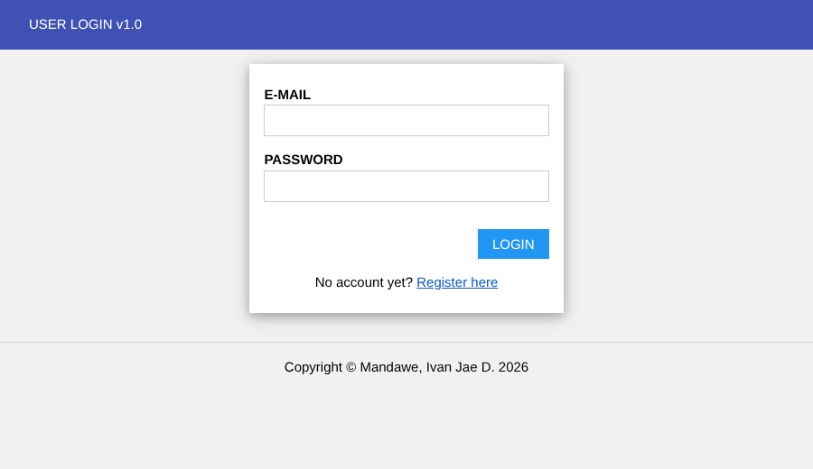

SM-02 Register page is reachable from the login page | RESULT: PASS
Procedure  On the login page click the 'Register here' link.  Expected result  Browser goes to /register and the CREATE ACCOUNT form is displayed.  Actual result  URL is http://127.0.0.1:5057/register; register form visible: True. | 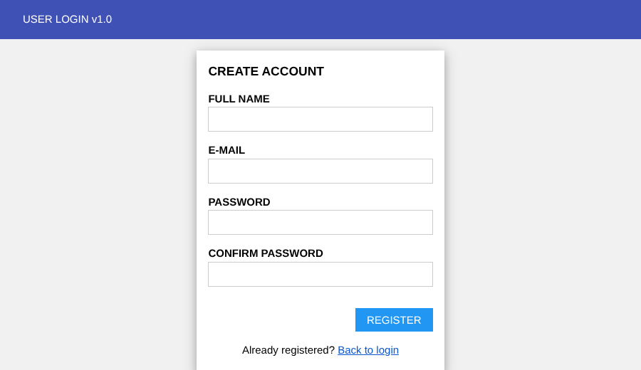

SM-03 Stylesheet loads | RESULT: PASS
Procedure
Request /static/css/w3.css.
Expected result
HTTP 200 and CSS content returned.
Actual result
HTTP 200; stylesheet contains the w3-* classes: True.

SM-04 Critical path: seeded user can log in | RESULT: PASS
Procedure  Enter alpha@uc.com / hello123 on the login page and press LOGIN.  Expected result  User is taken to /main and the students table is shown.  Actual result  Landed on http://127.0.0.1:5057/main; students table visible: True. | 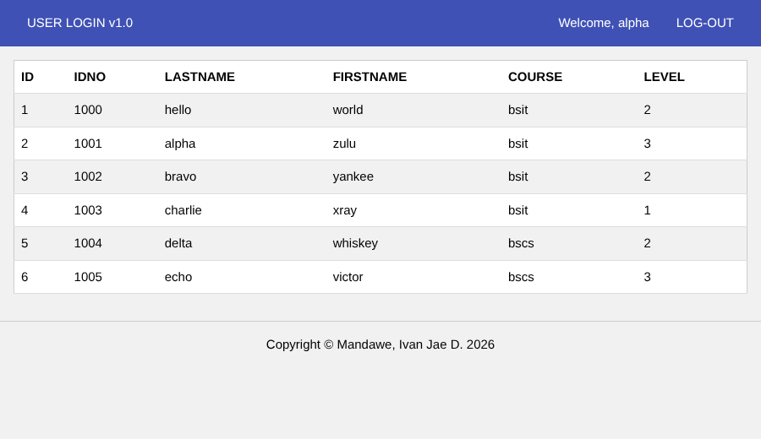

SM-05 Footer shows the correct copyright name | RESULT: PASS
Procedure
Open the login page and read the footer.
Expected result
Footer reads 'Copyright © Mandawe, Ivan Jae D. 2026'.
Actual result
Footer text: 'Copyright © Mandawe, Ivan Jae D. 2026'.

4.2 Functional testing
Checks each feature against its expected behaviour, including wrong and missing input.
FT-01 Register with valid details | RESULT: PASS
Procedure  Open /register; enter Name 'Juan Dela Cruz', E-mail juan@uc.com, Password Passw0rd! (twice); press REGISTER.  Expected result  Redirected to login page with a green 'Registration successful' message; one new row saved in the users table.  Actual result  Now on http://127.0.0.1:5057/; message: 'Registration successful. You can now log in.'; rows in users for juan@uc.com: 1. | 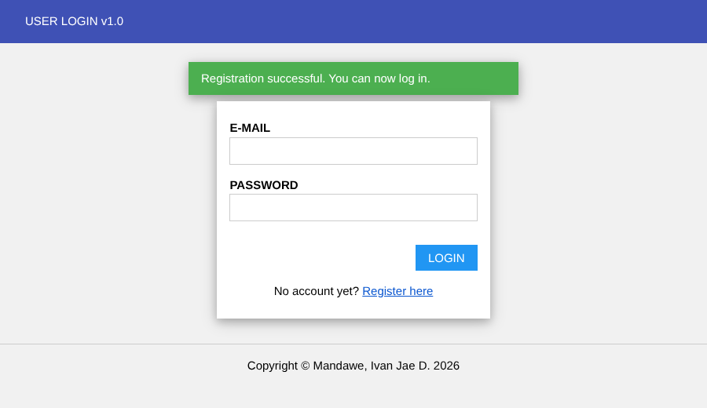

FT-02 Login with a newly registered account | RESULT: PASS
Procedure  Register ana@uc.com, then log in with ana@uc.com / Passw0rd!.  Expected result  Redirected to /main; header shows 'Welcome, Ana Reyes'.  Actual result  URL http://127.0.0.1:5057/main; header text: 'Welcome, Ana Reyes'. | 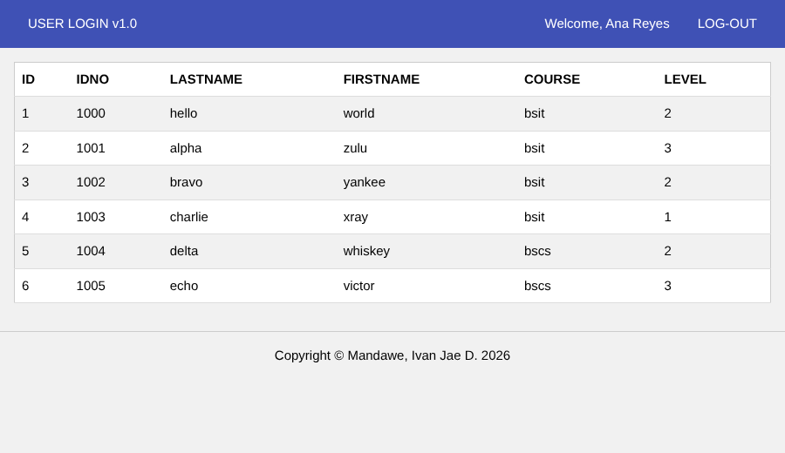

FT-03 Login with a wrong password | RESULT: PASS
Procedure  Enter alpha@uc.com with password 'wrongpass' and press LOGIN.  Expected result  Login refused; red 'Invalid e-mail or password.' message; /main stays inaccessible.  Actual result  Message: 'Invalid e-mail or password.'; /main redirected to login: True. | 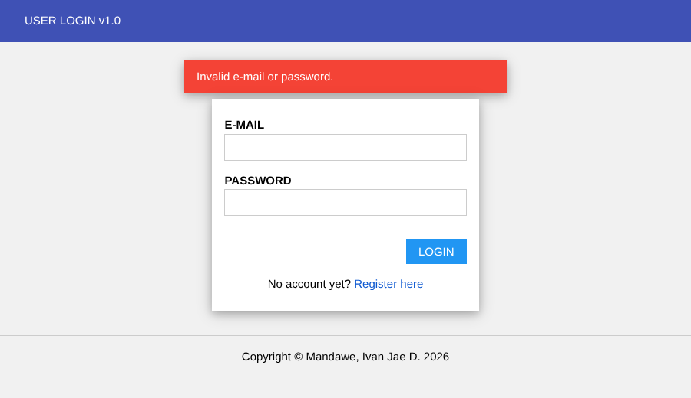

FT-04 Login with an unregistered e-mail | RESULT: PASS
Procedure
Enter nobody@uc.com / Passw0rd! and press LOGIN.
Expected result
Login refused with the same generic 'Invalid e-mail or password.' message.
Actual result
Message: 'Invalid e-mail or password.'; URL http://127.0.0.1:5057/.

FT-05 Register with an e-mail that already exists | RESULT: PASS
Procedure  Register beto@uc.com once, then register beto@uc.com again with another name.  Expected result  Second attempt refused with 'That e-mail is already registered.'; only one row exists.  Actual result  Message: 'That e-mail is already registered.'; rows with that e-mail: 1. | 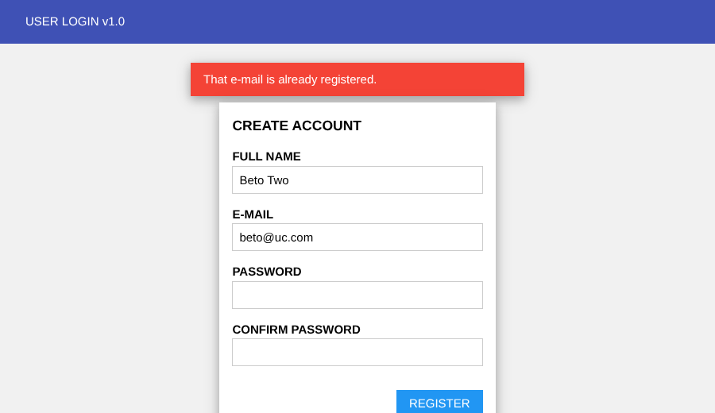

FT-06 Register with mismatched passwords | RESULT: PASS
Procedure  Register carla@uc.com with Password 'Passw0rd!' and Confirm 'Different1!'.  Expected result  Refused with 'Passwords do not match.'; no row saved; entered name/e-mail are kept in the form.  Actual result  Message: 'Passwords do not match.'; rows saved: 0; e-mail field kept: True. | 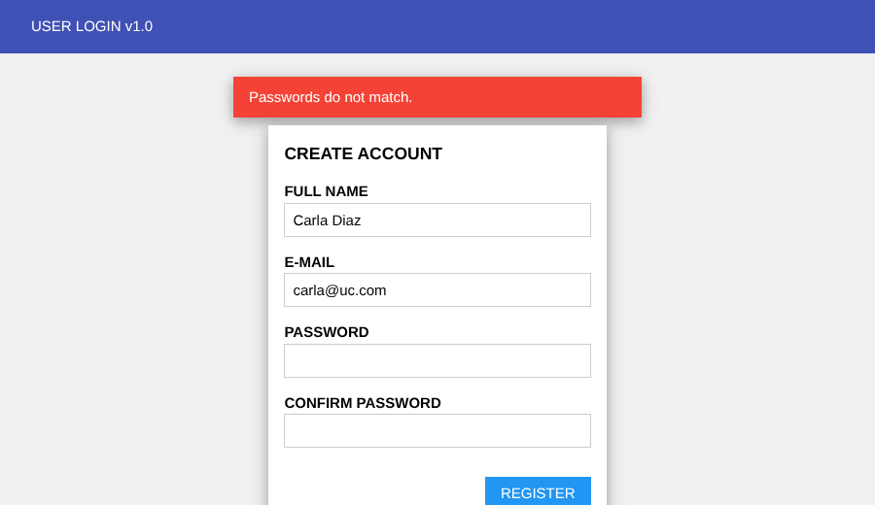

FT-07 Required field validation (server side) | RESULT: PASS
Procedure  Send a registration request with an empty Name field (bypassing the browser's 'required' check).  Expected result  Refused with 'All fields are required.'; no row saved.  Actual result  Response contains the required-fields message: True; rows saved: 0. | 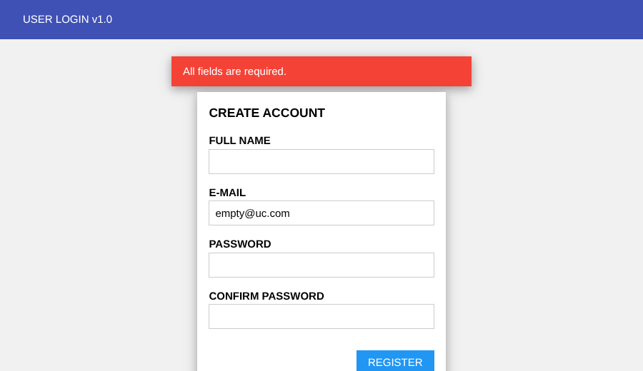

FT-08 Logout | RESULT: PASS
Procedure  Log in as alpha@uc.com, then click LOG-OUT.  Expected result  Redirected to the login page with 'You have been logged out.'; /main is no longer accessible.  Actual result  After logout URL http://127.0.0.1:5057/; message 'You have been logged out.'; /main now redirects to login: True. | 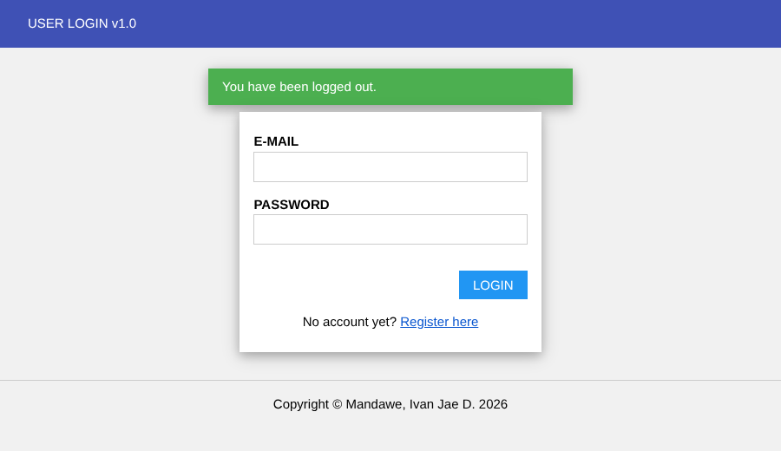

FT-09 Protected page without logging in | RESULT: PASS
Procedure  In a new browser session open /main directly.  Expected result  Redirected to login page with 'Please log in first.'  Actual result  URL http://127.0.0.1:5057/; message 'Please log in first.'. | 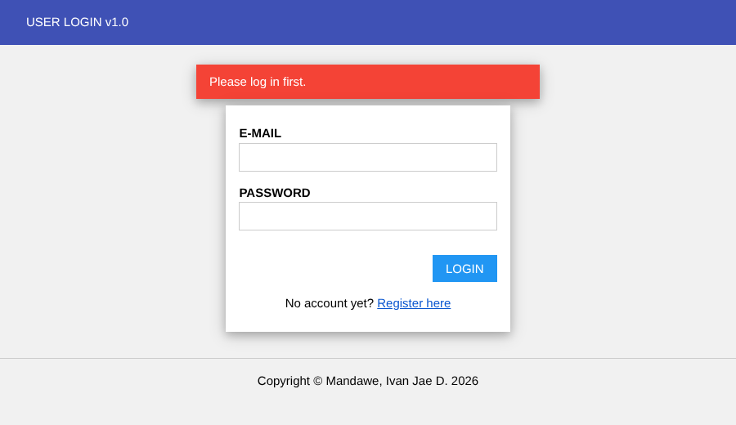

FT-10 Main page lists all students | RESULT: PASS
Procedure
Log in as alpha@uc.com and view /main.
Expected result
Table shows a header row plus 6 student rows (IDNO 1000-1005).
Actual result
Table rows counted (including header): 7.

FT-11 Session persists after page refresh | RESULT: PASS
Procedure
Log in, then press the browser refresh button on /main.
Expected result
User remains logged in and the table is still shown.
Actual result
After reload URL http://127.0.0.1:5057/main; table visible: True.

FT-12 'Back to login' link on the register page | RESULT: PASS
Procedure
Open /register and click 'Back to login'.
Expected result
Login page is displayed.
Actual result
URL http://127.0.0.1:5057/; login form visible: True.

4.3 Non-functional testing
Checks response time, password storage, injection attacks, cookies, mobile layout and reliability.
NF-01 Performance: page response time | RESULT: PASS
Procedure  Request /, /register and /main five times each and measure the average response time.  Expected result  Average response time under 1000 ms for every page.  Actual result  /: avg 4 ms; /register: avg 3 ms; /main: avg 3 ms. | 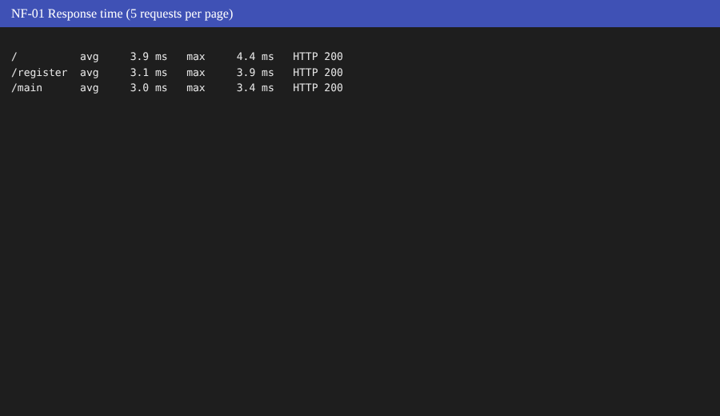

NF-02 Security: passwords are stored hashed | RESULT: PASS
Procedure  Register hash@uc.com with password 'Passw0rd!' and inspect the saved row in the database.  Expected result  The stored value is a salted hash, never the plain-text password.  Actual result  Stored value starts with 'scrypt:32768:8:1$PKV…' (162 characters); plain text not present. | 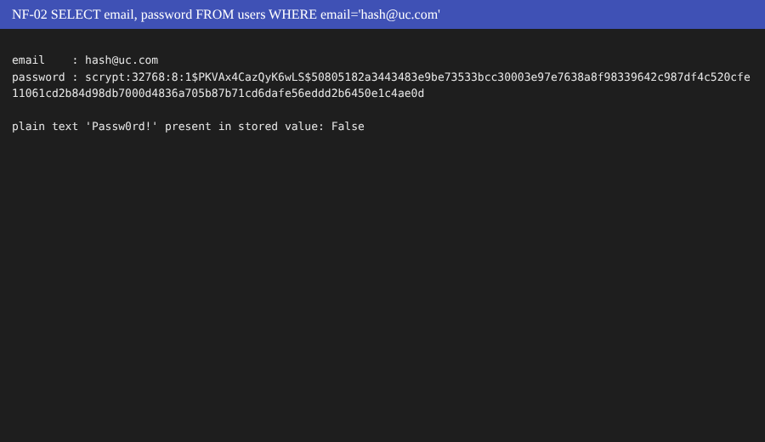

NF-03 Security: SQL injection on login | RESULT: PASS
Procedure
Send a login request with e-mail ' OR '1'='1 and any password.
Expected result
Login refused; no session created.
Actual result
Response contained 'Invalid e-mail or password.': True; /main reachable afterwards: False.

NF-04 Security: script injection (XSS) in the name field | RESULT: PASS
Procedure  Register with the name <script>document.title='HACKED'</script>, log in and view /main.  Expected result  The text is shown as plain text (escaped); no script runs; page title unchanged.  Actual result  Page title 'USER LOGIN'; header shows literal text: 'Welcome, <script>document.title='HACKED'</script>'. | 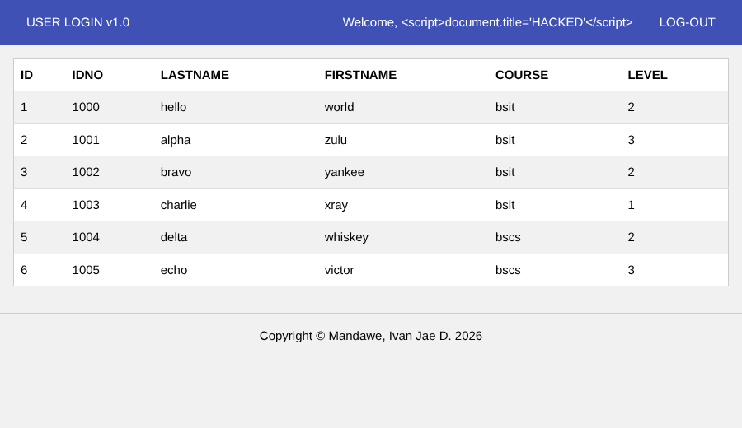

NF-05 Security: Back button after logout | RESULT: PASS
Procedure
Log in, open /main, click LOG-OUT, then press the browser Back button.
Expected result
Protected content is not shown again; user is sent back to the login page. /main is sent with no-store headers.
Actual result
Cache-Control on /main: 'no-cache, no-store, must-revalidate'; students table visible after Back: False; URL http://127.0.0.1:5057/.

NF-06 Security: session cookie flags | RESULT: PASS
Procedure  Log in and inspect the 'session' cookie.  Expected result  Cookie exists and is flagged HttpOnly (not readable by JavaScript).  Actual result  Session cookie present: True; HttpOnly: True. | 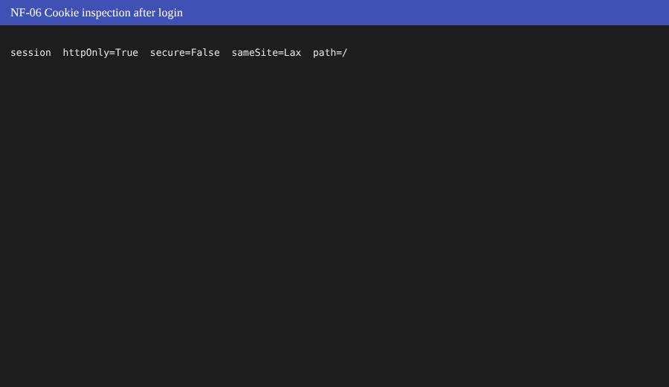

NF-07 Usability: mobile layout (375 px wide) | RESULT: PASS
Procedure  Resize the viewport to 375 x 667 and open the login and register pages.  Expected result  No horizontal scrolling; form fits inside the screen.  Actual result  /register: page width 375px, form right edge 359px; /: page width 375px, form right edge 359px (limit 375px). | 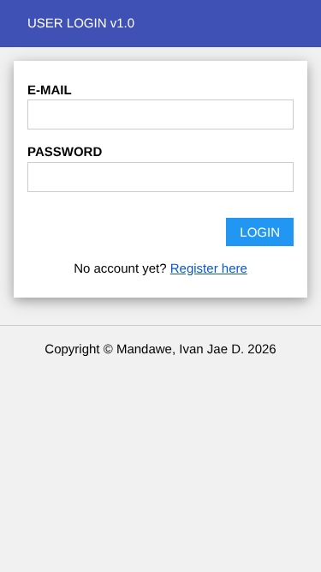

NF-08 Reliability: 25 consecutive logins | RESULT: PASS
Procedure  Send 25 valid login requests one after another.  Expected result  All requests succeed with no server error (HTTP 5xx).  Actual result  25 requests, statuses [200]; server errors: 0. | 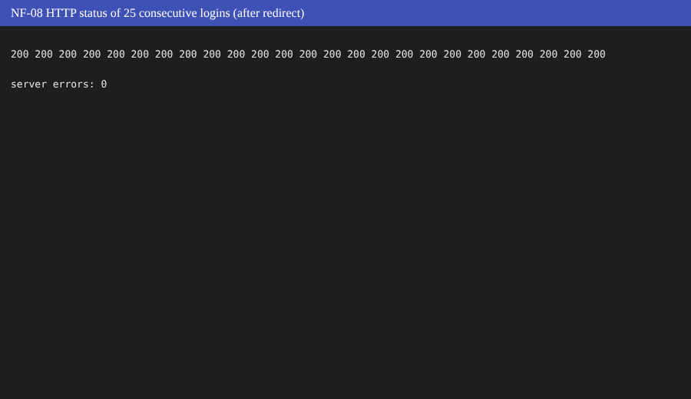

4.4 Exploratory testing
Unscripted probing with unusual input. Each session had a short goal (a charter) and the findings were written down as test cases. Results marked FAIL are defects, listed in section 5.
EX-01 Same e-mail typed with different letter case | RESULT: FAIL
Procedure
Register Case@Test.com, then try to register case@test.com.
Expected result
Second registration refused (e-mail addresses are not case-sensitive).
Actual result
Message: 'Registration successful. You can now log in.'; accounts now stored for this address: 2.

EX-02 Log in using different letter case than at registration | RESULT: FAIL
Procedure
Register Mixed@Case.com, then log in with mixed@case.com.
Expected result
Login succeeds.
Actual result
URL after login: http://127.0.0.1:5057/; message: 'Invalid e-mail or password.'.

EX-03 Name made only of spaces | RESULT: FAIL
Procedure
Register with Name ' ' (three spaces), valid e-mail and password.
Expected result
Registration refused (a name is required).
Actual result
Rows saved with a blank name: 1.

EX-04 Very short password | RESULT: FAIL
Procedure
Register with the one-character password 'a' (and confirmation 'a').
Expected result
Registration refused with a message about minimum password length.
Actual result
Message: 'Registration successful. You can now log in.'; rows saved with a 1-character password: 1.

EX-05 E-mail typed with extra spaces | RESULT: FAIL
Procedure  Send a registration with e-mail ' space@test.com ' (spaces before and after).  Expected result  Spaces are removed before saving (stored e-mail is 'space@test.com').  Actual result  Stored e-mail value: ' space@test.com '. | 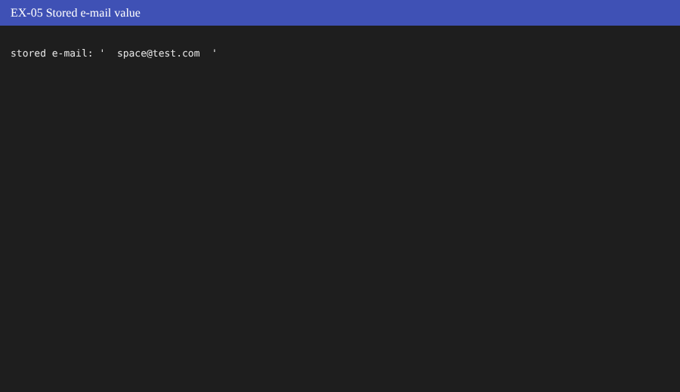

EX-06 Logged-in user opens the login/register pages | RESULT: FAIL
Procedure
Log in, then type / (and /register) in the address bar.
Expected result
User is sent straight to /main instead of seeing the login form again.
Actual result
Opening '/' ended at http://127.0.0.1:5057/; opening '/register' ended at http://127.0.0.1:5057/register.

EX-07 Extremely long name (200 characters) | RESULT: FAIL
Procedure
Register with a 200-character name.
Expected result
Refused with a message (database column allows 50 characters).
Actual result
Message: 'Registration successful. You can now log in.'; rows saved: 1; longest stored name length: 200.

EX-08 Open /userlogin directly in the address bar | RESULT: PASS
Procedure  Type /userlogin (a POST-only route) in the address bar.  Expected result  Server handles it without crashing (405 Method Not Allowed is acceptable).  Actual result  HTTP 405 (no server crash). | 

EX-09 Open a page that does not exist | RESULT: PASS
Procedure  Open /abc123.  Expected result  HTTP 404 page, application keeps running.  Actual result  HTTP 404. | 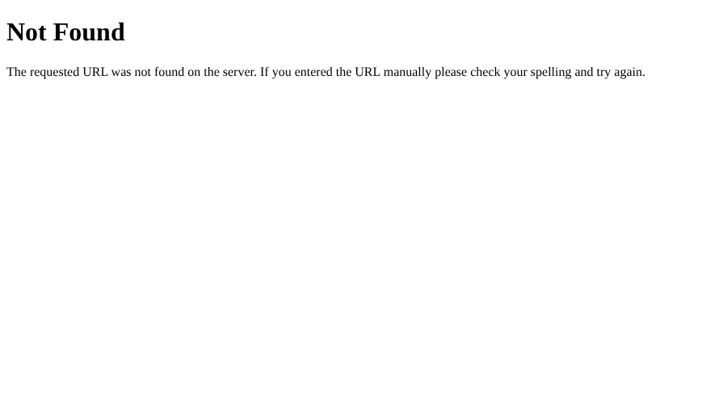

EX-10 Open /logout without being logged in | RESULT: PASS
Procedure
In a new session open /logout.
Expected result
No error; user lands on the login page.
Actual result
HTTP 200; login form visible: True.

EX-11 Name with accents and emoji | RESULT: PASS
Procedure  Register the name 'José Núñez 😀', log in and look at the welcome text.  Expected result  Name is saved and displayed correctly.  Actual result  Header text: 'Welcome, José Núñez 😀'. | 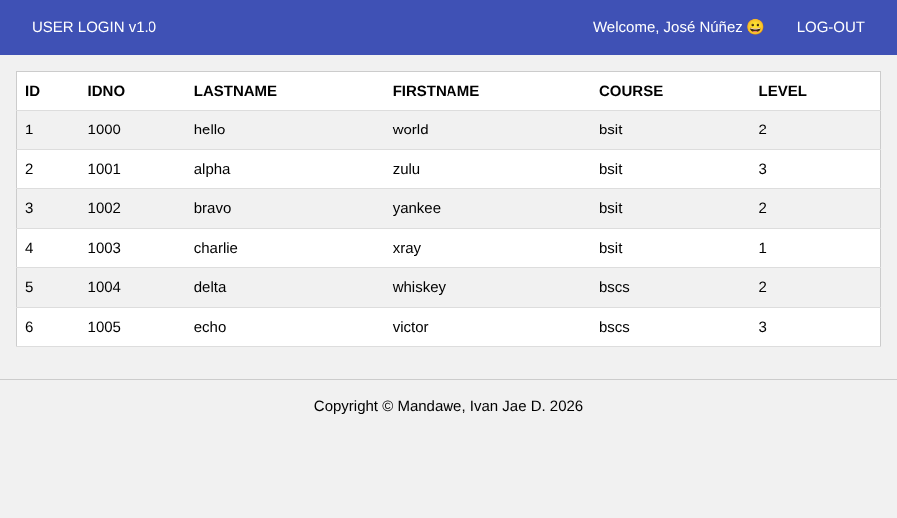

EX-12 Double submit of the register form | RESULT: PASS
Procedure  Send the same registration twice at the same moment.  Expected result  Only one account is created; no server error.  Actual result  Accounts created: 1; HTTP 200 and 200. | 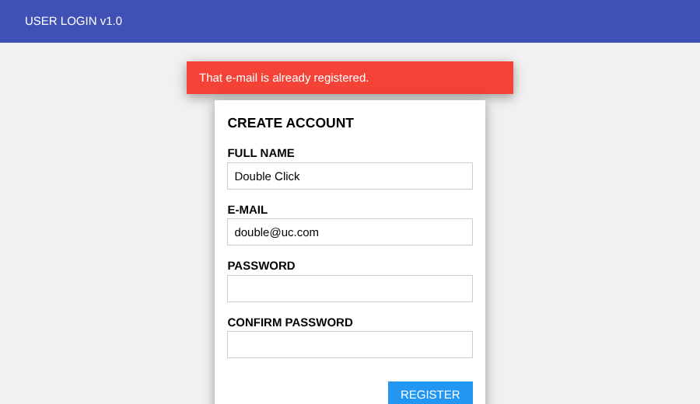

5. Defect log
Severity is the tester’s own assessment: High = could let bad data or weak accounts into the system, Medium = wrong behaviour that users would notice, Low = minor or cosmetic.
ID | Found by | Description | Severity | Fix in v1.1 | Retest
DEF-01 | EX-01, EX-02 | E-mail addresses were case-sensitive. Case@Test.com and case@test.com could both be registered, and a user who registered with capital letters could not log in by typing the e-mail in lower case. | Medium | E-mail is trimmed and converted to lower case before saving and before login (clean_email function). | PASS
DEF-02 | EX-03 | A name made only of spaces was accepted. | Low | Name is trimmed first, so a blank name is caught by the required-field check. | PASS
DEF-03 | EX-04 | A one-character password (“a”) was accepted. There was no minimum length. | High | Passwords shorter than 8 characters are refused with a clear message. | PASS
DEF-04 | EX-05 | Spaces before or after the e-mail were saved as part of the address. | Low | Fixed by the same clean_email function as DEF-01. | PASS
DEF-05 | EX-06 | A logged-in user who opened / or /register saw the login or register form again. | Low | Both routes now redirect a logged-in user to /main. | PASS
DEF-06 | EX-07 | A 200-character name was saved although the database column is meant for 50 characters (SQLite does not enforce the limit). | Low | Name and e-mail longer than 50 characters are refused with a message. | PASS

6. Round 2: sanity testing (v1.1)
Right after the fixes, six quick cases were run on v1.1 to check that the build was sound before the longer retest: the start-up check, the critical login path, registering, logging in with a new account, logging out, and one of the fixed cases.
ID | Test case | Result | Actual result
SM-01 | Application starts and home page loads | PASS | HTTP 200; title 'USER LOGIN'; header shows 'USER LOGIN v1.1'; login form visible: True.
SM-04 | Critical path: seeded user can log in | PASS | Landed on http://127.0.0.1:5057/main; students table visible: True.
FT-01 | Register with valid details | PASS | Now on http://127.0.0.1:5057/; message: 'Registration successful. You can now log in.'; rows in users for juan@uc.com: 1.
FT-02 | Login with a newly registered account | PASS | URL http://127.0.0.1:5057/main; header text: 'Welcome, Ana Reyes'.
FT-08 | Logout | PASS | After logout URL http://127.0.0.1:5057/; message 'You have been logged out.'; /main now redirects to login: True.
EX-02 | Log in using different letter case than at registration | PASS | URL after login: http://127.0.0.1:5057/main; message: ''.

7. Round 2: confirmation testing (re-testing)
The seven test cases that failed in Round 1 were run again, step for step, on v1.1. The screenshots show the same test before the fix (left) and after the fix (right).
EX-01 Same e-mail typed with different letter case (DEF-01)
BEFORE (v1.0): FAIL | AFTER (v1.1): PASS
 | 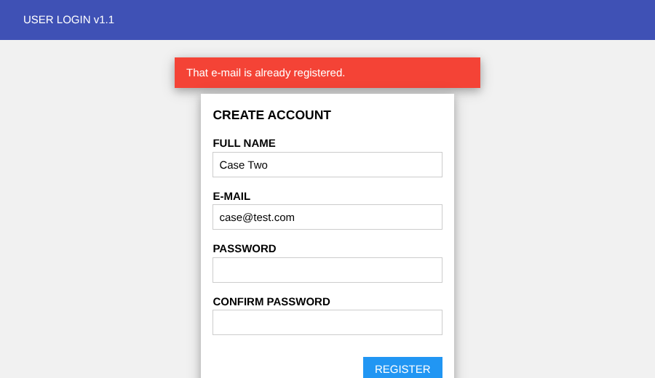
Expected: Second registration refused (e-mail addresses are not case-sensitive).  Actual: Message: 'Registration successful. You can now log in.'; accounts now stored for this address: 2. | Actual: Message: 'That e-mail is already registered.'; accounts now stored for this address: 1.

EX-02 Log in using different letter case than at registration (DEF-01)
BEFORE (v1.0): FAIL | AFTER (v1.1): PASS
 | 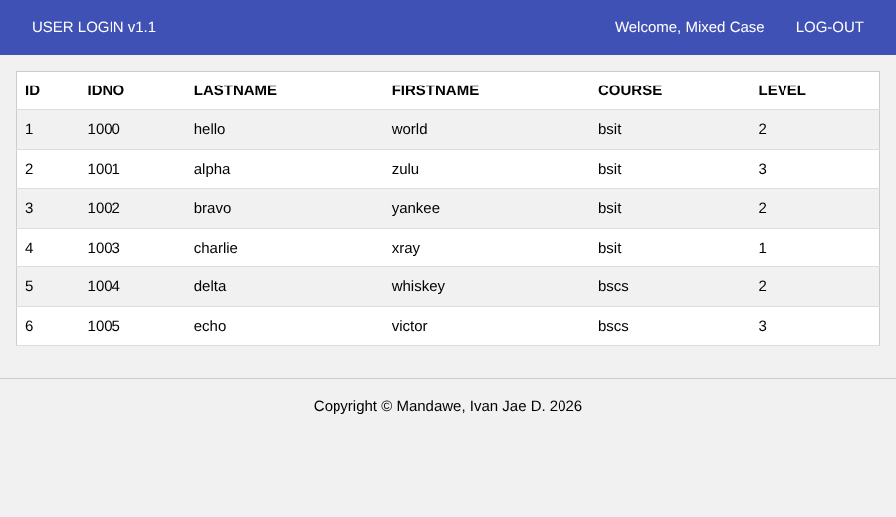
Expected: Login succeeds.  Actual: URL after login: http://127.0.0.1:5057/; message: 'Invalid e-mail or password.'. | Actual: URL after login: http://127.0.0.1:5057/main; message: ''.

EX-03 Name made only of spaces (DEF-02)
BEFORE (v1.0): FAIL | AFTER (v1.1): PASS
 | 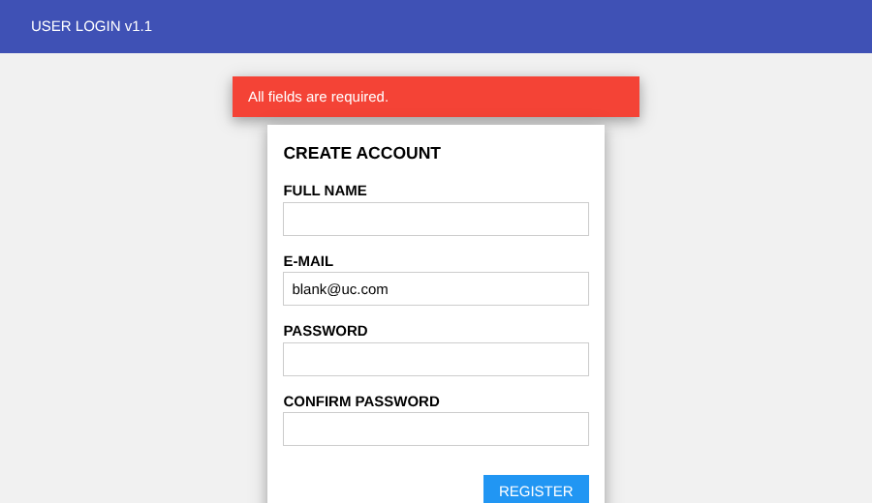
Expected: Registration refused (a name is required).  Actual: Rows saved with a blank name: 1. | Actual: Rows saved with a blank name: 0.

EX-04 Very short password (DEF-03)
BEFORE (v1.0): FAIL | AFTER (v1.1): PASS
 | 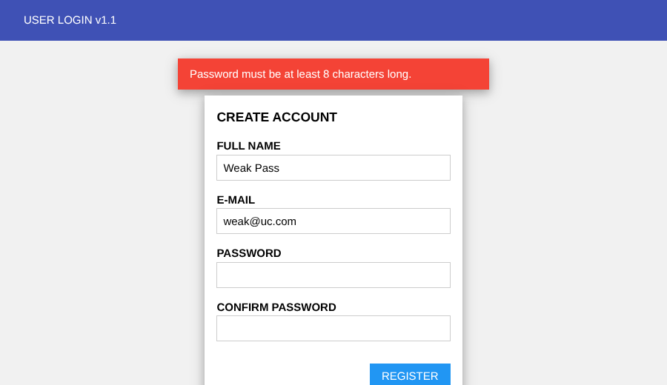
Expected: Registration refused with a message about minimum password length.  Actual: Message: 'Registration successful. You can now log in.'; rows saved with a 1-character password: 1. | Actual: Message: 'Password must be at least 8 characters long.'; rows saved with a 1-character password: 0.

EX-05 E-mail typed with extra spaces (DEF-04)
BEFORE (v1.0): FAIL | AFTER (v1.1): PASS
 | 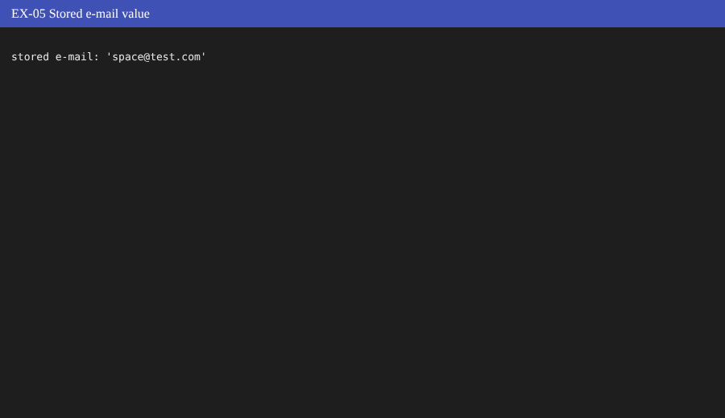
Expected: Spaces are removed before saving (stored e-mail is 'space@test.com').  Actual: Stored e-mail value: ' space@test.com '. | Actual: Stored e-mail value: 'space@test.com'.

EX-06 Logged-in user opens the login/register pages (DEF-05)
BEFORE (v1.0): FAIL | AFTER (v1.1): PASS
 | 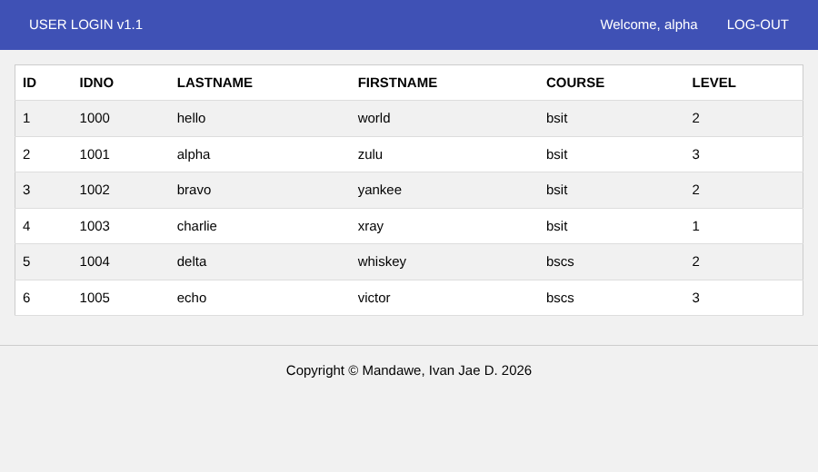
Expected: User is sent straight to /main instead of seeing the login form again.  Actual: Opening '/' ended at http://127.0.0.1:5057/; opening '/register' ended at http://127.0.0.1:5057/register. | Actual: Opening '/' ended at http://127.0.0.1:5057/main; opening '/register' ended at http://127.0.0.1:5057/main.

EX-07 Extremely long name (200 characters) (DEF-06)
BEFORE (v1.0): FAIL | AFTER (v1.1): PASS
 | 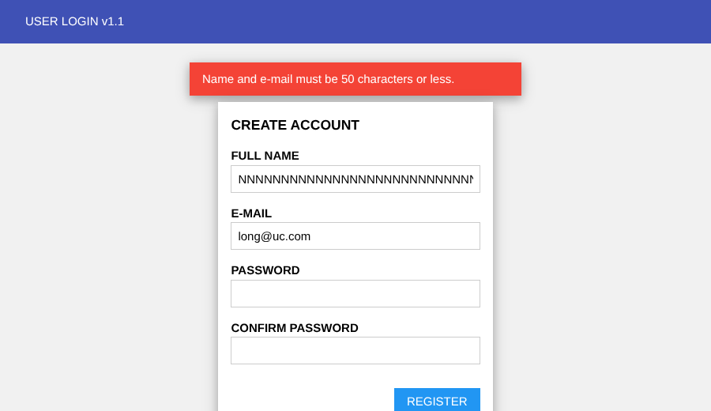
Expected: Refused with a message (database column allows 50 characters).  Actual: Message: 'Registration successful. You can now log in.'; rows saved: 1; longest stored name length: 200. | Actual: Message: 'Name and e-mail must be 50 characters or less.'; rows saved: 0; longest stored name length: None.

8. Round 2: regression testing (v1.1)
The complete suite of 37 test cases was run again on v1.1 to make sure the fixes did not break any feature that was working before. Screenshots for the regression run are saved in the SemiFinal folder (tests/results/regression-v1.1).
ID | Type | Test case | v1.0 (Round 1) | v1.1 (regression)
SM-01 | Smoke | Application starts and home page loads | PASS | PASS
SM-02 | Smoke | Register page is reachable from the login page | PASS | PASS
SM-03 | Smoke | Stylesheet loads | PASS | PASS
SM-04 | Smoke | Critical path: seeded user can log in | PASS | PASS
SM-05 | Smoke | Footer shows the correct copyright name | PASS | PASS
FT-01 | Functional | Register with valid details | PASS | PASS
FT-02 | Functional | Login with a newly registered account | PASS | PASS
FT-03 | Functional | Login with a wrong password | PASS | PASS
FT-04 | Functional | Login with an unregistered e-mail | PASS | PASS
FT-05 | Functional | Register with an e-mail that already exists | PASS | PASS
FT-06 | Functional | Register with mismatched passwords | PASS | PASS
FT-07 | Functional | Required field validation (server side) | PASS | PASS
FT-08 | Functional | Logout | PASS | PASS
FT-09 | Functional | Protected page without logging in | PASS | PASS
FT-10 | Functional | Main page lists all students | PASS | PASS
FT-11 | Functional | Session persists after page refresh | PASS | PASS
FT-12 | Functional | 'Back to login' link on the register page | PASS | PASS
NF-01 | Non-functional | Performance: page response time | PASS | PASS
NF-02 | Non-functional | Security: passwords are stored hashed | PASS | PASS
NF-03 | Non-functional | Security: SQL injection on login | PASS | PASS
NF-04 | Non-functional | Security: script injection (XSS) in the name field | PASS | PASS
NF-05 | Non-functional | Security: Back button after logout | PASS | PASS
NF-06 | Non-functional | Security: session cookie flags | PASS | PASS
NF-07 | Non-functional | Usability: mobile layout (375 px wide) | PASS | PASS
NF-08 | Non-functional | Reliability: 25 consecutive logins | PASS | PASS
EX-01 | Exploratory | Same e-mail typed with different letter case | FAIL | PASS
EX-02 | Exploratory | Log in using different letter case than at registration | FAIL | PASS
EX-03 | Exploratory | Name made only of spaces | FAIL | PASS
EX-04 | Exploratory | Very short password | FAIL | PASS
EX-05 | Exploratory | E-mail typed with extra spaces | FAIL | PASS
EX-06 | Exploratory | Logged-in user opens the login/register pages | FAIL | PASS
EX-07 | Exploratory | Extremely long name (200 characters) | FAIL | PASS
EX-08 | Exploratory | Open /userlogin directly in the address bar | PASS | PASS
EX-09 | Exploratory | Open a page that does not exist | PASS | PASS
EX-10 | Exploratory | Open /logout without being logged in | PASS | PASS
EX-11 | Exploratory | Name with accents and emoji | PASS | PASS
EX-12 | Exploratory | Double submit of the register form | PASS | PASS

Result: 37 of 37 test cases passed on v1.1. No regressions were found.

9. Exploratory testing notes
Exploratory testing was done with three short charters. The session notes below summarise what was tried and what was learned.
Charter | Cases | What was learned
Explore how the registration form handles unusual input | EX-01, EX-03, EX-04, EX-05, EX-07, EX-11, EX-12 | Five problems found (letter case, blank name, short password, extra spaces, over-long name). Accents/emoji (EX-11) and a double submit (EX-12) were handled correctly. The UNIQUE constraint on the e-mail column prevented duplicate rows on double submit.
Explore login behaviour with different e-mail forms | EX-02 | Logging in with a different letter case than the one used at registration failed. This led to DEF-01.
Explore navigation and error handling | EX-06, EX-08, EX-09, EX-10 | Wrong URLs return proper 404/405 pages and /logout without a session is harmless. A logged-in user could still see the login and register forms (DEF-05).

10. Conclusion
The user login system works as required. Registration, login, logout and the protected page behave correctly, passwords are stored as salted hashes, SQL injection and script injection attempts were blocked, the session cookie is HttpOnly, the Back button does not reveal protected content after logout, and pages respond in a few milliseconds on localhost.
The first build had six defects in input handling and navigation, found mainly through exploratory testing. They were fixed in v1.1 and confirmed by re-testing, and the regression run shows no side effects. The exploratory results also show why scripted tests alone are not enough: the 30 scripted cases that were written first all passed on v1.0, while the unusual-input sessions found the defects.

10.1 Limits of this testing and suggested improvements
- Only Chromium was used. Other browsers (Firefox, Safari, mobile browsers) were not tested.
- The tests ran against the Flask development server on localhost, so the response-time results are not a measure of real-world performance.
- The forms have no CSRF protection and the login has no limit on repeated wrong passwords. These were not tested and should be added before real use.
- The session secret key has a default value in app.py. For real use it should be set through the SECRET_KEY environment variable and the cookie should be marked Secure when HTTPS is used.
- There is no password reset or e-mail verification; both are outside the scope of this activity.

Appendix A. How to run the application
Open a terminal in the SemiFinal/userlogin folder and run:
python -m venv venv
venv\Scripts\activate (Windows)
python -m pip install flask
python app.py
Then open http://127.0.0.1:5000 in a browser. The database (db/school.db) and the sample data are created automatically the first time the app runs. Sample login: alpha@uc.com / hello123, or use the Register page to create a new account.

Appendix B. Contents of the SemiFinal folder
Path | Description
SemiFinal/Test_Report.pdf | This report (PDF).
SemiFinal/Test_Report.docx | This report (Word version).
SemiFinal/userlogin/app.py | Flask application: routes for login, register, main page and logout.
SemiFinal/userlogin/db/dbhelper.py | SQLite helper functions and automatic creation of the tables and sample data.
SemiFinal/userlogin/templates/ | base.html, index.html (login), register.html, main.html.
SemiFinal/userlogin/static/css/w3.css | Stylesheet (W3.CSS-compatible subset).
SemiFinal/tests/run_tests.py | Automated test script (Playwright) used to execute all test cases.
SemiFinal/tests/results/ | Screenshots and results.json for each run: round1-v1.0, sanity-v1.1, confirm-v1.1, regression-v1.1.

