**Міністерство Освіти І НАУКИ України**

**Національний університет "Львівська політехніка"**

Інститут **КНІТ**

Кафедра **ПЗ**

### ЗВІТ

До лабораторної роботи № 1

**З дисципліни:** *“Моделювання і аналіз програмного забезпечення”*

**На тему:** *“* *Шаблон інтерпретатор”*

**Лектор:**

к.т.н. доцент.

Сердюк П.В

**Виконав:**

ст. гр. ПЗ-22

Хамар Іван

**Прийняв:**

к.т.н. доцент

Білас О.Є.

« ____ » ________ 2020 р.

∑= _____ .

Львів – 2020

**Тема:** Шаблон інтерпретатор

**Мета:** Навчитися розробляти, створювати і використовувати   
мову програмування та її інтерпретатор.

**ЗАВДАННЯ**

Розробити імперативну мову, описати її синтаксис. Мова повинна підтримувати лінійне виконання та умовні оператори та цикли (щонайменше один вид циклів). Розробити інтерпретатор/транслятор для неї. Виводити синтаксичне дерево, що будує інтерпретатор з вхідного коду. Оптимізувати дерево.

Варіант 35.

Інтерпретатор формул, який би надавав можливість тримати у собі формули, та дозволяв різні операції з ними. Повинна бути можливість оголошувати змінні, використовувати функції, диференціювання, тощо.

**ХІД ВИКОНАННЯ**

На рис.1 зображено розроблений інтерпретатор, синтаксичне дерево, яке він будує та лінійне виконання команд в ньому.

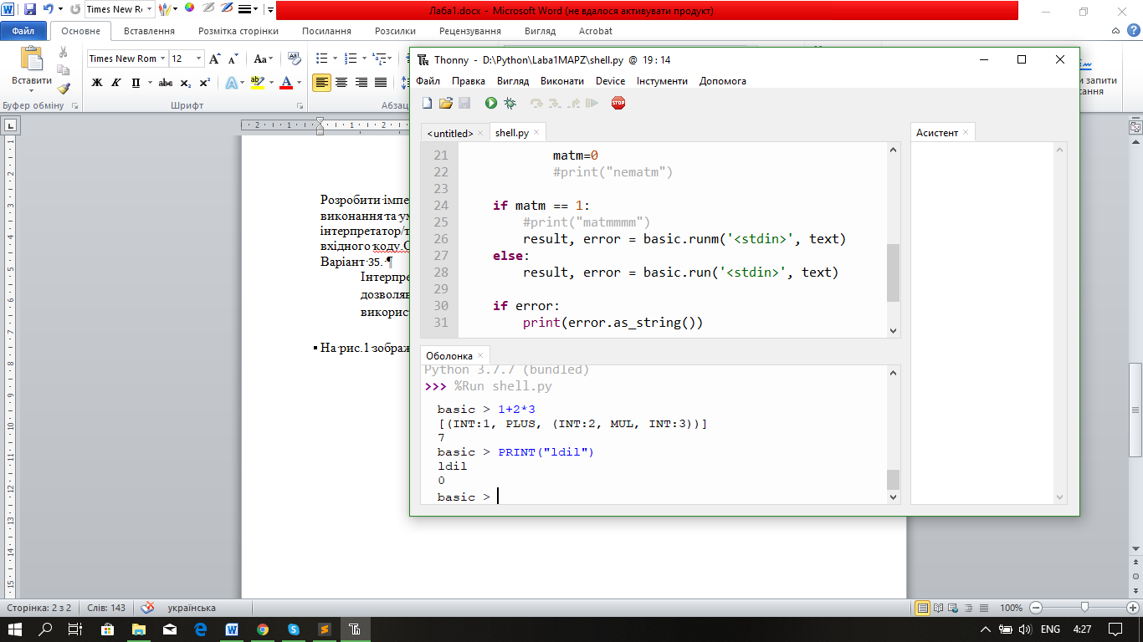

Рис. 1. Інтерпретатор

На рис.2 зображена підтримка змінних і умовного оператора IF THEN.

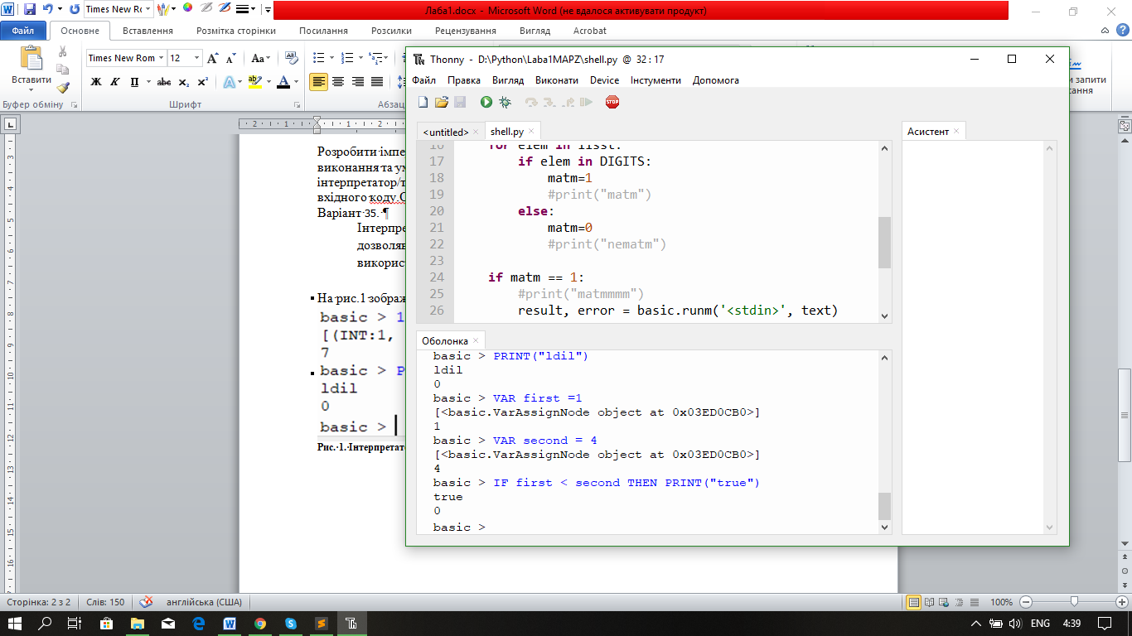

Рис. 2.Змінні і умовний оператор

На рис.3 зображена підтримка циклу FOR THEN.

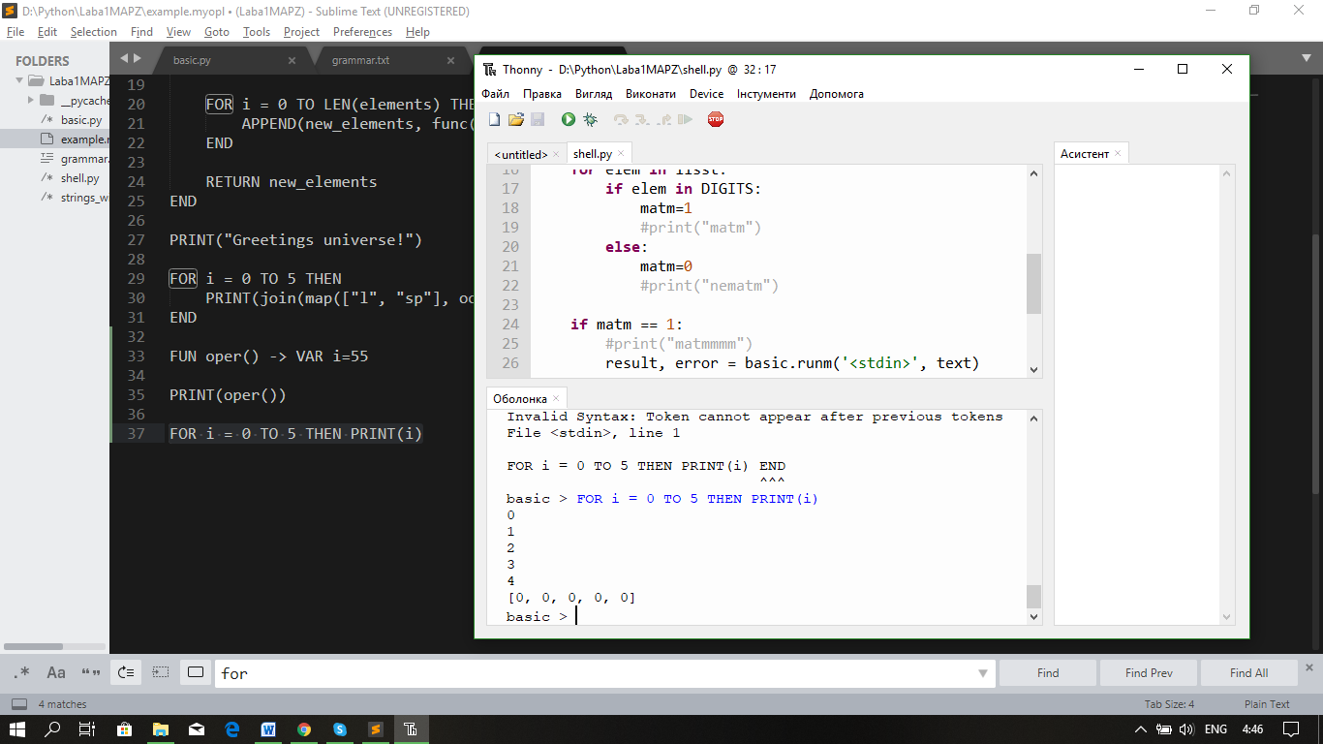

Рис. 3.Цикл FOR

На рис.4 зображена підтримка оголошення і використання функцій.

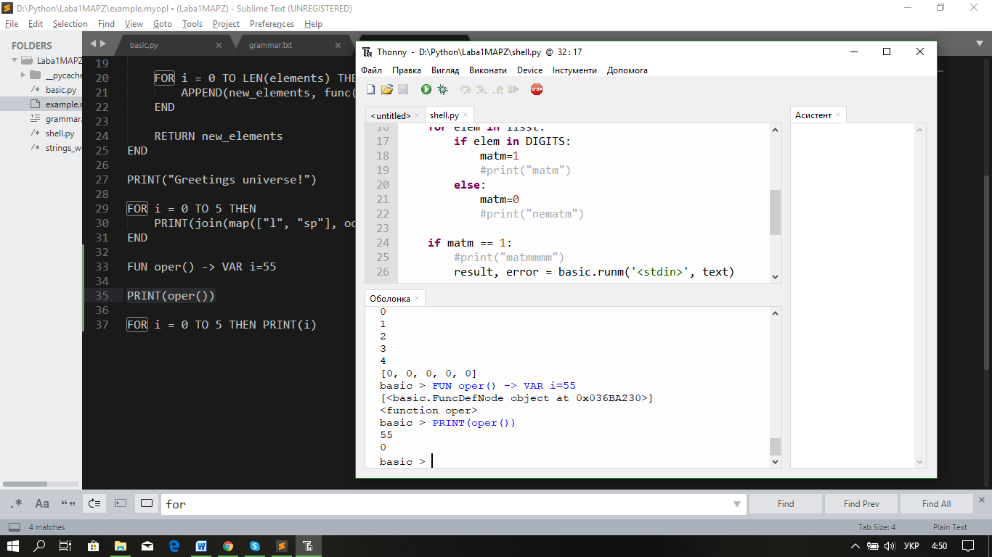

Рис. 4. Функція оголошення змінної

ВИСНОВОК

В результаті виконання цієї лабораторної роботи я навчився розробляти, створювати і використовувати мову програмування та її інтерпретатор

ДОДАТОК

**Shell.py:**

import basic

DIGITS = '0123456789+-*/^'

matm = 0

def split(word):

return [char for char in word]

while True:

text = input('basic > ')

if text.strip() == "": continue

lisst = split(text)

#print(lisst)

for elem in lisst:

if elem in DIGITS:

matm=1

#print("matm")

else:

matm=0

#print("nematm")

if matm == 1:

#print("matmmmm")

result, error = basic.runm('<stdin>', text)

else:

result, error = basic.run('<stdin>', text)

if error:

print(error.as_string())

elif result:

if len(result.elements) == 1:

print(repr(result.elements[0]))

else:

print(repr(result))

**Basic.py:**

#######################################

# IMPORTS

#######################################

from strings_with_arrows import *

import string

import os

import math

#######################################

# CONSTANTS

#######################################

DIGITS = '0123456789'

LETTERS = string.ascii_letters

LETTERS_DIGITS = LETTERS + DIGITS

#######################################

# ERRORS

#######################################

class Error:

def __init__(self, pos_start, pos_end, error_name, details):

self.pos_start = pos_start

self.pos_end = pos_end

self.error_name = error_name

self.details = details

def as_string(self):

result = f'{self.error_name}: {self.details}\n'

result += f'File {self.pos_start.fn}, line {self.pos_start.ln + 1}'

result += '\n\n' + string_with_arrows(self.pos_start.ftxt, self.pos_start, self.pos_end)

return result

class IllegalCharError(Error):

def __init__(self, pos_start, pos_end, details):

super().__init__(pos_start, pos_end, 'Illegal Character', details)

class ExpectedCharError(Error):

def __init__(self, pos_start, pos_end, details):

super().__init__(pos_start, pos_end, 'Expected Character', details)

class InvalidSyntaxError(Error):

def __init__(self, pos_start, pos_end, details=''):

super().__init__(pos_start, pos_end, 'Invalid Syntax', details)

class RTError(Error):

def __init__(self, pos_start, pos_end, details, context):

super().__init__(pos_start, pos_end, 'Runtime Error', details)

self.context = context

def as_string(self):

result = self.generate_traceback()

result += f'{self.error_name}: {self.details}'

result += '\n\n' + string_with_arrows(self.pos_start.ftxt, self.pos_start, self.pos_end)

return result

def generate_traceback(self):

result = ''

pos = self.pos_start

ctx = self.context

while ctx:

result = f' File {pos.fn}, line {str(pos.ln + 1)}, in {ctx.display_name}\n' + result

pos = ctx.parent_entry_pos

ctx = ctx.parent

return 'Traceback (most recent call last):\n' + result

#######################################

# POSITION

#######################################

class Position:

def __init__(self, idx, ln, col, fn, ftxt):

self.idx = idx

self.ln = ln

self.col = col

self.fn = fn

self.ftxt = ftxt

def advance(self, current_char=None):

self.idx += 1

self.col += 1

if current_char == '\n':

self.ln += 1

self.col = 0

return self

def copy(self):

return Position(self.idx, self.ln, self.col, self.fn, self.ftxt)

#######################################

# TOKENS

#######################################

TT_INT = 'INT'

TT_FLOAT = 'FLOAT'

TT_STRING = 'STRING'

TT_IDENTIFIER = 'IDENTIFIER'

TT_KEYWORD = 'KEYWORD'

TT_PLUS = 'PLUS'

TT_MINUS = 'MINUS'

TT_MUL = 'MUL'

TT_DIV = 'DIV'

TT_POW = 'POW'

TT_EQ = 'EQ'

TT_LPAREN = 'LPAREN'

TT_RPAREN = 'RPAREN'

TT_LSQUARE = 'LSQUARE'

TT_RSQUARE = 'RSQUARE'

TT_EE = 'EE'

TT_NE = 'NE'

TT_LT = 'LT'

TT_GT = 'GT'

TT_LTE = 'LTE'

TT_GTE = 'GTE'

TT_COMMA = 'COMMA'

TT_ARROW = 'ARROW'

TT_NEWLINE = 'NEWLINE'

TT_EOF = 'EOF'

KEYWORDS = [

'VAR',

'AND',

'OR',

'NOT',

'IF',

'ELIF',

'ELSE',

'FOR',

'TO',

'STEP',

'WHILE',

'FUN',

'THEN',

'END',

'RETURN',

'CONTINUE',

'BREAK',

]

class Token:

def __init__(self, type_, value=None, pos_start=None, pos_end=None):

self.type = type_

self.value = value

if pos_start:

self.pos_start = pos_start.copy()

self.pos_end = pos_start.copy()

self.pos_end.advance()

if pos_end:

self.pos_end = pos_end.copy()

def matches(self, type_, value):

return self.type == type_ and self.value == value

def __repr__(self):

if self.value: return f'{self.type}:{self.value}'

return f'{self.type}'

#######################################

# LEXER

#######################################

class Lexer:

def __init__(self, fn, text):

self.fn = fn

self.text = text

self.pos = Position(-1, 0, -1, fn, text)

self.current_char = None

self.advance()

def advance(self):

self.pos.advance(self.current_char)

self.current_char = self.text[self.pos.idx] if self.pos.idx < len(self.text) else None

def make_tokens(self):

tokens = []

while self.current_char != None:

if self.current_char in ' \t':

self.advance()

elif self.current_char == '#':

self.skip_comment()

elif self.current_char in ';\n':

tokens.append(Token(TT_NEWLINE, pos_start=self.pos))

self.advance()

elif self.current_char in DIGITS:

tokens.append(self.make_number())

elif self.current_char in LETTERS:

tokens.append(self.make_identifier())

elif self.current_char == '"':

tokens.append(self.make_string())

elif self.current_char == '+':

tokens.append(Token(TT_PLUS, pos_start=self.pos))

self.advance()

elif self.current_char == '-':

tokens.append(self.make_minus_or_arrow())

elif self.current_char == '*':

tokens.append(Token(TT_MUL, pos_start=self.pos))

self.advance()

elif self.current_char == '/':

tokens.append(Token(TT_DIV, pos_start=self.pos))

self.advance()

elif self.current_char == '^':

tokens.append(Token(TT_POW, pos_start=self.pos))

self.advance()

elif self.current_char == '(':

tokens.append(Token(TT_LPAREN, pos_start=self.pos))

self.advance()

elif self.current_char == ')':

tokens.append(Token(TT_RPAREN, pos_start=self.pos))

self.advance()

elif self.current_char == '[':

tokens.append(Token(TT_LSQUARE, pos_start=self.pos))

self.advance()

elif self.current_char == ']':

tokens.append(Token(TT_RSQUARE, pos_start=self.pos))

self.advance()

elif self.current_char == '!':

token, error = self.make_not_equals()

if error: return [], error

tokens.append(token)

elif self.current_char == '=':

tokens.append(self.make_equals())

elif self.current_char == '<':

tokens.append(self.make_less_than())

elif self.current_char == '>':

tokens.append(self.make_greater_than())

elif self.current_char == ',':

tokens.append(Token(TT_COMMA, pos_start=self.pos))

self.advance()

else:

pos_start = self.pos.copy()

char = self.current_char

self.advance()

return [], IllegalCharError(pos_start, self.pos, "'" + char + "'")

tokens.append(Token(TT_EOF, pos_start=self.pos))

return tokens, None

def make_number(self):

num_str = ''

dot_count = 0

pos_start = self.pos.copy()

while self.current_char != None and self.current_char in DIGITS + '.':

if self.current_char == '.':

if dot_count == 1: break

dot_count += 1

num_str += self.current_char

self.advance()

if dot_count == 0:

return Token(TT_INT, int(num_str), pos_start, self.pos)

else:

return Token(TT_FLOAT, float(num_str), pos_start, self.pos)

def make_string(self):

string = ''

pos_start = self.pos.copy()

escape_character = False

self.advance()

escape_characters = {

'n': '\n',

't': '\t'

}

while self.current_char != None and (self.current_char != '"' or escape_character):

if escape_character:

string += escape_characters.get(self.current_char, self.current_char)

else:

if self.current_char == '\\':

escape_character = True

else:

string += self.current_char

self.advance()

escape_character = False

self.advance()

return Token(TT_STRING, string, pos_start, self.pos)

def make_identifier(self):

id_str = ''

pos_start = self.pos.copy()

while self.current_char != None and self.current_char in LETTERS_DIGITS + '_':

id_str += self.current_char

self.advance()

tok_type = TT_KEYWORD if id_str in KEYWORDS else TT_IDENTIFIER

return Token(tok_type, id_str, pos_start, self.pos)

def make_minus_or_arrow(self):

tok_type = TT_MINUS

pos_start = self.pos.copy()

self.advance()

if self.current_char == '>':

self.advance()

tok_type = TT_ARROW

return Token(tok_type, pos_start=pos_start, pos_end=self.pos)

def make_not_equals(self):

pos_start = self.pos.copy()

self.advance()

if self.current_char == '=':

self.advance()

return Token(TT_NE, pos_start=pos_start, pos_end=self.pos), None

self.advance()

return None, ExpectedCharError(pos_start, self.pos, "'=' (after '!')")

def make_equals(self):

tok_type = TT_EQ

pos_start = self.pos.copy()

self.advance()

if self.current_char == '=':

self.advance()

tok_type = TT_EE

return Token(tok_type, pos_start=pos_start, pos_end=self.pos)

def make_less_than(self):

tok_type = TT_LT

pos_start = self.pos.copy()

self.advance()

if self.current_char == '=':

self.advance()

tok_type = TT_LTE

return Token(tok_type, pos_start=pos_start, pos_end=self.pos)

def make_greater_than(self):

tok_type = TT_GT

pos_start = self.pos.copy()

self.advance()

if self.current_char == '=':

self.advance()

tok_type = TT_GTE

return Token(tok_type, pos_start=pos_start, pos_end=self.pos)

def skip_comment(self):

self.advance()

while self.current_char != '\n':

self.advance()

self.advance()

#######################################

# NODES

#######################################

class NumberNode:

def __init__(self, tok):

self.tok = tok

self.pos_start = self.tok.pos_start

self.pos_end = self.tok.pos_end

def __repr__(self):

return f'{self.tok}'

class StringNode:

def __init__(self, tok):

self.tok = tok

self.pos_start = self.tok.pos_start

self.pos_end = self.tok.pos_end

def __repr__(self):

return f'{self.tok}'

class ListNode:

def __init__(self, element_nodes, pos_start, pos_end):

self.element_nodes = element_nodes

self.pos_start = pos_start

self.pos_end = pos_end

class VarAccessNode:

def __init__(self, var_name_tok):

self.var_name_tok = var_name_tok

self.pos_start = self.var_name_tok.pos_start

self.pos_end = self.var_name_tok.pos_end

class VarAssignNode:

def __init__(self, var_name_tok, value_node):

self.var_name_tok = var_name_tok

self.value_node = value_node

self.pos_start = self.var_name_tok.pos_start

self.pos_end = self.value_node.pos_end

class BinOpNode:

def __init__(self, left_node, op_tok, right_node):

self.left_node = left_node

self.op_tok = op_tok

self.right_node = right_node

self.pos_start = self.left_node.pos_start

self.pos_end = self.right_node.pos_end

def __repr__(self):

return f'({self.left_node}, {self.op_tok}, {self.right_node})'

class UnaryOpNode:

def __init__(self, op_tok, node):

self.op_tok = op_tok

self.node = node

self.pos_start = self.op_tok.pos_start

self.pos_end = node.pos_end

def __repr__(self):

return f'({self.op_tok}, {self.node})'

class IfNode:

def __init__(self, cases, else_case):

self.cases = cases

self.else_case = else_case

self.pos_start = self.cases[0][0].pos_start

self.pos_end = (self.else_case or self.cases[len(self.cases) - 1])[0].pos_end

class ForNode:

def __init__(self, var_name_tok, start_value_node, end_value_node, step_value_node, body_node, should_return_null):

self.var_name_tok = var_name_tok

self.start_value_node = start_value_node

self.end_value_node = end_value_node

self.step_value_node = step_value_node

self.body_node = body_node

self.should_return_null = should_return_null

self.pos_start = self.var_name_tok.pos_start

self.pos_end = self.body_node.pos_end

class WhileNode:

def __init__(self, condition_node, body_node, should_return_null):

self.condition_node = condition_node

self.body_node = body_node

self.should_return_null = should_return_null

self.pos_start = self.condition_node.pos_start

self.pos_end = self.body_node.pos_end

class FuncDefNode:

def __init__(self, var_name_tok, arg_name_toks, body_node, should_auto_return):

self.var_name_tok = var_name_tok

self.arg_name_toks = arg_name_toks

self.body_node = body_node

self.should_auto_return = should_auto_return

if self.var_name_tok:

self.pos_start = self.var_name_tok.pos_start

elif len(self.arg_name_toks) > 0:

self.pos_start = self.arg_name_toks[0].pos_start

else:

self.pos_start = self.body_node.pos_start

self.pos_end = self.body_node.pos_end

class CallNode:

def __init__(self, node_to_call, arg_nodes):

self.node_to_call = node_to_call

self.arg_nodes = arg_nodes

self.pos_start = self.node_to_call.pos_start

if len(self.arg_nodes) > 0:

self.pos_end = self.arg_nodes[len(self.arg_nodes) - 1].pos_end

else:

self.pos_end = self.node_to_call.pos_end

class ReturnNode:

def __init__(self, node_to_return, pos_start, pos_end):

self.node_to_return = node_to_return

self.pos_start = pos_start

self.pos_end = pos_end

class ContinueNode:

def __init__(self, pos_start, pos_end):

self.pos_start = pos_start

self.pos_end = pos_end

class BreakNode:

def __init__(self, pos_start, pos_end):

self.pos_start = pos_start

self.pos_end = pos_end

#######################################

# PARSE RESULT

#######################################

class ParseResult:

def __init__(self):

self.error = None

self.node = None

self.last_registered_advance_count = 0

self.advance_count = 0

self.to_reverse_count = 0

def register_advancement(self):

self.last_registered_advance_count = 1

self.advance_count += 1

def register(self, res):

self.last_registered_advance_count = res.advance_count

self.advance_count += res.advance_count

if res.error: self.error = res.error

return res.node

def try_register(self, res):

if res.error:

self.to_reverse_count = res.advance_count

return None

return self.register(res)

def success(self, node):

self.node = node

return self

def failure(self, error):

if not self.error or self.last_registered_advance_count == 0:

self.error = error

return self

#######################################

# PARSER

#######################################

class Parser:

def __init__(self, tokens):

self.tokens = tokens

self.tok_idx = -1

self.advance()

def advance(self):

self.tok_idx += 1

self.update_current_tok()

return self.current_tok

def reverse(self, amount=1):

self.tok_idx -= amount

self.update_current_tok()

return self.current_tok

def update_current_tok(self):

if self.tok_idx >= 0 and self.tok_idx < len(self.tokens):

self.current_tok = self.tokens[self.tok_idx]

def parse(self):

res = self.statements()

if not res.error and self.current_tok.type != TT_EOF:

return res.failure(InvalidSyntaxError(

self.current_tok.pos_start, self.current_tok.pos_end,

"Token cannot appear after previous tokens"

))

return res

###################################

def statements(self):

res = ParseResult()

statements = []

pos_start = self.current_tok.pos_start.copy()

while self.current_tok.type == TT_NEWLINE:

res.register_advancement()

self.advance()

statement = res.register(self.statement())

if res.error: return res

statements.append(statement)

more_statements = True

while True:

newline_count = 0

while self.current_tok.type == TT_NEWLINE:

res.register_advancement()

self.advance()

newline_count += 1

if newline_count == 0:

more_statements = False

if not more_statements: break

statement = res.try_register(self.statement())

if not statement:

self.reverse(res.to_reverse_count)

more_statements = False

continue

statements.append(statement)

return res.success(ListNode(

statements,

pos_start,

self.current_tok.pos_end.copy()

))

def statement(self):

res = ParseResult()

pos_start = self.current_tok.pos_start.copy()

if self.current_tok.matches(TT_KEYWORD, 'RETURN'):

res.register_advancement()

self.advance()

expr = res.try_register(self.expr())

if not expr:

self.reverse(res.to_reverse_count)

return res.success(ReturnNode(expr, pos_start, self.current_tok.pos_start.copy()))

if self.current_tok.matches(TT_KEYWORD, 'CONTINUE'):

res.register_advancement()

self.advance()

return res.success(ContinueNode(pos_start, self.current_tok.pos_start.copy()))

if self.current_tok.matches(TT_KEYWORD, 'BREAK'):

res.register_advancement()

self.advance()

return res.success(BreakNode(pos_start, self.current_tok.pos_start.copy()))

expr = res.register(self.expr())

if res.error:

return res.failure(InvalidSyntaxError(

self.current_tok.pos_start, self.current_tok.pos_end,

"Expected 'RETURN', 'CONTINUE', 'BREAK', 'VAR', 'IF', 'FOR', 'WHILE', 'FUN', int, float, identifier, '+', '-', '(', '[' or 'NOT'"

))

return res.success(expr)

def expr(self):

res = ParseResult()

if self.current_tok.matches(TT_KEYWORD, 'VAR'):

res.register_advancement()

self.advance()

if self.current_tok.type != TT_IDENTIFIER:

return res.failure(InvalidSyntaxError(

self.current_tok.pos_start, self.current_tok.pos_end,

"Expected identifier"

))

var_name = self.current_tok

res.register_advancement()

self.advance()

if self.current_tok.type != TT_EQ:

return res.failure(InvalidSyntaxError(

self.current_tok.pos_start, self.current_tok.pos_end,

"Expected '='"

))

res.register_advancement()

self.advance()

expr = res.register(self.expr())

if res.error: return res

return res.success(VarAssignNode(var_name, expr))

node = res.register(self.bin_op(self.comp_expr, ((TT_KEYWORD, 'AND'), (TT_KEYWORD, 'OR'))))

if res.error:

return res.failure(InvalidSyntaxError(

self.current_tok.pos_start, self.current_tok.pos_end,

"Expected 'VAR', 'IF', 'FOR', 'WHILE', 'FUN', int, float, identifier, '+', '-', '(', '[' or 'NOT'"

))

return res.success(node)

def comp_expr(self):

res = ParseResult()

if self.current_tok.matches(TT_KEYWORD, 'NOT'):

op_tok = self.current_tok

res.register_advancement()

self.advance()

node = res.register(self.comp_expr())

if res.error: return res

return res.success(UnaryOpNode(op_tok, node))

node = res.register(self.bin_op(self.arith_expr, (TT_EE, TT_NE, TT_LT, TT_GT, TT_LTE, TT_GTE)))

if res.error:

return res.failure(InvalidSyntaxError(

self.current_tok.pos_start, self.current_tok.pos_end,

"Expected int, float, identifier, '+', '-', '(', '[', 'IF', 'FOR', 'WHILE', 'FUN' or 'NOT'"

))

return res.success(node)

def arith_expr(self):

return self.bin_op(self.term, (TT_PLUS, TT_MINUS))

def term(self):

return self.bin_op(self.factor, (TT_MUL, TT_DIV))

def factor(self):

res = ParseResult()

tok = self.current_tok

if tok.type in (TT_PLUS, TT_MINUS):

res.register_advancement()

self.advance()

factor = res.register(self.factor())

if res.error: return res

return res.success(UnaryOpNode(tok, factor))

return self.power()

def power(self):

return self.bin_op(self.call, (TT_POW, ), self.factor)

def call(self):

res = ParseResult()

atom = res.register(self.atom())

if res.error: return res

if self.current_tok.type == TT_LPAREN:

res.register_advancement()

self.advance()

arg_nodes = []

if self.current_tok.type == TT_RPAREN:

res.register_advancement()

self.advance()

else:

arg_nodes.append(res.register(self.expr()))

if res.error:

return res.failure(InvalidSyntaxError(

self.current_tok.pos_start, self.current_tok.pos_end,

"Expected ')', 'VAR', 'IF', 'FOR', 'WHILE', 'FUN', int, float, identifier, '+', '-', '(', '[' or 'NOT'"

))

while self.current_tok.type == TT_COMMA:

res.register_advancement()

self.advance()

arg_nodes.append(res.register(self.expr()))

if res.error: return res

if self.current_tok.type != TT_RPAREN:

return res.failure(InvalidSyntaxError(

self.current_tok.pos_start, self.current_tok.pos_end,

f"Expected ',' or ')'"

))

res.register_advancement()

self.advance()

return res.success(CallNode(atom, arg_nodes))

return res.success(atom)

def atom(self):

res = ParseResult()

tok = self.current_tok

if tok.type in (TT_INT, TT_FLOAT):

res.register_advancement()

self.advance()

return res.success(NumberNode(tok))

elif tok.type == TT_STRING:

res.register_advancement()

self.advance()

return res.success(StringNode(tok))

elif tok.type == TT_IDENTIFIER:

res.register_advancement()

self.advance()

return res.success(VarAccessNode(tok))

elif tok.type == TT_LPAREN:

res.register_advancement()

self.advance()

expr = res.register(self.expr())

if res.error: return res

if self.current_tok.type == TT_RPAREN:

res.register_advancement()

self.advance()

return res.success(expr)

else:

return res.failure(InvalidSyntaxError(

self.current_tok.pos_start, self.current_tok.pos_end,

"Expected ')'"

))

elif tok.type == TT_LSQUARE:

list_expr = res.register(self.list_expr())

if res.error: return res

return res.success(list_expr)

elif tok.matches(TT_KEYWORD, 'IF'):

if_expr = res.register(self.if_expr())

if res.error: return res

return res.success(if_expr)

elif tok.matches(TT_KEYWORD, 'FOR'):

for_expr = res.register(self.for_expr())

if res.error: return res

return res.success(for_expr)

elif tok.matches(TT_KEYWORD, 'WHILE'):

while_expr = res.register(self.while_expr())

if res.error: return res

return res.success(while_expr)

elif tok.matches(TT_KEYWORD, 'FUN'):

func_def = res.register(self.func_def())

if res.error: return res

return res.success(func_def)

return res.failure(InvalidSyntaxError(

tok.pos_start, tok.pos_end,

"Expected int, float, identifier, '+', '-', '(', '[', IF', 'FOR', 'WHILE', 'FUN'"

))

def list_expr(self):

res = ParseResult()

element_nodes = []

pos_start = self.current_tok.pos_start.copy()

if self.current_tok.type != TT_LSQUARE:

return res.failure(InvalidSyntaxError(

self.current_tok.pos_start, self.current_tok.pos_end,

f"Expected '['"

))

res.register_advancement()

self.advance()

if self.current_tok.type == TT_RSQUARE:

res.register_advancement()

self.advance()

else:

element_nodes.append(res.register(self.expr()))

if res.error:

return res.failure(InvalidSyntaxError(

self.current_tok.pos_start, self.current_tok.pos_end,

"Expected ']', 'VAR', 'IF', 'FOR', 'WHILE', 'FUN', int, float, identifier, '+', '-', '(', '[' or 'NOT'"

))

while self.current_tok.type == TT_COMMA:

res.register_advancement()

self.advance()

element_nodes.append(res.register(self.expr()))

if res.error: return res

if self.current_tok.type != TT_RSQUARE:

return res.failure(InvalidSyntaxError(

self.current_tok.pos_start, self.current_tok.pos_end,

f"Expected ',' or ']'"

))

res.register_advancement()

self.advance()

return res.success(ListNode(

element_nodes,

pos_start,

self.current_tok.pos_end.copy()

))

def if_expr(self):

res = ParseResult()

all_cases = res.register(self.if_expr_cases('IF'))

if res.error: return res

cases, else_case = all_cases

return res.success(IfNode(cases, else_case))

def if_expr_b(self):

return self.if_expr_cases('ELIF')

def if_expr_c(self):

res = ParseResult()

else_case = None

if self.current_tok.matches(TT_KEYWORD, 'ELSE'):

res.register_advancement()

self.advance()

if self.current_tok.type == TT_NEWLINE:

res.register_advancement()

self.advance()

statements = res.register(self.statements())

if res.error: return res

else_case = (statements, True)

if self.current_tok.matches(TT_KEYWORD, 'END'):

res.register_advancement()

self.advance()

else:

return res.failure(InvalidSyntaxError(

self.current_tok.pos_start, self.current_tok.pos_end,

"Expected 'END'"

))

else:

expr = res.register(self.statement())

if res.error: return res

else_case = (expr, False)

return res.success(else_case)

def if_expr_b_or_c(self):

res = ParseResult()

cases, else_case = [], None

if self.current_tok.matches(TT_KEYWORD, 'ELIF'):

all_cases = res.register(self.if_expr_b())

if res.error: return res

cases, else_case = all_cases

else:

else_case = res.register(self.if_expr_c())

if res.error: return res

return res.success((cases, else_case))

def if_expr_cases(self, case_keyword):

res = ParseResult()

cases = []

else_case = None

if not self.current_tok.matches(TT_KEYWORD, case_keyword):

return res.failure(InvalidSyntaxError(

self.current_tok.pos_start, self.current_tok.pos_end,

f"Expected '{case_keyword}'"

))

res.register_advancement()

self.advance()

condition = res.register(self.expr())

if res.error: return res

if not self.current_tok.matches(TT_KEYWORD, 'THEN'):

return res.failure(InvalidSyntaxError(

self.current_tok.pos_start, self.current_tok.pos_end,

f"Expected 'THEN'"

))

res.register_advancement()

self.advance()

if self.current_tok.type == TT_NEWLINE:

res.register_advancement()

self.advance()

statements = res.register(self.statements())

if res.error: return res

cases.append((condition, statements, True))

if self.current_tok.matches(TT_KEYWORD, 'END'):

res.register_advancement()

self.advance()

else:

all_cases = res.register(self.if_expr_b_or_c())

if res.error: return res

new_cases, else_case = all_cases

cases.extend(new_cases)

else:

expr = res.register(self.statement())

if res.error: return res

cases.append((condition, expr, False))

all_cases = res.register(self.if_expr_b_or_c())

if res.error: return res

new_cases, else_case = all_cases

cases.extend(new_cases)

return res.success((cases, else_case))

def for_expr(self):

res = ParseResult()

if not self.current_tok.matches(TT_KEYWORD, 'FOR'):

return res.failure(InvalidSyntaxError(

self.current_tok.pos_start, self.current_tok.pos_end,

f"Expected 'FOR'"

))

res.register_advancement()

self.advance()

if self.current_tok.type != TT_IDENTIFIER:

return res.failure(InvalidSyntaxError(

self.current_tok.pos_start, self.current_tok.pos_end,

f"Expected identifier"

))

var_name = self.current_tok

res.register_advancement()

self.advance()

if self.current_tok.type != TT_EQ:

return res.failure(InvalidSyntaxError(

self.current_tok.pos_start, self.current_tok.pos_end,

f"Expected '='"

))

res.register_advancement()

self.advance()

start_value = res.register(self.expr())

if res.error: return res

if not self.current_tok.matches(TT_KEYWORD, 'TO'):

return res.failure(InvalidSyntaxError(

self.current_tok.pos_start, self.current_tok.pos_end,

f"Expected 'TO'"

))

res.register_advancement()

self.advance()

end_value = res.register(self.expr())

if res.error: return res

if self.current_tok.matches(TT_KEYWORD, 'STEP'):

res.register_advancement()

self.advance()

step_value = res.register(self.expr())

if res.error: return res

else:

step_value = None

if not self.current_tok.matches(TT_KEYWORD, 'THEN'):

return res.failure(InvalidSyntaxError(

self.current_tok.pos_start, self.current_tok.pos_end,

f"Expected 'THEN'"

))

res.register_advancement()

self.advance()

if self.current_tok.type == TT_NEWLINE:

res.register_advancement()

self.advance()

body = res.register(self.statements())

if res.error: return res

if not self.current_tok.matches(TT_KEYWORD, 'END'):

return res.failure(InvalidSyntaxError(

self.current_tok.pos_start, self.current_tok.pos_end,

f"Expected 'END'"

))

res.register_advancement()

self.advance()

return res.success(ForNode(var_name, start_value, end_value, step_value, body, True))

body = res.register(self.statement())

if res.error: return res

return res.success(ForNode(var_name, start_value, end_value, step_value, body, False))

def while_expr(self):

res = ParseResult()

if not self.current_tok.matches(TT_KEYWORD, 'WHILE'):

return res.failure(InvalidSyntaxError(

self.current_tok.pos_start, self.current_tok.pos_end,

f"Expected 'WHILE'"

))

res.register_advancement()

self.advance()

condition = res.register(self.expr())

if res.error: return res

if not self.current_tok.matches(TT_KEYWORD, 'THEN'):

return res.failure(InvalidSyntaxError(

self.current_tok.pos_start, self.current_tok.pos_end,

f"Expected 'THEN'"

))

res.register_advancement()

self.advance()

if self.current_tok.type == TT_NEWLINE:

res.register_advancement()

self.advance()

body = res.register(self.statements())

if res.error: return res

if not self.current_tok.matches(TT_KEYWORD, 'END'):

return res.failure(InvalidSyntaxError(

self.current_tok.pos_start, self.current_tok.pos_end,

f"Expected 'END'"

))

res.register_advancement()

self.advance()

return res.success(WhileNode(condition, body, True))

body = res.register(self.statement())

if res.error: return res

return res.success(WhileNode(condition, body, False))

def func_def(self):

res = ParseResult()

if not self.current_tok.matches(TT_KEYWORD, 'FUN'):

return res.failure(InvalidSyntaxError(

self.current_tok.pos_start, self.current_tok.pos_end,

f"Expected 'FUN'"

))

res.register_advancement()

self.advance()

if self.current_tok.type == TT_IDENTIFIER:

var_name_tok = self.current_tok

res.register_advancement()

self.advance()

if self.current_tok.type != TT_LPAREN:

return res.failure(InvalidSyntaxError(

self.current_tok.pos_start, self.current_tok.pos_end,

f"Expected '('"

))

else:

var_name_tok = None

if self.current_tok.type != TT_LPAREN:

return res.failure(InvalidSyntaxError(

self.current_tok.pos_start, self.current_tok.pos_end,

f"Expected identifier or '('"

))

res.register_advancement()

self.advance()

arg_name_toks = []

if self.current_tok.type == TT_IDENTIFIER:

arg_name_toks.append(self.current_tok)

res.register_advancement()

self.advance()

while self.current_tok.type == TT_COMMA:

res.register_advancement()

self.advance()

if self.current_tok.type != TT_IDENTIFIER:

return res.failure(InvalidSyntaxError(

self.current_tok.pos_start, self.current_tok.pos_end,

f"Expected identifier"

))

arg_name_toks.append(self.current_tok)

res.register_advancement()

self.advance()

if self.current_tok.type != TT_RPAREN:

return res.failure(InvalidSyntaxError(

self.current_tok.pos_start, self.current_tok.pos_end,

f"Expected ',' or ')'"

))

else:

if self.current_tok.type != TT_RPAREN:

return res.failure(InvalidSyntaxError(

self.current_tok.pos_start, self.current_tok.pos_end,

f"Expected identifier or ')'"

))

res.register_advancement()

self.advance()

if self.current_tok.type == TT_ARROW:

res.register_advancement()

self.advance()

body = res.register(self.expr())

if res.error: return res

return res.success(FuncDefNode(

var_name_tok,

arg_name_toks,

body,

True

))

if self.current_tok.type != TT_NEWLINE:

return res.failure(InvalidSyntaxError(

self.current_tok.pos_start, self.current_tok.pos_end,

f"Expected '->' or NEWLINE"

))

res.register_advancement()

self.advance()

body = res.register(self.statements())

if res.error: return res

if not self.current_tok.matches(TT_KEYWORD, 'END'):

return res.failure(InvalidSyntaxError(

self.current_tok.pos_start, self.current_tok.pos_end,

f"Expected 'END'"

))

res.register_advancement()

self.advance()

return res.success(FuncDefNode(

var_name_tok,

arg_name_toks,

body,

False

))

###################################

def bin_op(self, func_a, ops, func_b=None):

if func_b == None:

func_b = func_a

res = ParseResult()

left = res.register(func_a())

if res.error: return res

while self.current_tok.type in ops or (self.current_tok.type, self.current_tok.value) in ops:

op_tok = self.current_tok

res.register_advancement()

self.advance()

right = res.register(func_b())

if res.error: return res

left = BinOpNode(left, op_tok, right)

return res.success(left)

#######################################

# RUNTIME RESULT

#######################################

class RTResult:

def __init__(self):

self.reset()

def reset(self):

self.value = None

self.error = None

self.func_return_value = None

self.loop_should_continue = False

self.loop_should_break = False

def register(self, res):

self.error = res.error

self.func_return_value = res.func_return_value

self.loop_should_continue = res.loop_should_continue

self.loop_should_break = res.loop_should_break

return res.value

def success(self, value):

self.reset()

self.value = value

return self

def success_return(self, value):

self.reset()

self.func_return_value = value

return self

def success_continue(self):

self.reset()

self.loop_should_continue = True

return self

def success_break(self):

self.reset()

self.loop_should_break = True

return self

def failure(self, error):

self.reset()

self.error = error

return self

def should_return(self):

# Note: this will allow you to continue and break outside the current function

return (

self.error or

self.func_return_value or

self.loop_should_continue or

self.loop_should_break

)

#######################################

# VALUES

#######################################

class Value:

def __init__(self):

self.set_pos()

self.set_context()

def set_pos(self, pos_start=None, pos_end=None):

self.pos_start = pos_start

self.pos_end = pos_end

return self

def set_context(self, context=None):

self.context = context

return self

def added_to(self, other):

return None, self.illegal_operation(other)

def subbed_by(self, other):

return None, self.illegal_operation(other)

def multed_by(self, other):

return None, self.illegal_operation(other)

def dived_by(self, other):

return None, self.illegal_operation(other)

def powed_by(self, other):

return None, self.illegal_operation(other)

def get_comparison_eq(self, other):

return None, self.illegal_operation(other)

def get_comparison_ne(self, other):

return None, self.illegal_operation(other)

def get_comparison_lt(self, other):

return None, self.illegal_operation(other)

def get_comparison_gt(self, other):

return None, self.illegal_operation(other)

def get_comparison_lte(self, other):

return None, self.illegal_operation(other)

def get_comparison_gte(self, other):

return None, self.illegal_operation(other)

def anded_by(self, other):

return None, self.illegal_operation(other)

def ored_by(self, other):

return None, self.illegal_operation(other)

def notted(self):

return None, self.illegal_operation(other)

def execute(self, args):

return RTResult().failure(self.illegal_operation())

def copy(self):

raise Exception('No copy method defined')

def is_true(self):

return False

def illegal_operation(self, other=None):

if not other: other = self

return RTError(

self.pos_start, other.pos_end,

'Illegal operation',

self.context

)

class Number(Value):

def __init__(self, value):

super().__init__()

self.value = value

def added_to(self, other):

if isinstance(other, Number):

return Number(self.value + other.value).set_context(self.context), None

else:

return None, Value.illegal_operation(self, other)

def subbed_by(self, other):

if isinstance(other, Number):

return Number(self.value - other.value).set_context(self.context), None

else:

return None, Value.illegal_operation(self, other)

def multed_by(self, other):

if isinstance(other, Number):

return Number(self.value * other.value).set_context(self.context), None

else:

return None, Value.illegal_operation(self, other)

def dived_by(self, other):

if isinstance(other, Number):

if other.value == 0:

return None, RTError(

other.pos_start, other.pos_end,

'Division by zero',

self.context

)

return Number(self.value / other.value).set_context(self.context), None

else:

return None, Value.illegal_operation(self, other)

def powed_by(self, other):

if isinstance(other, Number):

return Number(self.value ** other.value).set_context(self.context), None

else:

return None, Value.illegal_operation(self, other)

def get_comparison_eq(self, other):

if isinstance(other, Number):

return Number(int(self.value == other.value)).set_context(self.context), None

else:

return None, Value.illegal_operation(self, other)

def get_comparison_ne(self, other):

if isinstance(other, Number):

return Number(int(self.value != other.value)).set_context(self.context), None

else:

return None, Value.illegal_operation(self, other)

def get_comparison_lt(self, other):

if isinstance(other, Number):

return Number(int(self.value < other.value)).set_context(self.context), None

else:

return None, Value.illegal_operation(self, other)

def get_comparison_gt(self, other):

if isinstance(other, Number):

return Number(int(self.value > other.value)).set_context(self.context), None

else:

return None, Value.illegal_operation(self, other)

def get_comparison_lte(self, other):

if isinstance(other, Number):

return Number(int(self.value <= other.value)).set_context(self.context), None

else:

return None, Value.illegal_operation(self, other)

def get_comparison_gte(self, other):

if isinstance(other, Number):

return Number(int(self.value >= other.value)).set_context(self.context), None

else:

return None, Value.illegal_operation(self, other)

def anded_by(self, other):

if isinstance(other, Number):

return Number(int(self.value and other.value)).set_context(self.context), None

else:

return None, Value.illegal_operation(self, other)

def ored_by(self, other):

if isinstance(other, Number):

return Number(int(self.value or other.value)).set_context(self.context), None

else:

return None, Value.illegal_operation(self, other)

def notted(self):

return Number(1 if self.value == 0 else 0).set_context(self.context), None

def copy(self):

copy = Number(self.value)

copy.set_pos(self.pos_start, self.pos_end)

copy.set_context(self.context)

return copy

def is_true(self):

return self.value != 0

def __str__(self):

return str(self.value)

def __repr__(self):

return str(self.value)

Number.null = Number(0)

Number.false = Number(0)

Number.true = Number(1)

Number.math_PI = Number(math.pi)

class String(Value):

def __init__(self, value):

super().__init__()

self.value = value

def added_to(self, other):

if isinstance(other, String):

return String(self.value + other.value).set_context(self.context), None

else:

return None, Value.illegal_operation(self, other)

def multed_by(self, other):

if isinstance(other, Number):

return String(self.value * other.value).set_context(self.context), None

else:

return None, Value.illegal_operation(self, other)

def is_true(self):

return len(self.value) > 0

def copy(self):

copy = String(self.value)

copy.set_pos(self.pos_start, self.pos_end)

copy.set_context(self.context)

return copy

def __str__(self):

return self.value

def __repr__(self):

return f'"{self.value}"'

class List(Value):

def __init__(self, elements):

super().__init__()

self.elements = elements

def added_to(self, other):

new_list = self.copy()

new_list.elements.append(other)

return new_list, None

def subbed_by(self, other):

if isinstance(other, Number):

new_list = self.copy()

try:

new_list.elements.pop(other.value)

return new_list, None

except:

return None, RTError(

other.pos_start, other.pos_end,

'Element at this index could not be removed from list because index is out of bounds',

self.context

)

else:

return None, Value.illegal_operation(self, other)

def multed_by(self, other):

if isinstance(other, List):

new_list = self.copy()

new_list.elements.extend(other.elements)

return new_list, None

else:

return None, Value.illegal_operation(self, other)

def dived_by(self, other):

if isinstance(other, Number):

try:

return self.elements[other.value], None

except:

return None, RTError(

other.pos_start, other.pos_end,

'Element at this index could not be retrieved from list because index is out of bounds',

self.context

)

else:

return None, Value.illegal_operation(self, other)

def copy(self):

copy = List(self.elements)

copy.set_pos(self.pos_start, self.pos_end)

copy.set_context(self.context)

return copy

def __str__(self):

return ", ".join([str(x) for x in self.elements])

def __repr__(self):

return f'[{", ".join([repr(x) for x in self.elements])}]'

class BaseFunction(Value):

def __init__(self, name):

super().__init__()

self.name = name or "<anonymous>"

def generate_new_context(self):

new_context = Context(self.name, self.context, self.pos_start)

new_context.symbol_table = SymbolTable(new_context.parent.symbol_table)

return new_context

def check_args(self, arg_names, args):

res = RTResult()

if len(args) > len(arg_names):

return res.failure(RTError(

self.pos_start, self.pos_end,

f"{len(args) - len(arg_names)} too many args passed into {self}",

self.context

))

if len(args) < len(arg_names):

return res.failure(RTError(

self.pos_start, self.pos_end,

f"{len(arg_names) - len(args)} too few args passed into {self}",

self.context

))

return res.success(None)

def populate_args(self, arg_names, args, exec_ctx):

for i in range(len(args)):

arg_name = arg_names[i]

arg_value = args[i]

arg_value.set_context(exec_ctx)

exec_ctx.symbol_table.set(arg_name, arg_value)

def check_and_populate_args(self, arg_names, args, exec_ctx):

res = RTResult()

res.register(self.check_args(arg_names, args))

if res.should_return(): return res

self.populate_args(arg_names, args, exec_ctx)

return res.success(None)

class Function(BaseFunction):

def __init__(self, name, body_node, arg_names, should_auto_return):

super().__init__(name)

self.body_node = body_node

self.arg_names = arg_names

self.should_auto_return = should_auto_return

def execute(self, args):

res = RTResult()

interpreter = Interpreter()

exec_ctx = self.generate_new_context()

res.register(self.check_and_populate_args(self.arg_names, args, exec_ctx))

if res.should_return(): return res

value = res.register(interpreter.visit(self.body_node, exec_ctx))

if res.should_return() and res.func_return_value == None: return res

ret_value = (value if self.should_auto_return else None) or res.func_return_value or Number.null

return res.success(ret_value)

def copy(self):

copy = Function(self.name, self.body_node, self.arg_names, self.should_auto_return)

copy.set_context(self.context)

copy.set_pos(self.pos_start, self.pos_end)

return copy

def __repr__(self):

return f"<function {self.name}>"

class BuiltInFunction(BaseFunction):

def __init__(self, name):

super().__init__(name)

def execute(self, args):

res = RTResult()

exec_ctx = self.generate_new_context()

method_name = f'execute_{self.name}'

method = getattr(self, method_name, self.no_visit_method)

res.register(self.check_and_populate_args(method.arg_names, args, exec_ctx))

if res.should_return(): return res

return_value = res.register(method(exec_ctx))

if res.should_return(): return res

return res.success(return_value)

def no_visit_method(self, node, context):

raise Exception(f'No execute_{self.name} method defined')

def copy(self):

copy = BuiltInFunction(self.name)

copy.set_context(self.context)

copy.set_pos(self.pos_start, self.pos_end)

return copy

def __repr__(self):

return f"<built-in function {self.name}>"

#####################################

def execute_print(self, exec_ctx):

print(str(exec_ctx.symbol_table.get('value')))

return RTResult().success(Number.null)

execute_print.arg_names = ['value']

def execute_print_ret(self, exec_ctx):

return RTResult().success(String(str(exec_ctx.symbol_table.get('value'))))

execute_print_ret.arg_names = ['value']

def execute_input(self, exec_ctx):

text = input()

return RTResult().success(String(text))

execute_input.arg_names = []

def execute_input_int(self, exec_ctx):

while True:

text = input()

try:

number = int(text)

break

except ValueError:

print(f"'{text}' must be an integer. Try again!")

return RTResult().success(Number(number))

execute_input_int.arg_names = []

def execute_clear(self, exec_ctx):

os.system('cls' if os.name == 'nt' else 'cls')

return RTResult().success(Number.null)

execute_clear.arg_names = []

def execute_is_number(self, exec_ctx):

is_number = isinstance(exec_ctx.symbol_table.get("value"), Number)

return RTResult().success(Number.true if is_number else Number.false)

execute_is_number.arg_names = ["value"]

def execute_is_string(self, exec_ctx):

is_number = isinstance(exec_ctx.symbol_table.get("value"), String)

return RTResult().success(Number.true if is_number else Number.false)

execute_is_string.arg_names = ["value"]

def execute_is_list(self, exec_ctx):

is_number = isinstance(exec_ctx.symbol_table.get("value"), List)

return RTResult().success(Number.true if is_number else Number.false)

execute_is_list.arg_names = ["value"]

def execute_is_function(self, exec_ctx):

is_number = isinstance(exec_ctx.symbol_table.get("value"), BaseFunction)

return RTResult().success(Number.true if is_number else Number.false)

execute_is_function.arg_names = ["value"]

def execute_append(self, exec_ctx):

list_ = exec_ctx.symbol_table.get("list")

value = exec_ctx.symbol_table.get("value")

if not isinstance(list_, List):

return RTResult().failure(RTError(

self.pos_start, self.pos_end,

"First argument must be list",

exec_ctx

))

list_.elements.append(value)

return RTResult().success(Number.null)

execute_append.arg_names = ["list", "value"]

def execute_pop(self, exec_ctx):

list_ = exec_ctx.symbol_table.get("list")

index = exec_ctx.symbol_table.get("index")

if not isinstance(list_, List):

return RTResult().failure(RTError(

self.pos_start, self.pos_end,

"First argument must be list",

exec_ctx

))

if not isinstance(index, Number):

return RTResult().failure(RTError(

self.pos_start, self.pos_end,

"Second argument must be number",

exec_ctx

))

try:

element = list_.elements.pop(index.value)

except:

return RTResult().failure(RTError(

self.pos_start, self.pos_end,

'Element at this index could not be removed from list because index is out of bounds',

exec_ctx

))

return RTResult().success(element)

execute_pop.arg_names = ["list", "index"]

def execute_extend(self, exec_ctx):

listA = exec_ctx.symbol_table.get("listA")

listB = exec_ctx.symbol_table.get("listB")

if not isinstance(listA, List):

return RTResult().failure(RTError(

self.pos_start, self.pos_end,

"First argument must be list",

exec_ctx

))

if not isinstance(listB, List):

return RTResult().failure(RTError(

self.pos_start, self.pos_end,

"Second argument must be list",

exec_ctx

))

listA.elements.extend(listB.elements)

return RTResult().success(Number.null)

execute_extend.arg_names = ["listA", "listB"]

def execute_len(self, exec_ctx):

list_ = exec_ctx.symbol_table.get("list")

if not isinstance(list_, List):

return RTResult().failure(RTError(

self.pos_start, self.pos_end,

"Argument must be list",

exec_ctx

))

return RTResult().success(Number(len(list_.elements)))

execute_len.arg_names = ["list"]

def execute_run(self, exec_ctx):

fn = exec_ctx.symbol_table.get("fn")

if not isinstance(fn, String):

return RTResult().failure(RTError(

self.pos_start, self.pos_end,

"Second argument must be string",

exec_ctx

))

fn = fn.value

try:

with open(fn, "r") as f:

script = f.read()

except Exception as e:

return RTResult().failure(RTError(

self.pos_start, self.pos_end,

f"Failed to load script \"{fn}\"\n" + str(e),

exec_ctx

))

_, error = run(fn, script)

if error:

return RTResult().failure(RTError(

self.pos_start, self.pos_end,

f"Failed to finish executing script \"{fn}\"\n" +

error.as_string(),

exec_ctx

))

return RTResult().success(Number.null)

execute_run.arg_names = ["fn"]

BuiltInFunction.print = BuiltInFunction("print")

BuiltInFunction.print_ret = BuiltInFunction("print_ret")

BuiltInFunction.input = BuiltInFunction("input")

BuiltInFunction.input_int = BuiltInFunction("input_int")

BuiltInFunction.clear = BuiltInFunction("clear")

BuiltInFunction.is_number = BuiltInFunction("is_number")

BuiltInFunction.is_string = BuiltInFunction("is_string")

BuiltInFunction.is_list = BuiltInFunction("is_list")

BuiltInFunction.is_function = BuiltInFunction("is_function")

BuiltInFunction.append = BuiltInFunction("append")

BuiltInFunction.pop = BuiltInFunction("pop")

BuiltInFunction.extend = BuiltInFunction("extend")

BuiltInFunction.len = BuiltInFunction("len")

BuiltInFunction.run = BuiltInFunction("run")

#######################################

# CONTEXT

#######################################

class Context:

def __init__(self, display_name, parent=None, parent_entry_pos=None):

self.display_name = display_name

self.parent = parent

self.parent_entry_pos = parent_entry_pos

self.symbol_table = None

#######################################

# SYMBOL TABLE

#######################################

class SymbolTable:

def __init__(self, parent=None):

self.symbols = {}

self.parent = parent

def get(self, name):

value = self.symbols.get(name, None)

if value == None and self.parent:

return self.parent.get(name)

return value

def set(self, name, value):

self.symbols[name] = value

def remove(self, name):

del self.symbols[name]

#######################################

# INTERPRETER

#######################################

class Interpreter:

def visit(self, node, context):

method_name = f'visit_{type(node).__name__}'

method = getattr(self, method_name, self.no_visit_method)

return method(node, context)

def no_visit_method(self, node, context):

raise Exception(f'No visit_{type(node).__name__} method defined')

###################################

def visit_NumberNode(self, node, context):

return RTResult().success(

Number(node.tok.value).set_context(context).set_pos(node.pos_start, node.pos_end)

)

def visit_StringNode(self, node, context):

return RTResult().success(

String(node.tok.value).set_context(context).set_pos(node.pos_start, node.pos_end)

)

def visit_ListNode(self, node, context):

res = RTResult()

elements = []

for element_node in node.element_nodes:

elements.append(res.register(self.visit(element_node, context)))

if res.should_return(): return res

return res.success(

List(elements).set_context(context).set_pos(node.pos_start, node.pos_end)

)

def visit_VarAccessNode(self, node, context):

res = RTResult()

var_name = node.var_name_tok.value

value = context.symbol_table.get(var_name)

if not value:

return res.failure(RTError(

node.pos_start, node.pos_end,

f"'{var_name}' is not defined",

context

))

value = value.copy().set_pos(node.pos_start, node.pos_end).set_context(context)

return res.success(value)

def visit_VarAssignNode(self, node, context):

res = RTResult()

var_name = node.var_name_tok.value

value = res.register(self.visit(node.value_node, context))

if res.should_return(): return res

context.symbol_table.set(var_name, value)

return res.success(value)

def visit_BinOpNode(self, node, context):

res = RTResult()

left = res.register(self.visit(node.left_node, context))

if res.should_return(): return res

right = res.register(self.visit(node.right_node, context))

if res.should_return(): return res

if node.op_tok.type == TT_PLUS:

result, error = left.added_to(right)

elif node.op_tok.type == TT_MINUS:

result, error = left.subbed_by(right)

elif node.op_tok.type == TT_MUL:

result, error = left.multed_by(right)

elif node.op_tok.type == TT_DIV:

result, error = left.dived_by(right)

elif node.op_tok.type == TT_POW:

result, error = left.powed_by(right)

elif node.op_tok.type == TT_EE:

result, error = left.get_comparison_eq(right)

elif node.op_tok.type == TT_NE:

result, error = left.get_comparison_ne(right)

elif node.op_tok.type == TT_LT:

result, error = left.get_comparison_lt(right)

elif node.op_tok.type == TT_GT:

result, error = left.get_comparison_gt(right)

elif node.op_tok.type == TT_LTE:

result, error = left.get_comparison_lte(right)

elif node.op_tok.type == TT_GTE:

result, error = left.get_comparison_gte(right)

elif node.op_tok.matches(TT_KEYWORD, 'AND'):

result, error = left.anded_by(right)

elif node.op_tok.matches(TT_KEYWORD, 'OR'):

result, error = left.ored_by(right)

if error:

return res.failure(error)

else:

return res.success(result.set_pos(node.pos_start, node.pos_end))

def visit_UnaryOpNode(self, node, context):

res = RTResult()

number = res.register(self.visit(node.node, context))

if res.should_return(): return res

error = None

if node.op_tok.type == TT_MINUS:

number, error = number.multed_by(Number(-1))

elif node.op_tok.matches(TT_KEYWORD, 'NOT'):

number, error = number.notted()

if error:

return res.failure(error)

else:

return res.success(number.set_pos(node.pos_start, node.pos_end))

def visit_IfNode(self, node, context):

res = RTResult()

for condition, expr, should_return_null in node.cases:

condition_value = res.register(self.visit(condition, context))

if res.should_return(): return res

if condition_value.is_true():

expr_value = res.register(self.visit(expr, context))

if res.should_return(): return res

return res.success(Number.null if should_return_null else expr_value)

if node.else_case:

expr, should_return_null = node.else_case

expr_value = res.register(self.visit(expr, context))

if res.should_return(): return res

return res.success(Number.null if should_return_null else expr_value)

return res.success(Number.null)

def visit_ForNode(self, node, context):

res = RTResult()

elements = []

start_value = res.register(self.visit(node.start_value_node, context))

if res.should_return(): return res

end_value = res.register(self.visit(node.end_value_node, context))

if res.should_return(): return res

if node.step_value_node:

step_value = res.register(self.visit(node.step_value_node, context))

if res.should_return(): return res

else:

step_value = Number(1)

i = start_value.value

if step_value.value >= 0:

condition = lambda: i < end_value.value

else:

condition = lambda: i > end_value.value

while condition():

context.symbol_table.set(node.var_name_tok.value, Number(i))

i += step_value.value

value = res.register(self.visit(node.body_node, context))

if res.should_return() and res.loop_should_continue == False and res.loop_should_break == False: return res

if res.loop_should_continue:

continue

if res.loop_should_break:

break

elements.append(value)

return res.success(

Number.null if node.should_return_null else

List(elements).set_context(context).set_pos(node.pos_start, node.pos_end)

)

def visit_WhileNode(self, node, context):

res = RTResult()

elements = []

while True:

condition = res.register(self.visit(node.condition_node, context))

if res.should_return(): return res

if not condition.is_true():

break

value = res.register(self.visit(node.body_node, context))

if res.should_return() and res.loop_should_continue == False and res.loop_should_break == False: return res

if res.loop_should_continue:

continue

if res.loop_should_break:

break

elements.append(value)

return res.success(

Number.null if node.should_return_null else

List(elements).set_context(context).set_pos(node.pos_start, node.pos_end)

)

def visit_FuncDefNode(self, node, context):

res = RTResult()

func_name = node.var_name_tok.value if node.var_name_tok else None

body_node = node.body_node

arg_names = [arg_name.value for arg_name in node.arg_name_toks]

func_value = Function(func_name, body_node, arg_names, node.should_auto_return).set_context(context).set_pos(node.pos_start, node.pos_end)

if node.var_name_tok:

context.symbol_table.set(func_name, func_value)

return res.success(func_value)

def visit_CallNode(self, node, context):

res = RTResult()

args = []

value_to_call = res.register(self.visit(node.node_to_call, context))

if res.should_return(): return res

value_to_call = value_to_call.copy().set_pos(node.pos_start, node.pos_end)

for arg_node in node.arg_nodes:

args.append(res.register(self.visit(arg_node, context)))

if res.should_return(): return res

return_value = res.register(value_to_call.execute(args))

if res.should_return(): return res

return_value = return_value.copy().set_pos(node.pos_start, node.pos_end).set_context(context)

return res.success(return_value)

def visit_ReturnNode(self, node, context):

res = RTResult()

if node.node_to_return:

value = res.register(self.visit(node.node_to_return, context))

if res.should_return(): return res

else:

value = Number.null

return res.success_return(value)

def visit_ContinueNode(self, node, context):

return RTResult().success_continue()

def visit_BreakNode(self, node, context):

return RTResult().success_break()

#######################################

# RUN

#######################################

global_symbol_table = SymbolTable()

global_symbol_table.set("NULL", Number.null)

global_symbol_table.set("FALSE", Number.false)

global_symbol_table.set("TRUE", Number.true)

global_symbol_table.set("MATH_PI", Number.math_PI)

global_symbol_table.set("PRINT", BuiltInFunction.print)

global_symbol_table.set("PRINT_RET", BuiltInFunction.print_ret)

global_symbol_table.set("INPUT", BuiltInFunction.input)

global_symbol_table.set("INPUT_INT", BuiltInFunction.input_int)

global_symbol_table.set("CLEAR", BuiltInFunction.clear)

global_symbol_table.set("CLS", BuiltInFunction.clear)

global_symbol_table.set("IS_NUM", BuiltInFunction.is_number)

global_symbol_table.set("IS_STR", BuiltInFunction.is_string)

global_symbol_table.set("IS_LIST", BuiltInFunction.is_list)

global_symbol_table.set("IS_FUN", BuiltInFunction.is_function)

global_symbol_table.set("APPEND", BuiltInFunction.append)

global_symbol_table.set("POP", BuiltInFunction.pop)

global_symbol_table.set("EXTEND", BuiltInFunction.extend)

global_symbol_table.set("LEN", BuiltInFunction.len)

global_symbol_table.set("RUN", BuiltInFunction.run)

def run(fn, text):

# Generate tokens

lexer = Lexer(fn, text)

tokens, error = lexer.make_tokens()

if error: return None, error

# Generate AST

parser = Parser(tokens)

ast = parser.parse()

#print(ast.node.element_nodes)

if ast.error: return None, ast.error

# Run program

interpreter = Interpreter()

context = Context('<program>')

context.symbol_table = global_symbol_table

result = interpreter.visit(ast.node, context)

return result.value, result.error

def runm(fn, text):

# Generate tokens

lexer = Lexer(fn, text)

tokens, error = lexer.make_tokens()

if error: return None, error

# Generate AST

parser = Parser(tokens)

ast = parser.parse()

print(ast.node.element_nodes)

if ast.error: return None, ast.error

# Run program

interpreter = Interpreter()

context = Context('<program>')

context.symbol_table = global_symbol_table

result = interpreter.visit(ast.node, context)

return result.value, result.error

**Grammar.txt:**

statements : NEWLINE* statement (NEWLINE+ statement)* NEWLINE*

statement : KEYWORD:RETURN expr?

: KEYWORD:CONTINUE

: KEYWORD:BREAK

: expr

expr : KEYWORD:VAR IDENTIFIER EQ expr

: comp-expr ((KEYWORD:AND|KEYWORD:OR) comp-expr)*

comp-expr : NOT comp-expr

: arith-expr ((EE|LT|GT|LTE|GTE) arith-expr)*

arith-expr : term ((PLUS|MINUS) term)*

term : factor ((MUL|DIV) factor)*

factor : (PLUS|MINUS) factor

: power

power : call (POW factor)*

call : atom (LPAREN (expr (COMMA expr)*)? RPAREN)?

atom : INT|FLOAT|STRING|IDENTIFIER

: LPAREN expr RPAREN

: list-expr

: if-expr

: for-expr

: while-expr

: func-def

list-expr : LSQUARE (expr (COMMA expr)*)? RSQUARE

if-expr : KEYWORD:IF expr KEYWORD:THEN

(statement if-expr-b|if-expr-c?)

| (NEWLINE statements KEYWORD:END|if-expr-b|if-expr-c)

if-expr-b : KEYWORD:ELIF expr KEYWORD:THEN

(statement if-expr-b|if-expr-c?)

| (NEWLINE statements KEYWORD:END|if-expr-b|if-expr-c)

if-expr-c : KEYWORD:ELSE

statement

| (NEWLINE statements KEYWORD:END)

for-expr : KEYWORD:FOR IDENTIFIER EQ expr KEYWORD:TO expr

(KEYWORD:STEP expr)? KEYWORD:THEN

statement

| (NEWLINE statements KEYWORD:END)

while-expr : KEYWORD:WHILE expr KEYWORD:THEN

statement

| (NEWLINE statements KEYWORD:END)

func-def : KEYWORD:FUN IDENTIFIER?

LPAREN (IDENTIFIER (COMMA IDENTIFIER)*)? RPAREN

(ARROW expr)

| (NEWLINE statements KEYWORD:END)