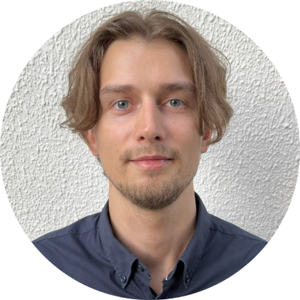

I'm an enthusiastic and result-oriented frontend developer willing to use my skills in coding, troubleshooting complex problems, and assisting in the timely completion of projects. My main professional activity is development of single page applications using TypeScript and React. Also, I used to cover created features and components by unit tests. Apart from strong experience in frontend development I’m currently actively learning and working on the backend side. Capable of working productively and efficiently both independently and within a team.

I have an engineering background and inherited the best principles such as problem-solving and finding creative solutions.

**DIPLOMA - 2013-2019**

**MINING University – SAINT-PETERSBURG, RUSSIA**

National mineral resources university (University of mines). Qualification awarded: Engineer’s degree, Mining and Mineral Engineering. 5,5 years of education.

**EDUCATION**

**LANGUAGE**

**RUSSIAN – native**

**ENGLISH – b2 (upper-intermediate)**

**SKILLS**

**FRONTEND DEVELOPER - SEP. 2022 - Present**

**Andersen Lab** - Tbilisi, Georgia

Working on web-based online-bank application that included accounts management and cards order, currency exchange and other functionality.

Technologies: React, Redux/toolkit, React Router, TypeScript, Material UI, Styled Сomponents, React-hook-form, Jest, Enzyme, React Testing Library, Git, Gitlab, Jira, Figma.

Responsibilities:

• Developing new features and components according to design, integration with backend

• Developing SPA using React, Redux and other libraries

• Working in an agile environment

• Writing unit tests with React Testing Library, Jest and Enzyme

• Code review

Implemented functionality of bank cards order and management, transfer between cards and accounts in application, worked on transaction history. All components have been covered by unit tests.

**EXPERIENCE**

|  |  |
| --- | --- |
| **JavaScript** | **••••••••••** |
| **HTML/CSS** | **••••••••••** |
| **TypeScript** | **••••••••••** |
| **React** | **••••••••••** |
| **Redux/toolkit** | **••••••••••** |
| **React Router** | **••••••••••** |
| **MobX** | **••••••••••** |
| **Testing tools** | **••••••••••** |
| **NodeJS** | **••••••••••** |
| **NestJS** | **••••••••••** |
| **Express** | **••••••••••** |
| **SQL** | **••••••••••** |
| **MongoDB** | **••••••••••** |

**CONTACT**

|  |  |
| --- | --- |
|  | Belgrade, Serbia |
|  | ivankurt96@gmail.com |
|  | [@IvanKurtts](https://t.me/IvanKurtts) |
|  | [linkedin.com/in/ivan-kurtts-07910b255/](https://www.linkedin.com/in/ivan-kurtts-07910b255/) |
|  | [github.com/IvanKurtts](https://github.com/IvanKurtts) |

SOFTWARE DEVELOPER

**IVAN KURTTS**

**PROFILE**