

YouTube Data Archive

Bachelor of Science in Software Design with Artificial Intelligence Cloud Computing

**Software Development for Cloud 2.2**

Ivan Lapickij

A00277326

22/03/2023

# Introduction

In the final project I was tasked to build a GUI application which archives & stores data. Implementing knowledge gotten during classes, with encouragement from lecture to go outside of learning scope. Theme & goal of my project is to get data from YouTube and store in Python GUI.

# Design

At the start of my application, you can notice at the top big image of youtube logo. Just below is label guiding user to insert the link into white input with green stylish button “Get Detail”. As well a table which contains title, likes, views & id of link.

# Specification

For my design I have chosen dark mode theme, since traditional “tkinter” GUI is limited to design I imported custom one which is more flexible to shape design. Some buttons change color on click giving some user interaction. As you can see you can check previous archived data, save data by getting details from YouTube, change data manually or quit application.

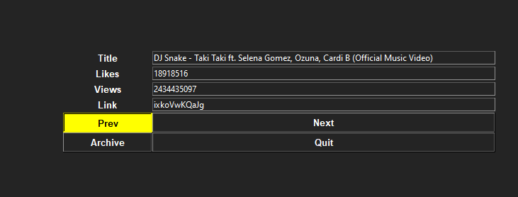

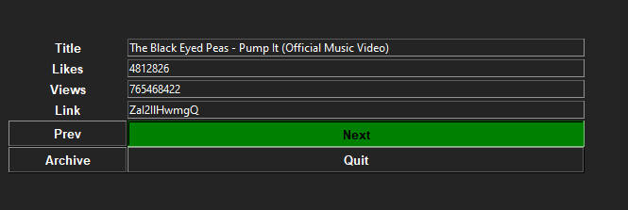

# Functionality

Below I copied link from YouTube of “Michael Jackson - You Rock My World" and requested data.

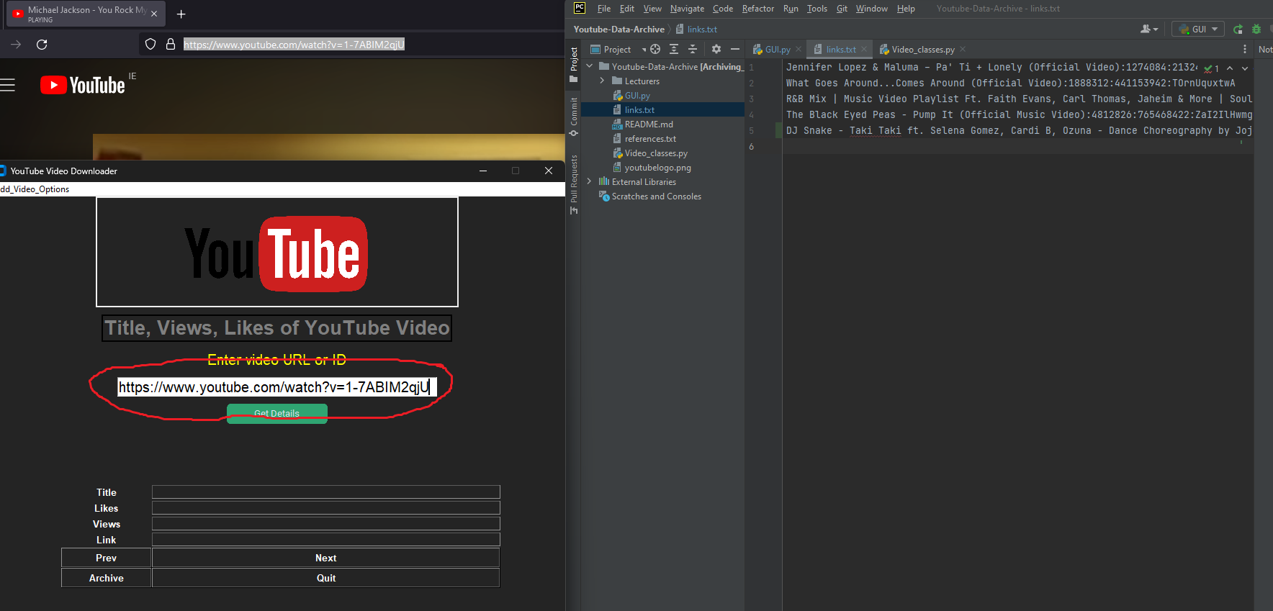

Data successfully retrieved & archived to text file “links.txt”

# Connectivity

User uses Python GUI which allows retrieve data from text file “links.txt” and see already existing library in application. Either using provided input user can request data with help off YouTube API 3. To retrieve data from API, I had to create Google cloud console to use developer key. 🗝

*Supporting packages and comment included in code.*

# Code & Error

In this section I briefly include screenshot of functions and error handling that I made.

Removed checking for typo and shadowing, after that code is perfectly fine and have no issues.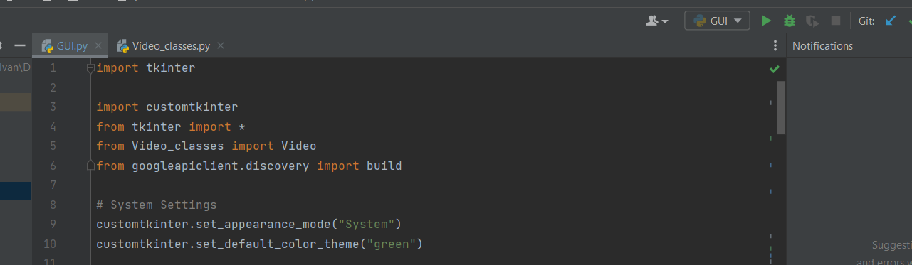

# Conclusion

Working on this assignment improved my understanding and gave me chance to integrate topics from class in my own project.

The biggest challenge was to follow guidance implementing codes and merging them. Initially to merge more complex code, programmer should know what it does, so I followed best practices learned from lectures, went through whole code, and simply explain to myself what every line does. In more complicated functions I left comments for myself & others who going to work on or investigate my code.

Given freedom of choice on assignment let me to express myself and made working on assignment interesting as much as going out of scope and learning new ways of coding. Like gathering data from server & designing application. For this vision to succeed I took peace of lecturer’s code and other code that I found on internet, merged them together & modified till adaptation. (Supporting references included in documentation “references.txt”).