Dokumentasi Pengujian White-Box Testing: Unit A (LMS & Kelas Interaktif)
Dokumen ini berisi rincian analisis White-Box Testing untuk 9 Sub-Unit Controller yang terdapat pada Unit A (Unit Pengendali LMS & Kelas Interaktif) pada sistem BasaKula.

Ringkasan 9 Sub-Unit (Controller) Unit A
No | Sub-Unit Controller | Method Utama yang Diuji | Cyclomatic Complexity V(G) | Jumlah Jalur Independen
A1 | Teacher\ClassroomController | removeMember() | 2 | 2 Jalur
A2 | Teacher\ClassroomPostController | toggleVisibility() | 2 | 2 Jalur
A3 | Teacher\MaterialController | store() | 2 | 2 Jalur
A4 | Student\ClassroomController | join() | 2 | 2 Jalur
A5 | Student\ClassroomSubmissionController | store() | 2 | 2 Jalur
A6 | Student\ClassroomQuizController | show() | 3 | 3 Jalur
A7 | Student\MaterialController | show() | 2 | 2 Jalur
A8 | ClassroomCommentController | store() | 2 | 2 Jalur
A9 | CalendarController | index() | 2 | 2 Jalur

Sub-Unit A1: `Teacher\ClassroomController` (Keluarkan Anggota Kelas)
Kode Sumber Method: `removeMember()`
public function removeMember(Classroom $classroom, User $user)
{
// N1: Gate Authorize 'manageMembers'
Gate::authorize('manageMembers', $classroom);
// N2: Query keanggotaan aktif
$member = ClassroomMember::where('classroom_id', $classroom->id)
->where('user_id', $user->id)
->whereNull('out_at')
->first();
// N3 (Decision): Cek apakah data member ditemukan
if ($member) {
// N4: Update kolom out_at dengan timestamp saat ini
$member->update(['out_at' => now()]);
}
// N5 (Exit): Return back dengan alert sukses
return back()->with('success', 'Anggota berhasil dikeluarkan dari kelas.');
}

Analisis CFG & Perhitungan $V(G)$
- Node (N) = 5, Edge (E) = 5, Predicate Node (P) = 1 (if ($member))
- V(G) = E - N + 2P = 5 - 5 + 2(1) = \mathbf{2}
Jalur Independen (*Independent Paths*)
- Path 1 (Member Ditemukan): N1 \rightarrow N2 \rightarrow N3 \text{ (TRUE)} \rightarrow N4 \rightarrow N5
- Path 2 (Member Tidak Ditemukan / Sudah Keluar): N1 \rightarrow N2 \rightarrow N3 \text{ (FALSE)} \rightarrow N5
Kasus Uji (*Test Cases*)
ID Test Case | Scenario / Input | Expected Result | Status
TC-A1-01 | Member aktif ditemukan | Data out_at terisi timestamp & alert sukses tampil | PASS
TC-A1-02 | Member tidak ada / sudah out_at | Tidak ada perubahan record & alert sukses tampil | PASS

Sub-Unit A2: `Teacher\ClassroomPostController` (Toggle Visibilitas Postingan)
Kode Sumber Method: `toggleVisibility()`
public function toggleVisibility(ClassroomPost $post)
{
// N1: Pembaruan status is_published (kebalikan dari nilai awal)
$post->update([
'is_published' => !$post->is_published,
]);
// N2 (Decision): Cek status setelah update untuk menentukan teks pesan
$statusText = $post->is_published ? 'ditampilkan kepada siswa' : 'disembunyikan dari siswa';
// N3 (Exit): Return back dengan pesan sukses
return back()->with('success', "Status postingan berhasil {$statusText}.");
}

Analisis CFG & Perhitungan $V(G)$
- Node (N) = 4, Edge (E) = 4, Predicate Node (P) = 1 ($post->is_published ?)
- V(G) = E - N + 2P = 4 - 4 + 2(1) = \mathbf{2}
Jalur Independen (*Independent Paths*)
- Path 1 (Awal Draf $\rightarrow$ Dipublikasi): N1 \rightarrow N2 \text{ (TRUE: ditampilkan)} \rightarrow N3
- Path 2 (Awal Dipublikasi $\rightarrow$ Didrafkan): N1 \rightarrow N2 \text{ (FALSE: disembunyikan)} \rightarrow N3
Kasus Uji (*Test Cases*)
ID Test Case | Scenario / Input | Expected Result | Status
TC-A2-01 | Post draf (is_published = false) | Status berubah ke true & alert *"ditampilkan kepada siswa"* | PASS
TC-A2-02 | Post terbit (is_published = true) | Status berubah ke false & alert *"disembunyikan dari siswa"* | PASS

Sub-Unit A3: `Teacher\MaterialController` (Simpan Materi Baru)
Kode Sumber Method: `store()`
public function store(Request $request)
{
// N1: Gate Authorize 'teacher' & Validasi Request Data
Gate::authorize('teacher');
$request->validate([ ... ]);
// N2: Membuka Transaksi Database (DB::beginTransaction)
DB::beginTransaction();
try {
// N3: Insert record Material ke database & commit
$material = Material::create([ ... ]);
DB::commit();
// N4 (Exit 1): Redirect ke daftar materi dengan alert sukses
return redirect()->route('teacher.materials.index')->with('success', 'Materi berhasil dibuat.');
} catch (\Exception $e) {
// N5: Rollback transaksi jika terjadi eksepsi
DB::rollBack();
// N6 (Exit 2): Kembali ke form dengan alert error
return back()->with('error', 'Terjadi kesalahan: ' . $e->getMessage())->withInput();
}
}

Analisis CFG & Perhitungan $V(G)$
- Node (N) = 6, Edge (E) = 6, Predicate Node (P) = 1 (try-catch block)
- V(G) = E - N + 2P = 6 - 6 + 2(1) = \mathbf{2}
Jalur Independen (*Independent Paths*)
- Path 1 (Transaksi Sukses): N1 \rightarrow N2 \rightarrow N3 \rightarrow N4 \text{ (Exit 1)}
- Path 2 (Eksepsi / Gagal Simpan): N1 \rightarrow N2 \rightarrow \text{Catch Exception} \rightarrow N5 \rightarrow N6 \text{ (Exit 2)}
Kasus Uji (*Test Cases*)
ID Test Case | Scenario / Input | Expected Result | Status
TC-A3-01 | Form valid & DB normal | Data terimpan di DB, commit sukses, redirect ke index | PASS
TC-A3-02 | Gangguan DB saat create() | Catch exception, DB rollback, kembali ke form dengan pesan error | PASS

Sub-Unit A4: `Student\ClassroomController` (Gabung Kelas)
Kode Sumber Method: `join()`
public function join(Request $request)
{
// N1: Validasi masukan kode kelas
$request->validate(['code' => 'required|string']);
// N2: Query pencarian kelas berdasarkan kode & status aktif
$classroom = Classroom::where('code', strtoupper(trim($request->code)))
->where('status', 'active')
->first();
// N3 (Decision): Cek apakah kelas TIDAK ditemukan
if (!$classroom) {
// N4 (Exit 1): Return back dengan pesan error
return back()->withErrors(['code' => 'Kode kelas tidak ditemukan atau tidak aktif.']);
}
// N5: Gate Authorize 'join' & buat record ClassroomMember
Gate::authorize('join', $classroom);
ClassroomMember::create([ ... ]);
// N6 (Exit 2): Redirect ke detail kelas dengan pesan sukses
return redirect()->route('student.classroom.show', $classroom)
->with('success', "Berhasil bergabung ke kelas: {$classroom->name}!");
}

Analisis CFG & Perhitungan $V(G)$
- Node (N) = 6, Edge (E) = 6, Predicate Node (P) = 1 (if (!$classroom))
- V(G) = E - N + 2P = 6 - 6 + 2(1) = \mathbf{2}
Jalur Independen (*Independent Paths*)
- Path 1 (Kode Salah/Tidak Aktif): N1 \rightarrow N2 \rightarrow N3 \text{ (TRUE)} \rightarrow N4 \text{ (Exit 1)}
- Path 2 (Kode Benar/Aktif): N1 \rightarrow N2 \rightarrow N3 \text{ (FALSE)} \rightarrow N5 \rightarrow N6 \text{ (Exit 2)}
Kasus Uji (*Test Cases*)
ID Test Case | Scenario / Input | Expected Result | Status
TC-A4-01 | Input code = 'INVALID' | Kembali ke form dengan error session "Kode kelas tidak ditemukan..." | PASS
TC-A4-02 | Input code = 'JW5A-26' | Record tersimpan di classroom_members & Redirect ke student.classroom.show | PASS

Sub-Unit A5: `Student\ClassroomSubmissionController` (Kumpul Tugas)
Kode Sumber Method: `store()`
public function store(Request $request, ClassroomAssignment $assignment)
{
// N1: Gate Authorize & Validasi Berkas Tugas
Gate::authorize('submit', $assignment);
$request->validate(['file' => 'required|file|max:20480', 'note' => 'nullable|string|max:500']);
// N2: Cari data submission lama siswa untuk tugas ini
$existing = ClassroomSubmission::where('assignment_id', $assignment->id)
->where('student_id', Auth::id())
->first();
// N3 (Decision): Jika sudah ada pengumpulan lama & ada file lama
if ($existing && $existing->file_path) {
// N4: Hapus berkas lama dari storage disk
Storage::disk('public')->delete($existing->file_path);
}
// N5: Upload file baru & updateOrCreate record submission
$file = $request->file('file');
$path = $file->store("classrooms/{$assignment->post->classroom_id}/submissions/{$assignment->id}", 'public');
ClassroomSubmission::updateOrCreate([ ... ]);
// N6 (Exit): Return back dengan alert sukses
return back()->with('success', 'Tugas berhasil dikumpulkan!');
}

Analisis CFG & Perhitungan $V(G)$
- Node (N) = 6, Edge (E) = 6, Predicate Node (P) = 1 (if ($existing && $existing->file_path))
- V(G) = E - N + 2P = 6 - 6 + 2(1) = \mathbf{2}
Jalur Independen (*Independent Paths*)
- Path 1 (Ganti File / Re-upload): N1 \rightarrow N2 \rightarrow N3 \text{ (TRUE)} \rightarrow N4 \rightarrow N5 \rightarrow N6
- Path 2 (Pengumpulan Pertama): N1 \rightarrow N2 \rightarrow N3 \text{ (FALSE)} \rightarrow N5 \rightarrow N6
Kasus Uji (*Test Cases*)
ID Test Case | Scenario / Input | Expected Result | Status
TC-A5-01 | Siswa re-upload file baru | Berkas lama di Storage terhapus, berkas baru tersimpan di DB | PASS
TC-A5-02 | Siswa pertama kali kumpul tugas | Berkas tersimpan di Storage & record baru terbuat di DB | PASS

Sub-Unit A6: `Student\ClassroomQuizController` (Tampilan Pengerjaan Kuis)
Kode Sumber Method: `show()`
public function show(ClassroomQuiz $quiz)
{
// N1: Gate Authorize 'view'
Gate::authorize('view', $quiz);
// N2 (Decision 1): Cek apakah kuis dibatasi 1x pengerjaan
if ((int)$quiz->max_attempts === 1) {
// N3: Query pengerjaan sebelumnya
$existingAttempt = QuizAttempt::where('quiz_set_id', $quiz->quiz_set_id)
->where('user_id', Auth::id())
->first();
// N4 (Decision 2): Cek apakah siswa sudah pernah mengerjakan
if ($existingAttempt) {
// N5 (Exit 1): Redirect dengan pesan error "Hanya dapat diisi 1 kali"
return redirect()->route('student.classroom.show', $quiz->post->classroom_id)
->with('error', 'Anda telah menyelesaikan kuis ini. Kuis hanya dapat diisi 1 kali.');
}
}
// N6: Ambil daftar soal aktif kuis dari database
$questions = QuizQuestion::where('quiz_set_id', $quiz->quiz_set_id)->where('is_active', true)->get();
// N7 (Exit 2): Tampilkan view lembar kuis (quiz_take)
return view('student.classroom.quiz_take', compact('quiz', 'questions'));
}

Analisis CFG & Perhitungan $V(G)$
- Node (N) = 7, Edge (E) = 7, Predicate Node (P) = 2 (if max_attempts === 1, if ($existingAttempt))
- V(G) = E - N + 2P = 7 - 7 + 2(2) = \mathbf{3}
Jalur Independen (*Independent Paths*)
- Path 1 (Batas 1x & Sudah Pernah Mengisi): N1 \rightarrow N2 \text{ (TRUE)} \rightarrow N3 \rightarrow N4 \text{ (TRUE)} \rightarrow N5 \text{ (Exit 1)}
- Path 2 (Batas 1x & Belum Pernah Mengisi): N1 \rightarrow N2 \text{ (TRUE)} \rightarrow N3 \rightarrow N4 \text{ (FALSE)} \rightarrow N6 \rightarrow N7 \text{ (Exit 2)}
- Path 3 (Batas Pengerjaan Bebas / > 1x): N1 \rightarrow N2 \text{ (FALSE)} \rightarrow N6 \rightarrow N7 \text{ (Exit 2)}
Kasus Uji (*Test Cases*)
ID Test Case | Scenario / Input | Expected Result | Status
TC-A6-01 | max_attempts = 1 & sudah ada attempt | Redirect ke kelas dengan error *"Kuis hanya dapat diisi 1 kali"* | PASS
TC-A6-02 | max_attempts = 1 & belum ada attempt | Berhasil membuka lembar kuis quiz_take | PASS
TC-A6-03 | max_attempts = 0 (unlimited) | Berhasil membuka lembar kuis quiz_take meskipun ada attempt lama | PASS

Sub-Unit A7: `Student\MaterialController` (Baca Detail Materi)
Kode Sumber Method: `show()`
public function show(Material $material)
{
// N1 (Decision): Cek apakah status materi BUKAN 'published'
if ($material->status !== 'published') {
// N2 (Exit 1): Hentikan eksekusi dengan HTTP 404
abort(404);
}
// N3: Load relasi category, unggah-ungguh, dan lampiran
$material->load(['category', 'unggahUngguhBasas', 'attachments']);
// N4 (Exit 2): Tampilkan view detail materi
return view('student.materials.show', compact('material'));
}

Analisis CFG & Perhitungan $V(G)$
- Node (N) = 4, Edge (E) = 4, Predicate Node (P) = 1 (if ($material->status !== 'published'))
- V(G) = E - N + 2P = 4 - 4 + 2(1) = \mathbf{2}
Jalur Independen (*Independent Paths*)
- Path 1 (Materi Draf/Archived): N1 \text{ (TRUE)} \rightarrow N2 \text{ (HTTP 404 Exit)}
- Path 2 (Materi Terbit/Published): N1 \text{ (FALSE)} \rightarrow N3 \rightarrow N4 \text{ (View Exit)}
Kasus Uji (*Test Cases*)
ID Test Case | Scenario / Input | Expected Result | Status
TC-A7-01 | Akses materi ber-status 'draft' | Sistem mengembalikan respon HTTP 404 Not Found | PASS
TC-A7-02 | Akses materi ber-status 'published' | Halaman materi student.materials.show terbuka lengkap dengan lampiran | PASS

Sub-Unit A8: `ClassroomCommentController` (Tambah Komentar Kelas)
Kode Sumber Method: `store()`
public function store(Request $request, ClassroomPost $post)
{
// N1: Gate Authorize 'create'
Gate::authorize('create', [ClassroomComment::class, $post]);
// N2: Validasi input teks komentar
$request->validate(['comment' => 'required|string|max:1000']);
// N3: Insert komentar ke database
ClassroomComment::create([
'post_id' => $post->id,
'user_id' => Auth::id(),
'comment' => $request->comment,
]);
// N4 (Exit): Return back dengan alert sukses
return back()->with('success', 'Komentar berhasil ditambahkan.');
}

Analisis CFG & Perhitungan $V(G)$
- Node (N) = 4, Edge (E) = 4, Predicate Node (P) = 1 (Validasi Request)
- V(G) = E - N + 2P = 4 - 4 + 2(1) = \mathbf{2}
Jalur Independen (*Independent Paths*)
- Path 1 (Komentar Kosong / Validation Error): N1 \rightarrow N2 \text{ (FAIL)} \rightarrow \text{Validation Exception (Back)}
- Path 2 (Komentar Valid / Sukses Simpan): N1 \rightarrow N2 \text{ (PASS)} \rightarrow N3 \rightarrow N4 \text{ (Exit)}
Kasus Uji (*Test Cases*)
ID Test Case | Scenario / Input | Expected Result | Status
TC-A8-01 | Input comment = '' (kosong) | Validasi gagal, kembali ke halaman dengan error comment | PASS
TC-A8-02 | Input comment = 'Sugeng enjing pak' | Komentar tersimpan di database & alert sukses tampil | PASS

Sub-Unit A9: `CalendarController` (Index Kalender Pembelajaran)
Kode Sumber Method: `index()`
public function index(Request $request)
{
// N1: Cek autentikasi & peranan user (isTeacher)
$user = Auth::user();
$isTeacher = $user->isTeacher();
// N2 (Decision): Cabang query kelas berdasarkan role
if ($isTeacher) {
// N3: Ambil ID kelas diajar guru
$classroomIds = Classroom::where('teacher_id', $user->id)->where('status', 'active')->pluck('id')->toArray();
} else {
// N4: Ambil ID kelas yang di-ikuti siswa
$classroomIds = Classroom::whereHas('members', fn($q) => $q->where('user_id', $user->id)->whereNull('out_at'))->where('status', 'active')->pluck('id')->toArray();
}
// N5: Fetch agenda tugas, kuis, materi & format event kalender
$assignments = ClassroomAssignment::whereHas('post', fn($q) => $q->whereIn('classroom_id', $classroomIds))->get();
...
// N6 (Exit): Render view kalender
return view('calendar.index', compact('currentDate', 'events', 'isTeacher'));
}

Analisis CFG & Perhitungan $V(G)$
- Node (N) = 6, Edge (E) = 6, Predicate Node (P) = 1 (if ($isTeacher))
- V(G) = E - N + 2P = 6 - 6 + 2(1) = \mathbf{2}
Jalur Independen (*Independent Paths*)
- Path 1 (Role Pengajar / Teacher): N1 \rightarrow N2 \text{ (TRUE)} \rightarrow N3 \rightarrow N5 \rightarrow N6
- Path 2 (Role Pelajar / Student): N1 \rightarrow N2 \text{ (FALSE)} \rightarrow N4 \rightarrow N5 \rightarrow N6
Kasus Uji (*Test Cases*)
ID Test Case | Scenario / Input | Expected Result | Status
TC-A9-01 | Login sebagai Pengajar | Kalender memuat seluruh agenda dari kelas yang diajar oleh pengajar | PASS
TC-A9-02 | Login sebagai Pelajar | Kalender memuat seluruh agenda tugas/kuis dari kelas yang diikuti siswa | PASS

Lampiran: Diagram Visual Control Flow Graph (CFG) Hitam-Putih
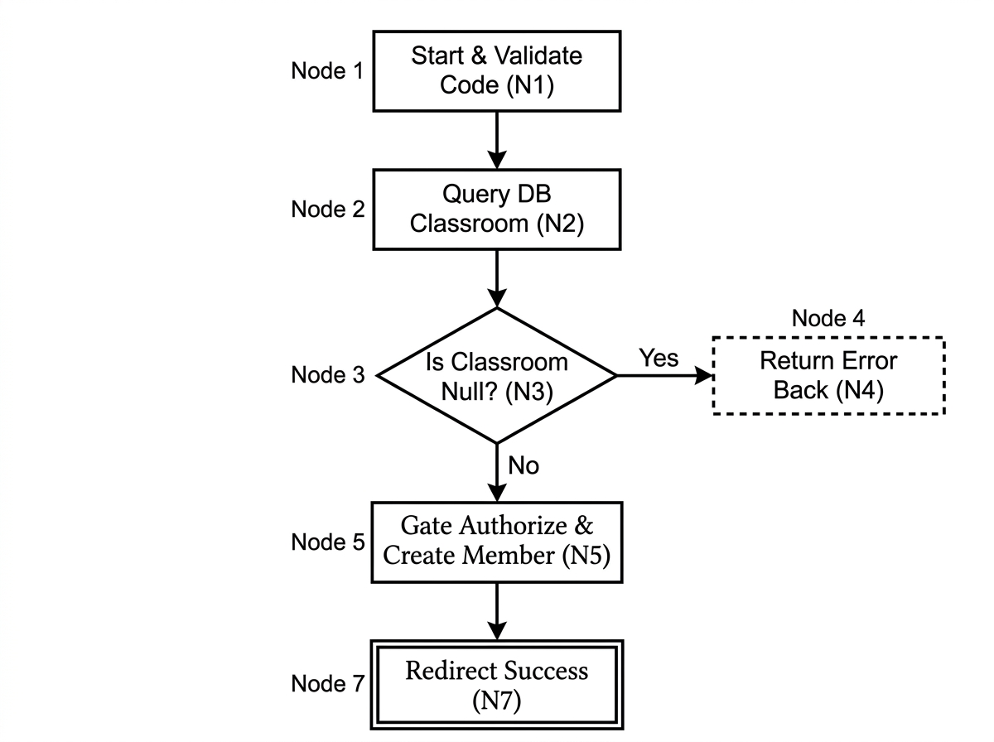
Gambar A4.1: Control Flow Graph (CFG) Student\ClassroomController::join() (Format Cetak Hitam-Putih)

