|  |
| --- |
| Close-up image showing the leaf-sides of two oversized books side-by-side on a bookshelf, with additional books in soft focus background |
| Installation and Configuration Guide  Ionic System |
| |  |  |  | | --- | --- | --- | | IVAN MC GANN - Student | 4/27/18 | Professional Practice | |

# Installing Node JS

1. First visit the following site <https://nodejs.org/en/>
2. Choose the recommended version on your left.

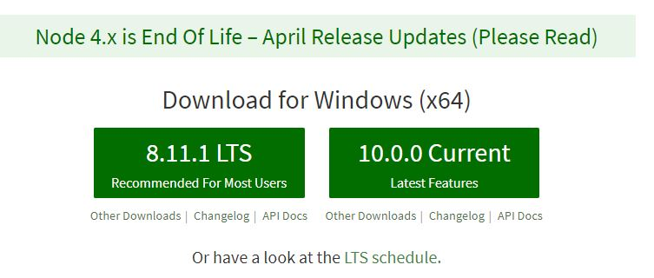

1. Run the .msi file downloaded and wait for it to check your systems space requirements.
2. Accept the license agreement and press next.

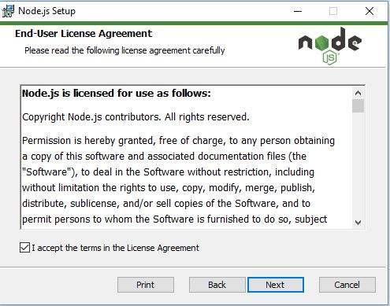

1. Select the destination for the node folder and once done press next.
2. Customise your setup although I recommend choosing the default setup.

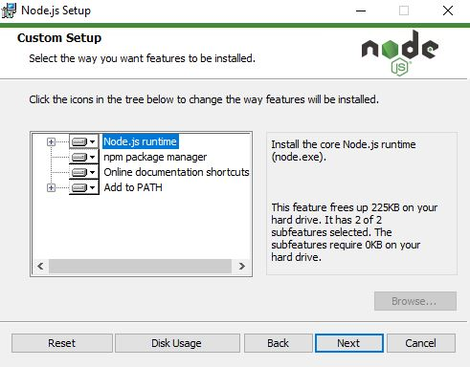

1. Finally, when prompted press install and wait for completion.

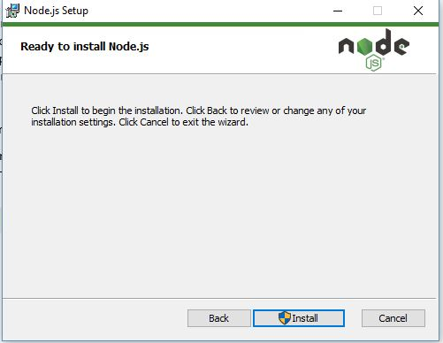

1. Update npm by entering: npm install npm@latest -g

in the command line.

# Install Ionic

1. First, we install the latest version of Apache Cordova, which will take our app and bundle it into a native wrapper to turn it into a traditional native app.
2. Make sure to install node JS first.
3. Then in a command line enter: npm install -g cordova into the command line.

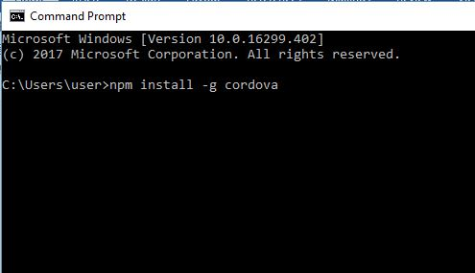

1. -g is a global install.
2. Wait for Cordova to install.
3. Then once entered enter: npm install -g ionic into the command line.
4. This may take some time to install but wait and once successful ionic has been installed on your desktop.
5. Check if its installed: ionic -v

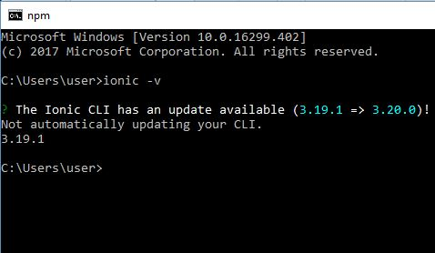

# Create Firebase:

1. Log in to a verified Gmail account, preferably in Chrome.
2. Visit: <https://firebase.google.com>
3. Go to console in the top right corner.
4. Choose (+) Add a project.
5. Enter the name and set the region to Ireland then press - Create Project button.



1. Press continue, and you will visit the homepage of the project.
2. Go to the database tab on the left hand side.

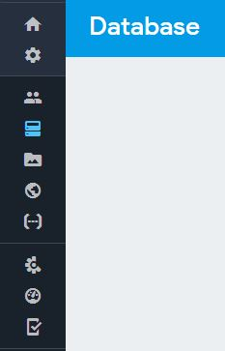

1. Choose a Realtime database.
2. Start in test mode so you can read and write by default.

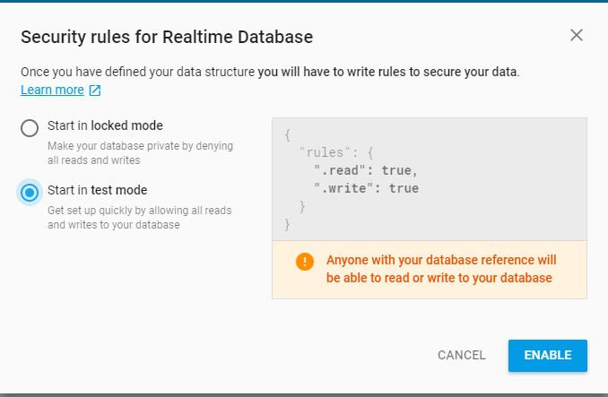

1. Return to the home screen and press the button that says, ‘Add Firebase to your web app’.
2. Copy the contents of the var config below and put it in the firebase.credentials.ts class inside the constant FIREBASE_CONFIG.

