Pictures

Templater can copy existing pictures or inject new ones at the place of tag when Image type is provided (either built-in such as BufferedImage/Image or Templater specific ImageInfo). Due to Java API restrictions Templater will assume picture have 96dpi and will inject them as is into the document. If Java ImageInputStream is used it will try and extract DPI information from the image. When we want to change the size of the image, we can resize it through the plugin before it’s inserted into the document.

# Cars on sale

|  |
| --- |
| Really fast car |
| Ford Focus |
| Regular car |

# Boats on sale

* Speadboat
  + 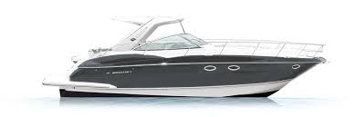
* Slowboat
  + 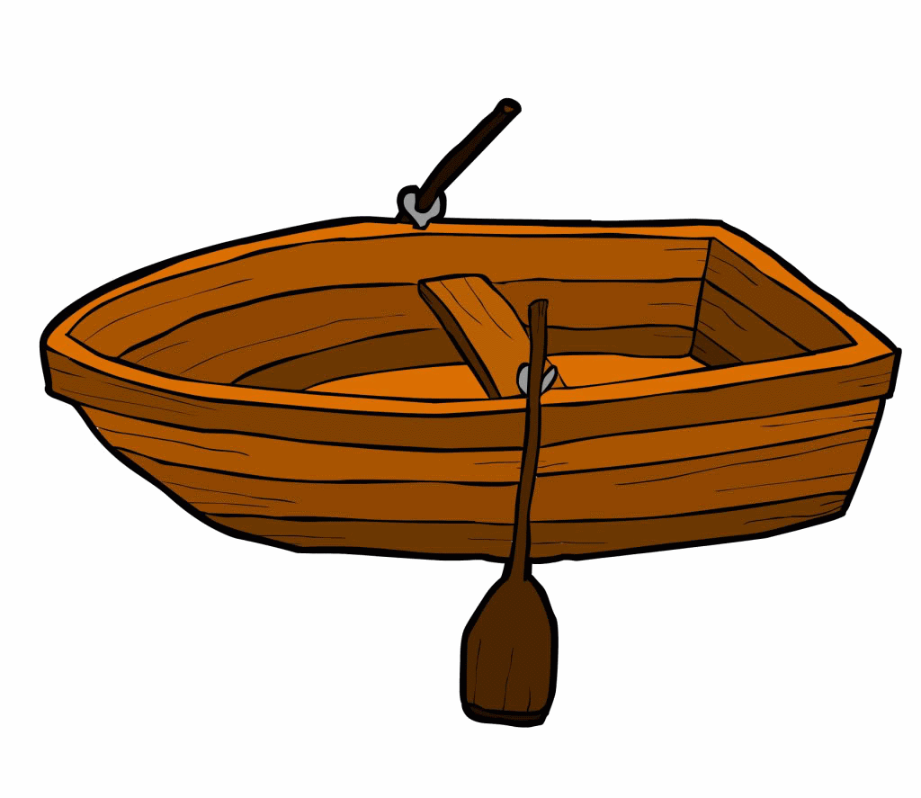
* Cruiser
  + 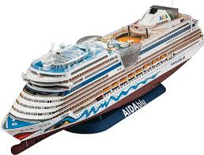

# SVG images

|  |
| --- |
| Cat face – without fallback image conversion - works only in MS Word 2016+ |
| Happy cat – with fallback image conversion |

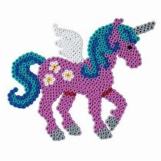Templater can also replace existing pictures if a tag is defined in picture Alt Text. This is useful when picture needs to use some effects which are not available with ordinary insert: