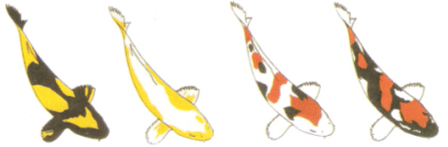Chapter 18: Classification

**I.** **Metacognition:**  By the end of this unit you are expected to be able to do/complete all objectives below. Your teacher will help you understand this material, but it is ultimately your responsibility. Constantly ask yourself whether or not you are meeting these targets, and what are you doing to master them?

|  |  |  |  |
| --- | --- | --- | --- |
| Pre  Check | TB  Section | Objectives (*EOB) | Post  Check |
|  | 18.1 | 1. Recognize the necessity of scientific names.* |  |
|  | 18.1 | 2. Identify what criteria are necessary for organisms to be considered members of the same species.* |  |
|  | 18.1 | 3. Demonstrate how the major categories of biological classification scheme show that some organisms are more closely related than others.* |  |
|  | 18.2 | 4. Explain modern evolutionary classification and the use of cladograms to demonstrate evolutionary relationships. |  |
|  | 18.3 | 5. Understand the importance in building the tree of life. |  |

**II. Vocabulary Building:** Due Date: __________________

How am I going to learn the terms? (select one or create your own idea that is teacher approved)

* Make flashcards of all vocabulary terms and definitions.
* Make a flip chart including all vocabulary terms and definitions.
* Other Ideas (teacher approved)? ________________________________________________

**III. Chapter Vocabulary and Root Words:**

|  |  |  |
| --- | --- | --- |
| Term | Definition | Memory Cue |
| Binomial nomenclature |  |  |
| Species |  |  |
| Genus |  |  |
| Systematics |  |  |
| Taxon |  |  |
| Family |  |  |
| Order |  |  |
| Class |  |  |
| Phylum |  |  |
| Kingdom |  |  |
| Phylogeny |  |  |
| Clade |  |  |
| Monophyletic group |  |  |
| Cladogram |  |  |
| Derived character |  |  |
| Domain |  |  |
| Bacteria |  |  |
| Archaea |  |  |
| Eukarya |  |  |

**IV. Guided Reading Section Questions (*EOB):**

**Section 18.1 p.508-515: Finding Order in Diversity**

|  |  |  |
| --- | --- | --- |
| Pre  Check | Objectives (*EOB) | Post  Check |
|  | 1. Recognize the necessity of scientific names.* |  |
|  | 2. Identify what criteria are necessary for organisms to be considered members of the same species.* |  |
|  | 3. Demonstrate how the major categories of biological classification scheme show that some organisms are more closely related than others.* |  |

1. Why can common names of organisms cause problems for scientists?* _________________

___________________________________________________________________________

1. What is the goal of binomial nomenclature?* ______________________________________

___________________________________________________________________________

1. In the 1730s, what Swedish botanist developed binomial nomenclature? ________________
2. Why is a dichotomous key useful for identifying organism? ___________________________

___________________________________________________________________________

1. Complete the graphic organizer.*

A useful scientific name must have two characteristics:

1. What are the rules for writing a scientific name?* ___________________________________

______________________________________________________________________________________________________________________________________________________

1. What genus does the grizzly bear, *Ursus arctos*, belong to?* _________________________________
2. What is the goal of systematics?* ________________________________________________

___________________________________________________________________________

1. 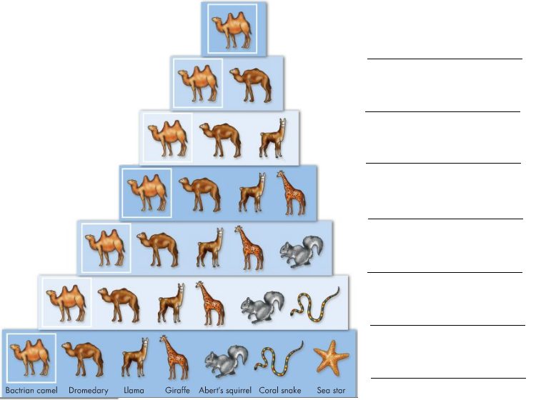List the main levels of organization on the diagram to the right.
2. Which level encompasses the greatest diversity of organisms?

_________________

The least diversity of organisms?

_________________

Hint: **K**ing **P**hillip **C**ame **O**ver **F**or **G**ood **S**oup.*

1. In which group of organisms are the members more closely associated -all of the organisms in the same kingdom or all of the organisms in the same order? Explain your answer.*

___________________________________________________________________________

___________________________________________________________________________

**Section 18.2 p. 516-522: Modern Evolutionary Classification**

|  |  |  |
| --- | --- | --- |
| Pre  Check | Objectives (*EOB) | Post  Check |
|  | 1. Explain modern evolutionary classification and the use of cladograms to demonstrate evolutionary relationships. |  |

1. Explain the difference between evolutionary classification and Linnaean classification.

___________________________________________________________________________

___________________________________________________________________________

___________________________________________________________________________

1. Describe how to make and interpret a cladogram. __________________________________

___________________________________________________________________________

___________________________________________________________________________

___________________________________________________________________________

1. Explain the use of DNA sequences in classification. __________________________________

___________________________________________________________________________

___________________________________________________________________________

*For Questions 4–7, complete each statement by writing the correct word or words.*

1. All species descended from a(n) _______________ are part of a monophyletic group.
2. is the study of how living and extinct organisms are related to one another.
3. A clade includes a common ancestor and all its descendants, living or .
4. Characteristics shared by members of a clade and only by members of that clade are called .
5. Examine the cladogram below to complete the following:

* Shade in the two organisms that belong to a clade that does not include the third.
* Circle the point that shows the most recent common ancestor of the crab & the barnacle.
* Mark an X on the point that shows most recent common ancestor of mollusks & crustaceans.
* 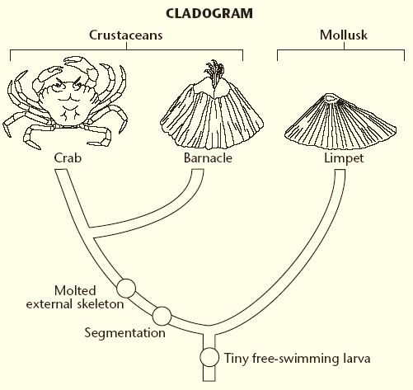Underline the characteristic that all three organisms have in common.

1. According to the figure, which species is most closely related to red pandas? _____________
2. 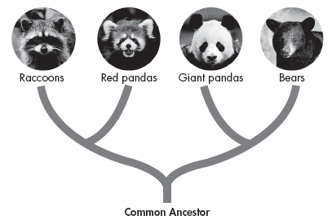Although giant pandas and raccoons share some similarities, they are in different clades. What type of evidence do you think was used to construct this diagram?

_______________________________

_________________________________

_________________________________

1. Biologists had previously classified giant pandas together with raccoons & red pandas. What did DNA analysis reveal about giant pandas and bears?

___________________________________________________________________________

___________________________________________________________________________

___________________________________________________________________________

**Section 18.3 p. 523-530: Building the Tree of Life**

|  |  |  |
| --- | --- | --- |
| Pre  Check | Objectives (*EOB) | Post  Check |
|  | 1. Understand the importance in building the tree of life. |  |

1. Explain what the tree of life represents. ___________________________________________

___________________________________________________________________________

___________________________________________________________________________

1. What are the six kingdoms of life as they are now identified? Complete the concept map.

Animalia

The Six-Kingdom System

Includes

1. Match the kingdom with the description that applies to members of that kingdom.

**Kingdom Description**

____ Protista A. They feed on dead or decaying organic matter.

____ Fungi B. They have no cell walls and they move about.

____ Plantae C. They are a “catchall” group of eukaryotes.

____ Animalia D. They include mosses and ferns.

1. Why did systematics establish the domain and what are the three domains of life?

___________________________________________________________________________

___________________________________________________________________________

___________________________________________________________________________

1. Do you think that tree of life cladogram will always stay the same as it is in Figure 18-18 on pages 526-527? Explain your answer. ____________________________________________

___________________________________________________________________________

___________________________________________________________________________

1. Complete the chart below.

|  |  |  |
| --- | --- | --- |
| **Classification of Living Things** | | |
| **Domain** | **Kingdom** | **Examples** |
|  | Eubacteria | *Salmonella typhimurium* |
| Archaea |  | *Sulfolobus archaea* |
|  | “Protista” |  |
|  | mushrooms, yeasts |
| Plantae |  |
|  | Sponges, worms, insects, fishes, mammals |

1. Read the Technology and Biology section on page 529. Explain how bar-coding is linked to studying evolutionary relationships between two birds. Be specific!

___________________________________________________________________________

___________________________________________________________________________

___________________________________________________________________________

___________________________________________________________________________

___________________________________________________________________________

**V. I can statements: Read the following I can statements and complete the table with evidence you know that I can statement. This could include a sentence, a picture, etc. You MUST complete this section for credit.**

|  |  |  |
| --- | --- | --- |
| TB  Section | I can statement (*EOB) | Evidence |
| 18.1 | 1a. I can describe the goals of binomial nomenclature and systematics. | Binomial nomenclature-  Systematics- |
| 18.1 | 1b. I can explain the confusion caused by common names.* |  |
| 18.1 | 1c. I can explain why scientific names are universally accepted and important in science.* |  |
| 18.1 | 1d. I can write a scientific name using the rules for scientific names.* |  |
| 18.1 | 1e. I can identify genus and species from the scientific name.* |  |
| 18.1 | 1f. I can describe Carolus Linnaeus’s contribution to classification. |  |
| 18.1. | 1g. I can illustrate the use of a dichotomous key. | (Example) |
| 18.1 | 2a. I can describe when two organisms are the same species vs. when they are not the same species.* |  |
| 18.1 | 3a. I can list the taxonomic levels of classification in order of specificity.* |  |
| 18.1 | 3b. I can name the broadest group and most specific group of the taxonomic classification levels.* |  |
| 18.1 | 3c. I can use the taxonomic levels to determine how closely related two organisms are.* |  |
| 18.2 | 4a. I can explain the goal of evolutionary classification. |  |
| 18.2 | 4b. I can define cladogram and describe how to create one and why they are important in evolutionary classification. | Cladogram-  How to make-  Importance- |
| 18.2 | 4c. I can define derived characteristics and explain the use of derived characteristics in relating organisms. | Derived characteristics-  Use- |
| 18.2 | 4d. I can explain how DNA sequences are used in classification. |  |
| 18.3 | 5a. I can name and describe the six kingdoms of life as they are currently identified. | -  -  -  -  -  - |
| 18.3 | 5b. I can name and describe the three domains of life as they are currently identified. | -  -  - |
| 18.3 | 5c. I can explain what the tree of life represents. |  |

**VI. Study Guide**

The final chapter assessment is on ____________________________

To study for the test I have completed the following:

___ Completing the entire reading guide

___ Rereading the entire chapter

___ Making flashcards

___ Making my own study guide

___ Reviewing all of my notes

___ Reviewing all of my labs

___ Reviewing all of my worksheets

___ Reviewing all of my quizzes

___ Quizzing myself

___ Quizzing a classmate

___ Creating a practice test

___ Outlining the chapter

___ Copying my notes

___Making a graph organizer

___ Getting additional help from my teacher

___ Taking online quizzes/tests on Biology.com website

___ Other (explain: _______________________________)

___ Other (explain: _______________________________)

___ Other (explain: _______________________________)

___ Other (explain: _______________________________)

I predict that I will earn the following grade on my assessment ___________ because ___________________

_________________________________________________________________________________________

_________________________________________________________________________________________